Claim Summary: HURTX-2024-0456

# Claim Details

Claim ID: HURTX-2024-0456

Claimant: Contoso Electronics Inc.

Date Filed: January 27, 2025

Incident Type: Hurricane Alicia

Incident Date: May 15, 2024

Store Location: Contoso Electronics #TX-230, 1125 Main Street, Houston, TX 77002

Contact: Gabriel Allen (Store Manager)

# Damage Assessment

Types of Damage:

- Severe roof damage and water intrusion on the south side.

- Flooded inventory storage with electronics submerged.

- Electrical panels shorted due to water ingress.

- Potential structural compromise in the south wing support beams.

Preliminary Damage Estimates:

Inventory Loss: $380,000

Structural Damage: $200,000

Equipment Replacement: $160,000

Business Interruption: TBD.

# Mitigation Steps Taken

- Secure site and prevent unauthorized entry.

- Engage emergency restoration team for water extraction.

- Move salvageable inventory to upper floors.

- Install temporary roof patch.

# Policy Coverage Details

Policy Number: CP-TX-2024087

Period: January 1, 2024 - December 31, 2024

Coverage:

- Hurricane/Wind Coverage: Included

- Flood Coverage: Included (Deductible: $50,000)

- Business Interruption: Included (sub-limit $500,000)

- Replacement Cost: Included

Total Insured Value: $2,000,000

Sublimits:

- Building Structure: Up to $1,000,000

- Business Property (Incl. Inventory): Up to $600,000

- Electronic Equipment: Up to $200,000

Deductibles:

- Hurricane/Wind: 5% of Total Insured Value ($100,000)

- Flood: $50,000

- Standard: $25,000

# Weather Report

Storm: Hurricane Alicia

Category: 3

Max Sustained Winds: ~120 mph

Date: May 15, 2024

Impact on Houston:

- Landfall near Galveston, TX

- Severe conditions lasting 6-8 hours over Houston

- Sustained winds of 100-120 mph, gusts up to 130+ mph

Rainfall totaling 10-14 inches

Storm Surge: 8-10 feet along coastal areas

# Damage Cost Breakdown

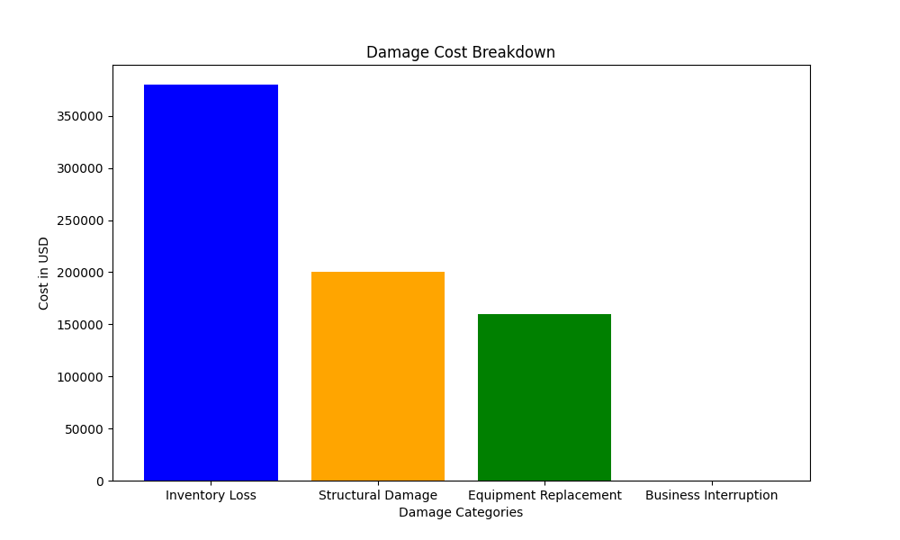

# Deductions Applied

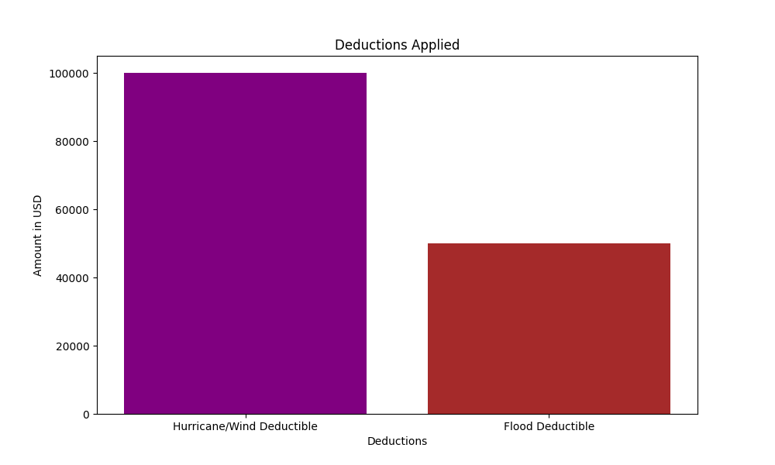

# Risk Assessment Metrics

