**Appendix**

Table 2. Effect sizes (>.05) of main effects and interactions for the bias and RMSE of estimation on item parameters.

|  |  |  |  |  |  |
| --- | --- | --- | --- | --- | --- |
| Statistic and Source of Variation | a.G | a.S | c1 | c2 | c3 |
| **Bias** |  |  |  |  |  |
| Skewness on General Factor | **.857** | .001 | **.343** | **.621** | **.440** |
| Skewness on Specific Factor | .000 | **.214** | .022 | **.052** | .026 |
| Item Number per Factor | .001 | **.054** | **.090** | .018 | .022 |
| Sample Size | .020 | .021 | **.080** | .004 | **.051** |
|  |  |  |  |  |  |
| **RMSE** |  |  |  |  |  |
| Skewness on General Factor | **.409** | .001 | .039 | **.255** | .007 |
| Item Number per Factor | **.080** | **.236** | **.112** | .049 | **.103** |
| Sample Size | **.084** | **.234** | **.256** | **.264** | **.261** |

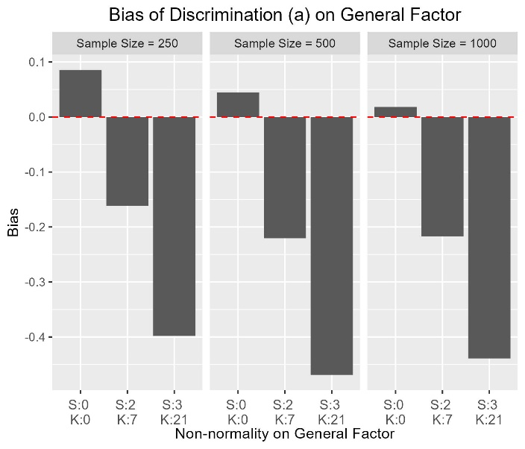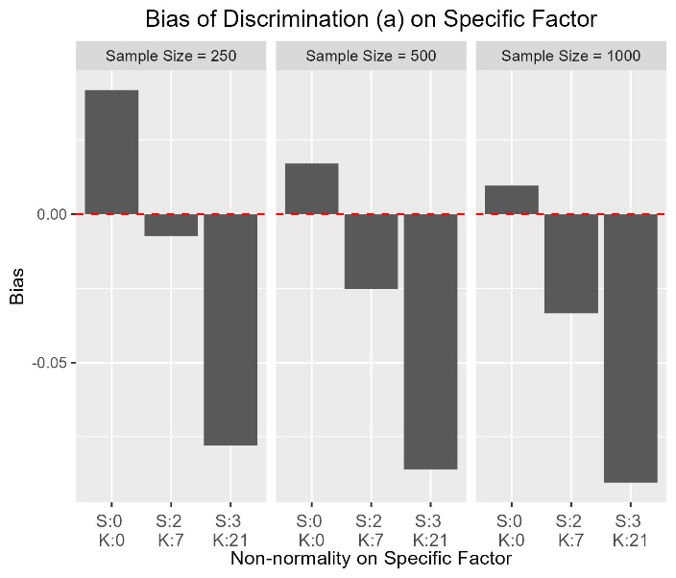

Figure 1. Bias of parameter "a" on the general factor (aG) and the specific factor (aS)

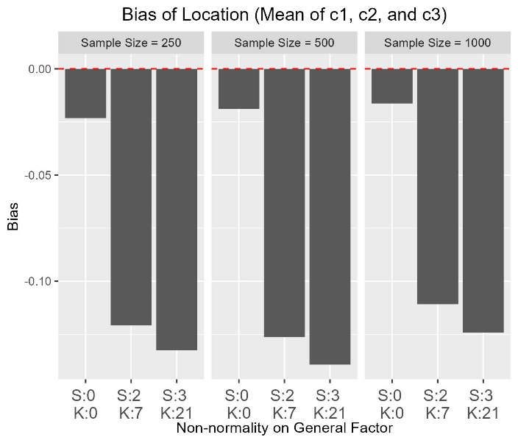

Figure 2. Bias of parameter c1, c2 and c3.

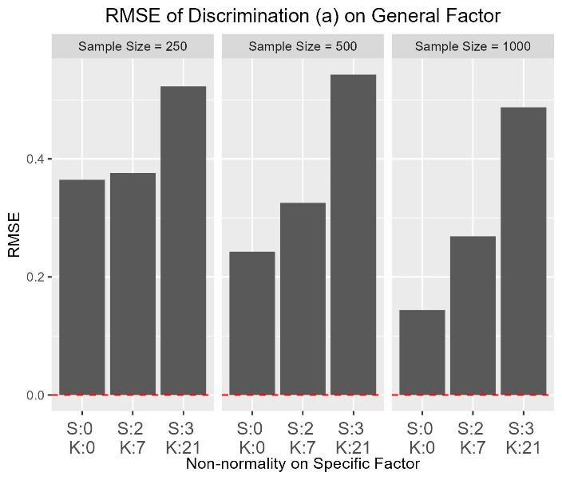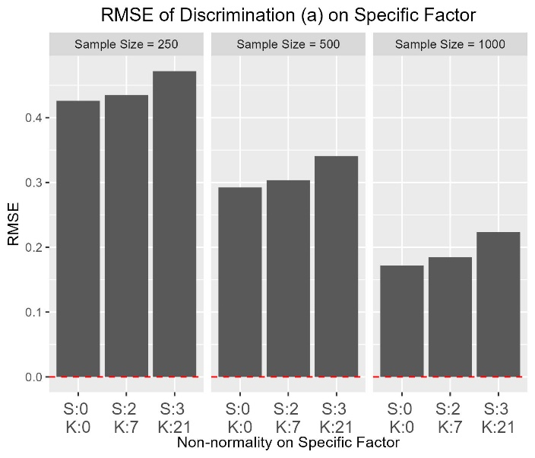

Figure 3. RMSE of parameter "a" on the general factor (aG) and the specific factor (aS).

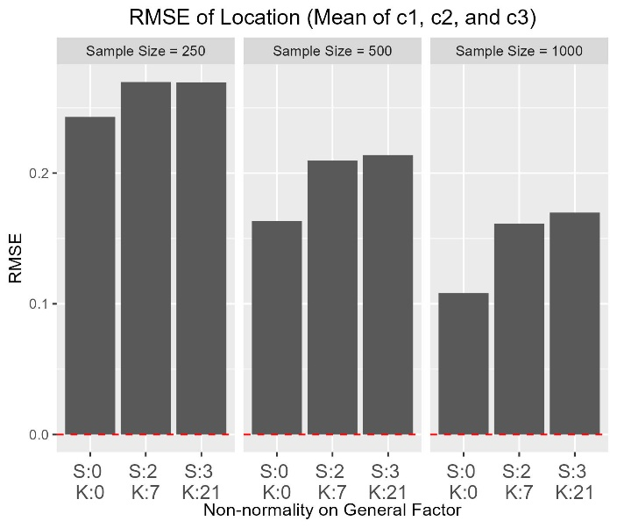

Figure 4. RMSE of parameter c1, c2 and c3.

Table 2. Effect sizes (>.05) of main effects and interactions for the bias of bias, RMSE and Correlation of estimation on personal parameters.

|  |  |  |  |  |  |  |
| --- | --- | --- | --- | --- | --- | --- |
|  | **Bias** | | **RMSE** | | **Correlation** | |
|  | ThetaG | ThetaS | ThetaG | ThetaS | ThetaG | ThetaS |
| Factor | **.080** | **.155** | **.611** | **.700** | **.714** | .034 |
| I | .003 | .042 | **.596** | **.759** | **.713** | **.706** |
| N | .027 | .034 | **.068** | **.064** | .014 | **.134** |
| Fg | **.499** | .014 | **.269** | **.074** | **.481** | .020 |
| Fs | .001 | .009 | .003 | **.063** | .006 | **.221** |
| MAP | **.184** | .008 | **.906** | **.965** | **.771** | **.074** |
|  |  |  |  |  |  |  |
| Factor:I | .049 | **.060** | **.227** | **.087** | **.298** | .041 |
| Factor:N | .047 | **.050** | .090 | **.071** | **.157** | **.147** |
| I:N | .003 | .024 | .001 | .018 | .001 | **.080** |
| Factor:Fg | .004 | .007 | .001 | .000 | **.055** | .000 |
| I:Fg | .000 | .023 | .002 | .001 | **.092** | .001 |
| Factor:MAP | .037 | **.152** | **.284** | **.273** | **.095** | .001 |
| I:MAP | .009 | .038 | **.374** | **.662** | **.258** | .003 |
| N:MAP | .012 | .036 | **.059** | **.100** | .010 | .003 |
| Fg:MAP | **.066** | .004 | **.083** | **.059** | .013 | .001 |
| Factor:I:N | .031 | .023 | **.12** | .031 | **.126** | **.084** |
| Factor:I:MAP | .039 | **.065** | **.128** | .045 | .037 | .000 |
| Factor:N:MAP | **.057** | **.056** | **.064** | .032 | **.057** | .002 |
| Factor:I:N:MAP | .034 | .029 | **.059** | .017 | .040 | .001 |

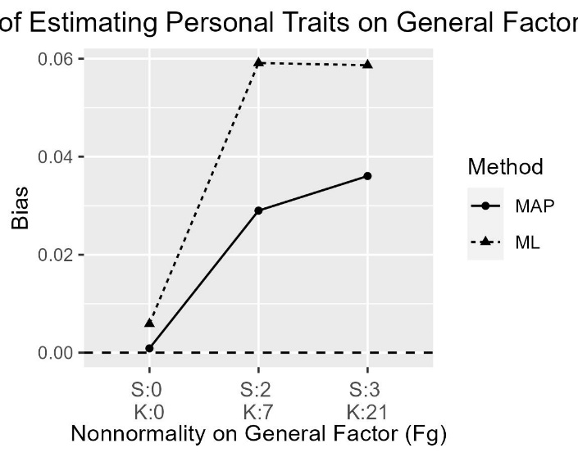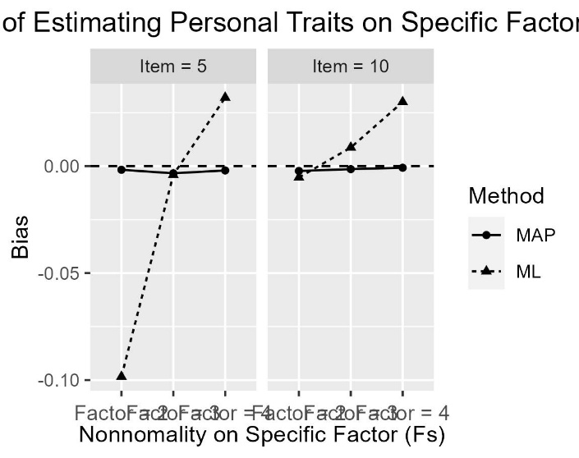

Figure 5. Bias of theta on General Factor and Specific Factor estimated by MAP and ML method.

Figure 6. RMSE of theta on General Factor and Specific Factor estimated by MAP and ML method.

Figure 7. Correlation of theta on General Factor and Specific Factor estimated by MAP and ML method.