**Appendix**

**Table 1.**

*Simulation Design*

|  |  |  |
| --- | --- | --- |
| Design factors | levels | Values of levels |
| **Data Structure** |  |  |
| Sample size (N) | 3 | N = 250, 500, 1000 |
| Number of Item per Factor (I) | 3 | I = 5, 10, 20 |
| Number of Specific Factor (Fs) | 2 | Fs = 2, 4 |
|  |  |  |
| **Nonnormality** |  |  |
| Nonnormality on General Factor (θg) | 2 | Normal: Skewness = 0, Kurtosis = 0  Non-normal: Skewness = 2, Kurtosis = 7 |
| Nonnormality on General Factor (θsk) | 2 | Normal: Skewness = 0, Kurtosis = 0  Non-normal: Skewness = 2, Kurtosis = 7 |

**Table 2.**

*Analyzing Effect Sizes (> .06) of Main Effects and Interactions on Estimation Accuracy for Item Parameters*

|  |  |  |  |  |  |  |
| --- | --- | --- | --- | --- | --- | --- |
| term |  | Bias |  |  | RMSE |  |
|  | aG | aS_mean | c_mean | aG | aS_mean | c_mean |
| Fg | .804 | .004 | .783 | .032 | .001 | .011 |
| Fs | .001 | .168 | .043 | .000 | .000 | .002 |
| I | .016 | .133 | .042 | .169 | .253 | .141 |
| N | .049 | .147 | .000 | .202 | .196 | .415 |
| I:N | .015 | .108 | .000 | .091 | .100 | .063 |

|  |  |  |  |  |  |
| --- | --- | --- | --- | --- | --- |
| Source of Variation | ag | as | c1 | c2 | c3 |
| Bias |  |  |  |  |  |
| Fg | **.804** | .004 | **.443** | **.766** | **.610** |
| Fs | .001 | **.168** | .029 | .047 | .025 |
| I | .016 | **.133** | **.180** | .050 | .017 |
| N | .049 | **.147** | **.090** | .000 | **.085** |
| I: N | .015 | .108 | .042 | .000 | .036 |
| I: Fg | .019 | .000 | .024 | .051 | .042 |
| RMSE |  |  |  |  |  |
| Fg | .032 | .001 | .021 | .059 | .000 |
| I | **.169** | **.253** | **.149** | .058 | **.151** |
| N | **.202** | **.196** | **.316** | **.601** | **.385** |
| I: N | **.091** | **.100** | **.075** | .012 | **.071** |

**Note:** The table presents effect sizes for bias and RMSE in item parameter estimation, affected by item discrimination on general (ag) and average discrimination on specific factors (as), item thresholds (c1, c2, c3), non-normality on general (Fg) and specific factors (Fs), item number within factors (I), sample size (N), and their interactions (I: N, I: Fg). Non-normality reflects deviations from normal distribution in abilities or traits. Interactions explore how item sequencing and sample characteristics influence estimation accuracy.

**Table 3.**

*Effect sizes (> .06) of main effects and interactions for the bias of bias, RMSE and Correlation of estimation on personal parameters*

|  |  |  |  |  |  |  |  |  |  |  |  |  |  |
| --- | --- | --- | --- | --- | --- | --- | --- | --- | --- | --- | --- | --- | --- |
| Source of Variation | Bias | |  | |  | | RMSE | |  | | Correlation | | |
| Thetag | Thetas | |  | | Thetag | | Thetas | |  | | Thetag | Thetas |
| Fg | **.163** | .003 | |  | | .039 | | **.082** | |  | | **.165** | .006 |
| Fs | .001 | .047 | |  | | .009 | | .038 | |  | | .006 | **.128** |
| Factor | .004 | .036 | |  | | **.539** | | **.657** | |  | | **.681** | .005 |
| I | .012 | **.092** | |  | | **.742** | | **.880** | |  | | **.826** | **.836** |
| N | .002 | .000 | |  | | .005 | | .016 | |  | | .016 | **.158** |
| MAP | .042 | .020 | |  | | **.856** | | **.967** | |  | | **.827** | .360 |
| Factor: I | .000 | .004 | |  | | **.117** | | **.168** | |  | | **.216** | .066 |
| I: N | .000 | .002 | |  | | .041 | | .014 | |  | | .020 | **.123** |
| I: Fg | .004 | **.091** | |  | | .002 | | .005 | |  | | .042 | .002 |
| Factor: MAP | .000 | .028 | |  | | **.264** | | **.179** | |  | | **.179** | .008 |
| I: MAP | .001 | **.093** | |  | | **.589** | | **.826** | |  | | **.537** | .043 |
| Fg: MAP | .031 | .000 | |  | | .006 | | **.074** | |  | | .022 | .001 |
| Factor: N: Fg | .000 | .001 | |  | | .001 | | .009 | |  | | .016 | **.071** |
| I: N: Fs | .004 | .002 | |  | | **.072** | | .011 | |  | | **.072** | .035 |
| Factor: I: MAP | .001 | .004 | |  | | **.079** | | **.085** | |  | | .020 | .005 |
| I: Fg: MAP | .003 | **.093** | |  | | .001 | | .005 | |  | | .003 | .001 |
| Factor: I: N: Fg | .003 | .003 | |  | | .011 | | .029 | |  | | .032 | **.101** |
| Factor: I: N: Fg: Fs | .001 | .001 | |  | | .049 | | .003 | |  | | **.063** | .012 |

**Figure 1.**

*

**Figure 2.**

*Interaction plots of bias of item parameters*

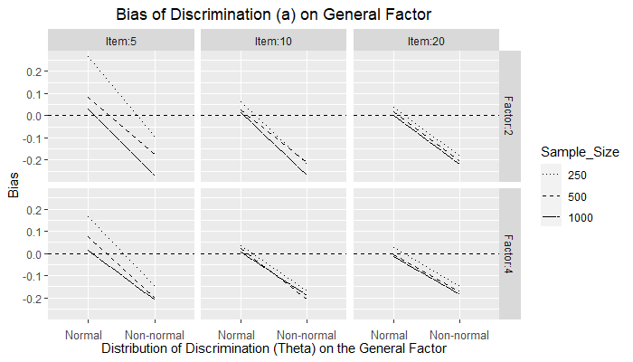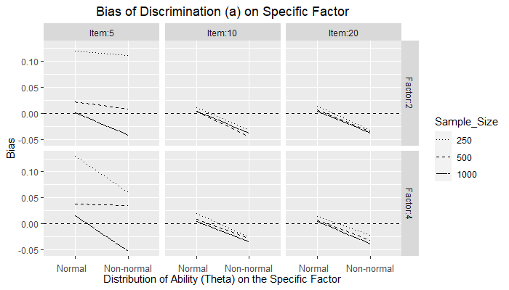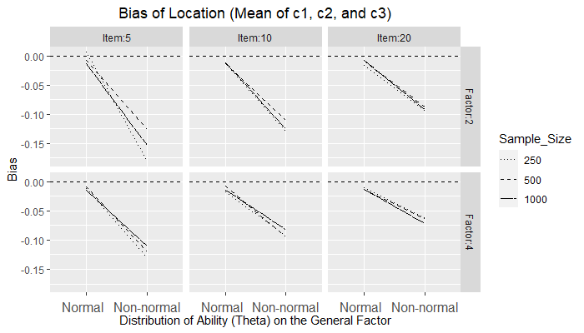

**Figure 3.**

*Interaction plots of RMSE of item parameters*

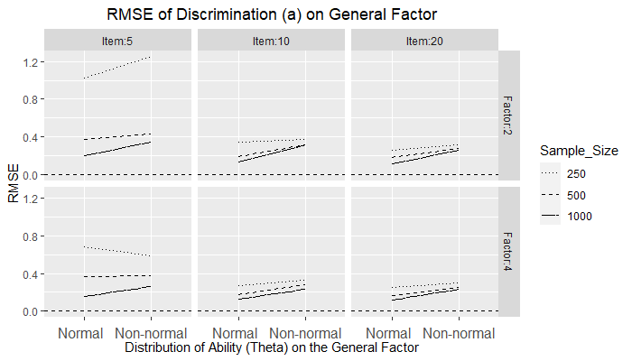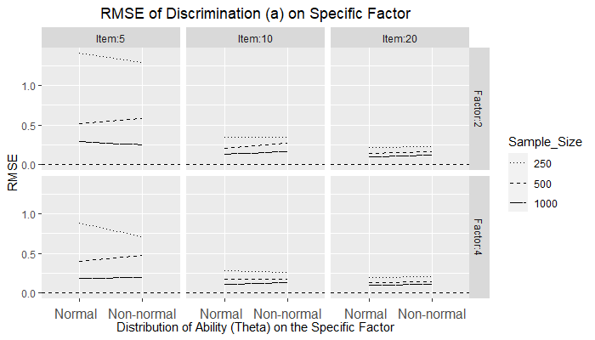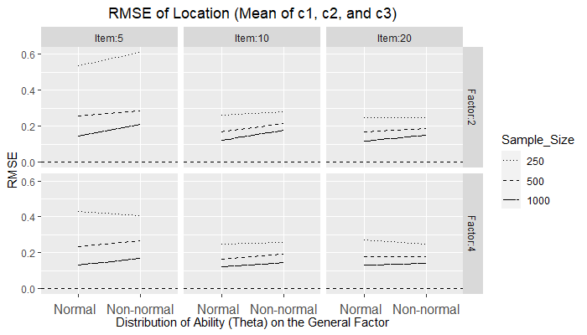

**Figure 4.**

*Interaction plots of Bias of person parameters*

**Figure 5.**

*Interaction plots of RMSE of person parameters*

**Figure 6.**

*Interaction plots of Correlation of person parameters*

