Results
Descriptive Statistics
Figure x. Annual ER Opioid Cases by County
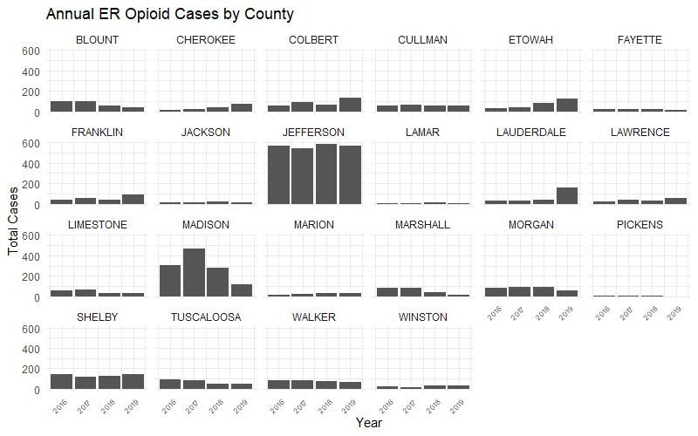
In Figure x, Jefferson has consistently highest counts across all four years (about 500–600/year). Madison is second highest ER opioid count with a peak in 2017, followed by a sharp drop in 2019. Shelby, Morgan, and Walker have stable and moderately high levels across the years. Blount, Tuscaloosa, Limestone, and Marshall decrease ER opioid counts from 2016 to 2019, while Etowah, Cherokee, and Lauderdale demonstrate an increasing trend.

Figure x. Monthly ER Opioid Cases by County
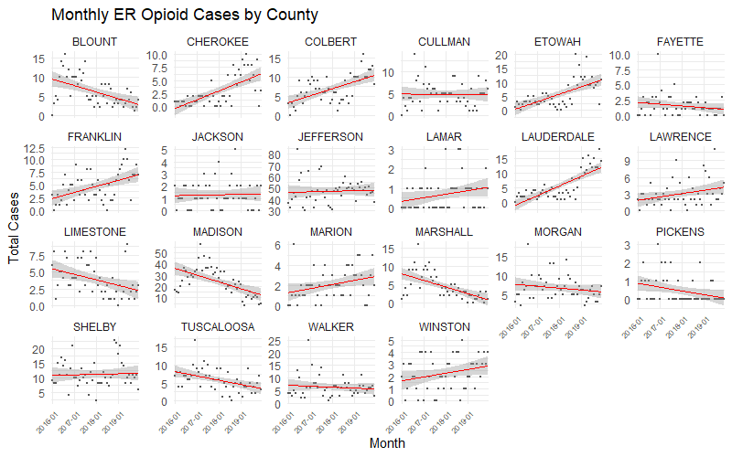
Figure x illustrates monthly emergency room (ER) opioid case trends from 2016 to 2019 across 24 Alabama counties. Each panel displays a time series of monthly case counts with an overlaid linear trend line to visualize changes over time. Notably, several counties, including Cherokee, Colbert, Etowah, Franklin, Lauderdale, Marion, Winston, exhibited a clear upward trajectory in opioid-related ER visits, suggesting a sustained or worsening opioid crisis in those areas. In contrast, counties such as Limestone, Madison, Marshall, Pickens, and Tuscaloosa demonstrated declining trends, potentially indicating improved intervention efforts or shifts in reporting practices. Some counties (e.g., Jackson, Marion, Pickens) showed relatively stable or low case counts with no distinct temporal pattern, though underreporting cannot be ruled out. These county-level differences highlight the importance of localized monitoring and intervention strategies, as temporal dynamics of opioid-related ER visits are not uniform across the state.
Figure x. Heatmap of Monthly ER Opioid Cases by County
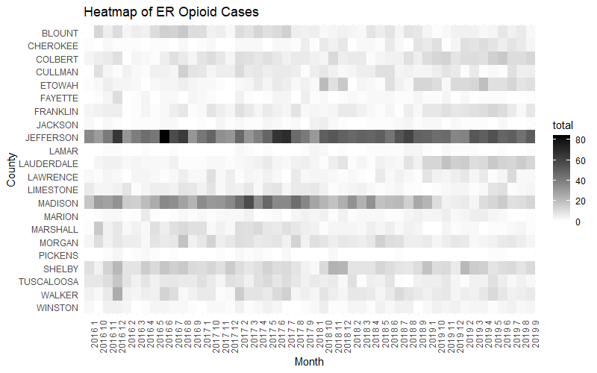
Figure X. Heatmap of monthly ER opioid case totals by county from 2016 to 2019. Darker shades represent higher case counts. Counties like Jefferson and Madison consistently show elevated case volumes, while others exhibit sporadic or lower-level activity.
Table x. ANOVA Table for ER Opioid Case Counts by County
 | Df | Sum Sq | Mean Sq | F value | Pr(>F)
County | 21 | 3437 | 163.67 | 641.248 | < 0.001
year | 3 | 6 | 1.85 | 7.257 | < 0.001
month | 11 | 13 | 1.2 | 4.694 | < 0.001
Year:month | 33 | 46 | 1.39 | 5.427 | < 0.001
County:year | 63 | 268 | 4.25 | 16.663 | < 0.001
County:month | 231 | 94 | 0.41 | 1.595 | < 0.001
Residuals | 31779 | 8111 | 0.26
The ANOVA reveals statistically significant main and interaction effects, confirming that ER opioid case rates are not uniform — they vary by county, time of year, and across years, with meaningful county-specific temporal dynamics. This supports the need for targeted and time-sensitive public health interventions.
Figure x. Annual Drug Consumption by County
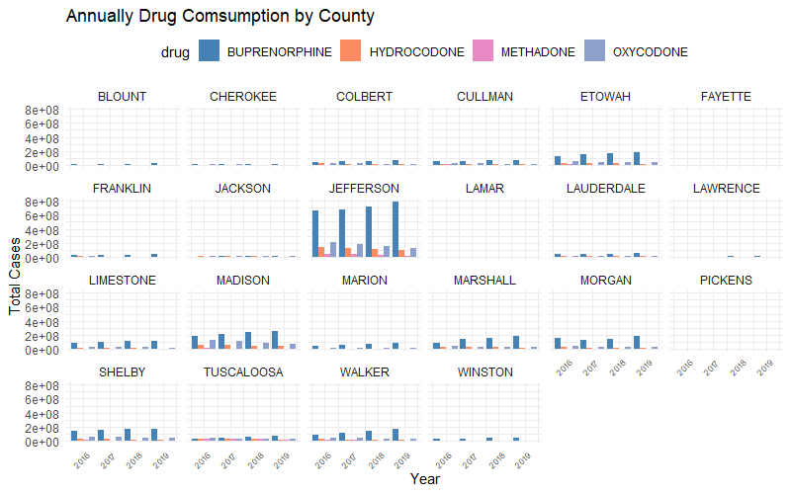

Figure x. Monthly Drug Consumption by County
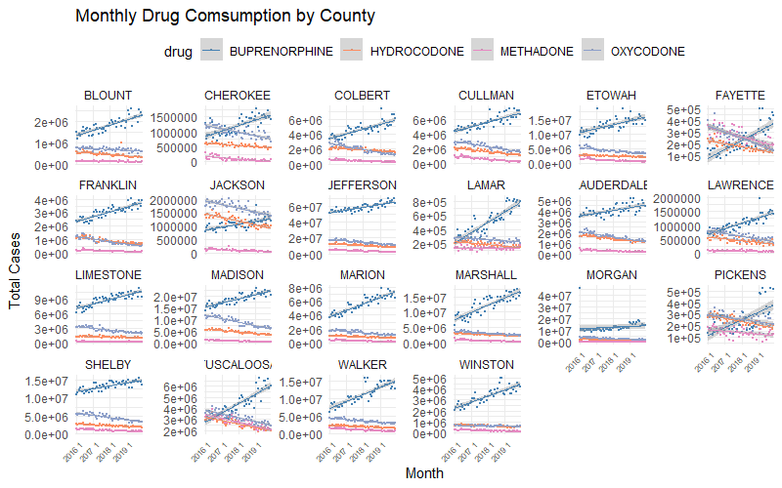

Table x. ANOVA Table for Drug Consumption by County
 | Df | Sum Sq | Mean Sq | F value | Pr(>F)
county | 21 | 2.80E+15 | 1.33E+14 | 2845.198 | < 0.001
year | 3 | 3.47E+11 | 1.16E+11 | 2.47 | 0.060
month | 11 | 2.49E+11 | 2.26E+10 | 0.483 | 0.915
drug | 3 | 1.26E+15 | 4.19E+14 | 8938.813 | < 0.001
county:year | 63 | 4.65E+12 | 7.38E+10 | 1.575 | 0.002
county:month | 231 | 4.71E+12 | 2.04E+10 | 0.435 | 1
county:drug | 63 | 2.90E+15 | 4.60E+13 | 980.436 | < 0.001
Residuals | 128172 | 6.01E+15 | 4.69E+10

Global Moran's I Summary
Moran's Index | 0.23272
Expected Index | -0.015625
Variance | 0.006405
z-score | 3.103184
p-value | 0.001915

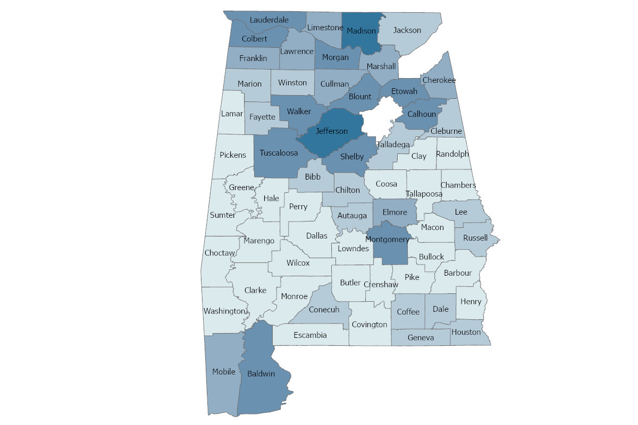

Table x. Global Moran's I Summary
 | Buprenorphine | Hydrocodone | Methadone | Oxycodone
Moran's Index | 0.325407 | 0.321203 | 0.251552 | 0.410012
Expected Index | -0.015625 | -0.015625 | -0.015625 | -0.015625
Variance | 0.006822 | 0.009249 | 0.009528 | 0.009851
z-score | 4.128897 | 3.502429 | 2.737151 | 4.288393
p-value | 0.000036 | 0.000461 | 0.006197 | 0.000018

