Results
Descriptive Statistics
Figure x. Annual ER Opioid Visits by County
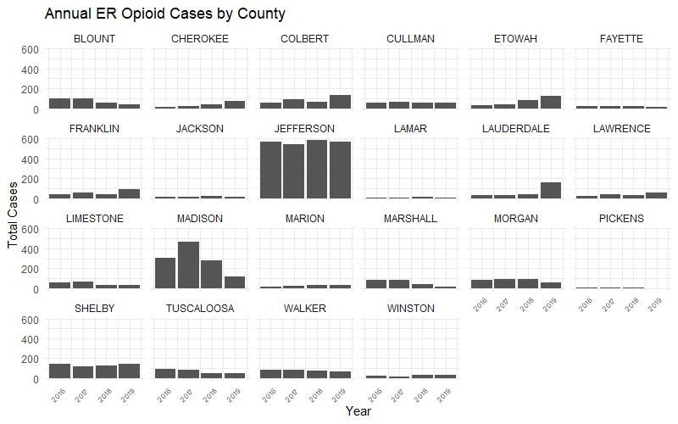
In Figure x, Jefferson has consistently highest counts across all four years (about 500–600/year). Madison is second highest ER opioid count with a peak in 2017, followed by a sharp drop in 2019. Shelby, Morgan, and Walker have stable and moderately high levels across the years. Blount, Tuscaloosa, Limestone, and Marshall decrease ER opioid counts from 2016 to 2019, while Etowah, Cherokee, and Lauderdale demonstrate an increasing trend.
Figure x. Annual Drug Consumption by County
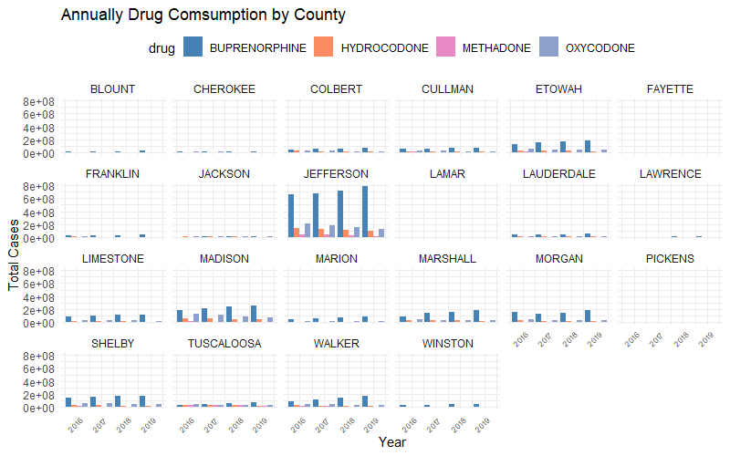

ER Opioid Visits (Total) Analysis
Table x. Global Moran’s I Summary of ER Visits (Total)
Moran's Index | 0.089473
Expected Index | -0.047619
Variance | 0.016048
z-score | 1.082190
p-value | 0.279168
Figure Total Opioid-Related ER Visits by County in Northern Alabama (2016–2019)
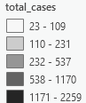
Figure. Hot Spot Analysis (Geti-Ord Gi*) of ER Visit (Total)


ER Opioid Visits (Per Capita) Analysis
Table x. Global Moran’s I Summary of ER Visits (Per Capita)
Moran's Index | 0.205992
Expected Index | -0.047619
Variance | 0.035017
z-score | 1.355284
p-value | 0.175327


Figure x.
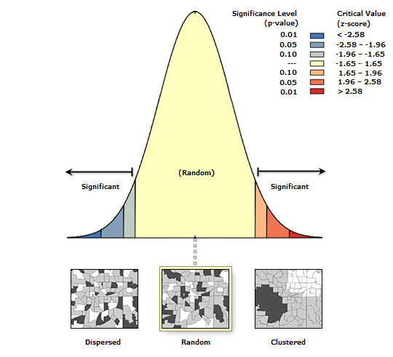

Figure. Hot Spot Analysis (Geti-Ord Gi*) of ER Visit (Per Capita)

Table x. Global Moran's I Summary of Drug Consumption (Total) for Counties in North AL
 | Buprenorphine | Hydrocodone | Methadone | Oxycodone
Moran's Index | 0.188334 | 0.069519 | 0.047698 | 0.192005
Expected Index | -0.047619 | -0.047619 | -0.047619 | -0.047619
Variance | 0.013436 | 0.017010 | 0.025978 | 0.022887
z-score | 2.035562 | 0.898135 | 0.591382 | 1.583932
p-value | 0.041794 | 0.369114 | 0.554265 | 0.113209

Table x. Global Moran's I Summary of Drug Consumption (Per Capita) for Counties in North AL
 | Buprenorphine | Hydrocodone | Methadone | Oxycodone
Moran's Index | 0.088832 | 0.062552 | 0.455197 | -0.072075
Expected Index | -0.047619 | -0.047619 | -0.047619 | -0.047619
Variance | 0.035280 | 0.036123 | 0.033704 | 0.033338
z-score | 0.726468 | 0.579659 | 2.738834 | -0.133944
p-value | 0.467552 | 0.562144 | 0.006166 | 0.893447

Table x. Global Moran's I Summary of Drug Consumption (Total) for All Counties in AL
 | Buprenorphine | Hydrocodone | Methadone | Oxycodone
Moran's Index | 0.325407 | 0.321203 | 0.251552 | 0.410012
Expected Index | -0.015625 | -0.015625 | -0.015625 | -0.015625
Variance | 0.006822 | 0.009249 | 0.009528 | 0.009851
z-score | 4.128897 | 3.502429 | 2.737151 | 4.288393
p-value | 0.000036 | 0.000461 | 0.006197 | 0.000018
Buprenorphine’s (Total) Global Morans’ I
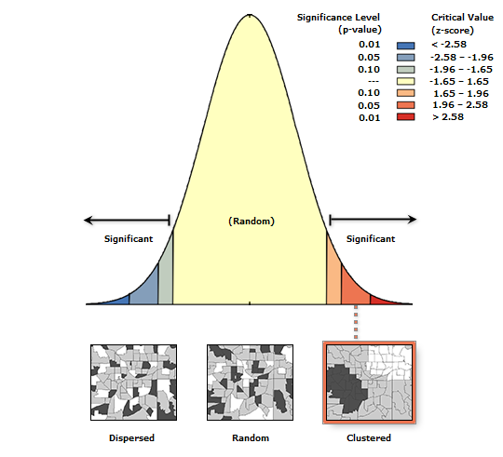
Classification of Buprenorphine (Total)

Buprenorphine (Per Captia)

Buprenorphine (Per Captia)

Hydrocodone (Total)

Hydrocodone (Per Capita)

Methadone (Total)

Methadone (Per Capita)
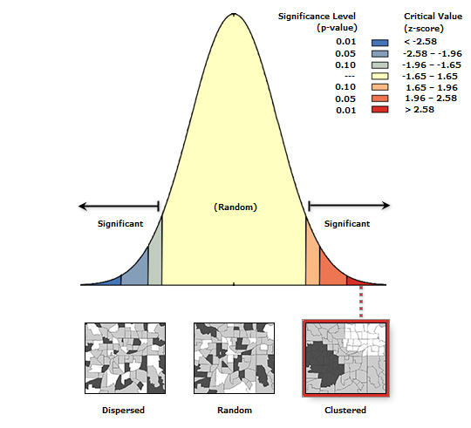
Oxycodone (Total)

Oxycodone (Per Capita)


