6/24/2025 Update
- Enabled Free Y-Axis Scaling by County
- Plotted Monthly ER Opioid Visits for Target Counties with Increasing Trends
- Separated Drug Consumption into Independent Plots
- To reduce big number, changed the y-axis scale “Total Cases (Million)”
- Terminology Updated: “West” Changed to “Northwest”
- Plotted Monthly Drug Consumption for Selected Counties with Increasing Trends
- Initial Observations and Interpretation Added
7/4/2025 Update
- All of the histogram charts should ideally share the same Y-axis scale.
I have changed all of the histogram charts to the same Y-axis scale.

- I’m not sure what he means by “per capita”—is it visits per person? If not, it would be better to compute everything as rates (i.e., visits per person and drug consumption per person) and then run Moran’s I and Getis‐Ord on those rates to see if the results become more significant.
Dr. Yao comment: Do we have the seperated tables for total sums and sums per person? If so, please categorize them.
To answer Dr. Hu’s question, “per capita” here is visit per 100,000 residents in new added Figure 2, County-Level Trends in ER Opioid Visit Rates (per 100,000 Residents), which is an ideal alternative of Annual ER Opioid Visits by County. It offers a balance between clear trends and fixed scale.
To Dr. Yao’s suggestion, I added Table 1, Summary of ER Opioid-Related Visits (Counts and Rates per 100,000 Residents) by County and Year (2016–2019), for both total sums and sums per person. If my understanding is incorrect, please let me know.

- Remove the Moran’s I analysis for total visits, since it isn’t significant and won’t add value. Instead, keep only the Moran’s I and Getis‐Ord analyses for visits per capita and for each drug per capita.
Dr. Yao comment: For the table removal, I think at this point we should move them to the appendix first and then we will decide whether we will remove them in the manuscript.
Regarding ER visit, Moran’s I for neither total visit nor per capita are not significant. Should we keep the figure of visit per capita? I moved them to Appendix A.
I updated all medication distribution figures to fixed y-axis scale and replace the “Total Case (Million)” to “Total MME (Million)”.
Moved drug total MME distribution to Appendix B. I kept Per Capita Opioid Medication Distribution Analysis, but only Methadone per capita distribution is significant. Then, I updated the monthly Methadone per capita distribution figure by fixing the y-axis scale (see Figure 9).

- Then focus your description on the spatial patterns for those drugs whose tests yield p-values below 0.05.
As mentioned in #3 question, only Methadone per capita distribution yielded p-value below 0.05, should we drop other three hot spot figures?

Descriptive Statistics
Table 1. Summary of ER Opioid-Related Visits (Counts and Rates per 100,000 Residents) by County and Year (2016–2019)
County | 2016 |  | 2017 |  | 2018 |  | 2019 |  | Total  Visit | Per Capita
County | Total | Rate | Total | Rate | Total | Rate | Total | Rate | Total  Visit | Per Capita
BLOUNT | 102 | 0.48 | 94 | 0.45 | 58 | 0.28 | 42 | 0.20 | 296 | 1.41
CHEROKEE | 10 | 0.11 | 19 | 0.20 | 39 | 0.41 | 75 | 0.78 | 143 | 1.50
COLBERT | 52 | 0.26 | 86 | 0.43 | 61 | 0.30 | 134 | 0.66 | 333 | 1.65
CULLMAN | 53 | 0.18 | 67 | 0.22 | 59 | 0.19 | 52 | 0.17 | 231 | 0.76
ETOWAH | 32 | 0.09 | 36 | 0.10 | 80 | 0.21 | 124 | 0.33 | 272 | 0.73
FAYETTE | 25 | 0.41 | 20 | 0.33 | 18 | 0.30 | 11 | 0.18 | 74 | 1.22
FRANKLIN | 37 | 0.32 | 59 | 0.51 | 37 | 0.32 | 94 | 0.82 | 227 | 1.97
JACKSON | 12 | 0.06 | 17 | 0.09 | 21 | 0.11 | 12 | 0.06 | 62 | 0.32
JEFFERSON | 567 | 0.23 | 544 | 0.23 | 583 | 0.24 | 565 | 0.24 | 2259 | 0.94
LAMAR | 4 | 0.08 | 5 | 0.10 | 16 | 0.32 | 8 | 0.16 | 33 | 0.66
LAUDERDALE | 28 | 0.08 | 35 | 0.10 | 43 | 0.13 | 160 | 0.47 | 266 | 0.78
LAWRENCE | 26 | 0.21 | 38 | 0.31 | 27 | 0.22 | 55 | 0.46 | 146 | 1.20
LIMESTONE | 57 | 0.17 | 62 | 0.18 | 31 | 0.09 | 35 | 0.10 | 185 | 0.54
MADISON | 302 | 0.23 | 471 | 0.36 | 279 | 0.21 | 118 | 0.09 | 1170 | 0.89
MARION | 17 | 0.16 | 23 | 0.21 | 28 | 0.26 | 32 | 0.30 | 100 | 0.93
MARSHALL | 79 | 0.23 | 81 | 0.23 | 38 | 0.11 | 16 | 0.05 | 214 | 0.62
MORGAN | 79 | 0.18 | 93 | 0.21 | 90 | 0.21 | 57 | 0.13 | 319 | 0.73
PICKENS | 9 | 0.12 | 9 | 0.12 | 3 | 0.04 | 2 | 0.03 | 23 | 0.31
SHELBY | 147 | 0.19 | 118 | 0.15 | 129 | 0.16 | 143 | 0.18 | 537 | 0.68
TUSCALOOSA | 91 | 0.12 | 87 | 0.11 | 51 | 0.07 | 51 | 0.07 | 280 | 0.37
WALKER | 82 | 0.35 | 85 | 0.36 | 73 | 0.31 | 69 | 0.30 | 309 | 1.32
WINSTON | 25 | 0.29 | 20 | 0.23 | 30 | 0.35 | 34 | 0.39 | 109 | 1.26
Note: “Total” refers to the sum of ER visit count; “Rate” is the average rate per 100,000 residents.
Figure 1. County-Level Trends in ER Opioid Visit
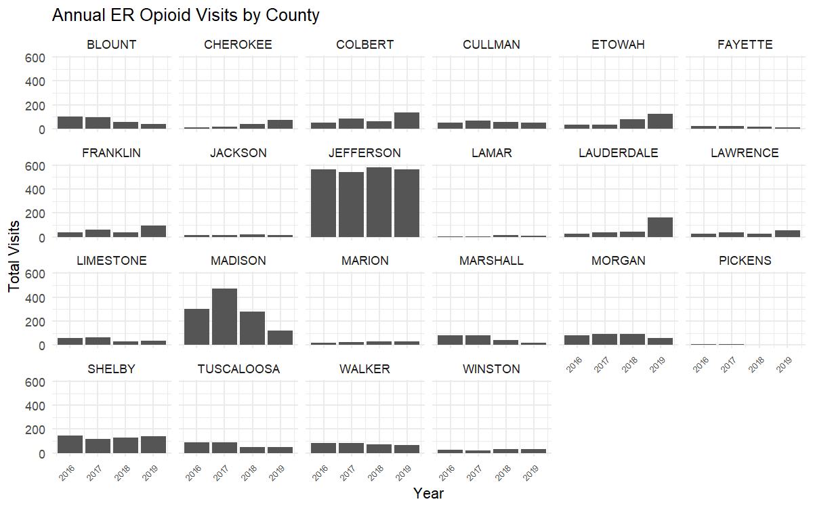

Figure 2. County-Level Trends in ER Opioid Visit Rates (per 100,000 Residents)
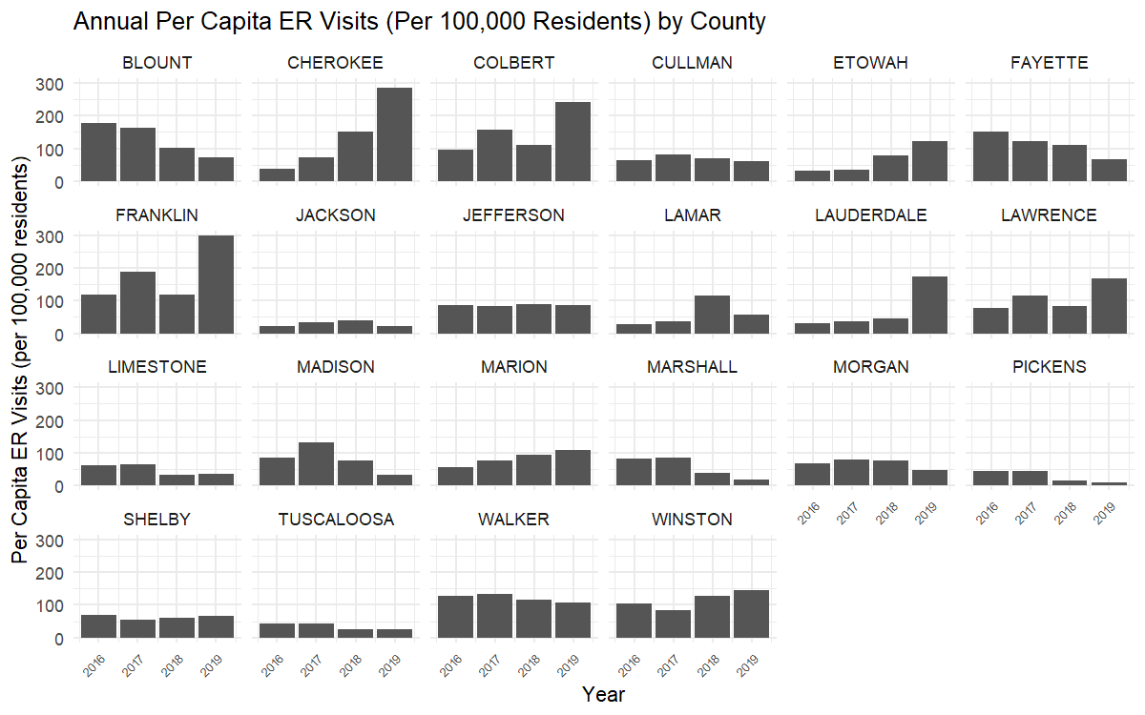

In Figure 1 and 2, Jefferson has consistently highest counts across all four years (about 500–600/year). Madison is second highest ER opioid count with a peak in 2017, followed by a sharp drop in 2019. Blount, Tuscaloosa, Limestone, and Marshall decrease ER opioid counts from 2016 to 2019, while Cherokee, Etowah, Lauderdale, and Marion show consistently increasing trends, requiring a future exploration on monthly scale. (Not report value less than 10, just not show, and keep reporting)

Figure 3. Monthly ER Opioid Visits in Cherokee, Etowah, Lauderdale, and Marion
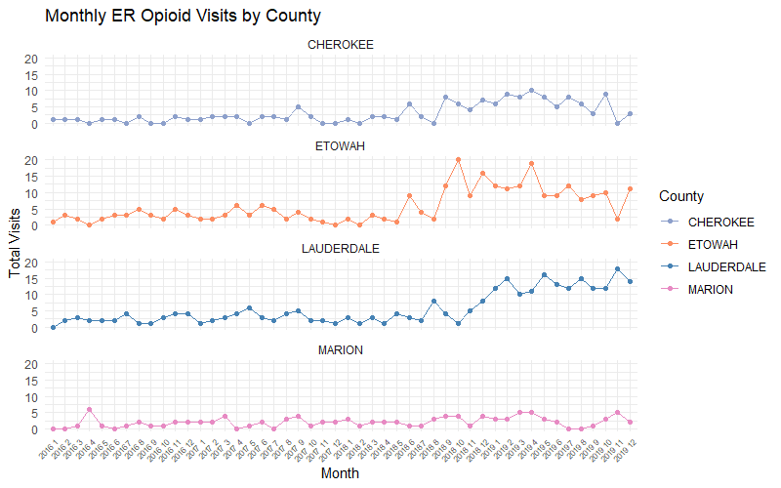
According to Figure 3, Cherokee exhibits a dramatical increase in ER opioid visits in September 2016 and keeps a high value (around 5 visits) until a decrease in November 2017. Etowah demonstrates a similar pattern to Cherokee, with two peaks (around 20 visits) in October 2016 and April 2017, as well as a drop in November 2017. In contrast, although Lauderdale has increasing pattern in later 2016 and the whole of 2017, it has continued growth in November 2017. We will discuss the potential reason by collecting information and news at that time point. Try quartly.
Figure 4. Annual Buprenorphine Distribution by County in MME
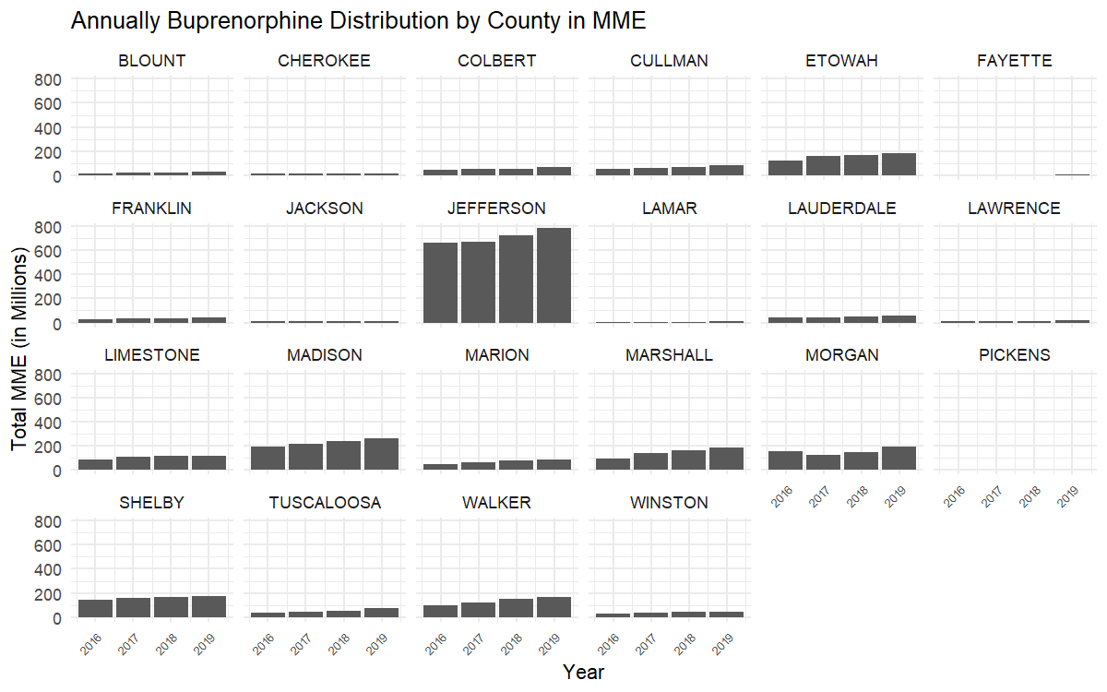
According to Figure 4, most counties exhibit a consistent increase in buprenorphine consumption over time, except Morgan and Pickens. These two counties display a distinct dip in 2017, forming a sharp trough in their otherwise upward trends.
Figure 5. Annual Hydrocodone Distribution by County in MME

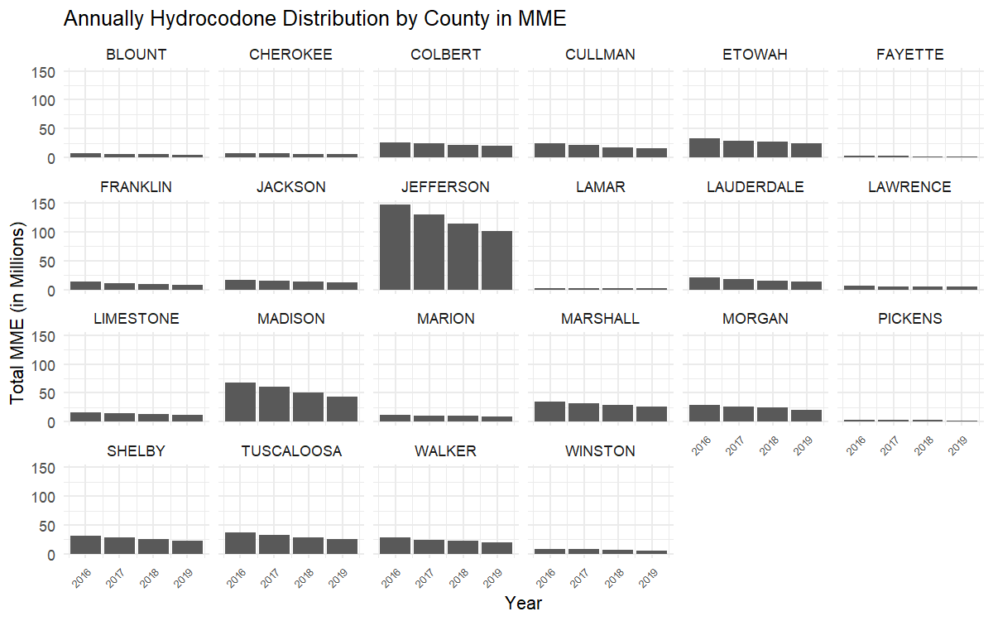
In contrast to the increasing trend in buprenorphine consumption, hydrocodone use demonstrates a consistent decline from 2016 to 2019 across all counties (Figure 5).
Figure 6. Annual Methadone Distribution by County in MME

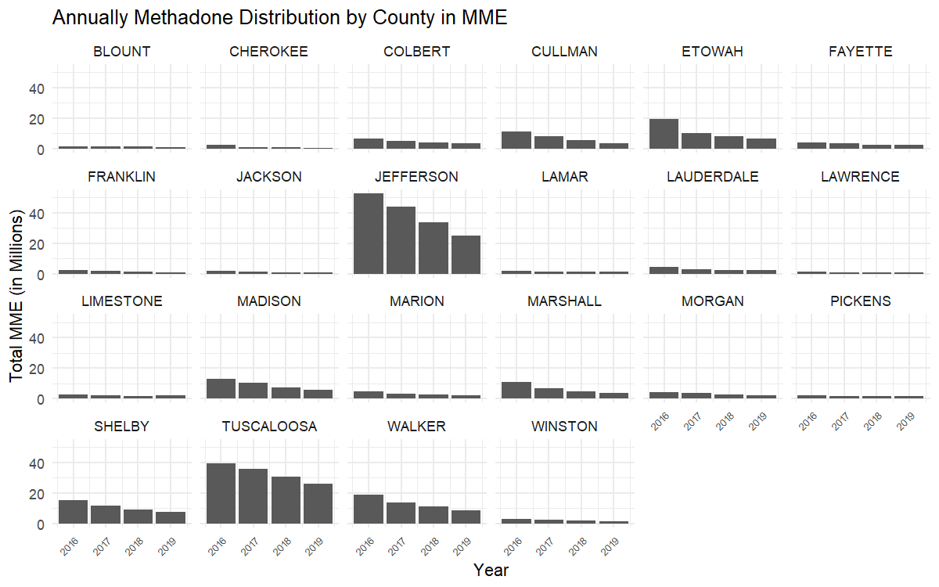
Similar to the trend observed for hydrocodone, methadone consumption also declined from 2016 to 2019 across most counties. However, Blount, Cherokee, Lamar, Limestone, and Pickens showed relatively stable patterns between 2017 and 2019, with only minor fluctuations (Figure 6).
Figure 7. Annual Oxycodone Distribution by County in MME

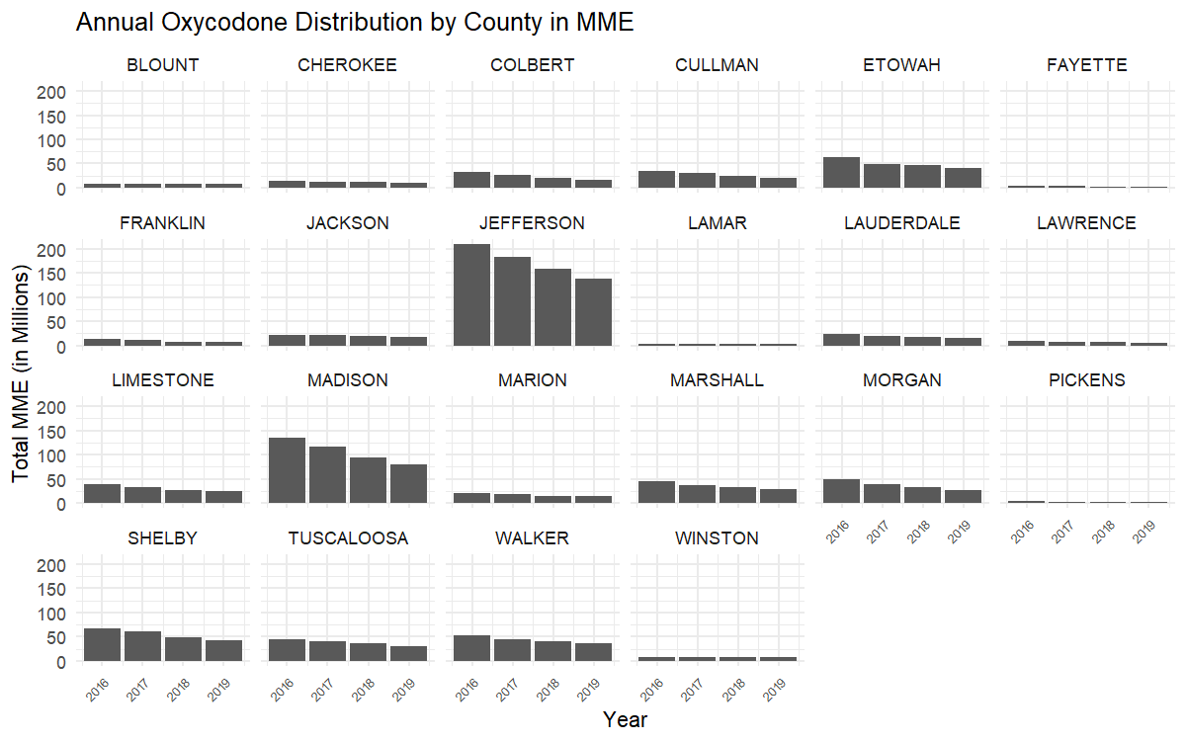
Figure 7 shows that all counties exhibited consistently decreasing trends in oxycodone consumption, except Lamar County, which reached its peak in 2017. In summary, buprenorphine is the only opioid medication that demonstrated a sustained increase in consumption from 2016 to 2019 across most counties in northwest Alabama.

Moran’s I and Hot Spot Analysis

In this study, Moran’s I was calculated to measure the overall spatial clustering of ER visit counts and the consumption of four major opioid medications. The Moran’s I values for both total ER visits (0.089, p = 0.279) and per capita ER visits (0.206, p = 0.175) were not statistically significant. These results indicate an absence of strong spatial clustering patterns in ER opioid-related visits across the northwest Alabama region.
Figure 8. Hot Spot Analysis (Geti-Ord Gi*) of ER Visits (Per Capita)


In Figure 8 shows that Colbert, Franklin, and Lawrence counties exhibited increasing trends in ER visits, while Pickens and Madison counties demonstrated a decreasing pattern. Despite these localized variations, Moran’s I was not statistically significant for either total or per capita ER visits, indicating no strong spatial autocorrelation overall.

Per Capita Opioid Drug Distribution Analysis
Table 2. Global Moran's I Summary of Medication Distribution (Per Capita) across Counties in Northwest Alabama
 | Buprenorphine | Hydrocodone | Methadone | Oxycodone
Moran's Index | 0.088832 | 0.062552 | 0.455197 | -0.072075
Expected Index | -0.047619 | -0.047619 | -0.047619 | -0.047619
Variance | 0.035280 | 0.036123 | 0.033704 | 0.033338
z-score | 0.726468 | 0.579659 | 2.738834 | -0.133944
p-value | 0.467552 | 0.562144 | 0.006166 | 0.893447

Figure 9. Monthly Methadone Per Capita Distribution by County
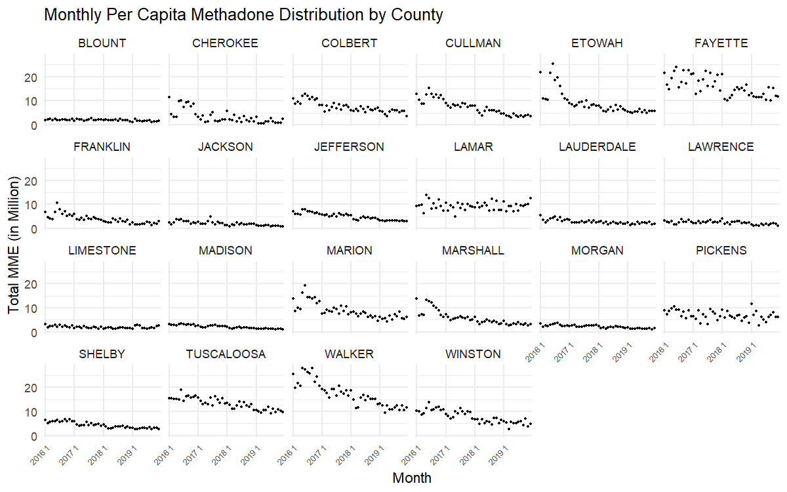
Figure 9 illustrates declining monthly methadone consumption trends across most counties in northwest Alabama exhibited. High-use counties such as Etowah and Marshall showed substantial decreases over time, suggesting possible policy changes, treatment shifts, or public health interventions targeting methadone-related opioid dependency. Jefferson and Tuscaloosa counties, despite their larger populations, maintained moderate and stable per-capita consumption patterns with slight downward slopes. Meanwhile, counties such as Lamar and Pickens demonstrated relatively steady trends, with minor fluctuations and no pronounced decline. The widespread reduction in methadone consumption may reflect a regional move away from methadone in favor of other medication-assisted treatments (e.g., buprenorphine), or increased regulation and monitoring of opioid prescriptions in the area.
Figure 10. Hot Spot Analysis (Geti-Ord Gi*) of Medication Consumption (Per Capita)

(a) Buprenorphine (b) Hydrocodone

(c) Methadone (d) Oxycodone
Figure 10 (c) illustrates the spatial clustering of methadone consumption per capita using Getis-Ord Gi* statistics. The results identify a significant hot spot in the southwestern portion of the region, particularly in Tuscaloosa, Fayette, Walker, and Lamar counties. This suggests that residents in these counties have higher access to or greater utilization of methadone treatment programs, potentially reflecting localized public health strategies or higher opioid dependence treatment demand. Conversely, a cold spot cluster comprising Madison, Limestone, and Morgan counties may indicate limited methadone distribution, possibly due to policy, access, or demographic factors.
Although the Global Moran’s I values for hydrocodone, methadone, and oxycodone were not statistically significant (p > 0.05), we still offer the hot spot figure for reference (Figure 10 (a), (b), and (d)).

Appendix A
Table A1. Global Moran’s I of ER Visits (Total and Per Capita)
 |  | Per Capita
Moran's Index |  | 0.206
Expected Index |  | -0.048
Variance |  | 0.035
z-score |  | 1.355
p-value |  | 0.175

Figure A1. Hot Spot Analysis (Geti-Ord Gi*) of ER Visits (Total and Per Capita)

(a) Total ER Visits (b) Per Capita ER Visits
A closer examination of total ER visit counts (Figure 6(a)) reveals a potential hot spot in Jefferson and Shelby counties. However, this clustering is likely influenced by the high population density in these areas. In contrast, using per capita data, Figure 6(b) shows that Colbert, Franklin, and Lawrence counties exhibited increasing trends in ER visits, while Pickens and Madison counties demonstrated a decreasing pattern. Despite these localized variations, Moran’s I was not statistically significant for either total or per capita ER visits, indicating no strong spatial autocorrelation overall.

Appendix B
Opioid Medication Distribution Analysis
Table B1. Global Moran's I Summary of Medication Consumption (Total) for Counties in Northwest Alabama
 | Buprenorphine | Hydrocodone | Methadone | Oxycodone
Moran's Index | 0.188 | 0.070 | 0.048 | 0.192
Expected Index | -0.048 | -0.048 | -0.048 | -0.048
Variance | 0.013 | 0.017 | 0.026 | 0.023
z-score | 2.036 | 0.898 | 0.591 | 1.584
p-value | 0.042 | 0.369 | 0.554 | 0.113
Table B1 presents the results of Global Moran’s I analysis for the total consumption of four major opioid medications across counties in Northwest Alabama. Among the four drugs, only buprenorphine exhibited a statistically significant spatial autocorrelation, with a Moran’s I of 0.188 and a p-value of 0.042. This suggests a moderate positive spatial clustering of buprenorphine consumption—counties with high (or low) consumption are likely near other counties with similar levels. In contrast, hydrocodone, methadone, and oxycodone all showed non-significant Moran’s I values (p > 0.05), indicating that their consumption patterns were not significantly clustered across the region. These results imply that buprenorphine use may be influenced by localized factors, such as treatment access, provider availability, or targeted public health interventions, while the other drugs show a more diffuse or random spatial pattern in this region. Sequentially, the monthly Buprenorphine consumption and hot spot graph will be demonstrated for future study.
Figure B1. Monthly Buprenorphine Consumption by County

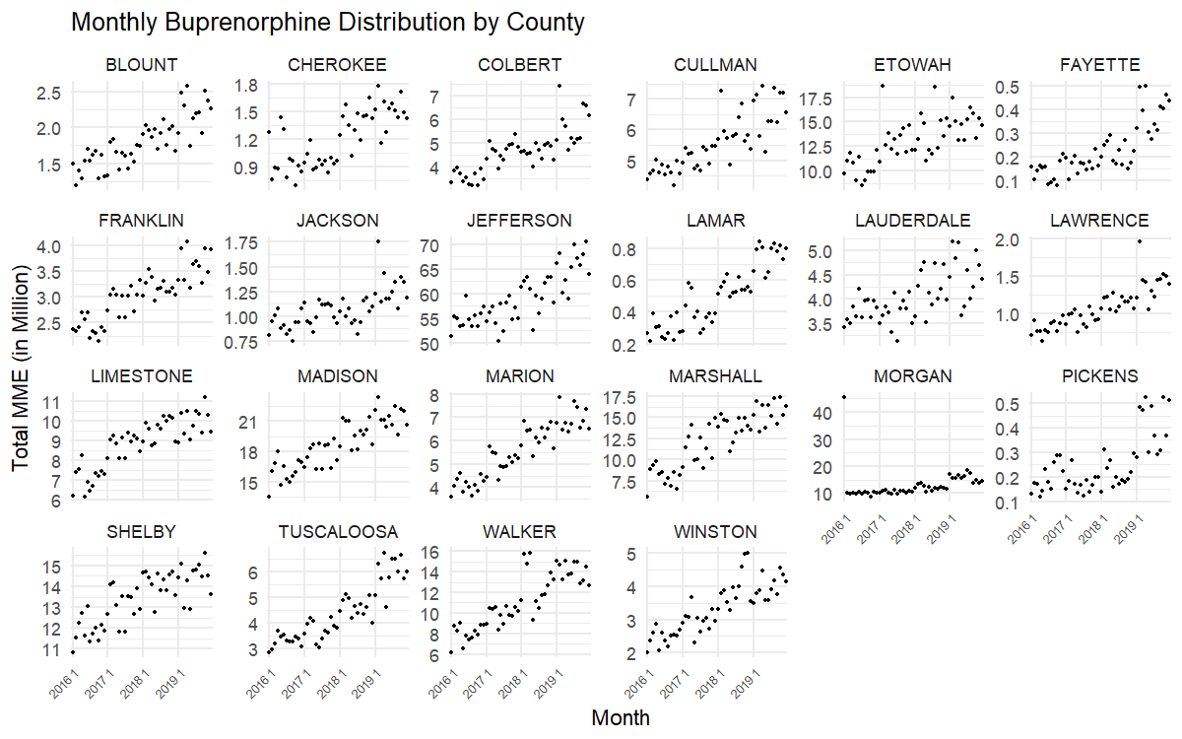
Figure B1 shows that a consistent upward trend of monthly Buprenorphine consumption is evident in most counties. This increase suggests a regional shift toward buprenorphine as a preferred opioid treatment option, potentially driven by expanding treatment programs or increased awareness of medication-assisted therapy. While urban counties reported the highest per capita use, even rural areas such as Marion, Franklin, and Lawrence exhibited gradual increases. These results support the hypothesis that buprenorphine availability and uptake have grown substantially across northwest Alabama during the study period.
In contrast, Morgan County stands out as an exception. Unlike the general upward trajectory, buprenorphine consumption in Morgan County remained relatively flat throughout the study period. This stagnation may point to limited provider availability, regulatory barriers, or differences in local treatment infrastructure that warrant further investigation.
Figure B2. Hot Spot Analysis (Geti-Ord Gi*) of Medication Consumption (Total)

(a) Buprenorphine (b) Hydrocodone

(c) Methadone (d) Oxycodone
Figure B2 (a) presents the spatial distribution of Buprenorphine consumption across northwest Alabama counties. The map reveals a distinct concentration of higher consumption in Jefferson and Shelby counties, shown in dark red, indicating that these areas had the most substantial usage during the study period. Walker County, in a lighter red shade, also demonstrates moderately elevated consumption. In contrast, the remaining counties are displayed in light gray, signifying lower or negligible levels of Buprenorphine use. This pattern suggests that Buprenorphine treatment was more accessible or more widely utilized in metropolitan areas such as Jefferson and Shelby, possibly due to the presence of more healthcare providers or greater treatment-seeking populations. These findings may reflect regional differences in access to medication-assisted treatment (MAT) services and underscore the need to investigate disparities in treatment availability and uptake across rural and urban contexts. In Figure x, we also present the spatial distribution of the other three opioid medications for comparison. Although the Moran’s I statistics for these drugs were not statistically significant, the maps still reveal notable concentrations of consumption in Jefferson and Shelby counties.

