A. SIGNIFICANCE
County health departments across Alabama have no tool to identify where the illicit fentanyl supply and the illicit methamphetamine supply are concentrating, expanding, or surging across the state's 67 counties. Opioid-involved overdose deaths claimed more than 81,000 lives nationally in 2022, with illicit fentanyl driving the majority of fatalities.¹ Approximately four in ten illicitly-manufactured-fentanyl-involved overdose deaths also involve a stimulant, the defining feature of the fourth wave.^{2,4,5} Alabama's illicit supply has shifted since 2019 toward illicitly manufactured fentanyl and high-purity methamphetamine, both moving along the same interstate trafficking corridors. Emerging analogs (nitazenes, xylazine) have entered the supply.²⁹ County-level estimates of either supply remain unavailable for Alabama's 67 counties, the administrative unit at which naloxone, treatment, and harm-reduction resources are deployed. The OOAC Central Data Repository tracks county-level deaths, ED visits, EMS runs, and arrests,¹⁴ but those lagging indicators correlate only with prior, not concurrent, changes in upstream supply.
The fourth-wave era is fentanyl- and methamphetamine-driven. Fentanyl displaced heroin as the dominant illicit opioid in the U.S. drug supply over the 2019-2024 period,^{2,3} and high-purity methamphetamine seizures and overdose co-involvement rose in parallel.^{4,5} Fentanyl is roughly 50 to 100 times more potent than morphine, and synthetic opioids have driven up overdose deaths more than the number of users.³ Polysubstance overdose deaths involving both substances account for a large and rising share of mortality.^{4,5} Cocaine, heroin, and prescription-opioid diversion are addressed only as time-permitting secondary analyses; the planned R01 extends to all U.S. states and all illicit drug classes.
Existing county-level opioid surveillance models do not jointly characterize fentanyl and methamphetamine. The most advanced models⁶⁻⁹ summarize opioid risk through a single continuous demand-side prevalence index from indirect indicators. They share five limitations: the continuous demand index does not map onto operational supply-state surveillance triggers; only a single substance class is modeled; mortality is not jointly integrated as a multivariate output of an upstream supply process; data pre-date 2019; none have been built for Alabama. A discrete multi-state representation, applied in parallel to fentanyl and methamphetamine and using all observed measures as multivariate outputs of the latent supplies, yields directly interpretable substance-specific transition probabilities together with a dual-supply co-elevation surveillance indicator. NSDUH undercounts opioid use disorder by roughly four- to fivefold relative to capture-recapture and benchmark-multiplier estimates,^{11,13} and Reuter and colleagues conclude that heroin use "cannot be measured adequately with a general population survey";¹² administrative footprints capture both supplies through system contacts.
Scientific premise. The design draws on three established findings. Illicit drug markets persist in space and time: Cutler and Donahoe¹⁰ show that without spillovers there would have been 88 percent fewer opioid deaths. Fourth-wave fentanyl is differentially lethal and methamphetamine is rising in co-involvement.^{3,4,5} Supply-side measures lead mortality, opening a window for early-warning surveillance. National findings leave county-level heterogeneity unmeasured for Alabama; this project fills that gap. Outputs serve the OOAC and ADPH (substance-specific state-probability maps and a dual-supply co-elevation map for naloxone, fentanyl test strip, and stimulant-treatment siting),^{14,15} local health districts (transition-risk maps), and state policymakers (RUCA-stratified emission intercepts).²⁷
B. INNOVATION
1. First parallel county-monthly fentanyl-and-methamphetamine supply surveillance for Alabama. Discrete multi-state representation of both fourth-wave drivers in parallel, with cross-substance correlation capturing co-trafficking. Produces directly interpretable substance-specific transition probabilities and a dual-supply co-elevation indicator that single-substance demand-index models⁶⁻⁹ do not.
2. Multivariate-output latent-process specification. Rather than separating data into "transition covariates" and "second-stage outcomes", all illicit-supply-related observed measures (NFLIS chemistry shares, LIMS state-monthly exhibits and purity, NIBRS arrests and incidents, ADPH opioid- and stimulant-suspected EMS runs, opioid mortality, all-drug mortality, drug-related ED encounters) are multivariate outputs of the two latent supply processes, jointly emitted at each county-month and estimated through a single likelihood. Transitions depend only on exogenous events, avoiding circularity.
3. EM-based disaggregation and missing-data handling. The Expectation-Maximization (EM) algorithm is the primary method addressing two analytic difficulties: coarser-than-monthly observations (state-annual chemistry; county-annual mortality and ED) are linked to the county-monthly latent state through EM imputation, and missing data segments (LIMS 2023-2024, lagged NFLIS, incomplete CDC 2024 cells) are imputed by the same EM algorithm. Cubic-spline disaggregation and missing-at-random marginalization serve as sensitivity comparators.
4. Backlog-aware estimation. Alabama agency reporting in the Federal incident-reporting system rose from approximately 2,800 records in 2019 to 90,000+ per year in 2022-2023 after the Federal January 2021 mandate. The county-month reporting-agency count enters as an exposure offset on the arrest and incident emissions; pre-specified sensitivity analyses contrast restricted (2021-2024), extended-with-offset (2019-2024), and coverage-trimmed analytic windows.
5. Tailored adjustment for rural Alabama counties. Nineteen of Alabama's 67 counties fall in the rural-tier USDA RUCA classification (codes 7-10), and another 12 are micropolitan (codes 4-6), so almost half of the state is non-metropolitan. In these counties slower EMS response, sparser treatment infrastructure, and limited surveillance capacity widen the policy gap. Hierarchical RUCA-group priors on transition coefficients and emission intercepts, optional rural-specific transition matrices, and a hybrid spatial weight matrix (queen contiguity plus inverse-distance interstate-corridor weights) explicitly tailor the model to rural counties; rural-vs-metro contrasts are headline quantities of interest.
C. APPROACH
Scope. Primary deliverables are county-month posterior supply-state probabilities for both substances, decoded trajectories, emission intercepts for every output, transition-coefficient estimates, the dual-supply co-elevation map, and surveillance-signal maps for Alabama's 67 counties. Secondary deliverables, time permitting, include parallel HMMs for cocaine and heroin within the same framework. Per RFA-DA-26-056, no primary data collection is performed.
C.1 Conceptual Framework
Figure 1 summarizes the model. Two parallel county-monthly latent supply processes are estimated jointly: illicit fentanyl supply and illicit methamphetamine supply, each a discrete multi-state process. Each supply jointly generates all opioid-related observed measures as multivariate state-conditional outputs; substance-specific intercepts identify which output is more closely associated with which supply. A cross-substance correlation parameter couples the initial-state distributions and off-diagonal joint-transition logits. Transitions are governed by exogenous events only (COVID-19 onset, the Alabama Act 2023-004 effective-date indicator, monthly time, and an optional RUCA stratifier); including any opioid-related observed measure in transitions would induce circularity. The number of supply states for each substance is selected by approximate leave-one-out cross-validation (PSIS-LOO) and WAIC computed on the joint posterior log-likelihood; for four states the substantive labels are quiescent, stable-baseline, expanding, and surge.
Testable hypotheses. (1) Each substance's chemistry-share emission intensity is monotone-increasing in its own supply state. (2) Opioid-mortality emission intensity is monotone-increasing in fentanyl supply; all-drug-mortality intensity is monotone-increasing in both substance states. (3) The two HMMs exhibit positive correlation in elevated states. (4) Median lead time of the substance-specific elevated-state surveillance signal over the corresponding county-annual mortality elevation is at least one month. (5) Rural counties (RUCA 7-10) show higher rates of transition into elevated supply states than metro counties (RUCA 1-3).
Analytic units and identification. The unit of analysis is the county-month for the latent state and the corresponding county-month, county-year, state-month, or state-year for each multivariate emission. Identification of the substance-specific latent supplies rests on three pillars. First, the DEA NFLIS state-annual chemistry shares and the DEA LIMS state-monthly substance-specific exhibit counts and purity bins are substance-specific outputs whose state-conditional emission intercepts load only on their own substance's HMM. Second, transitions depend only on exogenous covariates (COVID, the Alabama Act 2023-004 effective-date indicator, time, RUCA), so the upstream supply state is not informed by the same outputs it generates. Third, within-county time variation in the exogenous covariates separates state-occupation from secular trend at the county level, while the hierarchical RUCA pooling stabilizes estimation in low-incident-count rural county-months. Posterior decoding therefore recovers the joint county-month state from all observed outputs without circular feedback into the transition kernel. The full joint likelihood, the conditionally-autoregressive spatial prior, the cross-substance coupling, the EM disaggregation step, and the prior specification appear in the Statistical Appendix.
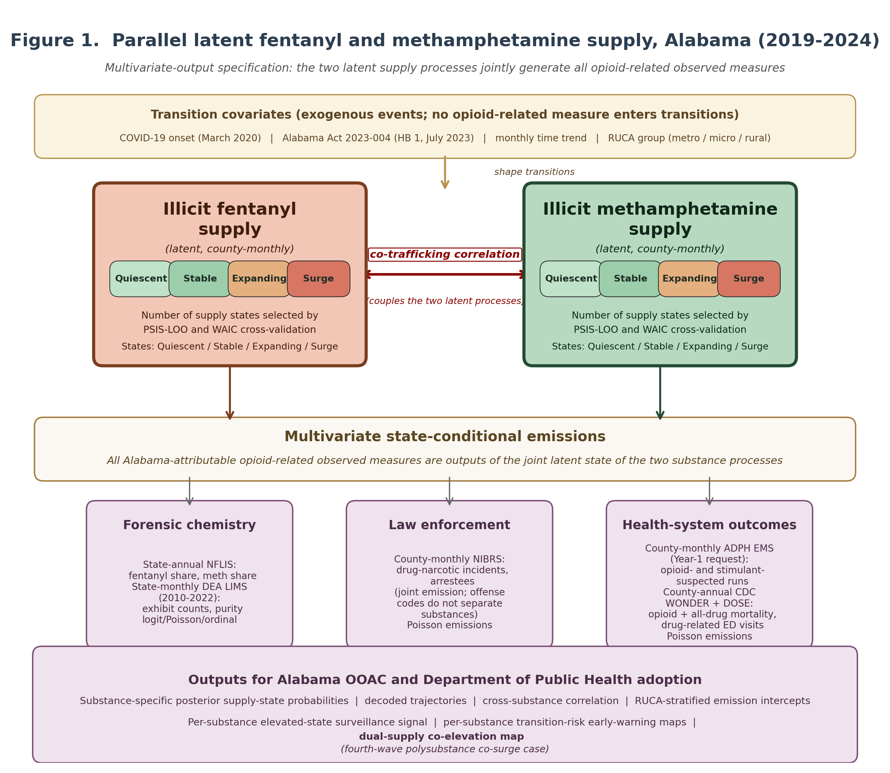
Figure 1. Parallel latent fentanyl and methamphetamine supply, Alabama (2019-2024). Multivariate-output specification: two parallel discrete-state county-monthly latent supply processes, coupled by a cross-substance correlation, jointly generate all Alabama-attributable illicit-supply-related observed measures (forensic chemistry shares; drug-narcotic incidents and arrestees; ADPH EMS runs; opioid, all-drug, and ED outcomes) as multivariate state-conditional emissions. Transitions are governed only by exogenous events (COVID-19, HB 1, time, RUCA).
C.2 Data Sources (all multivariate outputs, restricted to Alabama)
Data source | Granularity | Role in model
State-annual forensic chemistry (DEA NFLIS via SR-DDRC)^{17,18} | State-annual | Two outputs: fentanyl-and-related share, methamphetamine share; emit from year-aggregated state proportions of each substance HMM
State-monthly drug-laboratory exhibits (DEA LIMS Public-Use File, 2010-2022)¹⁹ | Per-record with year/month | State-monthly substance-specific exhibit counts (Poisson) and ordinal purity-bin (multinomial); emit from state-aggregated monthly HMM state; 2023-2024 imputed by EM (B.1)
County-monthly drug-narcotic incidents and arrestees (FBI NIBRS via SR-DDRC)²⁰ | Incident- and arrestee-level with date | Joint outputs: county-monthly counts emit from joint state of both HMMs (offense codes do not separate substances); reporting-agency-count exposure offset absorbs 2019-2021 ramp-up
County-monthly opioid- and stimulant-suspected EMS runs (Alabama Department of Public Health, ADPH; Year-1 data-sharing request)²³ | Run-record with date | Two outputs: opioid-suspected and stimulant-suspected EMS counts; emit from the matching HMM. If delayed, EM-imputed (B.1) or omitted
County-annual opioid overdose deaths (CDC WONDER opioid file via SR-DDRC) | County-annual | Output: emits from annual aggregated fentanyl supply state primarily; suppressed cells interval-censored
County-annual all-drug overdose deaths (CDC WONDER all-drug file via SR-DDRC) | County-annual | Output: emits from annual aggregated states of both HMMs; captures polysubstance burden
County-annual drug-related ED encounters (CDC DOSE via SR-DDRC)^{21,22} | County-annual | Output: emits from annual aggregated joint state
County-annual ACS 5-year estimate (via SR-DDRC)²⁴ | County-annual | Adjustment covariate (median household income, percent uninsured, percent in poverty)
County-annual population estimates (US Census via SR-DDRC) | County-annual | Population offset for count emissions
County-biennial CDC SVI²⁵ | County-biennial | Vulnerability covariate (forward-filled)
USDA RUCA codes²⁶ | County-fixed | Stratifier for transitions and emission intercepts

Counties identified by 5-digit FIPS code; the agency-to-county crosswalk is the FBI Crime Data Explorer reference table.
C.3 Aim 1: Jointly estimate the parallel multi-state county-monthly illicit fentanyl supply trajectory and illicit methamphetamine supply trajectory for Alabama's 67 counties (2019-2024) using a multivariate-emission latent-process model in which all opioid-related observed measures are treated as outputs.
The two unobserved county-monthly substance-specific supplies are parallel discrete multi-state processes with first-order Markov transitions (probabilities depend only on exogenous events: COVID, HB 1, time, RUCA). Multivariate state-conditional emission distributions cover all opioid-related observed measures listed in C.2. Within each substance, emission intercepts are ordered as a label-switching constraint, providing the substantive quiescent-to-surge labeling. The number of states is selected separately by PSIS-LOO and WAIC across {2, 3, 4, 5} candidates.
We adopt the dependent-mixture-model framework exemplified by depmixS4²⁸ (which implements such models by expectation-maximization) and re-implement it in a Bayesian setting (Stan, Hamiltonian Monte Carlo) for accuracy and flexibility. The Bayesian implementation accommodates the joint emission structure, hierarchical RUCA pooling, suppressed-cell interval censoring, and cross-substance coupling within a single coherent likelihood. We extend with (i) a spatiotemporal component pooling transition and emission information across neighboring Alabama counties through a hybrid spatial weight matrix combining queen contiguity and inverse distance along Alabama's four interstate corridors (I-20, I-65, I-59, I-10), and (ii) a joint-substance coupling linking the fentanyl and methamphetamine HMM parameters through a bivariate prior. Details are in the Statistical Appendix.
Estimation and identification. Implementation in R and Stan. Posterior inference uses Hamiltonian Monte Carlo with four chains of 2,000 iterations each (1,000 warm-up); convergence assessed by the Gelman-Rubin diagnostic and effective sample size. The 67 counties enter as separate sequences with shared parameters within each substance HMM. Identification rests on (i) substance-specific emission-intercept ordering, (ii) substance-specific chemistry outputs whose intercepts load only on their own substance's state, and (iii) within-county time variation in transition covariates. Primary window: January 2021 through December 2024 (48 months times 67 counties = 3,216 county-months); calendar 2024 held out; rolling-origin cross-validation within 2021-2023 yields 35 one-step-ahead predictions per county.
C.4 Aim 2: Validate the parallel models against pre-specified Alabama events and produce actionable county-level dual-supply surveillance outputs including a co-elevation indicator.
Substantive validation. The rise of fentanyl in Alabama forensic chemistry (2019-2024) provides the first test: the state-annual fentanyl-related chemistry share rises monotonically over the window, and the state-conditional emission intercept on this output should rise across the quiescent-to-surge states of the fentanyl HMM. COVID-19 onset (March 2020, extended window) provides a second test: the COVID indicator should show a discontinuity in transition probabilities for both substances, possibly differing across RUCA groups. Alabama Act 2023-004 (HB 1, July 2023)¹⁶ provides the third: post-July 2023 the arrest emission intensity is expected to rise, and the chemistry-output emission anchors a test of whether the fentanyl supply state shifted along with the arrest rise (genuine supply expansion) or whether enforcement intensified alone (transition probabilities unchanged given chemistry).
Surveillance signals. Three pre-specified signals at the county-month level. The substance-specific elevated-state probability signal flags when the posterior probability of higher supply states exceeds 0.80 for two consecutive months. The substance-specific transition-risk signal flags counties at elevated probability of imminent escalation. The dual-supply co-elevation signal flags counties with concurrently elevated probability for both substances (the polysubstance co-surge case). Bonferroni correction across 67 counties times months times signals controls family-wise false alarms; both uncorrected and Bonferroni-corrected signals are reported.
Lead-time validation. For each county on the 2024 holdout that experiences county-annual mortality elevation more than one standard deviation above the 2021-2023 mean, lead time is the months between the first substance-specific surveillance flag in the prior 12 months and the year of mortality elevation. Primary Aim 2 hypothesis. Median lead time across counties is at least one month for the fentanyl signal over opioid mortality and for the methamphetamine signal over all-drug mortality.
Responsible dissemination. Decoded supply-state maps could be misused for punitive enforcement targeting. All outputs shared with law-enforcement partners are accompanied by treatment-capacity and naloxone-coverage overlays.
C.5 Disaggregation and missing-data handling via EM
Three data resolutions enter at native granularity: county-monthly arrests and incidents; substance-specific state-annual NFLIS chemistry and state-monthly LIMS exhibits; county-annual mortality, ED, ACS, Census, and SVI. Two analytic difficulties (aligning coarse observations to the county-monthly latent state, and filling segments not yet released by data providers) are mainly addressed by EM.
EM for disaggregation. Coarse observations (state-annual NFLIS shares; county-annual mortality and ED) are linked to the county-monthly latent state through EM. The E-step computes expected monthly contributions consistent with the observed coarse aggregate and the smoothed posterior of the joint county-monthly state; the M-step updates state-conditional emission parameters; five random starts are retained to guard against local optima. Cubic-spline interpolation, linear interpolation, broadcast, and NIBRS-anchored disaggregation serve as sensitivity comparators against the EM solution.
EM for missing data with Year-1 agency outreach. Several sources do not cover the full 2019-2024 window: DEA LIMS covers 2010-2022 only; NFLIS has approximately a six-month reporting lag; CDC WONDER and DOSE may show incompletely-reported 2024 cells; the Alabama Department of Public Health EMS run-record dataset is not currently in hand and will be requested via a Year-1 data-sharing agreement. In Year 1 we approach DEA Office of Forensic Sciences (LIMS, NFLIS), CDC (WONDER, DOSE), and ADPH (EMS) directly to obtain the missing portions. Where any missing portion remains unavailable, the same EM algorithm imputes missing emissions (E-step: expected values under the current state-conditional emission distributions and smoothed posterior states; M-step: parameter update on the imputed dataset). Missing-at-random marginalization within the joint Bayesian likelihood is reported as a robustness comparator.
Backlog and suppression. Alabama agency reporting in the Federal incident-reporting system rose from approximately 1,000 records in 2018 and 2,800 in 2019 to 90,000+ per year in 2022-2023 after the Federal January 2021 mandate. Three pre-specified analyses: 2021-2024 primary window; extended 2019-2024 with reporting-agency offset; coverage-trimmed dropping counties whose 2019-2020 reporting rate is below the 25th percentile. CDC suppressed cells (deaths below 10; ED cells flagged suppressed) are interval-censored on integer 0-9; a robustness analysis drops cells flagged unreliable.
C.6 Rigor and Reproducibility
Pre-specified primary hypotheses; rolling-origin cross-validation within 2021-2023; calendar-2024 holdout for one- and twelve-step-ahead testing; PSIS-LOO and WAIC for K selection; pre-specified robustness checks (chemistry disaggregation, reporting-coverage windows, suppression handling, K sensitivity, label-switching). Weakly informative priors are centered at the empirical log-rate or at zero (Statistical Appendix). Posterior predictive checks compare the joint posterior predictive distribution against observed emissions per county-month and per state-year aggregate, with tail-area p-values per output. County-level data here are aggregated across sex and race; individual-level demographic variables are in the R01. Code, fitted-model objects, the protocol, and reproducibility packages are deposited on GitHub with a Zenodo DOI before model fitting begins.
C.7 Timeline
Period | Activities
Months 1-6 | NIBRS agency-to-county crosswalk; county-monthly aggregation; chemistry and covariate assembly; Year-1 outreach to DEA, CDC, and ADPH for missing data segments
Months 7-12 | Aim 1: synthetic dual-substance state-recovery test; estimation across candidate K for each substance; PSIS-LOO/WAIC selection; convergence diagnostics
Months 13-15 | Aim 1: spatiotemporal and joint-substance coupling; emission-intercept estimation; RUCA stratification
Months 16-18 | Aim 2: 2024 holdout testing; chemistry-rise, COVID, and HB 1 validation; surveillance-signal and co-elevation calibration; lead-time analysis
Months 19-21 | RUCA disparity analyses; transition-risk evaluation; sensitivity analyses; secondary cocaine and heroin analyses if time permits
Months 22-24 | Dissemination: OOAC and ADPH briefing materials; manuscripts; reproducibility package; R01 planning

C.8 Power Analysis
A preliminary hypothesis-aligned simulation in depmixS4²⁸ (50 reps, 48 months, K=4, two parallel substance HMMs, EM) was run on the actual Alabama 67-county population vector (range ≈8,200 to ≈659,000 per county) with the population-derived RUCA stratifier (metro ≥ 50k, micropolitan 20-50k, rural < 20k). Effect sizes: state-conditional incident log-rates -10/-9/-8/-7 across states 1-4 (≈2.7-fold per step); diagonal-dominant transition logits (≈92% diagonal); COVID +0.30, Alabama Act 2023-004 +0.40, time +0.005/month on up-transitions; rural counties an additional +0.70 (micropolitan +0.35); cross-substance ρ_FM = 0.40 in the joint initial-state copula; county-annual mortality log-rates -12.0/-11.5/-11.0/-10.0 (metro), -12.0/-11.4/-10.8/-9.7 (micro), -12.0/-11.3/-10.6/-9.4 (rural; ≈13-fold surge-vs-quiescent); initial-state distribution (0.50, 0.30, 0.15, 0.05). All 50 reps converged; Hungarian-aligned decoding accuracy 0.91/0.92 (fent/meth). Empirical power: 94-98% (H1 monotone chemistry intercepts), 94-98% (H2 mortality intercepts increasing in fentanyl state), 98% (H3 positive cross-substance correlation, one-sided Fisher z), 100% (H4 rural up-transition above metro), 100% (H5 median lead-time ≥ 1 month). These are a lower bound on power (and 67 counties an upper bound on required N) because between-county independence is assumed; the Stan implementation with CAR spatial coupling raises effective sample size and is re-run in Months 1-6 before substantive fitting.
C.9 Pitfalls and Alternative Approaches
Reporting-coverage backlog. If the agency-count offset does not fully absorb 2019-2020 coverage variation, the extended window may mis-classify low-coverage county-months as low-supply states; mitigations are the 2021-2024 primary window and coverage-trimmed sensitivity. Disaggregation. EM convergence checked across initializations; spline, linear, broadcast, and NIBRS-anchored alternatives reported. Suppression. Interval censoring; sensitivity to dropping unreliable cells. Label-switching. Pre-specified emission-intercept ordering; switching frequency reported. K mis-selection. PSIS-LOO and WAIC with Pareto-k diagnostics; refits at the next-most-likely K with state-confusion matrices. Spatiotemporal mis-specification. PSIS-LOO/WAIC reported for queen-only, highway-only, and hybrid weight matrices; best-fit selected. Reverse correlation supply-vs-enforcement. Chemistry outputs serve as exclusion-restriction anchors; HB 1 indicator separately enters transitions; sensitivity refit excludes the arrest output. Two-substance identification. If the two HMMs are too highly correlated to be separately identified, the joint-state combined HMM is the primary estimand and the two-substance decomposition is exploratory; a Months 7-8 synthetic recovery test evaluates separability.
C.10 Limitations and R01 Extension
Incarcerated, unhoused, and undocumented populations are underrepresented in NIBRS and CDC WONDER. Cocaine, heroin, and Rx-opioid diversion are time-permitting secondary analyses. Arrest outputs conflate enforcement with supply; chemistry outputs and HB 1 partially address this. County-monthly naloxone data are unavailable for 2019-2024. The R01 extends to all U.S. states and illicit drug classes with individual-level data, real-time surveillance streams, and multi-step horizons.

