The Hidden Opioid Crisis in Northwestern Alabama: Examining Emergency Department Visits and Mortality in an Underserved Former Pill Mill Region
Target Journal: JAMA Network Open (Original Investigation)
Format Requirements: Word limit: 3000 words | Abstract: 250-300 words | Tables/Figures: Up to 5 | References: 50-75
Method
EM
Direct effects
Bootstraping

Method
To empirically capture the clinical trajectory of opioid shipments to retail pharmacies through acute care pathways, researchers construct moderated mediation models. A critical application involves evaluating how severe opioid usage (X) predicts mortality (Y) through the mediating mechanism of Emergency Room (ER) visits (M), while simultaneously testing how geographic and economic disparities—specifically Rurality (Z) and Socioeconomic Status (W)—moderate these pathways. Theoretical foundations emphasize the ER as a critical vulnerability point, as mortality following an ED visit for an opioid overdose is exceptionally high; for instance, up to 5% of patients surviving an opioid overdose die within one year of discharge. Concurrently, rurality and SES dictate healthcare access, moderating both the likelihood of an ER visit and post-discharge survival.
Firstly, we aggregated the ARCOS data to calculate annual per capita per year pill volume (PCPV; Griffith, 2021) for four opioid drugs (e.g., Buprenorphine, Methadone, Hydrocodone and Oxycodone) at the county level.
Opioid Burden
To empirically capture the clinical trajectory of Opioid Use Disorder (PCPV) through acute care pathways, this study utilizes a moderated mediation framework to evaluate how opioid usage intensity predicts mortality through the mediating mechanism of Emergency Department (ED) visits. Severe opioid usage ($X$) is operationalized via two distinct predictors to address the mathematical reality of the data: an "Opioid Burden" composite—synthesized from Oxycodone, Hydrocodone, and Buprenorphine to mitigate high multicollinearity ($r = .54$ to $.81$)—and Methadone, retained independently due to its distinct clinical role in medication-assisted treatment and low correlation with other metrics ($r = .08$ to $.38$). The model simultaneously tests the "interaction lattice" created by geographic and economic disparities, specifically Rurality ($Z_1$) and Socioeconomic Status ($Z_2$), which dictate healthcare access and post-discharge survival. Theoretical foundations emphasize the ED as a critical vulnerability point, where post-overdose mortality remains exceptionally high; thus, the model tracks how these socioeconomic factors moderate both the likelihood of acute care utilization and the probability of one-year survival following discharge.
Socioeconomic Status Index Construction
To operationalize the contextual lattice of economic disparity, Socioeconomic Status (Z_2) was synthesized into a latent composite index derived from the Gini Index, poverty rate, and uninsured rate. This approach captures the structural safety net that dictates healthcare access and post-discharge survival pathways within the model. Principal Component Analysis (PCA) confirmed a cohesive latent structure, with the poverty rate (loading = 0.87) serving as the primary indicator of economic distress. By consolidating these metrics into a single weighted score, the model minimizes multicollinearity while providing a robust, multidimensional measure of the socioeconomic environment that moderates the transition from acute care utilization to long-term mortality.
Figure 1
The Moderated Mediation Path Diagram

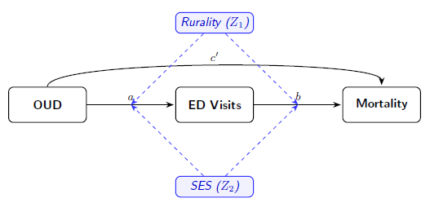
Model Specification and Equations
To evaluate the structural pathways, we fit generalized linear models using the sdmTMB package in R. We specified a negative binomial distribution with a log link to account for the overdispersion inherent in mortality count data. To ensure the estimated parameters reflected true underlying risk rather than population-driven artifacts, we included the natural log of the county population as an exposure offset, transforming the dependent variable into a per-capita incidence rate. Initial model diagnostics utilized a Matérn covariance structure with penalized complexity priors to estimate spatial random fields. However, the spatial standard deviation ($\sigma_O$) collapsed to zero, demonstrating that the fixed-effect covariates fully explained the county-level geographic variance. Consequently, we disabled the spatial field in the final models to guarantee mathematical convergence and interpretability.

This structural model requires a two-stage regression framework to estimate the conditional indirect effects. The analysis evaluates dual moderation on both the first stage (a-path, from opioid use to ER visit) and the second stage (b-path, from ER visit to mortality).
Equation 1: The Mediator Model (Predicting ER Visits)
Assuming ER visits (M) are measured as a continuous frequency over a defined period, Ordinary Least Squares (OLS) regression is utilized to test the a-path. The model includes the main effects of opioid usage (X), SES (W), and Rurality (Z), along with their interaction terms:
In this equation, a₄ and a₅ quantify whether SES and Rurality moderate the likelihood of opioid use resulting in an ER visit (first-stage moderation).
Equation 2: The Outcome Model (Predicting Mortality)
Because the dependent variable of mortality (Y) is a dichotomous clinical event (survival vs. fatal overdose), the second stage of the model utilizes a logistic regression framework with a logit link function:
Here, c' represents the direct effect of opioid usage on mortality. The coefficients b₄ and b₅ test second-stage moderation, determining whether the mathematical relationship between an ER visit and subsequent death is conditionally dependent on the patient's SES and rural geographic location.
The moderated mediation lattice employs a dual-distribution approach to accommodate the varying dispersion profiles of the dependent variables. Emergency Department utilization ($M$) is modeled via a Negative Binomial distribution ($nbinom2$) to account for significant overdispersion in acute care encounters. In contrast, mortality counts ($Y$) are modeled via a Poisson distribution, as the high dispersion parameter in preliminary trials indicated a convergence with the Poisson state after accounting for spatial random fields.
Analytical Procedures and Assumptions
Executing this moderated mediation model requires strict adherence to several statistical procedures.
Mean Centering
Prior to computing the interaction product terms (XW, XZ, MW, MZ), all continuous predictors and moderators must be mean-centered to mitigate nonessential multicollinearity and prevent standard error inflation.
Index of Moderated Mediation
The total indirect effect of X on Y via M is mathematically expressed as a function of the moderators (W and Z). Researchers must calculate the index of moderated mediation to formally test if the indirect path significantly varies across different geographic and economic strata.
Bootstrapping Confidence Intervals
Because the sampling distribution of conditional indirect effects is frequently asymmetrical, researchers must utilize bootstrapping techniques (e.g., 5,000 resamples) to generate robust 95% confidence intervals to determine statistical significance.
Probing the Interactions
Significant interaction terms must be probed using simple slopes analysis or the Johnson-Neyman technique to calculate the specific regions of significance, identifying the exact SES and rurality thresholds where ER visits critically predict mortality.
Results
Study Population and Descriptive Statistics
This study included 22 counties in Northwest Alabama from 2016 to 2019. It included a total population of approximately 2,457,531. Counties ranged from small rural aera Lamar (13,878) to urban aera Jefferson (659,148) in population (Appendix A1).
ED Visits (Rising Trend)
There was a substantial 35.3% increase in the aggregate rate of opioid-related ED visits over the four-year period. The total sum of county rates rose from 166.31 in 2016 to a peak of 225.01 in 2019. The sharpest year-over-year increase occurred between 2018 (176.83) and 2019 (225.01), driven by spikes in specific rural and micropolitan counties.
Mortality (Fluctuating Trend)
Opioid-related mortality rates were more volatile. The aggregate rate peaked in 2017 at 8.90, followed by a decline to 8.17 in 2018 and 6.24 in 2019. Attention is needed for that mortality has significant data suppression (hyphens) in rural counties with fewer than 10 deaths, which likely masks the full extent of mortality in smaller populations.
Socioeconomic Context & Disparities
There are stark contrasts between counties with better socioeconomic health and those facing structural disadvantages. Shelby County represents the most affluent profile with the lowest poverty rate (7.5%), lowest disability (14.1%), and lowest unemployment (3.6%). In contrast, Pickens has the highest poverty rate at 22.7% and highest unemployment at 10.3%.
Fayette county reports the highest disability rate at 28.7%, nearly double that of Shelby County.
Urban-Rural divide is another pattern. The data spans from Large Central Metro areas (UR 2, e.g., Jefferson, Shelby) to Rural Non-Core areas (UR 6, e.g., Winston, Cherokee). Notably, while urban centers like Jefferson have high absolute numbers, the rates of ED visits are surging most aggressively in rural counties like Cherokee (UR 6) and Franklin (UR 5), suggesting a shifting epicenter of the crisis.
Relationship Between ED Visits and Mortality
In Figure 1, across all observed years, the Adjusted metrics demonstrated a consistent, stable positive correlation with ED visits, suggesting that the normalization framework successfully identifies a latent trend within the spatial reasoning of the data . In contrast, the Observed data exhibited high variance and inconsistent slopes—notably showing a negative trend in 2017 and 2018—likely due to the high density of zero-inflation in raw mortality counts at the lower end of the ED visit distribution. By 2019, the Adjusted model indicated a clearer linear trajectory, with mortality rates increasing proportionally with ED service utilization.
Figure 2
Regression Analysis of Observed and Adjusted Opioid Mortality

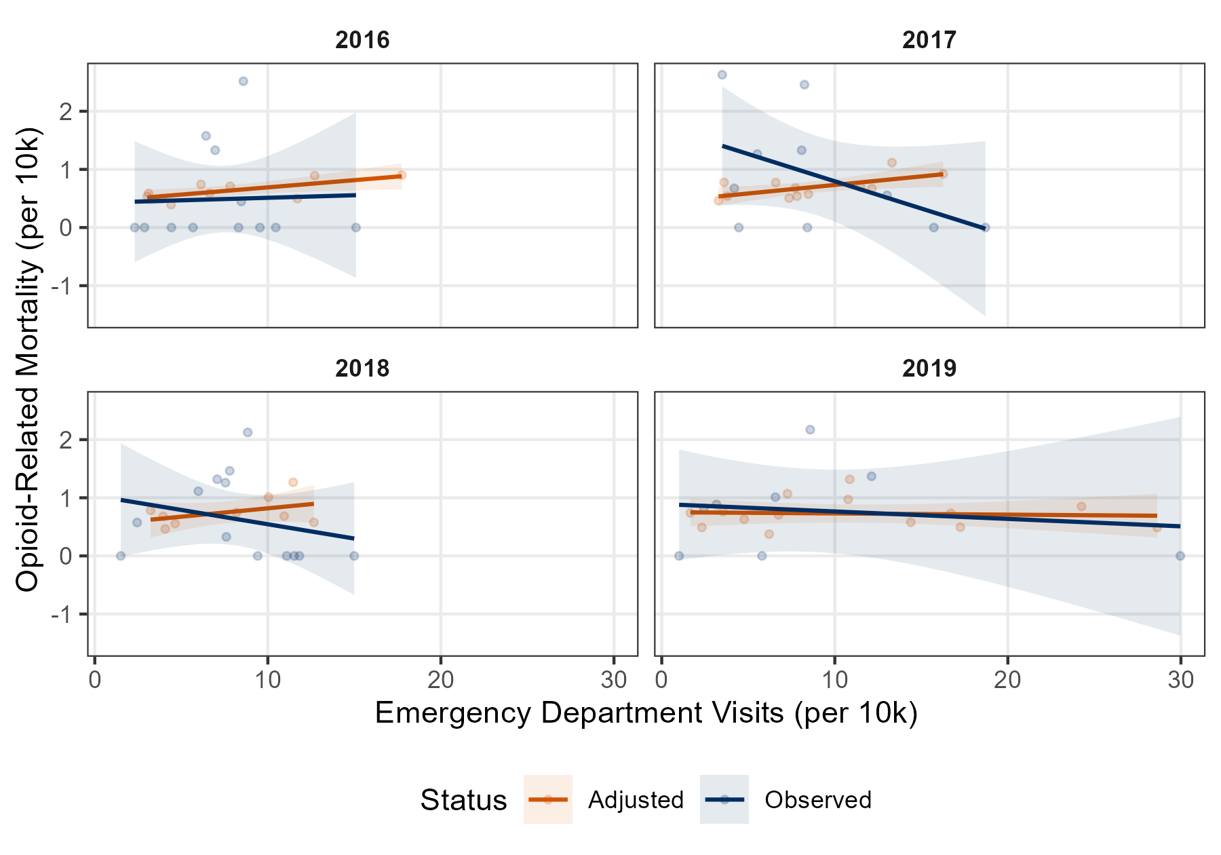

After controlling spatiotemporal variation, annual per capita ED visits were a significant positive predictor of mortality in counties. For everyone standard deviation increases in per capita ED visits, the expected count increased by approximately 8% (95% CI [0.00, 0.16]; see Appendix Table A2).
Figure 3
Linear Regression of Opioid-Related Mortality on Emergency Department Visits
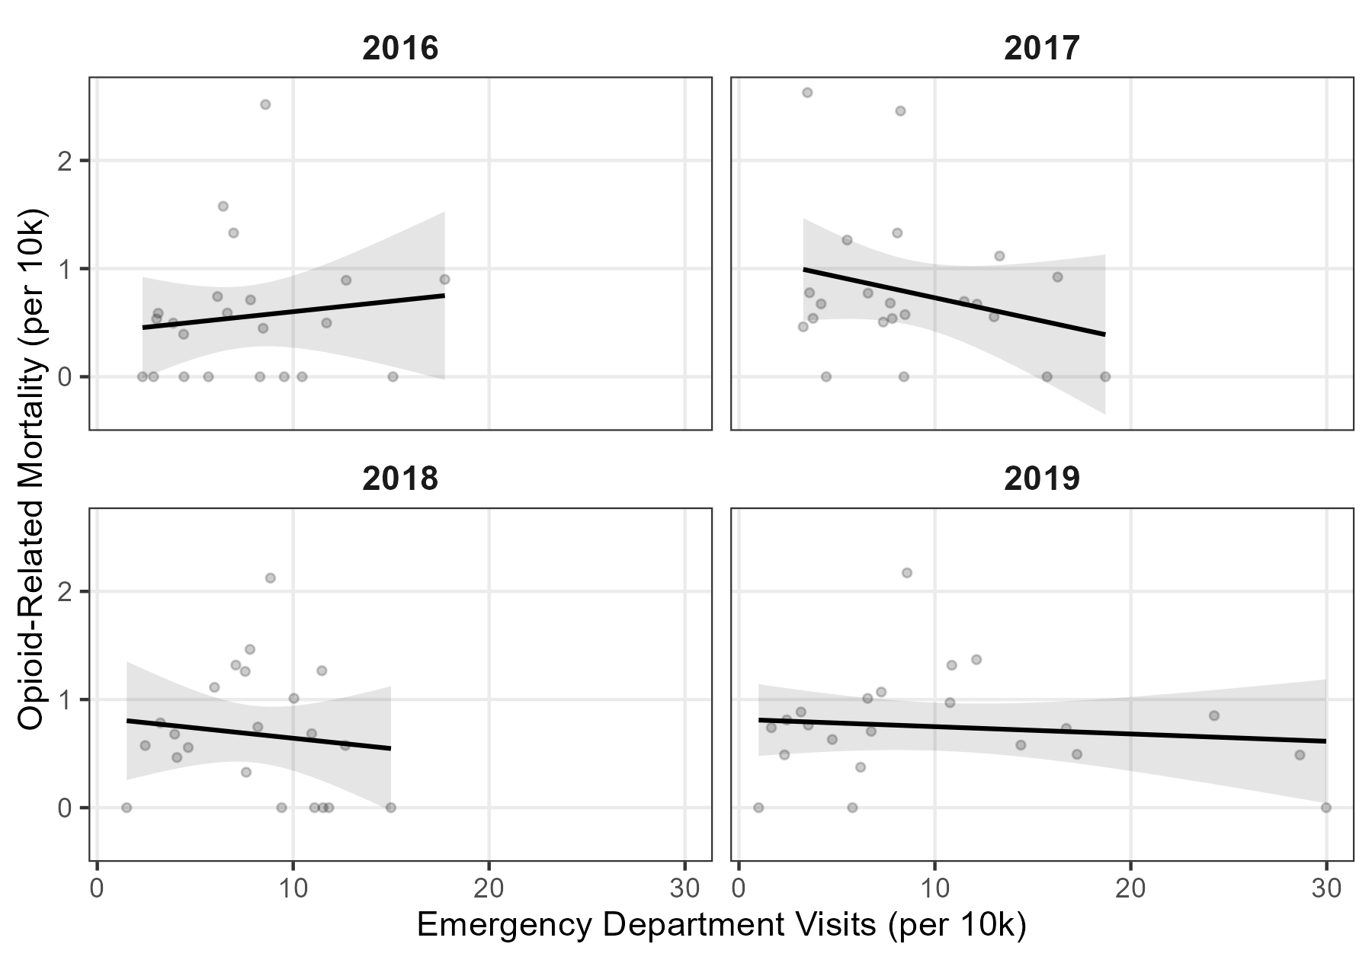
Figure 4
Linear Regression of Opioid-Related Mortality on Emergency Department Visits(Observed VS Combined)

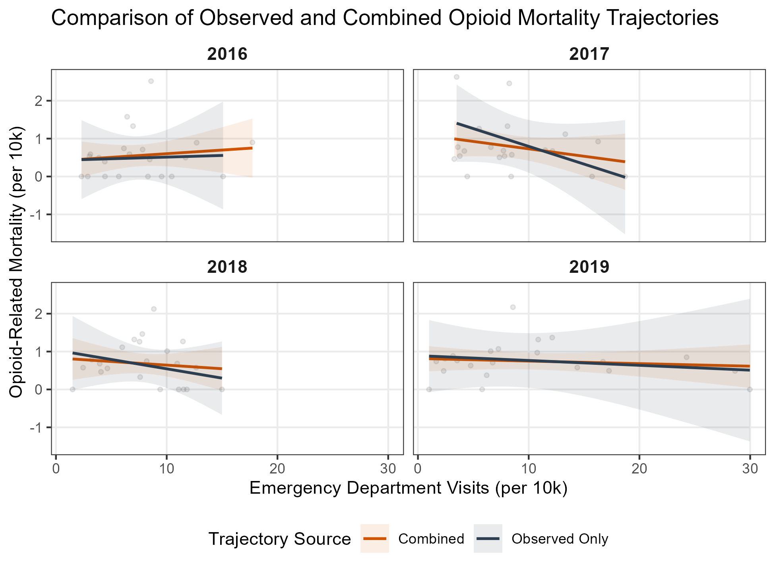

Spatial Patterns
Global Moran’s I analysis was conducted to evaluate the spatial autocorrelation of four opioid-related medications (Buprenorphine, Hydrocodone, Methadone, and Oxycodone) across counties in Northwest Alabama. Methadone exhibited a significant positive spatial clustering pattern, with a Moran’s Index of 0.455 and a z-score of 2.739 (p = .006). This indicates that high rates of Methadone per capita are geographically concentrated in specific clusters rather than being randomly distributed across the region. In contrast, Buprenorphine (I = 0.089, p = .468), Hydrocodone (I = 0.063, p = .562), and Oxycodone (I = -0.072, p = .893) did not reach statistical significance (see Appendix A3).
Figure 2
Hot Spot (Geti-Ord Gi*) of ED Visits (Per Capita) and Methadone Consumption (Per Capita)

(A) ED Visits (Per Capita) (B) Methadone Consumption (Per Capita)
In Figure 2 (A) shows that Colbert, Franklin, and Lawrence counties exhibited increasing trends in ED visits, while Pickens and Madison counties demonstrated a decreasing pattern. Despite these localized variations, Moran’s I was not statistically significant for either total or per capita ED visits, indicating no strong spatial autocorrelation overall.
Figure 2 (B) illustrates the spatial clustering of methadone consumption per capita using Getis-Ord Gi statistics. The results identify a significant hot spot in the southwestern portion of the region, particularly in Tuscaloosa, Fayette, Walker, and Lamar counties.

Additionally, opioid-related mortality hit in regional waves, with significant spatial clustering in 2016 (Moran's I = 0.33, p < .001) and 2018 (Moran's I = 0.36, p < .001) before scattering randomly in alternating years (see Appendix A4). Conversely, emergency department visits spread evenly across the map until 2019, when this acute medical strain suddenly anchored into concentrated local epicenters (Moran's I = 0.30, p = .003).

Exploratory Mediation Analysis
We employed a two-stage spatiotemporal path analysis. First, we fitted a 'Mediator Model' to predict ER Visits based on PCPV. Second, we fitted an 'Outcome Model' to predict mortality based on ER Visits (Table 1). SES, and rurality are mediators
In the Mediator model, higher per-capita availability of Buprenorphine ($\beta = -0.26, p < .001$) and Methadone ($\beta = -0.26, p < .001$) was associated with significantly lower [ER Visit] counts. In the Outcome model, we observed a significant positive association between the Gini index and [Mortality] ($\beta = 0.22, p < .001$). However, the interaction between Rurality and ER visits was not statistically significant across any rural categories, suggesting that the relationship between ER visits and [Mortality] does not vary by rural classification in this sample.

The Mediator Model (Predicting ED Visits)
The model identifies significant geospatial and temporal signals in acute care utilization. While the main effects of specific opioid drugs were varied, Hydrocodone demonstrated a significant positive baseline relationship with ED visits (B = 3.52, p < .05). Crucially, a significant interaction was detected between Oxycodone and mid-level rurality (Rural Factor 4; B = 3.19, p < .05), suggesting that the impact of prescription burden on acute care is significantly amplified in rural-adjacent zones compared to urban centers.
Furthermore, the model reveals a strong temporal surge in utilization (B = 0.68, p < .001) and a significant negative moderation by structural inequality (Gini Index; B = -0.50, p < .01). This interaction suggests that higher income inequality functions as a latent barrier to ED entry, effectively masking the clinical severity of the opioid burden in disadvantaged populations—a hallmark of healthcare "service deserts."
Stage 2: The Outcome Model (Predicting Mortality)
In the transition to mortality, the direct effects (c'-paths) of opioid burden remain primary drivers. Oxycodone (B = 0.51, p < .001) and Buprenorphine (B = 0.21, p < .05) exhibited significant positive direct associations with mortality risk, while Hydrocodone showed a significant negative association (B = -0.84, p < .001) after accounting for other predictors and the spatial random field.
The geospatial signal in mortality is further refined by the significant direct effects of rurality (Rural Factor 3; B = -0.95, p < .001) and income inequality (B = 0.29, p < .001). Unlike the utilization stage, the Gini Index contributes directly to increased mortality, indicating that the structural disparities that initially bar patients from the ED ultimately exacerbate the risk of death. The robust Matérn Range (20.17) and Spatial SD (1.09) confirm that these findings are not localized flukes but represent a stable geospatial pattern across the state of Alabama.

Reference
Griffith, K. N., Feyman, Y., Auty, S. G., Crable, E. L., & Levengood, T. W. (2021). Implications of county-level variation in US opioid distribution. Drug and alcohol dependence, 219, 108501.

Tables and Figures
Table 1. Characteristics of Northwestern Alabama Counties: Demographics, Socioeconomic Indicators, and Healthcare Access Appendix A1
[Table to be inserted with county-level data on population, % rural, median income, % uninsured, HPSA status, MAT providers]
Table 2. Summary of Opioid-Related ED Visits and Mortality by County (2016-2019)
[Table from preliminary analysis — total visits, rates per 100,000, mortality counts]
Figure 1. Map of Northwestern Alabama Study Region with Health Disparity Indicators
[Map showing 22 counties with HPSA designations, treatment facility locations]
Figure 2. The ED Visit–Mortality Relationship: Comparison to National Patterns
[Scatter plot with regression line, compared to Sumner et al. finding of r = 0.92]
Figure 3. Hot Spot Analysis — Geographic Clustering of Opioid Burden
[Getis-Ord Gi* maps for ED visits, mortality, and drug consumption]

Supplement (eAppendix)
eMethods 1: Data Processing and Suppressed Data Adjustment
- CDC WONDER suppression policy (counts 1-10 suppressed)
- EM algorithm-based adjustment approach
- Sensitivity analyses
eMethods 2: Spatial Analysis Technical Details
- Global Moran's I specifications
- Getis-Ord Gi* calculations
- Spatial weights matrix construction
eMethods 3: Exploratory Mediation Analysis
- Model specifications
- Limitations and caveats for ecological data
eTable 1. Complete County-Level Data
eTable 2. Sensitivity Analysis Results
eFigure 1. Additional Spatial Analysis Results

Article Information
Accepted for Publication: [Date]
Published: [Date]
Open Access: This is an open access article distributed under the terms of the CC-BY License.
Corresponding Author: [Name, degree, institution, address, email]
Author Affiliations: [List all author affiliations]
Author Contributions: [Concept and design; Acquisition, analysis, or interpretation of data; Drafting of the manuscript; Critical revision; Statistical analysis; Administrative, technical, or material support; Supervision]
Conflict of Interest Disclosures: None reported.
Funding/Support: [If applicable]
Role of the Funder/Sponsor: [If applicable]
Data Sharing Statement: [Describe data availability]
Additional Contributions: [Acknowledgments if any]

Table A1
Opioid-Related ED Visits, Mortality, and Characteristics of Northwestern Alabama Counties 2016-2019
County | Pop | UR | ED (per 10k) |  |  |  | Deaths (per 10k) |  |  |  | Gini | Uninsured | Unemployment | Poverty | Disability
 |  |  | 2016 | 2017 | 2018 | 2019 | 2016 | 2017 | 2018 | 2019
Blount | 57,846 | 2 | 17.74 | 16.27 | 10.04 | 7.26 | - | - | - | - | 45.7 | 4.6 | 3.4 | 13.6 | 17.0
Cherokee | 25,952 | 6 | 3.88 | 7.36 | 14.99 | 28.63 | - | - | 0 | - | 45.1 | 3.5 | 4.4 | 13.9 | 20.2
Colbert | 54,680 | 4 | 9.54 | 15.72 | 11.09 | 24.26 | 0 | 0 | 0 | - | 44.7 | 3.1 | 4.4 | 15.5 | 21.4
Cullman | 83,109 | 5 | 6.43 | 8.09 | 7.07 | 6.21 | 1.57 | 1.32 | 1.31 | - | 44.2 | 4.8 | 5.1 | 14.9 | 20.4
Etowah | 102,522 | 4 | 3.11 | 3.49 | 7.80 | 12.13 | - | 2.62 | 1.46 | 1.36 | 45.9 | 4.8 | 5.5 | 17.4 | 21.2
Fayette | 16,437 | 6 | 15.09 | 12.15 | 10.95 | 6.75 | 0 | - | - | - | 46.1 | 3.6 | 6.3 | 19.4 | 28.7
Franklin | 31,462 | 5 | 11.70 | 18.71 | 11.82 | 29.97 | - | 0 | 0 | 0 | 42.8 | 6.8 | 4.8 | 19.4 | 18.4
Jackson | 51,852 | 5 | 2.31 | 3.28 | 4.07 | 2.32 | 0 | - | - | - | 45.2 | 4.3 | 5.1 | 18.6 | 22.0
Jefferson | 659,148 | 2 | 8.59 | 8.25 | 8.84 | 8.58 | 2.51 | 2.45 | 2.12 | 2.17 | 50.1 | 4.7 | 6.5 | 16.0 | 18.5
Lamar | 13,878 | 6 | 2.87 | 3.60 | 11.53 | 5.80 | 0 | - | 0 | 0 | 47.2 | 6.8 | 8.8 | 20.6 | 25.5
Lauderdale | 92,493 | 4 | 3.03 | 3.78 | 4.64 | 17.25 | - | - | - | - | 46.0 | 4.3 | 4.7 | 14.6 | 17.3
Lawrence | 33,044 | 4 | 7.82 | 11.49 | 8.20 | 16.71 | - | - | - | - | 44.1 | 4.0 | 5.3 | 18.0 | 23.6
Limestone | 95,561 | 3 | 6.14 | 6.59 | 3.22 | 3.54 | - | - | - | - | 44.5 | 5.0 | 6.2 | 13.6 | 18.0
Madison | 364,360 | 3 | 8.47 | 13.02 | 7.60 | 3.16 | 0.44 | 0.55 | 0.32 | 0.88 | 46.2 | 4.5 | 5.0 | 12.5 | 16.0
Marion | 29,826 | 6 | 5.67 | 7.72 | 9.41 | 10.77 | 0 | - | 0 | - | 45.9 | 3.8 | 5.5 | 17.5 | 28.2
Marshall | 95,897 | 5 | 8.31 | 8.48 | 3.95 | 1.65 | 0 | - | - | - | 47.1 | 6.1 | 4.3 | 20.3 | 18.1
Morgan | 119,150 | 4 | 6.64 | 7.82 | 7.55 | 4.76 | - | - | 1.26 | - | 45.3 | 5.0 | 5.1 | 14.6 | 19.5
Pickens | 20,092 | 3 | 4.43 | 4.45 | 1.50 | 1.00 | 0 | 0 | 0 | 0 | 49.1 | 4.7 | 10.3 | 22.7 | 25.9
Shelby | 214,409 | 2 | 6.96 | 5.52 | 5.98 | 6.57 | 1.32 | 1.26 | 1.11 | 1.01 | 43.9 | 3.1 | 3.6 | 7.5 | 14.1
Tuscaloosa | 208,045 | 3 | 4.41 | 4.19 | 2.45 | 2.44 | - | 0.67 | 0.57 | 0.81 | 46.8 | 3.9 | 5.8 | 17.7 | 15.6
Walker | 64064 | 2 | 12.71 | 13.30 | 11.47 | 10.86 | - | - | - | - | 45.2 | 6.0 | 8.4 | 18.1 | 27.7
Winston | 23704 | 6 | 10.46 | 8.42 | 12.66 | 14.39 | 0 | 0 | - | - | 47.5 | 6.3 | 7.3 | 17.6 | 26.9
Total | 2,457,531 |  | 166.31 | 191.7 | 176.83 | 225.01 | 5.87 | 8.90 | 8.17 | 6.24 | Mean(sd)
Note. Pop = Total population; UR = Urban-Rural classification code by the National Center for Health Statistics (NCHS) , ranging from Large Central Metro (UR=2, e.g., Jefferson) to Rural (UR 6, e.g., Winston); ED = Emergency Department visits per 10,000 population; Deaths = Opioid-related mortality rate per 10,000 population. Hyphens (-) indicate data suppressed to protect patient confidentiality due to low case counts (n < 10) or unavailable data. Socioeconomic variables (Gini, Uninsured, Unemployment, Poverty, Disability) represent percentage for the study period.

Table A2
Basic Model of ED Visits and County-Level Mortality
Parameter | Estimate (β) | SE | 95% CI
Intercept | -9.00 | 0.03 | [-9.06, -8.94]
ED Visit Annual Per Capita (z) | 0.08 | 0.04 | [ 0.00, 0.16]
Note. SE = Standard Error; CI = Confidence Interval. The ED Visit variable was standardized (z-score) prior to analysis.

Table A3
Global Moran's I Summary of Medication (Per Capita) across Counties in Northwest Alabama
 | Buprenorphine | Hydrocodone | Methadone | Oxycodone
Moran's Index | 0.089 | 0.063 | 0.455 | -0.072
Expected Index | -0.048 | -0.048 | -0.048 | -0.048
Variance | 0.035 | 0.036 | 0.034 | 0.033
z-score | 0.726 | 0.580 | 2.739 | -0.134
p-value | 0.468 | 0.562 | 0.006 | 0.893

Table A4
Annual Global Moran's I Summary of Opioid-Related Emergency Visits and Mortality (2016–2019)
 | Emergency Department Visits |  |  |  | Opioid-Related Mortality
 | 2016 | 2017 | 2018 | 2019 | 2016 | 2017 | 2018 | 2019
Moran's Index | -0.118 | -0.100 | 0.002 | 0.295 | 0.333 | 0.141 | 0.358 | 0.087
Expected Index | -0.048 | -0.048 | -0.048 | -0.048 | -0.048 | -0.048 | -0.048 | -0.048
Variance | 0.015 | 0.016 | 0.016 | 0.015 | 0.013 | 0.014 | 0.016 | 0.014
z-score | -0.567 | -0.412 | 0.392 | 2.765 | 3.295 | 1.6 | 3.241 | 1.137
p-value | 0.715 | 0.660 | 0.348 | 0.003 | 0.001 | 0.055 | 0.001 | 0.128

Table A5 (move to appendix)
Spatiotemporal Path Analysis Examining on Opioid Availability, ER Visits, and Mortality
Term | PCPV to ED  (a-path) |  | PCPV, ED to Mortality  (b & c' paths)
(Intercept) | -6.36 (0.50) | *** | -9.26 (0.22) | ***
OXYCODONE | -2.17 (1.76) |  | 0.56 (0.16) | ***
BUPRENORPHINE | -0.81 (0.56) |  | 0.28 (0.12) | *
HYDROCODONE | 3.52 (1.43) | * | -1.01 (0.21) | ***
METHADONE | 0.18 (1.12) |  | 0.17 (0.08) | *
Rural_factor3 | -0.32 (1.02) |  | -0.89 (0.18) | ***
Rural_factor4 | -2.68 (0.46) | *** | 0.28 (0.24)
Rural_factor5 | -3.40 (0.66) | *** | 0.66 (0.33) | *
Rural_factor6 | -2.71 (0.62) | *** | -0.99 (0.34) | **
Gini Index | -0.50 (0.17) | ** | 0.37 (0.07) | ***
Poverty Rate | 0.42 (0.28) |  | 0.00 (0.14)
No-insurance Rate | 0.06 (0.20) |  | -0.17 (0.14)
Time Index | 0.68 (0.16) | *** | -0.11 (0.05) | *
OXYCODONE : Rural_factor3 | 0.94 (1.73) |  | -
OXYCODONE : Rural_factor4 | 3.19 (1.59) | * | -
OXYCODONE : Rural_factor5 | 0.39 (2.46) |  | -
OXYCODONE : Rural_factor6 | 1.37 (1.67) |  | -
OXYCODONE : Gini Index | -0.63 (0.48) |  | -
OXYCODONE : Poverty Rate | -0.35 (0.69) |  | -
OXYCODONE : No-insurance Rate | -0.08 (0.38) |  | -
OXYCODONE : Time Index | -0.07 (0.12) |  | -
BUPRENORPHINE : Rural_factor3 | 0.15 (0.68) |  | -
BUPRENORPHINE : Rural_factor4 | 0.14 (0.38) |  | -
BUPRENORPHINE : Rural_factor5 | -0.47 (0.65) |  | -
BUPRENORPHINE : Rural_factor6 | 0.30 (0.48) |  | -
BUPRENORPHINE : Gini Index | 0.26 (0.22) |  | -
BUPRENORPHINE : Poverty Rate | 0.56 (0.24) | * | -
BUPRENORPHINE : No-insurance Rate | -0.35 (0.20) | . | -
BUPRENORPHINE : Time Index | -0.09 (0.06) |  | -
HYDROCODONE : Rural_factor3 | 0.94 (2.08) |  | -
HYDROCODONE : Rural_factor4 | -4.16 (1.44) | ** | -
HYDROCODONE : Rural_factor5 | -2.14 (2.08) |  | -
HYDROCODONE : Rural_factor6 | -2.43 (1.44) | . | -
HYDROCODONE :Gini Index | 0.46 (0.39) |  | -
HYDROCODONE : Poverty Rate | 0.31 (0.72) |  | -
HYDROCODONE : No-insurance Rate | -0.11 (0.36) |  | -
HYDROCODONE : Time Index | 0.34 (0.11) | ** | -
METHADONE : Rural_factor3 | -1.19 (1.29) |  | -
METHADONE : Rural_factor4 | -0.85 (1.05) |  | -
METHADONE : Rural_factor5 | 1.37 (1.18) |  | -
METHADONE : Rural_factor6 | -0.50 (1.19) |  | -
METHADONE : Gini Index | 0.30 (0.38) |  | -
METHADONE : Poverty Rate | 0.66 (0.31) | * | -
METHADONE : No-insurance Rate | -0.58 (0.24) | * | -
METHADONE : Time Index | 0.00 (0.06) |  | -
ER Visit | - |  | 0.35 (0.23)
ER Visit : Rural_factor3 | - |  | -0.29 (0.27)
ER Visit : Rural_factor4 | - |  | -0.01 (0.27)
ER Visit : Rural_factor5 | - |  | -0.08 (0.41)
ER Visit : Rural_factor6 | - |  | 0.02 (0.39)
ER Visit :Gini Index | - |  | 0.07 (0.14)
ER Visit : Poverty Rate | - |  | 0.11 (0.13)
ER Visit : No-insurance Rate | - |  | -0.03 (0.13)
ER Visit : Time Index | - |  | -0.10 (0.07)
---
Family | NegativeBinomial (log) |  | Poisson (log)
Matérn Range | 24.3 |  | 20.17
Spatial SD | 0.89 |  | 1.09
Note. All values represent unstandardized coefficients (B) with standard errors in parentheses. The Mediator Model (a-path) employs Negative Binomial distribution with a log link to accommodate significant overdispersion in annual emergency department (ED) visit counts. The Outcome Model (b and c' paths) utilizes a Poisson distribution with a log link to estimate the mortality rate, adjusted for population size using a log-offset term. Spatial diagnostics (Matérn Range and Spatial SD) were random fields to account for geospatial autocorrelation across Alabama counties. *** p < .001; ** p < .01; * p < .05; . p < .10.

Table A5-2
Term | PCPV to ED  (a-path) |  | PCPV, ED to Mortality  (b & c' paths)
(Intercept) | -5.55 (0.51) | *** | -9.62 (0.38) |  | ***
OXYCODONE | -6.45 (2.34) | ** | 0.59 (0.17) |  | ***
BUPRENORPHINE | 1.13 (0.71) |  | 0.25 (0.13) |  | *
HYDROCODONE | 4.09 (1.56) | ** | -1.02 (0.22) |  | ***
METHADONE | 2.83 (1.34) | * | 0.19 (0.09) |  | *
Rural_factor3 | -0.27 (1.06) |  | -0.86 (0.20) |  | ***
Rural_factor4 | -2.31 (0.44) | *** | 0.27 (0.25)
Rural_factor5 | -3.66 (0.60) | *** | 0.70 (0.35) |  | *
Rural_factor6 | -3.05 (0.57) | *** | -0.94 (0.35) |  | **
Gini Index | -0.72 (0.16) | *** | 0.39 (0.08) |  | ***
Poverty Rate | 0.48 (0.26) | . | -0.03 (0.15)
No-insurance Rate | 0.17 (0.20) |  | -0.16 (0.14)
Time Index | -0.03 (0.27) |  | 0.15 (0.25)
Quadratic Time Index | 0.15 (0.05) | ** | -0.04 (0.05)
OXYCODONE : Rural_factor3 | 3.39 (2.03) | . | -
OXYCODONE : Rural_factor4 | 5.80 (1.82) | ** | -
OXYCODONE : Rural_factor5 | 2.94 (2.75) |  | -
OXYCODONE : Rural_factor6 | 4.26 (2.00) | * | -
OXYCODONE : Gini Index | -0.58 (0.47) |  | -
OXYCODONE : Poverty Rate | -0.89 (0.74) |  | -
OXYCODONE : No-insurance Rate | -0.24 (0.39) |  | -
OXYCODONE : Time Index | 0.84 (0.42) | * | -
OXYCODONE : Quadratic Time Index | -0.13 (0.07) | * | -
BUPRENORPHINE : Rural_factor3 | -0.57 (0.66) |  | -
BUPRENORPHINE : Rural_factor4 | -0.55 (0.41) |  | -
BUPRENORPHINE : Rural_factor5 | -1.38 (0.64) | * | -
BUPRENORPHINE : Rural_factor6 | -0.36 (0.49) |  | -
BUPRENORPHINE : Gini Index | 0.44 (0.21) | * | -
BUPRENORPHINE : Poverty Rate | 0.41 (0.23) | . | -
BUPRENORPHINE : No-insurance Rate | -0.40 (0.19) | * | -
BUPRENORPHINE : Time Index | -1.03 (0.27) | *** | -
BUPRENORPHINE : Quadratic Time Index | 0.15 (0.05) | ** | -
HYDROCODONE : Rural_factor3 | 1.15 (2.15) |  | -
HYDROCODONE : Rural_factor4 | -4.74 (1.40) | *** | -
HYDROCODONE : Rural_factor5 | -1.92 (2.06) |  | -
HYDROCODONE : Rural_factor6 | -2.45 (1.44) | . | -
HYDROCODONE :Gini Index | 0.66 (0.37) | . | -
HYDROCODONE : Poverty Rate | 0.74 (0.74) |  | -
HYDROCODONE : No-insurance Rate | -0.27 (0.36) |  | -
HYDROCODONE : Time Index | 0.18 (0.35) |  | -
HYDROCODONE : Quadratic Time Index | 0.03 (0.06) |  | -
METHADONE : Rural_factor3 | -4.01 (1.47) | ** | -
METHADONE : Rural_factor4 | -3.10 (1.22) | * | -
METHADONE : Rural_factor5 | -1.59 (1.52) |  | -
METHADONE : Rural_factor6 | -3.52 (1.47) | * | -
METHADONE : Gini Index | -0.12 (0.38) |  | -
METHADONE : Poverty Rate | 1.07 (0.31) | *** | -
METHADONE : No-insurance Rate | -0.76 (0.22) | *** | -
METHADONE : Time Index | 0.19 (0.18) |  | -
METHADONE : Quadratic Time Index | -0.01 (0.03) |  | -
ER Visit | - |  | 0.83 (0.45) |  | .
ER Visit : Rural_factor3 | - |  | -0.37 (0.30)
ER Visit : Rural_factor4 | - |  | -0.17 (0.31)
ER Visit : Rural_factor5 | - |  | -0.20 (0.45)
ER Visit : Rural_factor6 | - |  | -0.16 (0.41)
ER Visit :Gini Index | - |  | 0.09 (0.15)
ER Visit : Poverty Rate | - |  | 0.12 (0.14)
ER Visit : No-insurance Rate | - |  | -0.07 (0.14)
ER Visit : Time Index | - |  | -0.53 (0.38)
ER Visit : Quadratic Time Index | - |  | 0.09 (0.07)

