BLOCKCHAIN-BASED MUSIC COPYRIGHT AND ROYALTY MANAGEMENT
BACHELOR OF TECHNOLOGY
IN
COMPUTER SCIENCE AND ENGINEERING
Use Case Report
submitted by
JUJJUVARAPU BHAVYA
23501A0555
Under the guidance of
Mr. A. Prashant, Asst. Prof.

Department of Computer Science and Engineering
Prasad V Potluri Siddhartha Institute of Technology
(Permanently affiliated to JNTU-Kakinada, Approved by AICTE)
(An NBA & NAAC accredited and ISO 9001:2015 certified institute)
Kanuru, Vijayawada-520 007
2026-2027
Prasad V Potluri Siddhartha Institute of Technology
(Permanently affiliated to JNTU-Kakinada, Approved by AICTE)
(An NBA & NAAC accredited and ISO 9001:2015 certified institute)
Kanuru, Vijayawada-520 007
CERTIFICATE
This is to certify that the Use Case report entitled “Blockchain-Based Music Copyright and Royalty Management” that is being submitted by J.Bhavya 23501A0555, as part of Assignment-2 for the Blockchain Technology (20CS4601C) course in 3-2 during the academic year 2026-2027.
Course Coordinator  Mr. A. Prashant  Assistant Professor,  Department of CSE,  PVPSIT, Vijayawada | Head of the Department  Dr. A. Jayalakshmi,  Professor and Head,  Department of CSE,  PVPSIT, Vijayawada

MARKS
ASSIGNMENT-2: ____/5
INDEX
S. No. | Chapter | Page No.
1 | Introduction | 01
2 | Background | 02
3 | Blockchain Basics | 04
4 | Use Case Overview | 06
5 | Implementation | 11
6 | Benefits | 20
7 | Challenges | 22
8 | Conclusion | 24
9 | SDG’s Addressed | 25
10 | References | 26
11 | Appendix A | 27

1. INTRODUCTION

1.1. Overview of Blockchain Technology
Blockchain is a distributed ledger technology in which transactions are grouped into blocks, linked together with cryptographic hashes and replicated across many independent computers called nodes. Because every block carries the hash of the block before it, changing an old record would require recomputing every later block and convincing the network to accept the change, which makes silent tampering extremely difficult. The idea was first demonstrated in Bitcoin [1] and was later generalised by Ethereum, which added programmable smart contracts [2].
Unlike a conventional database that is owned and administered by a single organisation, a blockchain is maintained by a network whose participants agree on the state of the ledger through a consensus mechanism. This removes the need to trust one central authority, gives every authorised participant the same verifiable view of the data, and leaves a permanent, time-stamped audit trail. Today the technology is used well beyond cryptocurrency, in areas such as finance, supply chains, healthcare, identity management and digital rights management.

1.2. Relevance of Blockchain in Music Copyright and Royalty Management
A single song usually involves several contributors, such as the performing artist, the composer, the lyricist and a producer, and each of them is entitled to a share of the income the song earns. In the traditional music industry, ownership records and royalty splits are stored in separate databases belonging to labels, collecting societies and streaming platforms. These records can disagree with one another, are hard for creators to inspect, and are updated through slow manual processes. As a result, royalties are frequently delayed, disputed or paid in the wrong proportion.
A blockchain-based music copyright and royalty management system addresses these problems by recording ownership and royalty percentages on a shared, tamper-resistant ledger. When a creator registers a song, the contributors and their shares are written into a smart contract. The contract checks that the shares are valid, stores them permanently and later applies exactly the same percentages whenever royalties are paid. Licences, verified usage reports and royalty payments are recorded as transactions, so every stakeholder can trace what happened and when.
The use of smart contracts also allows royalty distribution to be automated. Once verified usage data reaches the contract through an approved oracle, the royalty is calculated from the licence rate and split among the rights holders without a manual accounting step. Large audio files are not stored on the blockchain itself; only their cryptographic hash and a content reference are kept on-chain, which links the record to the file without the cost of storing it. This project implements these ideas as a complete application using a Solidity smart contract, a Node.js and Express backend with MongoDB, and a React front end connected through MetaMask.

2. BACKGROUND
The conventional way of managing music rights and royalties depends on intermediaries, fragmented databases and manual reporting. These arrangements were built for an era of physical sales and radio play, and they struggle to cope with digital streaming, where a single song can be played millions of times across many platforms and countries. Some of the key issues with existing systems are described below.

2.1. Unclear and Fragmented Ownership Records
Information about who owns a song is often spread across publishers, labels and rights organisations. When these records are not synchronised, it becomes difficult to establish who holds which share of a work. Creators may have no simple way to check how their ownership has been recorded.

2.2. Disputes over Authorship and Royalty Splits
Agreements between artists, composers and lyricists are frequently documented on paper or in private files. Disagreements about who contributed what, and in which proportion, can surface long after a song has been released and may take a long time to settle.

2.3. Delayed and Complex Royalty Payments
Royalties usually travel through several intermediaries before reaching the creator, and each step involves reporting, reconciliation and deductions. This makes payments slow and makes it hard for a creator to understand how an amount was calculated.

2.4. Lack of Transparency in Usage Reporting
Creators typically depend on reports prepared by platforms and intermediaries. They have limited means to verify the number of plays or the rate that was applied, so errors and under-reporting are difficult to detect.

2.5. Duplicate and Fraudulent Registrations
When there is no shared, tamper-resistant registry, the same work can be registered more than once or claimed by someone who is not its creator. Detecting such claims relies on manual checks and takes time.

2.6. Barriers for Independent Artists
Independent artists often lack the legal and administrative support available to large labels. Registering works, negotiating licences and tracking income across platforms is costly and time-consuming for them, which weakens their bargaining position.

2.7. Complexity of Licensing Across Platforms and Regions
Licensing terms differ between platforms, regions and types of use. Managing duration, permitted use and rates for each licence by hand creates inconsistency and makes it hard to confirm whether a particular use was actually authorised.

2.8. Security Risks and Data Tampering
Centralised databases are single points of failure. They can be attacked, misconfigured or altered, and an unauthorised change to an ownership percentage or a payment record may go unnoticed because there is no independent copy to compare against.

2.9. Absence of a Unified Audit Trail
Registration, licensing, usage and payment events are recorded in different systems. Reconstructing the complete history of a song, for example during a dispute or an audit, requires collecting and reconciling records from several parties.

2.10. Slow Dispute Resolution
Because evidence is scattered and mutable, resolving a disagreement about ownership or payments depends on the goodwill and record-keeping of each party. This delays resolution and increases cost for creators.
Because of these challenges, there is a growing need for a secure, transparent and automated system for managing music copyrights and royalties. Blockchain technology offers a promising solution by providing a shared and tamper-resistant record of ownership, licences, usage and payments, together with smart contracts that apply the agreed rules automatically.

3. BLOCKCHAIN BASICS
Blockchain is a distributed ledger system that allows parties who do not fully trust one another to share a single, consistent record of transactions without relying on a central intermediary. The key concepts that make it suitable for copyright and royalty management are described below.

3.1. Decentralization
In a traditional system, one organisation hosts and controls the database. In a blockchain, many independent nodes hold copies of the ledger and validate new entries. No single participant can change the record unilaterally, and the failure or compromise of one node does not destroy the data. For a music registry, this means that no single label, platform or society controls the official record of who owns a song [1][2].

3.2. Immutability
Once a transaction has been confirmed and added to a block, it cannot be changed or deleted in practice. Each block stores the hash of its predecessor, so altering an old block would break the chain unless all later blocks were also recomputed and accepted by the network. In this project, if an ownership record needs to be corrected, the correction is made as a new authorised transaction and the earlier entry remains visible in the history.

3.3. Transparency and Traceability
Every participant with access to the network sees the same ledger, and every transaction is time-stamped and linked to the address that sent it. This allows registrations, licences, usage records and payments to be audited by anyone who is permitted to view them. In a permissioned deployment, access can be limited to authorised organisations while still preserving a shared view.

3.4. Smart Contracts
A smart contract is a program stored on the blockchain that executes predefined rules when its functions are called and the required conditions are satisfied [2][3]. The contract code and its data are replicated across the network, so all nodes reach the same result. In this project, a Solidity smart contract validates song registrations, enforces who may perform each action, calculates royalties and distributes them according to the registered percentages [4].

3.5. Consensus Mechanisms
A consensus mechanism is the method by which nodes agree on which transactions are valid and in what order they are added. In Proof of Work (PoW), participants spend computational effort to propose blocks. In Proof of Stake (PoS), validators are chosen according to the value they have staked. In Proof of Authority (PoA), only a set of approved validators may create blocks, which avoids heavy computation and suits controlled environments of known participants [9]. Because a music-industry network would be operated by identifiable organisations, PoA is a natural fit for this use case.

3.6. Cryptographic Security
Blockchains rely on public-key cryptography and hash functions. Each user controls a private key that is used to digitally sign transactions, and the network verifies the signature against the matching public address, so only the holder of the key can act as that account. Hash functions turn data of any size into a fixed-length fingerprint, which is how an audio file can be linked to an on-chain record without storing the file itself.

3.7. Types of Blockchain
Blockchain networks differ in who is allowed to participate and who controls them. The choice depends on the privacy, control and trust requirements of the application.
Type | Meaning | Suitability for this use case
Public | Anyone can join, read and submit transactions. | Useful for open verification, but offers little control over privacy and participation.
Private | A single organisation controls who may participate. | Suitable for controlled internal systems, but not for a multi-party industry.
Consortium | A group of trusted organisations jointly controls the network. | Well suited to shared music-industry workflows involving labels, societies and platforms.
Hybrid | Combines public and private characteristics. | Useful when some records need wider visibility than others.

3.8. Oracles
A blockchain cannot directly read information from outside the network. An oracle is a trusted mechanism that delivers external, off-chain data to a smart contract. In this project, information such as the number of plays reported by a streaming platform originates outside the blockchain, so it is supplied through an oracle. The contract accepts usage data only from an address that holds the Oracle role, which keeps unauthorised parties from reporting usage..

4. USE CASE OVERVIEW
The use case for a Blockchain-Based Music Copyright and Royalty Management system aims to record music ownership, licensing and royalty information in a transparent and tamper-resistant way. The system connects creators, rights holders, licensed platforms and authorised administrators through a blockchain-based web application.

4.1. Objectives
The first objective is to provide a trustworthy registry of music works. When a creator registers a song, the song identifier, contributors, ownership percentages and a hash of the audio file are recorded on the blockchain. Duplicate song identifiers and duplicate audio files are rejected, which discourages repeated or fraudulent registrations.
The second objective is to make ownership and royalty shares explicit and enforceable. The smart contract requires the shares of all rights holders to total exactly 100%, and it applies the same stored percentages whenever a royalty is distributed. This removes ambiguity about who is entitled to what.
The third objective is to simplify licensing. The owner of a verified song can create a licence for an authorised platform, specifying the duration, the permitted use and the royalty rate per play. Every licence is stored on-chain and can be inspected or revoked by authorised parties.
The fourth objective is to automate royalty calculation and distribution. Verified usage information is supplied through an approved oracle, the contract calculates the amount due from the licence rate, and the payment made by the licensee is split automatically among the rights holders. Each holder can then withdraw their share.
The final objective is traceability. Every important action produces an on-chain event, so a complete and tamper-resistant transaction history of copyright, licence and royalty activity is available to authorised users.

4.2. Scope of the System
The system covers the registration of music works, verification of ownership, management of ownership shares, licensing, usage reporting and royalty distribution. The participants and their functions are summarised below.
Actor | Functions
Artist / Creator | Registers music, provides metadata and ownership information, creates licences for the song and views records.
Composer / Lyricist / Rights Holder | Holds a defined royalty share and views and withdraws the royalties credited to them.
Copyright / Rights Authority | Verifies ownership information and can revoke songs or licences where applicable.
Music Platform / Licensee | Uses licensed music, is the source of usage data and pays the royalty due for reported usage.
Admin | Manages users and on-chain roles, pauses the contract in an emergency and monitors activity.
Blockchain Validators | Validate transactions and maintain the blockchain network.

4.3. Type of Blockchain and Consensus Algorithm
For this use case, a private, permissioned or consortium blockchain is the most suitable choice, because participation is restricted to authorised music-industry organisations and trusted participants. Validator nodes can be selected from these organisations, sensitive licensing information can be handled with controlled access, and the network still provides a shared and auditable record.
Proof of Authority is the consensus concept that fits such a controlled consortium network [9]. Only approved validators verify transactions and create blocks, so the heavy computation of Proof of Work is avoided and confirmation is fast. For development and demonstration, the project runs on an Ethereum-compatible local blockchain (a Hardhat node or Ganache), which behaves like a real Ethereum network but is free to use and resets easily.
When a transaction is submitted, the network first checks that it satisfies the smart-contract rules and authorisation requirements. A valid transaction is confirmed according to the consensus mechanism and included in a new block, which is then appended to the chain. If validation fails, the transaction is rejected, no state is changed and an error message is shown to the user.

4.4. System Architecture
The architecture of the system is illustrated in Figure 4.1 and consists of the following layers.

4.4.1. User Layer
This layer contains the people and organisations that interact with the system (Figure 4.1 - User Layer).
- Artists and creators register works and ownership shares and create licences.
- Rights holders view the songs they have a share in and withdraw their royalties.
- The copyright authority verifies ownership information.
- Music platforms act as licensees, supply usage data and pay royalties.
- Administrators manage users and roles and monitor the system.

4.4.2. Web Application Layer
This layer is the interface between users and the blockchain (Figure 4.1 - Web Application Layer).
- React.js front end: dashboard, song registration, licences, usage and royalties, transaction history and administration pages. It uses ethers.js to talk to the contract through the MetaMask wallet [6][7].
- Node.js and Express back end: provides the REST API, handles authentication with JSON Web Tokens, enforces role-based access, reads blockchain data and exposes the oracle endpoint.
- MongoDB: stores off-chain application data such as user accounts and song metadata [10].
- File storage: audio files are stored off-chain on IPFS or local storage, and only their SHA-256 hash and reference are placed on the blockchain [8].

4.4.3. Blockchain Layer
This layer provides security, transparency and immutability for copyright and royalty transactions (Figure 4.1 - Blockchain Layer).
- MusicCopyrightRoyalty smart contract: stores songs, rights holders, licences, usage records and royalty balances, and enforces the business rules and access control.
- Blockchain network: an Ethereum-compatible ledger (Hardhat or Ganache for development) that keeps an immutable record of all transactions and events.

4.4.4. Oracle and External Data
External music platforms report verified usage through a trusted integration. The backend exposes an authenticated endpoint, and a dedicated oracle wallet that holds the Oracle role submits the data to the smart contract. The contract itself checks the role, so even a compromised backend endpoint cannot record usage unless the oracle wallet signs the transaction.
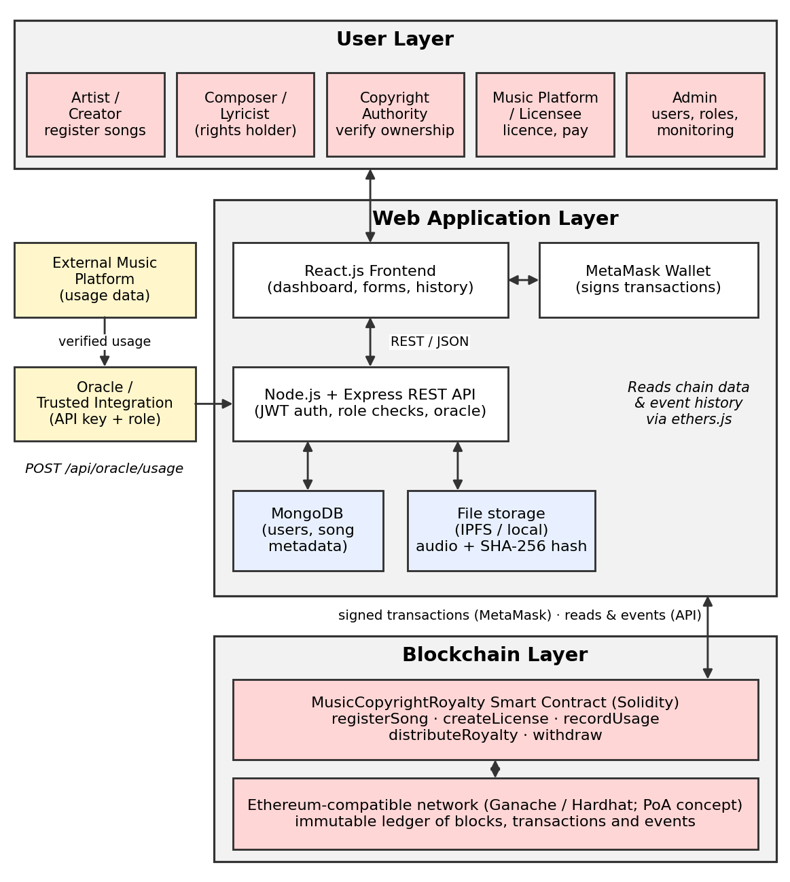
Figure 4.1: Architecture of Blockchain based Music Copyright and Royalty Management System

5. IMPLEMENTATION

5.1. Setting Up the Blockchain Environment
The system is implemented on an Ethereum-compatible blockchain. Hardhat is used as the development framework for compiling, testing and deploying the smart contract [5], and a local Hardhat node (or Ganache) provides a personal blockchain with pre-funded test accounts. MetaMask is connected to this local network to manage accounts and sign transactions [7]. The smart contract is written in Solidity 0.8.24, whose built-in overflow checks and revert messages improve safety [4]. The backend runs on Node.js with Express and MongoDB, and the frontend is built with React and ethers.js [6].
The project is organised into three folders: blockchain (contract, tests and deployment script), backend (REST API) and frontend (React application). The deployment script deploys the contract, grants demo roles to test accounts and writes the contract address and ABI to a shared configuration file, which the backend serves to the frontend.

5.2. Defining the Smart Contract
The MusicCopyrightRoyalty contract implements the complete flow from registration to royalty withdrawal. The sections below describe its main parts.
5.2.1. Writing the Smart Contract for Music Copyright and Royalty Management
The MusicCopyrightRoyalty contract is responsible for registering songs, certifying copyright, issuing licences, recording usage, and distributing royalties. It defines a Song struct holding the song ID, title, content identifier, registration time, and certification status. Rights holders are stored together with their share expressed in basis points (10,000 basis points equal 100%). Mappings track songs, rights holders per song, licences, and the withdrawable royalty balance of each address. The snippets below illustrate the core logic of the contract.
struct Song {
string songId;
string title;
string cid; // SHA-256 content identifier
uint256 registeredAt;
bool verified; // certified by authority
}

struct RightsHolder {
address wallet;
uint256 shareBps; // 10000 = 100%
}

mapping(string => Song) internal songs;
mapping(string => RightsHolder[]) internal holders;
mapping(address => uint256) public royaltyBalance;

5.2.2. Registering Songs with the 100% Split Rule
Before a song is accepted, the contract checks that the song ID has not been used already and that the shares of all contributors add up to exactly 100%. Any configuration that does not sum to 10,000 basis points, such as 115%, is rejected with an error. This guarantees that royalty distribution can never be mathematically inconsistent.
function registerSong(
string memory songId, string memory title, string memory cid,
address[] memory wallets, uint256[] memory sharesBps
) external {
require(bytes(songs[songId].songId).length == 0, "Duplicate song ID");
require(wallets.length == sharesBps.length, "Length mismatch");
uint256 total;
for (uint256 i = 0; i < sharesBps.length; i++) {
total += sharesBps[i];
holders[songId].push(RightsHolder(wallets[i], sharesBps[i]));
}
require(total == 10000, "Shares must equal 100%");
songs[songId] = Song(songId, title, cid, block.timestamp, false);
}

5.2.3. Copyright Certification and Licensing
Only the Copyright Authority or Admin may certify a song, which seals its ownership on-chain. Music platforms can then purchase a licence of a chosen type (Commercial Streaming, Synchronization, Broadcast, or Sample) with a validity duration. The fee sent with the transaction is divided among the rights holders in proportion to their shares, and the last holder receives any remainder so that no value is lost to rounding.
function verifySong(string memory songId) external onlyAuthority {
songs[songId].verified = true;
}

function createLicense(string memory songId, uint8 licType, uint256 duration)
external payable
{
require(songs[songId].verified, "Song not certified");
require(msg.value > 0, "Fee required");
_split(songId, msg.value); // credits each holder's balance
}

5.2.4. Recording Verified Usage via Oracles
Streaming consumption events from digital service providers such as Spotify, Apple Music, YouTube Music, Amazon Music, and Tidal are simulated by the oracle telemetry engine. The backend generates a SHA-256 oracle signature for each report and submits the verified stream count to the contract through recordUsage(). Only authorized oracle addresses are allowed to call this function, which prevents arbitrary users from inflating usage figures.
function recordUsage(string memory songId, uint256 streams)
external onlyOracle
{
require(songs[songId].verified, "Song not certified");
usage[songId] += streams;
}
5.2.5. Royalty Calculation, Distribution and Withdrawal
A pure view function allows any user to preview how a given revenue amount would be divided among the rights holders. When a platform deposits royalties by calling distributeRoyalty(), the native ETH is allocated according to basis points with remainder protection. The contract follows the pull-payment pattern: balances accumulate in the contract and each rights holder claims them by calling withdrawRoyalty(). This avoids failures caused by sending funds to many addresses in a single transaction and reduces reentrancy risk because the balance is set to zero before the transfer.
function distributeRoyalty(string memory songId) external payable {
require(msg.value > 0, "No funds");
_split(songId, msg.value);
}

function withdrawRoyalty() external {
uint256 amount = royaltyBalance[msg.sender];
require(amount > 0, "Nothing to withdraw");
royaltyBalance[msg.sender] = 0; // effects before interaction
(bool ok, ) = payable(msg.sender).call{value: amount}("");
require(ok, "Transfer failed");
}

5.2.9. Retrieving Records and Events
Read-only functions return song details, licence and usage records, royalty totals and a preview of how a usage amount will be split. Every state change also emits an event, and these events form the transaction history that the application displays. The main functions of the contract are summarised below.
Function | Purpose | Caller
registerSong() | Register a new music work with contributors and shares. | Creator
verifySong() / revokeSong() | Verify or revoke a registered work. | Authority / Admin
addRightsHolder() | Add a holder, taking the share from an existing holder. | Song owner
setRoyaltyShare() | Store the agreed ownership / royalty percentages. | Song owner
createLicense() | Create a licence with duration, use and rate. | Song owner
recordUsage() | Record approved, verified usage information. | Oracle
calculateRoyalty() | Calculate the royalty from plays and licence rate. | Anyone (view)
distributeRoyalty() | Pay and allocate the royalty to rights holders. | Licensee
withdraw() | Transfer a holder's credited balance to their wallet. | Rights holder
getSongDetails() | Retrieve song, ownership and registration details. | Anyone (view)
getRoyaltyDetails() | Retrieve royalty totals and usage history of a song. | Anyone (view)

5.3. Backend and Off-chain Storage
The Node.js and Express backend handles everything that does not need to be on the blockchain. Users register and log in with an email and password, which is stored as a salted hash, and receive a JSON Web Token. A user proves ownership of a wallet by signing a message with MetaMask, and the backend links that address to the account. Audio files are uploaded to the backend, which computes their SHA-256 hash and stores the file locally or on an IPFS node; only the hash and the reference are sent to the smart contract. After a registration transaction is mined, the backend verifies the transaction and the on-chain owner before saving the song's descriptive metadata in MongoDB.
Endpoint | Purpose
POST /api/auth/register, /login | User registration and login with role-based accounts.
PUT /api/auth/wallet | Link a MetaMask wallet using a signed message.
POST /api/songs/upload | Upload audio and obtain its hash and file reference.
POST /api/songs/metadata | Save off-chain metadata after verifying the on-chain registration.
GET /api/songs, /api/songs/:id | Songs with holders, licences and usage.
GET /api/licenses, /api/usage | Licence and usage records read from the chain.
GET /api/transactions | Audit trail decoded from the contract's event logs.
POST /api/oracle/usage | Oracle endpoint through which verified usage is recorded.
GET /api/stats, /api/users | Monitoring and user administration for admins.

5.4. Frontend Integration with MetaMask
The React application gives each type of user the screens they need: a dashboard with the royalty balance, a song registration form with a live check that shares total 100%, song pages with verification, licensing and share-management actions, a usage and royalties page for paying and withdrawing, a transaction history page, and an administration page for roles and monitoring. Blockchain actions are signed in the user's own wallet through ethers.js, so private keys never reach the application server. After a transaction is sent, the interface waits for the block confirmation and then refreshes the data.
// Register a song: the wallet prompts the user to sign
const tx = await contract.registerSong(
{ songId, name, metadataRef: fileRef, fileHash },
[{ account, label: "Artist", shareBps: 5000 }, /* ... */]
);
const receipt = await tx.wait(); // wait for block confirmation
await api.post("/songs/metadata", { songId, name, txHash: receipt.hash });

5.5. Testing
A Hardhat test suite exercises the smart contract on a local blockchain. It checks that only authorised roles can perform restricted actions, that a song with valid shares is registered and one with invalid shares (such as a total of 115%, a zero address or a duplicate holder) is rejected, that duplicate song identifiers and duplicate files are refused, and that verification, licensing and revocation behave as designed. It also checks that usage can be recorded only by the oracle and only once per period, that expired licences are refused, that a payment is split exactly according to the shares, that a rounding remainder is not lost, that holders can withdraw only once, and that shares cannot be changed while royalties are unsettled. After local testing, the contract can be deployed to a public Ethereum test network before any production use.

5.6. Workflow
The workflow of the system is shown in Figure 5.1. The process begins when an artist registers a song with its contributors and shares. The contract validates the request; if the shares do not total 100% or the song or file already exists, the transaction is rejected. Otherwise the song is recorded as Submitted. The copyright authority then verifies the song, making it Active, and the artist can create a licence for a platform.
When the licensed song is used, verified usage is submitted through the oracle and the contract calculates the royalty. The licensee pays the exact amount, the contract splits it among the rights holders by their shares, and each holder withdraws their balance. Every step is recorded as an event and appears in the transaction history.
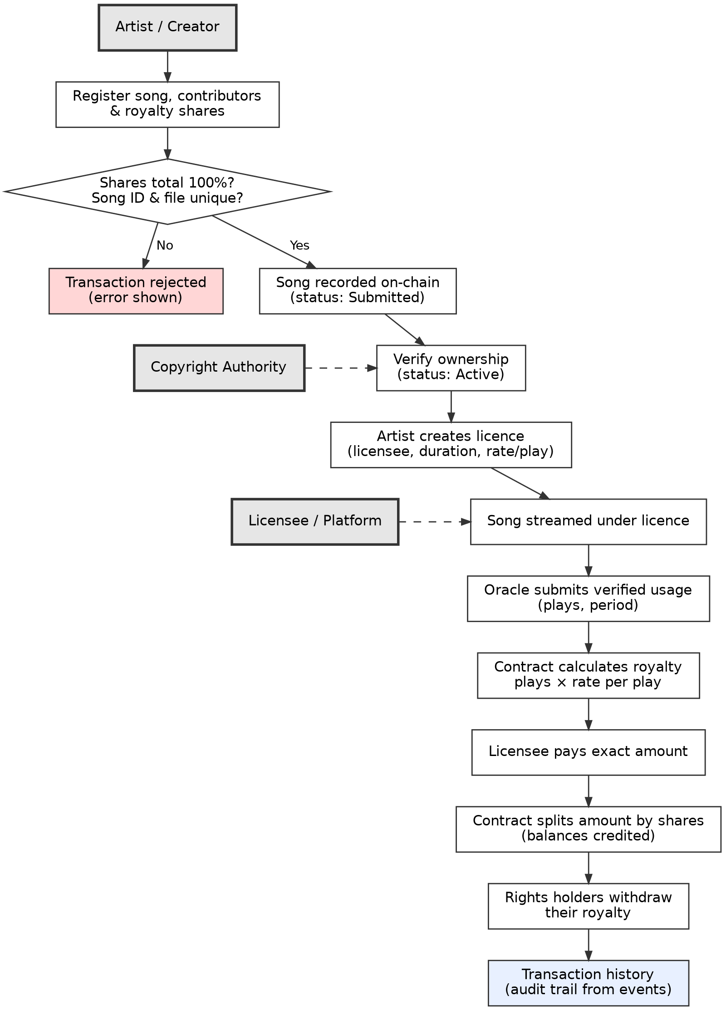
Figure 5.1: Workflow of Blockchain based Music Copyright and Royalty Management System
The stages through which a music work and its royalty process move are shown in Figure 5.2. If validation fails at any stage, the transaction is not accepted as a valid state change and an error message is displayed. A correction, if needed, is made as a new authorised transaction rather than by silently changing the historical record.
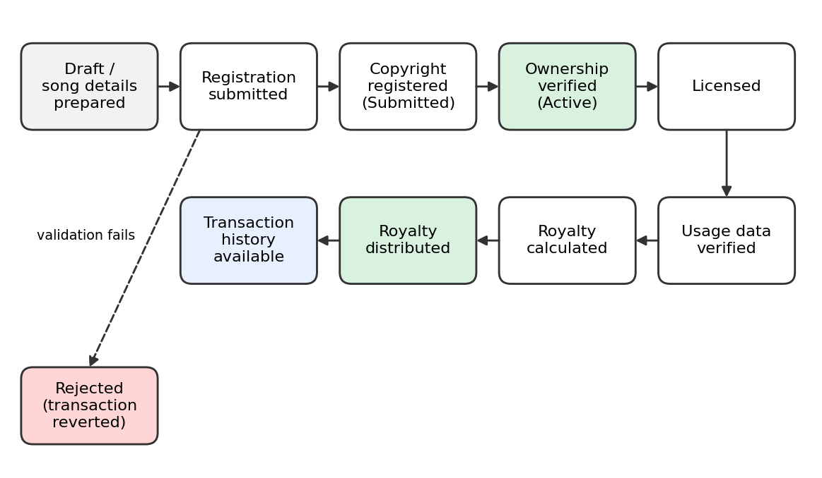
Figure 5.2: State diagram of the music copyright and royalty process

5.7. Security Aspects
Security is addressed at every layer of the system. The following table summarises the main measures.
Security aspect | Application in this project
Authentication | Only registered users can access protected functions; passwords are stored as salted hashes and sessions use signed tokens.
Role-based authorization | Creator, rights holder, licensee, authority and admin have different permissions in both the application and the contract.
Smart-contract access control | Sensitive functions verify the caller's on-chain role or ownership of the song.
Tamper resistance | Confirmed transactions make unauthorised modification of history extremely difficult.
Traceability | Events provide an auditable history of registrations, licences, usage and payments.
Wallet and key security | Users sign in their own wallets; private keys are never sent to the server.
Input validation | Song IDs, percentages, addresses and amounts are checked in the interface, the API and the contract.
Royalty validation | Shares must total exactly 100%; payments must equal the amount due; one usage report is accepted per licence and period.
Secure oracle integration | Usage is accepted only from an Oracle-role wallet, and the backend endpoint requires an API key or an administrator.
Safe payments | Pull-payment withdrawals, balance cleared before transfer, and an administrator pause switch for emergencies.

6. BENEFITS
Blockchain technology improves music rights management by adding transparency, security and automation. The main advantages of the proposed system are described below.

6.1. Tamper-Resistant Ownership Records
Once a song and its ownership shares are confirmed on the blockchain, they cannot be silently altered. Creators and rights holders can rely on a record that is not controlled by a single organisation.

6.2. Prevention of Duplicate and Fraudulent Registrations
Because every song identifier and audio file hash is stored on-chain, the contract rejects repeated registrations of the same identifier or file. This helps prevent the same work from being registered several times.

6.3. Transparent and Fair Royalty Splits
The percentages agreed at registration are stored in the contract and applied automatically, so each contributor receives exactly the agreed share and can see how an amount was divided.

6.4. Automated Royalty Calculation and Distribution
Royalties are calculated by the contract from verified plays and the licence rate and are divided without manual accounting, which reduces errors and the time needed to settle payments.

6.5. Reduced Dependence on Intermediaries
Because rules are enforced by smart contracts, fewer intermediaries are needed to record rights, calculate payments and keep records, which can lower administrative cost.

6.6. Support for Independent Artists
Independent creators can register works, issue licences and receive their share directly, without needing the administrative support of a large label.

6.7. Complete Audit Trail
Registrations, verifications, licences, usage records and payments are all recorded as time-stamped events. This simplifies audits and the resolution of disputes, since the history cannot be rewritten.

6.8. Controlled Licensing
Licences specify duration, permitted use and rate, and the contract refuses usage that falls outside an active licence. Licences can be revoked by authorised parties.

6.9. Efficient Off-chain and On-chain Balance
Large files and descriptive data are kept off-chain, while only hashes and critical records are stored on the blockchain. This keeps transaction costs low while preserving verifiability.

6.10. Increased Trust among Stakeholders
When creators, platforms and authorities all see the same verifiable record, there is less room for disagreement, which builds trust and encourages wider participation.

7. CHALLENGES
Although a blockchain-based music copyright and royalty system offers many advantages, it also has limitations that must be considered.

7.1. Proving Original Authorship
A blockchain preserves a submitted record, but it cannot automatically prove that the person who uploaded a work is its true original creator. Someone could register another person's work, so a verification step by a trusted authority remains necessary.

7.2. The Oracle Problem
The contract depends on external usage data. If the data supplied by the oracle is wrong or manipulated, the royalty results will also be wrong. Oracle sources must therefore be trusted and secured.

7.3. Legal Recognition
A blockchain record does not automatically replace copyright registration or legal procedures, and legal treatment of smart contracts and digital records differs between jurisdictions.

7.4. Scalability
Recording every individual stream as a separate transaction would create a very large transaction volume. This design reports usage per licence and period, and further aggregation or Layer 2 solutions can be considered for large scale.

7.5. Cost and Resources
Transactions on a public blockchain may require fees and network resources. A permissioned or consortium network can reduce these costs but requires the participating organisations to operate infrastructure.

7.6. Privacy
Sensitive copyright, licensing and payment details should not be exposed unnecessarily. Careful decisions are needed about what goes on-chain and who is allowed to read it.

7.7. Smart-Contract Logic
Mistakes in contract code can lead to incorrect calculations or payments, and a deployed contract is difficult to change. Thorough testing and an independent security audit are important before real funds are handled.

7.8. Account and Key Security
If a wallet or its private key is compromised, an attacker can perform authorised actions for that account. Users must protect their keys, and sensitive roles should use stronger protection such as hardware wallets.

7.9. User Awareness and Adoption
Many creators and organisations are not yet familiar with wallets and blockchain concepts. Simple interfaces, training and integration with existing platforms are needed for adoption.
Despite these challenges, blockchain-based royalty management can greatly improve transparency and trust. Careful design, audits, legal review and user education will help overcome the limitations.

8. CONCLUSION
This report presented the use case of a Blockchain-Based Music Copyright and Royalty Management system. It described the weaknesses of traditional rights management, such as fragmented records, opaque usage reporting, delayed payments and the lack of a single audit trail, and showed how blockchain technology addresses them. The report explained the key concepts used, including decentralisation, immutability, smart contracts, consensus and oracles.
The implementation consists of a Solidity smart contract, a Node.js and Express backend with MongoDB, and a React front end connected through MetaMask. Creators can register songs and ownership shares, an authority verifies them, licences are issued, verified usage is supplied through an oracle, and royalties are calculated, distributed and withdrawn according to the stored percentages. Validation rules such as the requirement that shares total 100%, role-based access control and an on-chain event history make the process secure and traceable.

8.1. Future Outlook for Enhancements
The system can be extended in several ways. Audio fingerprinting and artificial intelligence could detect near-duplicate works before registration and identify suspicious usage patterns. Direct integration with streaming platforms would replace manual reporting with automatic, signed usage feeds, and decentralised oracle networks could reduce reliance on a single data source.
Payments could be made in stable-value tokens to avoid price volatility, and Layer 2 networks or batched reporting could reduce fees at large scale. Decentralised identity solutions could strengthen the verification of creators, and zero-knowledge techniques could protect commercially sensitive terms while still proving that payments were made correctly. Tokenising rights as NFTs could allow shares to be transferred or sold, and interoperability with other blockchain networks could support cross-platform verification for international catalogues.
By continuing to improve the system in these directions, blockchain-based music copyright and royalty management can evolve into a secure, efficient and widely adopted solution for creators and the industry.

9. SDG’s ADDRESSED
The Blockchain-Based Music Copyright and Royalty Management system supports several United Nations Sustainable Development Goals [11] by promoting fair income for creators, innovation, reduced inequality and accountable institutions. The key goals addressed are described below.

SDG 8: Decent Work and Economic Growth
Creative work is a source of livelihood for many people. By ensuring that royalties are calculated transparently and divided according to agreed shares, the system helps creators receive fair and timely income, which supports decent work and sustainable growth in the creative economy.

SDG 9: Industry, Innovation and Infrastructure
The project applies blockchain, smart contracts and oracles to modernise the infrastructure of music rights management. Automated, verifiable processes reduce manual reconciliation and encourage innovation in how creative works are registered, licensed and monetised.

SDG 10: Reduced Inequalities
Independent and emerging artists often have less bargaining power and fewer administrative resources than large organisations. A shared, transparent registry with automatic payment rules lowers barriers for them and gives all creators the same verifiable access to their entitlements.

SDG 16: Peace, Justice and Strong Institutions
Tamper-resistant records, clear access rules and a complete audit trail increase transparency and accountability, and they make it easier to settle ownership and payment disputes fairly. This contributes to more trustworthy institutions in the music industry.
By integrating blockchain technology, the system aligns with these goals and fosters a fair, transparent and innovative ecosystem for managing music copyrights and royalties.

10. REFERENCES
[1] S. Nakamoto, “Bitcoin: A Peer-to-Peer Electronic Cash System,” 2008. Available: https://bitcoin.org/bitcoin.pdf
[2] V. Buterin, “Ethereum White Paper: A Next-Generation Smart Contract and Decentralized Application Platform,” 2014. Available: https://ethereum.org/en/whitepaper/
[3] N. Szabo, “Smart Contracts: Building Blocks for Digital Markets,” 1996.
[4] Solidity Documentation. Available: https://docs.soliditylang.org
[5] Hardhat Documentation. Available: https://hardhat.org/docs
[6] ethers.js v6 Documentation. Available: https://docs.ethers.org/v6/
[7] MetaMask Developer Documentation. Available: https://docs.metamask.io
[8] J. Benet, “IPFS - Content Addressed, Versioned, P2P File System,” arXiv:1407.3561, 2014. Available: https://arxiv.org/abs/1407.3561
[9] EIP-225: Clique Proof-of-Authority Consensus Protocol. Available: https://eips.ethereum.org/EIPS/eip-225
[10] MongoDB Documentation. Available: https://www.mongodb.com/docs/
[11] United Nations, “The 17 Sustainable Development Goals.” Available: https://sdgs.un.org/goals

11. APPENDIX A
Project source code (smart contract, backend and frontend):
[PASTE YOUR GOOGLE DRIVE / GITHUB LINK HERE]
[INSERT QR CODE IMAGE OF THE LINK HERE]

The project is organised into the following folders:
Folder / file | Contents
blockchain/contracts/ | MusicCopyrightRoyalty.sol, the Solidity smart contract.
blockchain/test/ | Hardhat test suite for the smart contract.
blockchain/scripts/deploy.js | Deploys the contract, grants demo roles and writes the contract configuration.
backend/src/ | Express REST API: authentication, songs, oracle, blockchain reads, MongoDB models.
frontend/src/ | React application: pages, wallet and authentication context.
shared/deployment.json | Generated contract address and ABI used by the backend and frontend.
README.md | Step-by-step instructions for running the project.

