Forecasting fine-particle pollution in Paris — RNCP Report

Forecasting fine-particle (PM2.5) pollution in central Paris one day ahead
Professional report — RNCP37827 « Développeur en intelligence artificielle » (level 6), block BC01: « Réaliser la collecte, le stockage et la mise à disposition des données d'un projet en intelligence artificielle »
Julie TRING · September 2026
GitHub repository: https://github.com/JujuGnirt/air-quality-paris

1. Use case, goal and objectives
Health stakes. Fine particles (PM2.5, diameter below 2.5 µm) are the air pollutant with the largest health impact: they reach deep into the lungs and the bloodstream and cause cardiovascular and respiratory disease. In France, they are linked to nearly 40,000 deaths a year, 7 % of total mortality [1]; in Île-de-France, 6,220 deaths in 2019 were attributable to long-term PM2.5 exposure [2]. The World Health Organization (WHO) states that health effects occur at any level and in 2021 lowered its daily guideline to 15 µg/m³ [3]. French information and alert thresholds are far less strict, so many moderately polluted days go unnoticed by the public.
Problem statement. Paris has improved over the last decade, yet about one day in five still exceeds the WHO guideline in the city centre. Residents cannot change the air, but they can limit their exposure on bad days if they know in advance. Hence the question: can we forecast, on the evening of day D, whether PM2.5 in central Paris will exceed the WHO guideline on day D+1? A reliable day-ahead signal would let sensitive people (asthmatics, children, elderly people) and local services adapt their activities.
Objectives.
- Collect air-quality, weather and calendar data from five types of sources (web scraping, API, flat files, relational database, big-data system).
- Clean, document and store them in a normalised MySQL database, expose them through a REST API (Flask) and load a denormalised copy into BigQuery.
- Explore the data (EDA) to understand what drives PM2.5.
- Build and evaluate a machine-learning model forecasting D+1 PM2.5 and WHO exceedances, and compare it with a simple baseline.
Scope and specifications.
Item | Content
Actors | Data providers: Airparif, Météo-France, api.gouv.fr, Ministry of Education. Users: sensitive people and local services (future alert); technical teams (analysts, data scientists) consuming the API. Author: collection, storage, API and model.
Functional objectives | Tell the evening before whether PM2.5 will exceed 15 µg/m³ in central Paris; make the cleaned data available to other components through an API.
Technical objectives | Re-runnable collection scripts for 5 source types; cleaned, normalised MySQL database; REST API protected by a key and documented (OpenAPI); denormalised BigQuery table; evaluated ML model.
Environment and tools | Windows laptop, Anaconda (Python 3, Jupyter), MySQL 8 Community + Workbench (local), Google BigQuery (cloud), Git/GitHub, Trello. Python libraries: pandas, requests, BeautifulSoup, pdfplumber, SQLAlchemy, PyMySQL, Flask, scikit-learn, matplotlib (requirements.txt).
External services | Météo-France API (free account, API key, asynchronous orders); public-holiday API (no key); BigQuery (Google Cloud project).
Constraints | No personal data; secrets outside the code; open licences (ODbL, Licence Ouverte); BigQuery free tier; API served locally (127.0.0.1), available when the author runs it.
Budget | 0 € of spending: open data, free API account, BigQuery free tier, free software. Human budget: one person over the project period planned in Trello (section 2).

2. Project planning
The project was planned in a Trello board (columns To Do / In Progress / Done, one card per deliverable, due dates on the critical items) and organised in five phases:
Phase | Content | Deliverables
1. Scoping | Use case, problem statement, choice and check of the data sources | Problem statement, source list
2. Collection & cleaning | Airparif flat files, web scraping of episodes, Météo-France API, holidays; cleaning pipeline | src/ scripts, notebook 01, data dictionary
3. Storage & exposure | MySQL schema + loading, ERD, 5 SQL queries, Flask API, BigQuery | sql/, api_flask.py, BigQuery table
4. Analysis | EDA, feature engineering, models, evaluation | Notebooks 02 and 03, figures
5. Communication | Report, slides, GitHub repository, rehearsal | This report, slides, repository
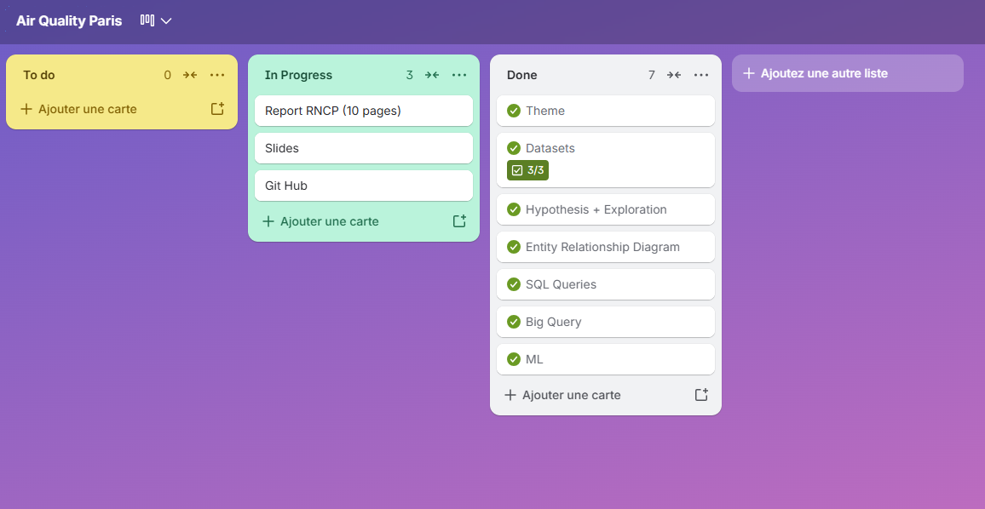
Figure 0 — Trello board of the project.

3. Data sources
Every required source type is used; each one answers a precise need of the model.
Type | Source | Data | Why this source
Flat files (CSV) | Airparif exports (official air-quality monitoring body of the Paris region); Airparif Open Data alrt_idf.csv; school calendar (data.education.gouv.fr) | Hourly PM2.5, NO2, NOx, O3, CO, PM10 at 52 stations, 2018 → 21/09/2026 (9.3 million values); alert procedures 2019-2025; school holidays | The target variable and the explanatory pollutants; only official, accredited measurements are acceptable for health questions
Web scraping | airparif.fr: HTML table of the current year + yearly PDF reports ("Bilan des épisodes") | Official pollution episodes (date, pollutant, level, forecast / observed, forecast quality) | No downloadable file exists; the PDFs also say whether Airparif had forecast each episode — an external reference for our model
API | Météo-France "Données Publiques Climatologie" (with key); calendrier.api.gouv.fr | Daily observed weather at Paris-Montsouris (temperature, wind, rain, pressure, humidity), 3,186 days; public holidays | Weather is the main driver of day-to-day pollution; Météo-France is the official source
Relational database | MySQL 8 (loaded from Python with SQLAlchemy) | Normalised star schema, 6 tables | Integrity (keys, constraints), SQL analysis, back-end of the API
Big-data system | Google BigQuery | Denormalised table, 386,561 rows × 27 columns, partitioned and clustered | Public datasets were checked first: the OpenAQ table stops in May 2022 with only 828 PM2.5 values for Paris, so our own data were loaded
Collection details worth noting. Scraping respects robots.txt, identifies itself with an explicit User-Agent and pauses 2 s between requests. The Airparif PDF tables could not be read with the standard text extraction (characters flagged as vertical text, subscript digits on another line): lines were rebuilt from the position of each character with pdfplumber. The Météo-France API is asynchronous (order → HTTP 202, then poll the file until HTTP 201), one order per year. The API key is stored in secrets/keys.env, excluded from Git.

4. Metadata and data dictionary
Final analysis table dataset_daily.csv (one row per day, 01/01/2018 → 21/09/2026, 3,186 rows, 27 columns). Pollutant values are daily means at the central-Paris urban background station (PA04C until 22/09/2019, then PA01H, 1 km apart).
Column(s) | Type | Unit | Source | Description
date | date | — | — | Day (Europe/Paris time)
pm25 | float | µg/m³ | Airparif CSV | Target: daily mean PM2.5 (valid if ≥ 18 hours out of 24)
no2, nox, o3, pm10 / co | float | µg/m³ / mg/m³ | Airparif CSV | Other pollutants, same station; o3_max = highest hourly ozone
source_station | text | — | derived | Station that measured PM2.5 that day (PA04C / PA01H)
temp_mean_c, temp_min_c, temp_max_c | float | °C | Météo-France API | Mean, minimum, maximum temperature (Météo-France codes TM, TN, TX)
humidity_mean_pct | int | % | Météo-France API | Mean relative humidity (UM)
pressure_mean_hpa | float | hPa | Météo-France API | Mean sea-level pressure (PMERM)
rain_mm | float | mm | Météo-France API | Daily precipitation (RR)
wind_mean_ms, wind_max_ms, wind_dir_deg | float | m/s, ° | Météo-France API | Mean wind (FFM), max 10-min wind (FXY) and its direction (DXY)
day_of_week, month, is_weekend | int | — | derived | Calendar (0 = Monday)
is_public_holiday / is_school_holiday | 0/1 | — | API gouv / CSV | Public holiday / school holiday (zone C, Paris)
episode_pm10, episode_o3, episode_no2 | 0/1 | — | Scraping + Open Data | Official information or alert procedure (or observed exceedance) that day
above_who | 0/1 | — | derived | 1 if pm25 > 15 µg/m³ (WHO 2021 daily guideline)
Full descriptions of every intermediate table (stations, pollutants, hourly and daily measurements, episodes, ring road, 2014-2017 indices) are in the repository README.

5. Data cleaning
Issue found | Decision | Justification
Wide format: 6 header rows, one column per station | Headers read separately (metadata); melt to long format | One row = one measurement, suited to SQL and pandas
Same station code twice in a file (RD934) | Columns identified by position | Avoids mixing a full and an empty column
Timestamps in UTC, marking the end of the hour | −1 h, then conversion to Paris time | Days aligned with Parisian life, daylight saving included
3,113 negative values (0.03 %, minimum −3 µg/m³) | Set to 0 | Device noise in clean air; deleting them would bias means upwards
965 duplicates (first hour of the next year in each file) | Dropped on (hour, station, pollutant) | Unique key of a measurement
Station type not given | Inferred from the name with whole-word regex (traffic / urban background / rural) | Needed to compare traffic and background; "Champigny-sur-Marne" was first misclassified as a road
Incomplete days | Daily mean kept only if ≥ 18 hours measured (7,177 of 393,738 days rejected) | Usual 75 % completeness rule
Station change in 2019 (PA04C → PA01H) | Joined into one "central Paris" series, origin kept in source_station | Same station type, 1 km apart, never measured on the same day; assumption reported
Episodes from 3 sources (PDF, HTML, Open Data) | Merged; priority PDF > HTML > Open Data | Keep the most complete row (forecast + observed)
Missing days | Complete calendar; gaps left as NaN, never imputed | Makes gaps visible; imputing the target would fake the evaluation
The 2014-2017 files are public-information indices per municipality, not concentrations; Airparif advises against using them for trend analysis, so they are stored in a separate context table and never joined to measurements.

6. Relational database (MySQL)
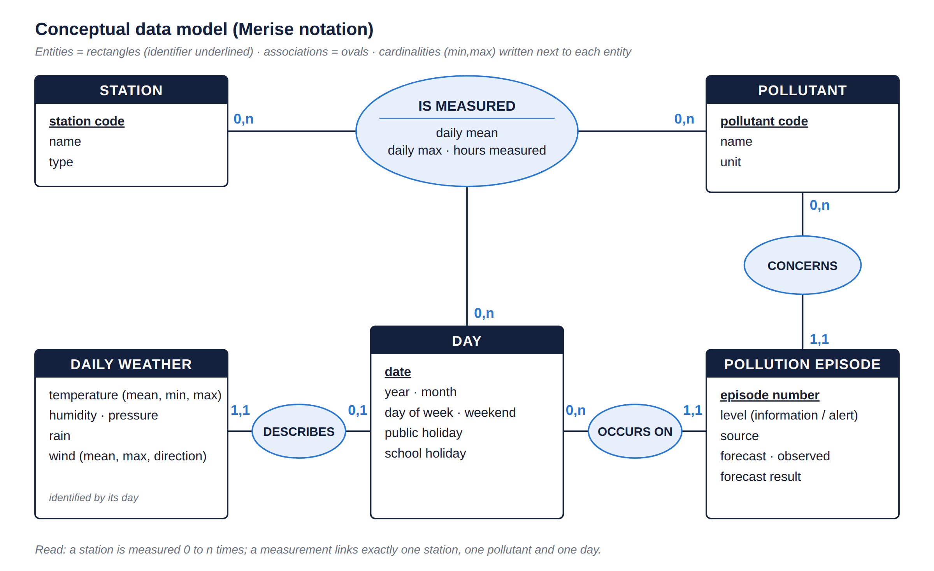
Figure 1a — Conceptual data model (Merise): business entities, associations and cardinalities, no technical types.
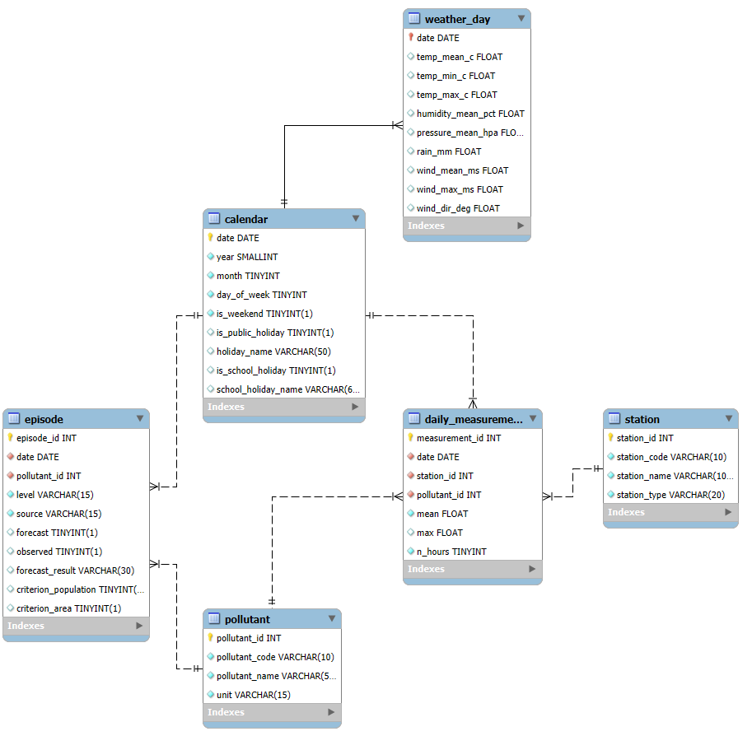
Figure 1b — Physical model (MySQL Workbench, reverse engineering): 6 tables, 6 foreign keys.
From conceptual to physical model. The ternary association IS MEASURED (station × pollutant × day) becomes the fact table daily_measurement, whose foreign keys are the identifiers of the three entities; each 1,1 cardinality becomes a foreign key on that side (episode.pollutant_id, episode.date, weather_day.date); business codes are replaced by numeric surrogate keys created in Python.
Star schema. The fact table daily_measurement (386,561 rows: one daily mean per station × pollutant × day) points to three dimensions — station (52), pollutant (6), calendar (3,186 days) — and two context tables are linked to the calendar: weather_day (1:1) and episode (107 rows, N:1 to calendar and pollutant).
- Normalisation: station names and units stored once; the fact table only holds numeric keys created in Python.
- Why MySQL: the data are tabular and strongly linked (every measurement refers to a station, a pollutant and a day), so a relational database enforces these links with foreign keys and answers the analysis questions with joins; MySQL is free, runs locally and is the system used in the training. A document database (NoSQL) would not check the links, and a warehouse like BigQuery is kept for the big-data copy.
- Integrity: primary and foreign keys, uniqueness on (date, station, pollutant), index on (station, pollutant).
- Loading with pandas + SQLAlchemy (to_sql, if_exists="append" into tables created by schema.sql, so keys are kept); dimensions first, then facts; row counts checked (6/6 OK).
- The 9.3 million hourly values are not stored in MySQL; the big-data copy goes to BigQuery.

Five analysis queries (sql/analysis_queries.sql)
# | Question | SQL techniques | Main result
1 | Is PM2.5 going down? | 4-table joins, GROUP BY | Urban background: 12.8 µg/m³ (2018) → 8.4 (2024); traffic stations always higher
2 | Which months are most at risk? | Conditional aggregation | March 37.5 %, January 34.5 % of days above the WHO guideline; August 5 %
3 | How much NO2 does traffic add? | CTE + CASE pivot | Traffic ≈ 2 × background; the excess fell from 30.8 to ≈ 15 µg/m³
4 | What weather comes with the worst days? | LEFT JOIN, ORDER BY / LIMIT | Top 10 all Dec-Mar, ≤ 0.2 mm rain, pressure > 1,020 hPa, wind < 2.5 m/s for 8 of 10
5 | Do official episodes show in our data? | Window function LAG, CTE | 48 of 49 PM10 episode days above the WHO PM2.5 guideline, incl. all 5 "false alarms"
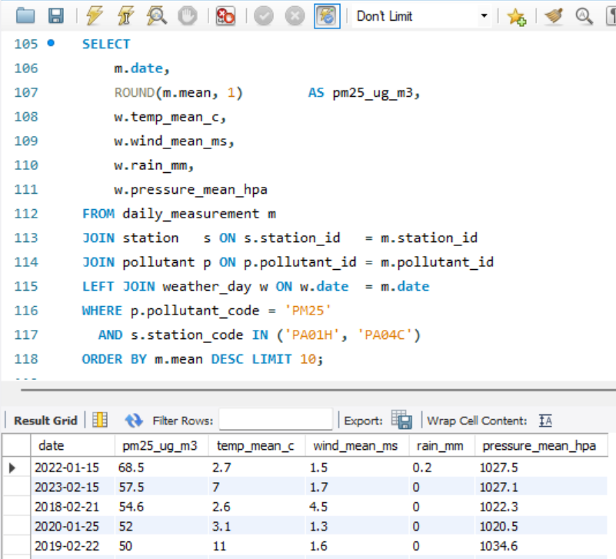
Figure 2 — Query 4 in MySQL Workbench: the ten most polluted days and their weather.

7. REST API (Flask)
The API (src/api_flask.py) reads MySQL and returns JSON. Two resources, four endpoints, each resource having a paginated list with filters and a single-object endpoint with nested details:
Endpoint | Returns | Parameters
GET /stations | Paginated list of stations | type, name, page, per_page
GET /stations/<code> | One station + summary per pollutant (days measured, period, mean, days above WHO) and links | —
GET /measurements | Paginated daily measurements, most recent first | station, pollutant, start, end, min_value, page, per_page
GET /measurements/<id> | One measurement with nested station, pollutant, weather of the day and episodes of the day | —
Design choices: pagination (20 by default, 100 maximum) with total_items, total_pages and next/previous links; filter values passed as SQL parameters (protection against SQL injection); JSON errors (400 invalid parameter, 401 missing or invalid key, 404 not found); an HTML documentation page at / and an OpenAPI 3 specification (docs/openapi.yaml, also served at /openapi.yaml).
Authentication. Every data endpoint requires an API key sent in the HTTP header X-API-Key; the valid key is read from secrets/keys.env (never in the code or on GitHub). Without a valid key the API answers 401; the documentation pages stay public because they contain no data.
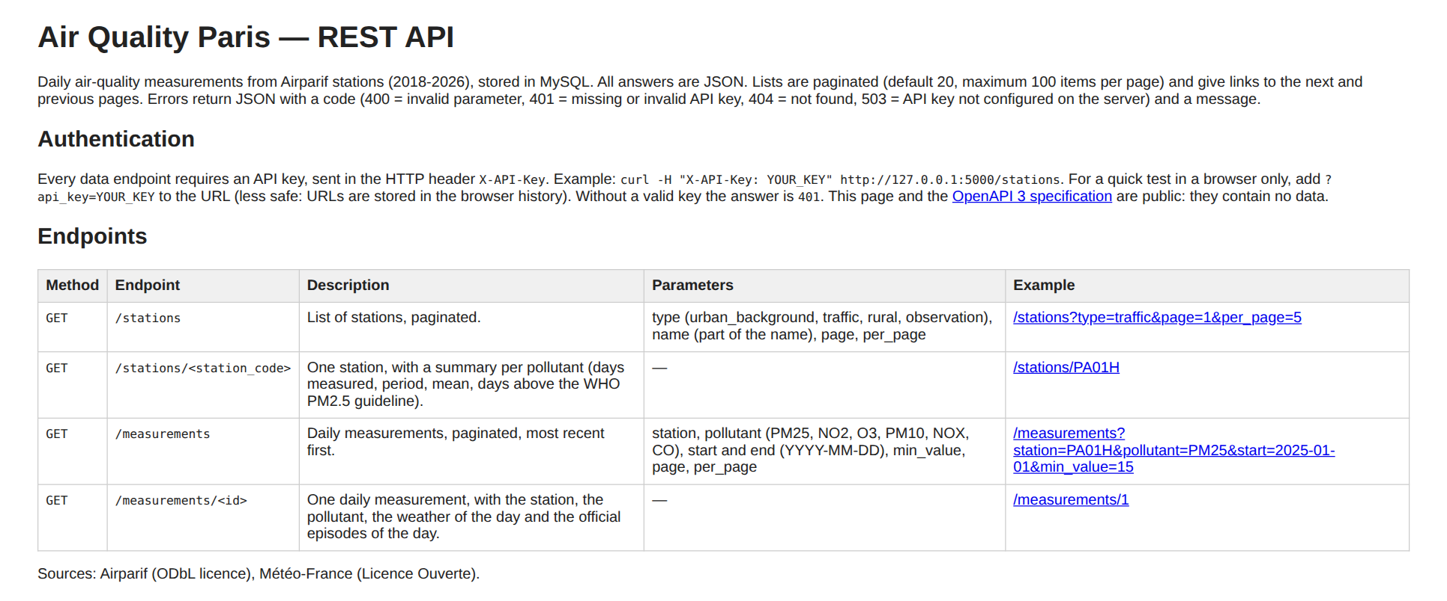
Figure 3 — Documentation page of the API.
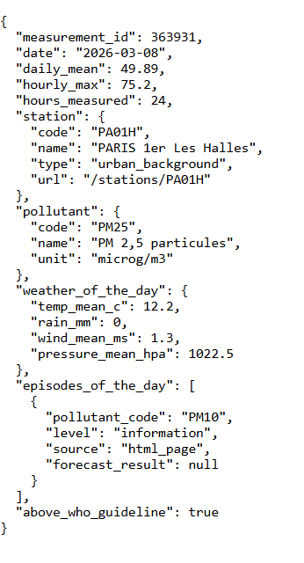
Figure 4 — /measurements/363931: 8 March 2026, 49.9 µg/m³, calm anticyclonic weather and an official PM10 episode.

8. Big-data system (BigQuery)
Public datasets first. The BigQuery public dataset bigquery-public-data.openaq.global_air_quality was queried for Paris: it holds only 828 PM2.5 values, from April 2018 to 26 May 2022, when it stops being updated. It covers neither 2023-2026 nor a daily series per station, so a denormalised version of our database was loaded instead (src/export_bigquery.py).
- Denormalised table air_quality_paris.daily_measurements: one row per station × pollutant × day with station, pollutant, calendar, weather and episode columns (386,561 rows × 27 columns). In a warehouse, storage is cheap and joins on large tables are expensive, so the data are stored "ready to query".
- Partitioning by integer range on year (2018 → 2027, step 1) rather than by date: it matches our queries, which filter by year, and it stays compatible with the free sandbox, which deletes date partitions older than 60 days and would have erased the history.
- Clustering on pollutant_code, station_code, the two most frequent filters.
Check (INFORMATION_SCHEMA.PARTITIONS): 9 partitions, 2018 to 2026, whose row counts add up to exactly 386,561 — no year was lost (2021 is smaller because there is no NO2 file that year).
Measured effect (bytes processed, from the job information of each query):
Query | Filter | Bytes processed | What reduced the scan
Mean of all rows | none | 2.95 MB | — (full scan of the column)
Mean for 2024 | year = 2024 | 0.64 MB | Partition pruning: ÷ 4.6
Monthly PM2.5 at PA01H, 2024 (query 1a) | year + pollutant + station | 1.42 MB | Clustering: the same 1.42 MB whether the year is filtered through the partition column or through date
Same with a date filter (query 1b) | date + pollutant + station | 1.42 MB
NO2 traffic vs background, all years (query 2) | pollutant only | 12.85 MB | —
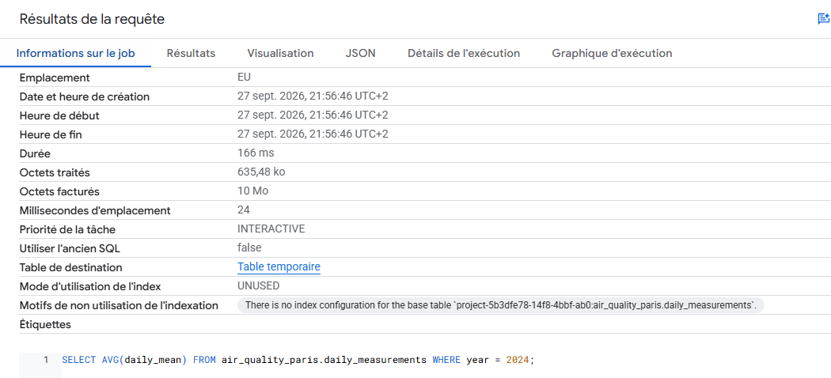
Figure 5 — Query filtered on the partition column: 635 KB processed.
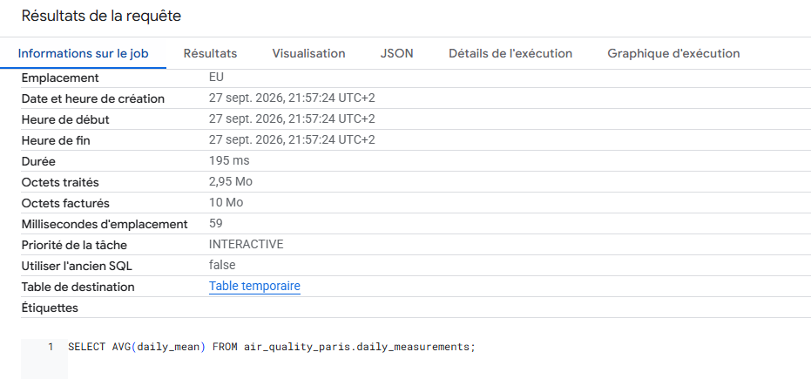
Figure 6 — Same query without filter: 2.95 MB processed.
Reading: when a query filters on station and pollutant, clustering already skips most blocks, so the partition adds nothing; when it filters only on time, the partition does the work. At this volume (58 MB) the cost is negligible either way (BigQuery bills at least 10 MB per query), but the same design scales to the 9.3 million hourly values.

9. Exploratory data analysis
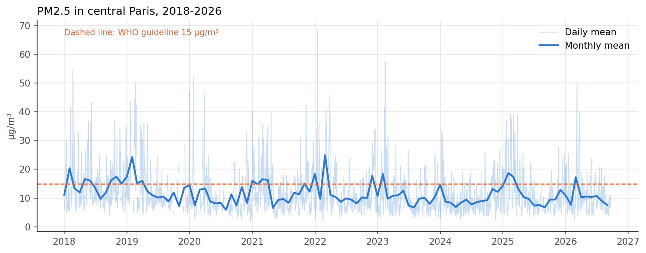
Figure 7 — Daily and monthly PM2.5 in central Paris.
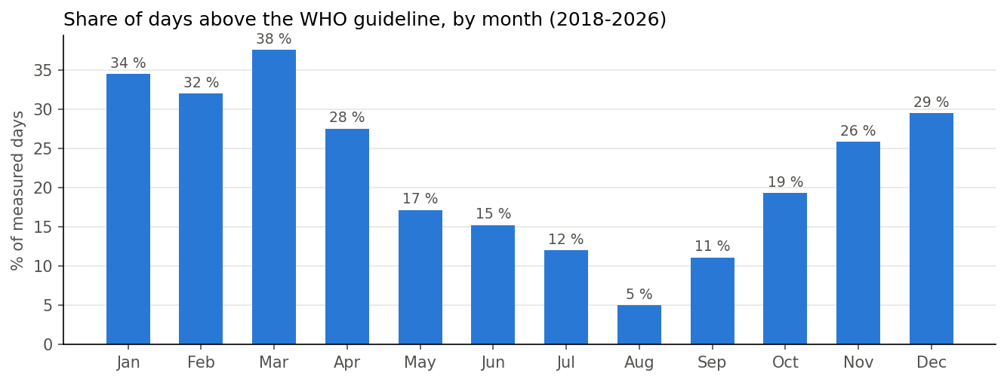
Figure 8 — Share of days above the WHO guideline by month.
- Downward trend: yearly mean 14.5 µg/m³ in 2018 → 9.7 in 2024 (11.6 in 2025), but 14 % to 34 % of days still exceed the WHO guideline: the problem is the peaks.
- Strong seasonality: January-March concentrate exceedances (heating, stable cold air, spring agricultural ammonia forming secondary particles); August only 5 %. Weekday effects are small (≈ 1 µg/m³).
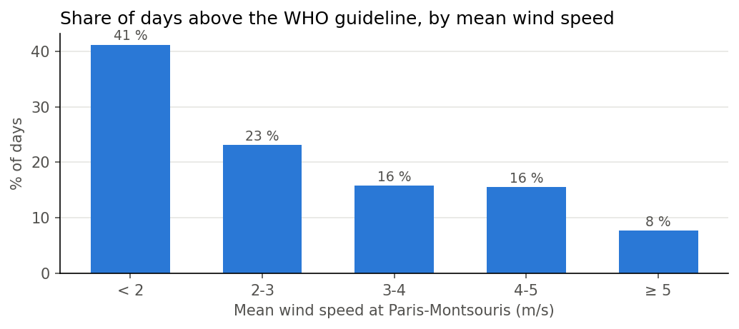
Figure 9 — Exceedances by mean wind speed.
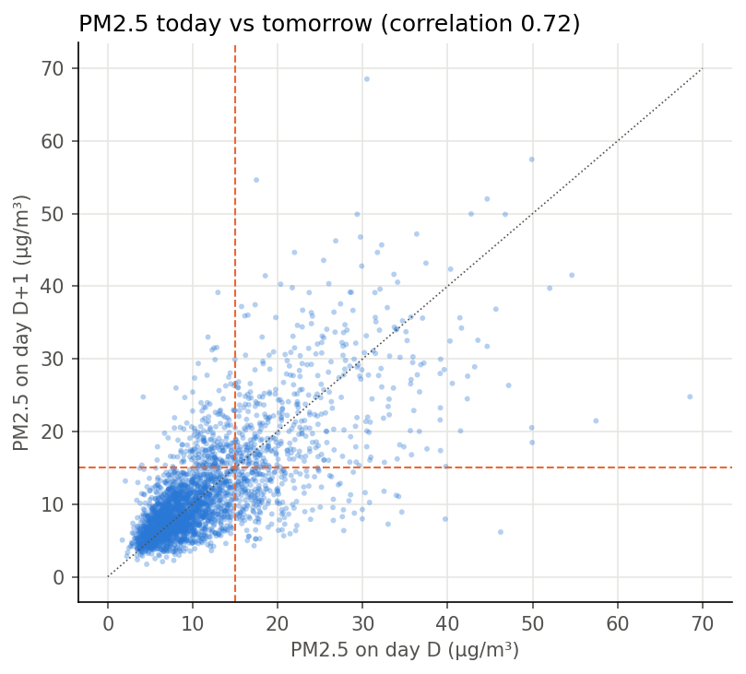
Figure 10 — PM2.5 today vs tomorrow.
- Weather: calm days (< 2 m/s) exceed the guideline in 41 % of cases, windy days (≥ 5 m/s) in 8 %; cold and high pressure also go with pollution (correlations: pressure +0.31, temperature −0.25, wind −0.28 to −0.31). NOx, NO2 and CO rise with PM2.5 (+0.57 to +0.65).
- Persistence: if today exceeds 15 µg/m³, tomorrow does too in 65 % of cases (10 % otherwise) → lagged features and a persistence baseline.
- Validation of the sources: on official PM10 episode days, mean PM2.5 is 35.0 µg/m³ against 11.3 on other days; 98 % of them exceed the WHO guideline.

10. Machine learning: D+1 forecast

Process
- Target: PM2.5 of D+1 (regression); an alert is raised when the forecast exceeds a threshold, evaluated as a classification of WHO exceedances.
- Feature engineering (only information available on the evening of D): PM2.5 of D, D−1, D−2 and 7-day mean; NOx and ozone peak of D; weather of D+1 (temperature, wind speed and direction, rain, pressure, humidity, pressure change); month, day of week and holidays of D+1 — 16 features, 2,531 usable days. PM10, CO and NO2 were excluded (too many gaps) and official episodes too (announced the same day: leakage). Assumption: observed D+1 weather stands in for the weather forecast.
- Time-based split (no random shuffling of a time series): train 2018-2023 (1,701 days), validation 2024 (296), test 2025 (280), demo 2026 (254).
- Models: persistence baseline ("tomorrow = today"), linear regression, Random Forest.
- Hyperparameter tuning: grid on max_depth {None, 8, 12}, min_samples_leaf {1, 5, 10}, max_features {1.0, 0.5}, selected on validation MAE (best: 12 / 5 / 0.5, MAE 2.66). A fixed validation year replaces k-fold cross-validation, whose folds would mix past and future.
- Imbalance (≈ 20 % exceedance days): accuracy is not used; instead MAE/RMSE and recall/precision/F1 on exceedances. Rather than re-sampling, the alert threshold is tuned on 2024: the highest threshold keeping recall ≥ 80 % (a missed exceedance costs more than a false alarm) → 13 µg/m³.

Results on the unseen test year (2025), models retrained on 2018-2024
Model | MAE (µg/m³) | RMSE | R² | Recall | Precision | F1
Persistence (baseline) | 3.88 | 5.66 | 0.41 | 0.67 | 0.67 | 0.67
Linear regression | 3.21 | 4.69 | 0.59 | 0.81 | 0.72 | 0.76
Random Forest, alert at 15 | 2.99 | 4.50 | 0.63 | 0.78 | 0.74 | 0.76
Random Forest, alert at 13 | 2.99 | 4.50 | 0.63 | 0.94 | 0.57 | 0.71
−23 % error vs persistence (MAE 2.99 vs 3.88) | 60 / 64 exceedances announced the day before in 2025 | 46 false alarms in 2025 (216 clean days) | 2.73 MAE on 2026 (persistence 3.34); recall 0.76
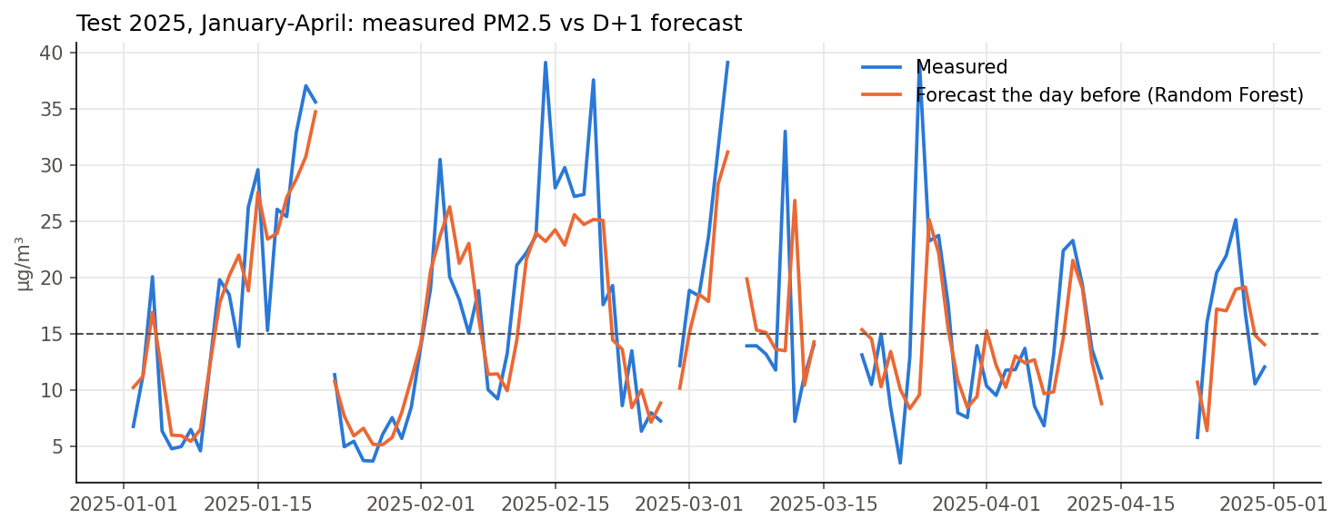
Figure 11 — Test 2025, January-April: measured vs forecast the day before.
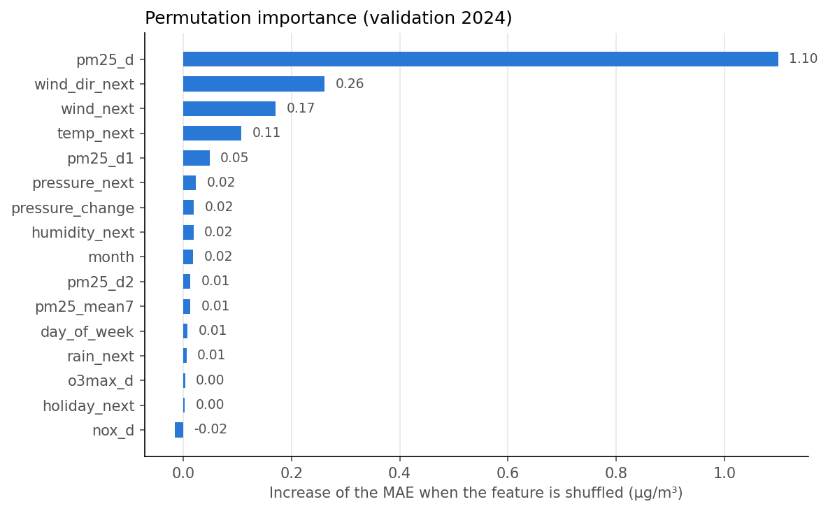
Figure 12 — Permutation importance (validation 2024).
Interpretation. Today's PM2.5 is by far the most important feature, followed by tomorrow's wind (direction first — north-easterly winds bring continental air — then speed) and temperature; NOx adds nothing once PM2.5 is known. The model follows episodes well but smooths the highest peaks and reacts one day late to sudden starts driven by factors it does not see (long-range transport, agricultural spreading). In 2026 recall drops to 0.76: performance varies from one year to the next.

11. Conclusions, limitations and next steps
Conclusions. PM2.5 in Paris is decreasing, but WHO exceedances remain frequent in winter and early spring and are driven by calm, cold, anticyclonic weather and by persistence from one day to the next. A Random Forest using today's pollution and tomorrow's weather forecasts D+1 PM2.5 with a mean error of about 3 µg/m³ and announces nine exceedances out of ten in 2025, clearly beating the persistence baseline.
Limitations. Observed weather used as a stand-in for the forecast (real performance slightly lower); a single urban background station (not valid next to heavy traffic); station change in 2019; peaks under-estimated; about one false alarm per correct alert at the chosen threshold; no NO2 file for 2021; ring-road files probably modelled rather than measured (to be confirmed with Airparif).
Next steps. Use real Météo-France forecasts; add boundary-layer height and regional background stations (imported pollution); try gradient boosting and D+2/D+3 horizons; serve the forecast through a /forecast endpoint of the API; schedule the collection.

12. GDPR, ethics and licences
- No personal data in the database: environmental measurements, weather, calendars and official public episodes only. The register of processing activities and the data-sorting procedures are in docs/rgpd.md: 8 processing activities listed; the only personal data met is the IP address shown in the Flask console (not stored); 6 procedures with their frequency (column check at each schema change and monthly, minimisation at loading, log deletion, secrets check before each push, yearly review).
- Scraping ethics: public pages only, robots.txt respected, identified User-Agent, pauses between requests, raw files kept to avoid re-downloading.
- Security: API access protected by a key (section 7); API keys and database password stored in secrets/keys.env, excluded by .gitignore, never in the code or the repository.
- Licences: Airparif data under ODbL (attribution: "Source: Airparif"); Météo-France, data.gouv.fr and data.education.gouv.fr data under Licence Ouverte / Etalab 2.0.

13. Sources
- [1] Santé publique France (14 April 2021). Pollution de l'air ambiant : nouvelles estimations de son impact sur la santé des Français (period 2016-2019). https://www.santepubliquefrance.fr/presse/pollution-de-lair-ambiant-nouvelles-estimations-de-son-impact-sur-la-sante-des-francais
- [2] ORS Île-de-France & Airparif (10 February 2022). Mortalité attribuable à la pollution atmosphérique en Île-de-France (year 2019). https://www.airparif.fr/actualite/2022/en-respectant-recommandations-de-loms-7-900-deces-pourraient-etre-evites-en-idf
- [3] World Health Organization (22 September 2021). WHO global air quality guidelines: particulate matter (PM2.5 and PM10), ozone, nitrogen dioxide, sulfur dioxide and carbon monoxide. Geneva: WHO.
- Airparif — measurements and Open Data: https://www.airparif.fr/airparif/nos-donnees ; episode history: https://www.airparif.fr/historique-des-episodes-de-pollution ; report "Bilan des épisodes 2025".
- Météo-France — API Données Publiques Climatologie: https://portail-api.meteofrance.fr/web/fr/api/DonneesPubliquesClimatologie
- Public holidays API: https://calendrier.api.gouv.fr · School calendar: https://data.education.gouv.fr
- Google Cloud — BigQuery sandbox documentation: https://cloud.google.com/bigquery/docs/sandbox
- Tools: Python (pandas, numpy, requests, BeautifulSoup, pdfplumber, SQLAlchemy, Flask, scikit-learn, matplotlib), MySQL 8 / Workbench, Google BigQuery, Trello.
AI use statement. Claude (Anthropic) was used throughout the project to generate and debug code, suggest methods and draft the report and presentation. The author executed all collection, loading and modelling steps herself, reviewed the code, and verified the results. Several AI outputs were corrected during this review, for example a wrong episode date, an unverified claim about the OpenAQ dataset, and a false-alarm count. The final choices and their justification are the author's.

