

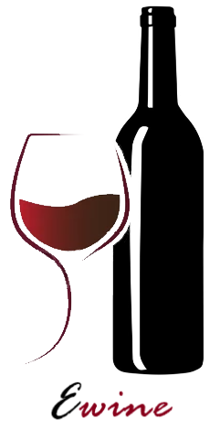



October 3, 2022 - MAY 31, 2023

isen m1 iot

https://github.com/Jules-Calvet/Ewine

Table of Contents

**No table of contents entries found.**