

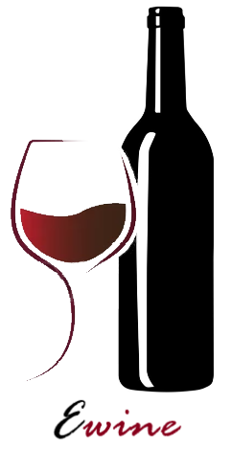



October 3, 2022 - MAY 31, 2023

isen m1 iot

https://github.com/Jules-Calvet/Ewine

Table of Contents

1 Context 2

1.1 Project context 2

1.2 User Characteristics 2

# 1 Context

## Project context

M1 IOT project by students: Calvet Jules and Nicolas Justin

Sometimes people are invited to a dinner and don’t know when their bottles are best for drinking (OR expired) or are just simply buying wine and don’t remember how many or which kind of wine's bottles were left in their wine cellar.

## User Characteristics

Our product is intended for any wine lover to manage their wine cellar.