Gepana Jan Paul V. BSIT 4B

TOPIC #1: REVIEW FOR IOT

REFERENCE VIDEO LINK: <https://www.youtube.com/watch?v=6mBO2vqLv38&ab_channel=Simplilearn>

QUESTION 1:

IN THE FIRST PART OF THE VIDEO, EXPLAIN THE SCENARIO ABOUT SMART AC.

In the first part of the video, if you forgot to turn off the aircon it wil be disaster and can be cost higher.

But with smart aircon/ac , if you forgot to turn off the aircon. Just grab the phone and click turn off  
it will automatically turn off ac using the phone. Whatever you go. And its amazing

QUESTION 2:

BASED ON THE VIDEO, WHAT ARE THE EXAMPLE OF IOT DEVICES IN THE AREA OR FIELD OF SMART HOME. GIVE ATLEAST THREE (3).

Aircon

Door Bell

Thermal Stats

QUESTION 3:

EXPLAIN THE SCENARIO ABOUT THE SMART HOME DEVICE ALARM CLOCK.

The alarm clock represent a trigger / activate , when the alarm clock hits the certain time. Automatically all the task needed in certain time activate. For example it can be open curtain automatically , then it can turn coffee cup heater for you and even water heater for shower.

QUESTION 4:

BASED ON THE VIDEO, GIVE ATLEAST TWO (2) EXAMPLE OF SENSING DEVICES.

Sensor

Humidity

QUESTION 5:

BASED ON THE VIDEO, GIVE ATLEAST TWO (2) EXAMPLE OF CONNECTIVITY.

Wifi

bluetotth

QUESTION 6:

EXAMPLE THE SCENARIO ABOUT SMART FARM OR AGRICULTURE.

Example you are using the water hose manually and spray them but you feel lazy.  
now with the helps of technology sensors and data can be help to water automatically by using sensors . what it does do is to detect the moisture level. When moisture level low automatically send the data to database and send again to your phone to see what status in. when moisture level low. It can automatically turn on the sprinkle by setting time in your phone.

QUESTION 7:

NAME THE FOLLOWING FIELD/AREA OF IOT

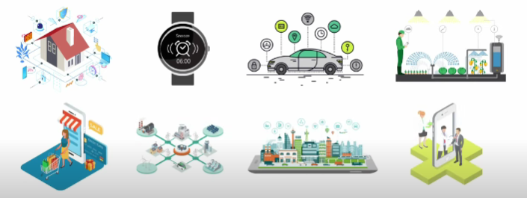

Smarthome

Smart wearables watches and bracelets

Smarts cars

Smart farming

Smart retail

Smart grids

Smart city

Smart health care

QUESTION 8:

HOW MANY CONNECTED DEVICES IN YEAR 2018?

23 billion connected devices

QUESTION 9:

ACCORDING TO EXPERT, HOW MANY CONNECTED DEVICES WILL BE IN THE YEAR 2025?

80 billion devices

QUESTION 10:

“IOT IS A VISION TO CONNECT ALL DEVICES WITH THE POWER OF THE internet”