Gepana Jan Paul V., Allen Consigna, Jules Salvador (BSIT 4B)

TOPIC #1: REVIEW FOR IOT

REFERENCE VIDEO LINK: <https://www.youtube.com/watch?v=6mBO2vqLv38&ab_channel=Simplilearn>

QUESTION 1:

IN THE FIRST PART OF THE VIDEO, EXPLAIN THE SCENARIO ABOUT SMART AC.

Ans: In the first part of the video, if you forgot to turn off the aircon it would be disaster and can cost higher electricity bill. But with smart aircon/ac, if you forgot to turn off the aircon you can just grab your phone and click turn off and it will automatically turn off the ac using your phone whenever and where ever you go. And it’s amazing!!!!!

QUESTION 2:

BASED ON THE VIDEO, WHAT ARE THE EXAMPLE OF IOT DEVICES IN THE AREA OR FIELD OF SMART HOME. GIVE ATLEAST THREE (3).

Aircon

Door Bell

Thermal Stats

QUESTION 3:

EXPLAIN THE SCENARIO ABOUT THE SMART HOME DEVICE ALARM CLOCK.

Ans: The alarm clock represents a trigger / activate, when the alarm clock hits the certain time. Automatically all the task needed in certain time activate. For example, it can be open curtain automatically, turn coffee cup heater, and even the water heater for shower.

QUESTION 4:

BASED ON THE VIDEO, GIVE ATLEAST TWO (2) EXAMPLE OF SENSING DEVICES.

Sensor

Humidity

QUESTION 5:

BASED ON THE VIDEO, GIVE ATLEAST TWO (2) EXAMPLE OF CONNECTIVITY.

Wi-Fi

Bluetooth

QUESTION 6:

EXAMPLE THE SCENARIO ABOUT SMART FARM OR AGRICULTURE.

Ans: Example you are using the water hose manually and use them for spraying the plant then suddenly you are feeling lazy. Now with the help of technology sensors and data can be help to water automatically by using sensors. what it does is to detect the moisture level. When moisture level low automatically send the data to database and send again to your phone to see what status are. when moisture level is low it can automatically turn on the sprinkle by setting time in your phone.

QUESTION 7:

NAME THE FOLLOWING FIELD/AREA OF IOT

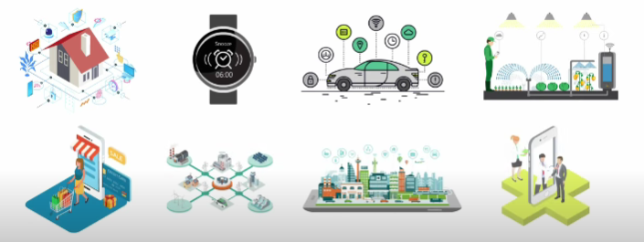

Smart home Smart wearables watches and bracelets

Smarts cars Smart farming

Smart retail Smart grids

Smart city Smart health care

QUESTION 8:

HOW MANY CONNECTED DEVICES IN YEAR 2018?

Ans: 23 billion connected devices

QUESTION 9:

ACCORDING TO EXPERT, HOW MANY CONNECTED DEVICES WILL BE IN THE YEAR 2025?

Ans: 80 billion devices

QUESTION 10:

“IOT IS A VISION TO CONNECT ALL DEVICES WITH THE POWER OF THE INTERNET”