Affordability of Houses in the Netherlands
  - Tutorial 6: Group 7
Melvin Hofman
Gijs Stevens
Hidde Voors - 2729826
Max Bergsma
Imad el Hilali
Jules Bierings
2026-06-21
Tutorial Group 6 Assignment Group 7 Tutorial lecturer: C. Schouwenaar

Set-up your environment

Title Page
Include the tutorial group number
Include your tutorial lecturer’s name

Part 1 - Identify a Social Problem
Use APA referencing throughout your document. Here’s a link to some explanation.

1.1 Describe the Social Problem
Housing affordability has become an increasingly important social issue in the Netherlands over the past decade. House prices have risen substantially in many parts of the country, while income growth have not kept pace. As a result, many households, particularly first-time buyers and younger generations, face greater difficulties entering the housing market, according to DNB (DNB, 2026). In addition, CBS states that housing costs in the Netherlands are higher than most EU countries (CBS, 2024).
Understanding whether house prices have increased faster than incomes is therefore important for evaluating changes in housing affordability. If housing prices grow more rapidly than household incomes, purchasing a home becomes increasingly difficult for a large share of the population. This may have significant social and economic consequences, including increased inequality between homeowners and non-homeowners.
The main research question of this study is:
Have housing prices in the Netherlands increased faster than incomes over the past ten years?
To answer this question, the following sub-questions are examined: 1. How have house prices and average incomes developed between 2014 and 2024? 2. How has housing affordability changed during this period? 3. Are there significant differences in housing affordability between Dutch provinces? 4. Is there a visible change in the affordability trend around the introduction of the 2024 rent regulation?

Part 2 - Data Sourcing

2.1 Load in the data
Preferably from a URL, but if not, make sure to download the data and store it in a shared location that you can load the data in from. Do not store the data in a folder you include in the Github repository!

2.2 Provide a short summary of the dataset(s)
The primairy data for this study is sourced from Statistics Netherlands (CBS). The original comprehensive dataset consists of 24,335 observations (rows) and 326 variabeles (columns), capturing key socio-economic indicators such as disposable income per employee and WOZ property values for different years and provinces.
Given the extensive nature of the data, the single source was programmatically divided into two distinct subsets within R to isolate the specific variabeles required for analysis. The first subset captures detailed data on income per region, while the second focuses on regional WOZ values over time. To reconstruct the data for analysis, these two refined datsets were subsequently merged back together using relational filtering. This process ensures data usability while retaining critical demographic data to evaluate differences across various sub-populations and regions.
Year | RegioS | RegioS_label | GemiddeldeWOZWaardeVanWoningen_98
2023 | PV20 | Groningen (PV) | 268
2023 | PV21 | Fryslân (PV) | 277
2023 | PV22 | Drenthe (PV) | 294
2023 | PV23 | Overijssel (PV) | 325
2023 | PV24 | Flevoland (PV) | 347
2023 | PV25 | Gelderland (PV) | 364
2023 | PV26 | Utrecht (PV) | 447
2023 | PV27 | Noord-Holland (PV) | 460
2023 | PV28 | Zuid-Holland (PV) | 359
2023 | PV29 | Zeeland (PV) | 281
2023 | PV30 | Noord-Brabant (PV) | 370
2023 | PV31 | Limburg (PV) | 288

Year | RegioS | RegioS_label | BronInkomenAlsWerknemer_141
2023 | PV20 | Groningen (PV) | 37.5
2023 | PV21 | Fryslân (PV) | 37.9
2023 | PV22 | Drenthe (PV) | 39.7
2023 | PV23 | Overijssel (PV) | 39.5
2023 | PV24 | Flevoland (PV) | 40.4
2023 | PV25 | Gelderland (PV) | 40.6
2023 | PV26 | Utrecht (PV) | 44.4
2023 | PV27 | Noord-Holland (PV) | 44.7
2023 | PV28 | Zuid-Holland (PV) | 42.4
2023 | PV29 | Zeeland (PV) | 40.3
2023 | PV30 | Noord-Brabant (PV) | 41.8
2023 | PV31 | Limburg (PV) | 39.9

Year | RegioS | RegioS_label | GemiddeldeWOZ | InkomenWerknemer | statcode
2023 | PV20 | Groningen (PV) | 268 | 37.5 | PV20
2023 | PV21 | Fryslân (PV) | 277 | 37.9 | PV21
2023 | PV22 | Drenthe (PV) | 294 | 39.7 | PV22
2023 | PV23 | Overijssel (PV) | 325 | 39.5 | PV23
2023 | PV24 | Flevoland (PV) | 347 | 40.4 | PV24
2023 | PV25 | Gelderland (PV) | 364 | 40.6 | PV25
2023 | PV26 | Utrecht (PV) | 447 | 44.4 | PV26
2023 | PV27 | Noord-Holland (PV) | 460 | 44.7 | PV27
2023 | PV28 | Zuid-Holland (PV) | 359 | 42.4 | PV28
2023 | PV29 | Zeeland (PV) | 281 | 40.3 | PV29
2023 | PV30 | Noord-Brabant (PV) | 370 | 41.8 | PV30
2023 | PV31 | Limburg (PV) | 288 | 39.9 | PV31

Descriptive statistics for home value in provinces in the Netherlands, 2023
Year | RegioS_label | InkomenWerknemer | GemiddeldeWOZ
2015 | Nederland | 30.3 | 206
2016 | Nederland | 31.4 | 208
2017 | Nederland | 32.0 | 217
2018 | Nederland | 32.3 | 230
2019 | Nederland | 33.7 | 250
2020 | Nederland | 35.3 | 271
2021 | Nederland | 37.1 | 290
2022 | Nederland | 39.0 | 317
2023 | Nederland | 41.8 | 368
2024 | Nederland | 44.7 | 378

Variable | Mean | Min | Max | SD
Average WOZ Value | 340.00 | 268.0 | 460.0 | 64.25
Employee Income | 40.76 | 37.5 | 44.7 | 2.24

2.3 Describe the type of variables included
The variabeles included in this study predominantly capture Socio-Economic Status (SES) and housing market characteristics. The key indicators can be broken down into three main categories: 1. SES metrics: Disposable income per employee serves as our primary continuous of household financial capacity. 2. Market metrics: The WOZ property value represents the offical appraised market valuation of residental real estate over time. 3. Demographic metrics: The use of regions and urbanization levels allow for granular sub-group analysis.
Rather than being collected through self-supported individual interviews or surveys, this dataset consist entirely of administrative data collected by Statistics Netherland (CBS). The income and demographic data originate directly from national municipal registries (BRP) and tax authority records, while the housing data is compiled from the national valuation registry (Landelijke Voorziening WOZ).Because this data relies on offical administrative registration rather than sample surveys, it minimizes self-reporting bias and provides comprehensive coverage of the target populations.

Part 3 - Quantifying

3.1 Data cleaning
To prepare our data for quantitative analysis, we executed several structured cleaning steps. First, provincial location data was originally recorded in numerical codes. We mapped and translated these administrative codes into their respective official Dutch province names. Second, we systematically handled missing values ($NAs$). To safeguard the statistical integrity of our analysis, we selected a time period that is relevant and without any missing values ($NAs$) at other variables.

3.2 Generate necessary variables
The affordability ratio divides the average WOZ value of homes by average employee income. Because both variables are measured in thousands of euros, the ratio can be interpreted as how many times the income of a worker corresponds to their house value, on average. A higher ratio indicates lower affordability.
Year | RegioS | RegioS_label | GemiddeldeWOZ | InkomenWerknemer | statcode | AffordabilityRatio
2023 | PV20 | Groningen (PV) | 268 | 37.5 | PV20 | 7.146667
2023 | PV21 | Fryslân (PV) | 277 | 37.9 | PV21 | 7.308707
2023 | PV22 | Drenthe (PV) | 294 | 39.7 | PV22 | 7.405542
2023 | PV23 | Overijssel (PV) | 325 | 39.5 | PV23 | 8.227848
2023 | PV24 | Flevoland (PV) | 347 | 40.4 | PV24 | 8.589109
2023 | PV25 | Gelderland (PV) | 364 | 40.6 | PV25 | 8.965517
2023 | PV26 | Utrecht (PV) | 447 | 44.4 | PV26 | 10.067568
2023 | PV27 | Noord-Holland (PV) | 460 | 44.7 | PV27 | 10.290828
2023 | PV28 | Zuid-Holland (PV) | 359 | 42.4 | PV28 | 8.466981
2023 | PV29 | Zeeland (PV) | 281 | 40.3 | PV29 | 6.972705
2023 | PV30 | Noord-Brabant (PV) | 370 | 41.8 | PV30 | 8.851675
2023 | PV31 | Limburg (PV) | 288 | 39.9 | PV31 | 7.218045

Year | RegioS_label | InkomenWerknemer | GemiddeldeWOZ | AffordabilityRatio | WOZ_growth_yoy | Income_growth_yoy | GrowthGap_yoy
2015 | Nederland | 30.3 | 206 | 6.798680 | NA | NA | NA
2016 | Nederland | 31.4 | 208 | 6.624204 | 0.9708738 | 3.630363 | -2.659489
2017 | Nederland | 32.0 | 217 | 6.781250 | 4.3269231 | 1.910828 | 2.416095
2018 | Nederland | 32.3 | 230 | 7.120743 | 5.9907834 | 0.937500 | 5.053283
2019 | Nederland | 33.7 | 250 | 7.418398 | 8.6956522 | 4.334365 | 4.361287
2020 | Nederland | 35.3 | 271 | 7.677054 | 8.4000000 | 4.747775 | 3.652226
2021 | Nederland | 37.1 | 290 | 7.816712 | 7.0110701 | 5.099150 | 1.911920
2022 | Nederland | 39.0 | 317 | 8.128205 | 9.3103448 | 5.121294 | 4.189051
2023 | Nederland | 41.8 | 368 | 8.803828 | 16.0883281 | 7.179487 | 8.908841
2024 | Nederland | 44.7 | 378 | 8.456376 | 2.7173913 | 6.937799 | -4.220408

3.3 Visualize temporal variation
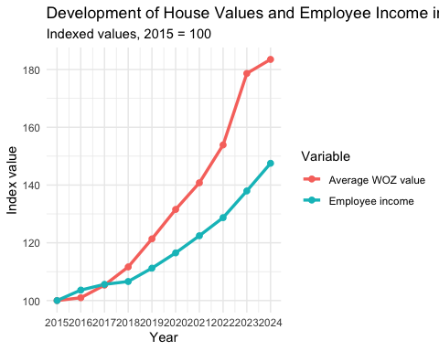

3.4 Visualize spatial variation
The map visualizes how housing affordability differs across Dutch provinces in 2023. The WOZ-to-income ratio is highest in Noord-Holland and Utrecht, meaning that average house values are high relative to employee income in these provinces. Provinces such as Zeeland, Groningen and Limburg show lower ratios, suggesting relatively better affordability. This spatial pattern is relevant because the housing affordability problem is not evenly distributed across the Netherlands. However, the province-level this map does not show the differences inside provinces which could vary a lot. For example, inside cities the affordability is likely different than outside cities.
## Reading layer `provincie_2023' from data source
## `https://cartomap.github.io/nl/rd/provincie_2023.geojson' using driver `GeoJSON'
## Simple feature collection with 12 features and 6 fields
## Geometry type: MULTIPOLYGON
## Dimension: XY
## Bounding box: xmin: 13565 ymin: 306960 xmax: 277529 ymax: 619172
## Projected CRS: Amersfoort / RD New
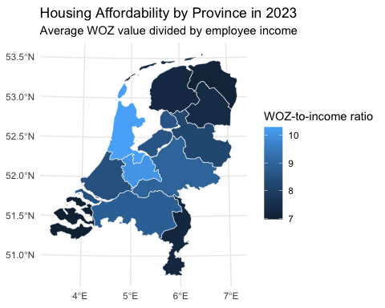 ## 3.5 Visualize sub-population variation

What is the poverty rate by state?
The boxplot compares housing affordability across municipalities grouped by the level of urbanization. This is relevant because housing pressure is often expected to be stronger in more urbanized areas, where demand for housing is higher and land is more scarce. The plot shows that affordability ratios differ across urbanization groups, but also that there is substantial variation within each group. This suggests that urbanization matters, but it does not fully explain differences in affordability.
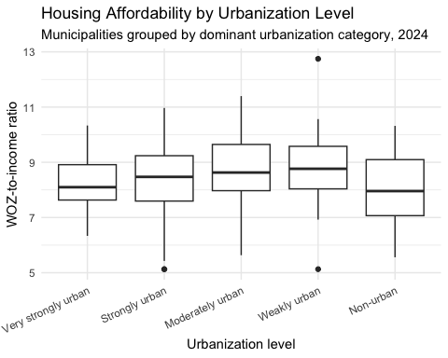

3.6 Event analysis
Interest rates are included as an external event because mortgage financing costs affect housing demand and house prices. Harris (1989) argues that housing prices are influenced by the real cost of mortgage financing, where nominal mortgage rates interact with expectations of future house-price appreciation. This supports using the 2022 increase in mortgage interest rates as a relevant event for analyzing changes in the WOZ-to-income affordability index. In this assignment, 2022 is treated as the turning point because mortgage interest rates started increasing after a period of decreasing rates (De Nederlandsche Bank, 2026). If higher interest rates reduce borrowing capacity and cool housing demand, we would expect WOZ growth to slow relative to income growth after this point. This pattern is visible in the affordability index: affordability worsened until 2023, but improved slightly in 2024 as income growth exceeded WOZ growth.
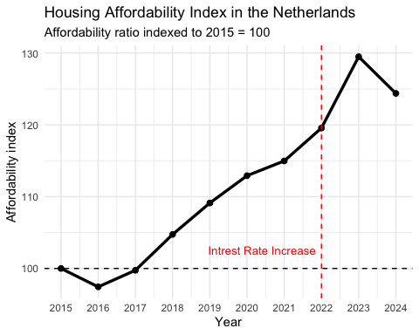 The effect of higher interest rates is not expected to appear immediately in the affordability index. Housing markets adjust with a delay because buyers and sellers need time to change their behavior. Therefore, the affordability index can still increase after the interest-rate turning point in 2022. This helps explain why affordability continues to deteriorate until 2023, before improving slightly in 2024.

Part 4 - Discussion

4.1 Discuss your findings

Affordability ratio

Growth gap

Temporal variation
If we look at the temporal variation, which is constructed by indexing the average WOZ value and disposable income per employee using 2015 as a starting point, we see an alignment initially. However, after 2017 there starts to emerge a growth divergence, which spikes until 2023. Although a period of consolidation will follow, the growth gap is unlikely to close.

Spatial variation

Sub-population variation

Event

Part 5 - Reproducibility

5.1 Github repository link
https://github.com/JulesBierings/PFE-group6-7-paper-2026

5.2 Reference list
De Nederlandsche Bank. (2026). Woningmarkt. https://www.dnb.nl/actuele-economische-vraagstukken/woningmarkt/
De Nederlandsche Bank. (2026). Interest rates | Dashboard. Retrieved June 21, 2026, from https://www.dnb.nl/en/statistics/dashboards/interest-rates/
Harris, J. C. (1989). The effect of real rates of interest on housing prices. Journal of Real Estate Finance and Economics, 2, 47–60.
Centraal Bureau voor de Statistiek. (2024, 14 mei). Housing costs in the Netherlands higher than in most EU countries. https://www.cbs.nl/en-gb/news/2024/20/housing-costs-in-the-netherlands-higher-than-in-most-eu-countries
Use APA referencing throughout your document.

