**ChessHub**

*Business Requirements Document   
for Business and IT Project*

Version: 1.0

Date: yyyy-mm-dd

Author, email

Author, email

Author, email  
  
Editorial note: please fill project name, version of document, date, authors and emails

Document template:

* Version Digital Strategy
* Version 3.1c
* 2018-07-18
* Alain Wegmann

Contents

Management Summary 3

1.1. Project Goal 3

2. Situation As-is 4

2.1. Business External (as-is) 4

2.1.1. External actors and IT service for each actor 4

2.2. Business Internal (as-is) 4

2.2.1. Security, legal & compliance issues 5

2.2.2. Sizing 5

2.2.3. Historical information, past projects 5

3. As-is Analysis and To-be Selection 6

3.1. To-be solution Alternative 1 6

3.1.1. Business external and relevant IT services 6

3.1.2. IT internal and relevant IT services 6

3.2. To-be solution Alternative 2 6

3.2.1. Business external and relevant IT services 6

3.2.2. Business internal and relevant IT services 6

3.3. Solution Selection 7

3.3.1. ROI Justification 7

3.3.2. Risk-based Justification 7

4. To-be Detailed Description 8

4.1. Business External (to-be) 8

4.1.1. External actors and IT service for each actor 8

4.1.2. Competitors 8

4.1.3. Excluded from project 8

4.2. Business Internal (to-be) 8

4.2.1. Internal actors and IT service for each actor 8

4.2.2. Security, legal & compliance solutions 8

4.2.3. Sizing 8

4.2.4. Excluded from project 8

4.3. Information Model (to-be) 8

4.4. IT Internal 8

4.4.1. Application 8

4.4.2. Technical and infrastructure services 8

4.5. Project Description 10

4.6. Service Operation Description 10

5. To-be Long-Term Evolution 11

6. Annex I – Abbreviations & References 12

7. Annex II – Customer Meetings, Joint Sessions 13

8. Annex V - Template Versioning 14

Management Summary

Editorial note: this section summarizes the project for the management. It should be self-contained. Note that the current BRD does not include planned cost and schedule in its current form. Most projects would have to include such information.

For readability, the subsection can be removed as long as the contents remains.

## Project Goal

It has been observed in the environment of chess tournaments that there are some usability or efficiency pitfalls caused in general by a lack of a good digitalization of a previously existing manual mechanism. This project aims to correct a part of these pitfalls to provide a saner environment and reduce time consumption for tournament organizers, players, and federation officials.

# Situation As-is

To describe the situation, we will use the world of chess software, federations, clubs, and players as the external component, since all four members of this list are distinct actors in the scope of the solution. The project will inject itself in an existing environment, where no other solution exists currently.

## Business External (as-is)

### External actors and IT service for each actor

Because of recent events (October 2018), an important external actor has been revealed in the form of banks and international politics. Because of allegations against the previous president of the World Chess Federation (FIDE), all the federation’s accounts at UBS have been closed. This is a drawback, requiring much attention from the new president and committee to keep the federation running while administrative and financial solutions are being fond. This situation influences the possibility of cooperating directly with the FIDE and might reduce it’s potential as a sponsor to the project.

The FIDE also provides a service to retrieve a list of all official players, as well as some information like their ELO and unique identification number. This is done through a simple HTML webpage. Tournament results can be sent to the federation by email for manual input into their database. The Federation also endorses tournament organizing software according to precise requirements and guidelines.

Clubs use tournament software to create, organize, and run tournaments. There are currently 6 endorsed programs with relatively small differences, which all fill their roles correctly. The most notable, for the scope of this project, are Swiss-Manager (SM) and Vega. Such programs are developed and sold independently from any other system, by the developer to clubs. They all run locally, with some distributed solutions for pairing (SM) or entering results (Vega).

Clubs also receive tournament registrations using an external method (ex: Google Forms, simple email registration, dedicated website…) for manual input into organizer programs.

Organizer programs also output a tournament’s result file which clubs must send by email to the FIDE upon completion.

National federations (like the FSE in Switzerland) provide services to retrieve the list of players. Such a list can be used in the programs to lighten the load of manual input and simply retrieve player info using a search query of the license number or name.

## Business Internal (as-is)

The injection of our solution is at the crossroads between Federations, clubs and players, offering a centralized tournament registration system.

In the current state of being, Federations provide their list of players independently. Organizers must design and provide their own system to receive tournament registrations, which players must be aware of and follow to successfully register.

Finally, organizer software provides the link between Federation and organizers, through the local importation of a list and manual comparison.

### Security, legal & compliance issues

In the current state of things, there are no official ways to distinguish a real subscription from a malicious one, except by two checks from the tournament organizer (first, the player does belong to the federation he claims to belong to, then the player truly is who he claims to be). This is a massive security pitfall. In practice, the second check is almost never made, which opens the door for falsification of player results.

### Sizing

On average, using only Swiss-Manager’s database as a source of information, there is between one and three tournaments per day in the world with over 20 people.

### Historical information, past projects

According to Luigi Forlano, developer of Vega, this project has been an idea of his (but at a national scale, within the Italian Chess Federation) for multiple years but never went into development.

# As-is Analysis and To-be Selection

## To-be solution Alternative 1

The first solution alternative describes a situation where the FIDE does not wish to partake in the development of the solution.

An API will be developed which would allow users to authenticate themselves, organizers to create tournaments, and players to subscribe to tournaments from any platform in contact with the API. The creation of such a platform (as a Web-app), would be part of the solution, and would also come with extra features like online registration payment.

### Business external and relevant IT services

Organizer programs would need to create a link to the newly created API. This should allow them to directly import entire tournaments, and completely diminish the load of this operation when opposed to the current state. After discussion with Luigi Forlano, developer of Vega, this seems to be a feasible implementation and extension to organizer programs.

### IT internal and relevant IT services

A new API will be created, running permanently and independently from any other service, program, or federation.

The API should automatically pull new data from the different Federations’ services.

Player authentication will not be guaranteed because of the lack of cooperation from the FIDE. Instead, organizers will have an authentication system to create, manage and import tournaments.

## To-be solution Alternative 2

This solution is akin to the first alternative, except a collaboration has been struck with the FIDE.

### Business external and relevant IT services

This collaboration would take shape in the creation of a full-size authentication system: players would now get accounts upon their registration to the FIDE. This would necessitate a password recovery system, password delivery system, potentially modifications to the way registrations are currently validated and digitalized. This system could be developed either by the FIDE, or by an independent developer, but would probably necessitate a dedicated employee at the Federation.

### Business internal and relevant IT services

With complete collaboration from both the FIDE and organizer programs, most of the internal project would be designing the API and plugging it into the service offered by the FIDE. The creation of a user interface would still partake in the process of an efficient environment

## Solution Selection

The first solution was selected. Although being a harder technical challenge to overcome, this selection mainly came to be because of the difficulty of striking a good agreement with the FIDE. Apart from obvious communication barriers (language, distance, experience…) there were also, as explained before, strong events which the FIDE had to handle with higher priority than the described extension of their information system.

### ROI Justification

The development of the first solution, without any limitations on the implementation, will have an estimated development time of at most 100 man-hours. Such a workload can be delegated as a semester project for a student, reducing development costs to nearly nothing.

The largest part of the investment will come from the rent of the cloud services.

Three business models could potentially be implemented:

* Pay-per-use: every time an organizer wishes to create a tournament, he has to pay a certain amount depending on the maximal number of participants. Although this would be the most flexible and with the most benefits, we would risk losing clients of certain types: small clubs who organize many small tournaments would find it too expensive, or large organizations who organize massive tournaments every year for long durations.
* Subscription: this is the less likely to work, although it could potentially interest the clients described above, subscriptions for online services tend to discourage clients for the fear of losing their investment.
* License: at the opposite of the subscription, a timeless, one-time-payment solution could be the good halfway point between profit per client and overall number of clients.

What we are thinking of truly developing would be offering a choice to the organizers between pay-per-use and timeless license.

# To-be Detailed Description

## Business External (to-be)

### External actors and IT service for each actor

* FIDE / National Federations: The Federations will hold all player data. With no partnership or affiliations with any federation, these actors will have no direct influence on the project. Their webservices are usually public, accessible through http, and allow the retrieval of rankings, names, and identification numbers. The greatest interaction will be having to update the software if the webservices are modified, since there is currently no regulation, feed of updates, or standard for the services.
* Vega: We have struck a deal with Vega. Thanks to the cooperation of Luigi Forlano, support for the ChessHub API will be directly integrated into Vega. This implies building a solid Rest API and good documentation, as well as providing an authentication tokens system.
* Clubs: The clubs will be our clients, and our primary, if not only, source of return on interest. We can safely suppose that at some point in time, a club organizer will have access to the Internet and will use a modern browser, no matter their device or operating system. As such, to ensure the widest possible range of clients, we will need to make the software accessible through a WebApp compatible with as many browsers as possible. This can be done with software like React.
* Cloud-based services provider: Supposing a provider akin to AWS, most management is done through a responsive and functional WebApp. This actor will hold all the data of the application and will handle incoming and outgoing connections from the clients and the federations’ webservices.

## Business Internal (to-be)

### Internal actors and IT service for each actor

As was described above, since all services are distributed, there aren’t any completely internal actors or IT services.

An important point would be developing a strong workflow diagram. Most cloud-based services allow for automated recompilation when a push is detected on Github. Such a feature would be very important for an always-up, production application, but would require training of new developers to the workflow.

Resident developers will have access to the repository, and the WebApp will allow for a bug-reporting form to be sent. This will ensure that we detect bugs as soon as possible (for example, as said earlier, federation API changes) and can fix them under short notice.

## **Information Model (to-be)**

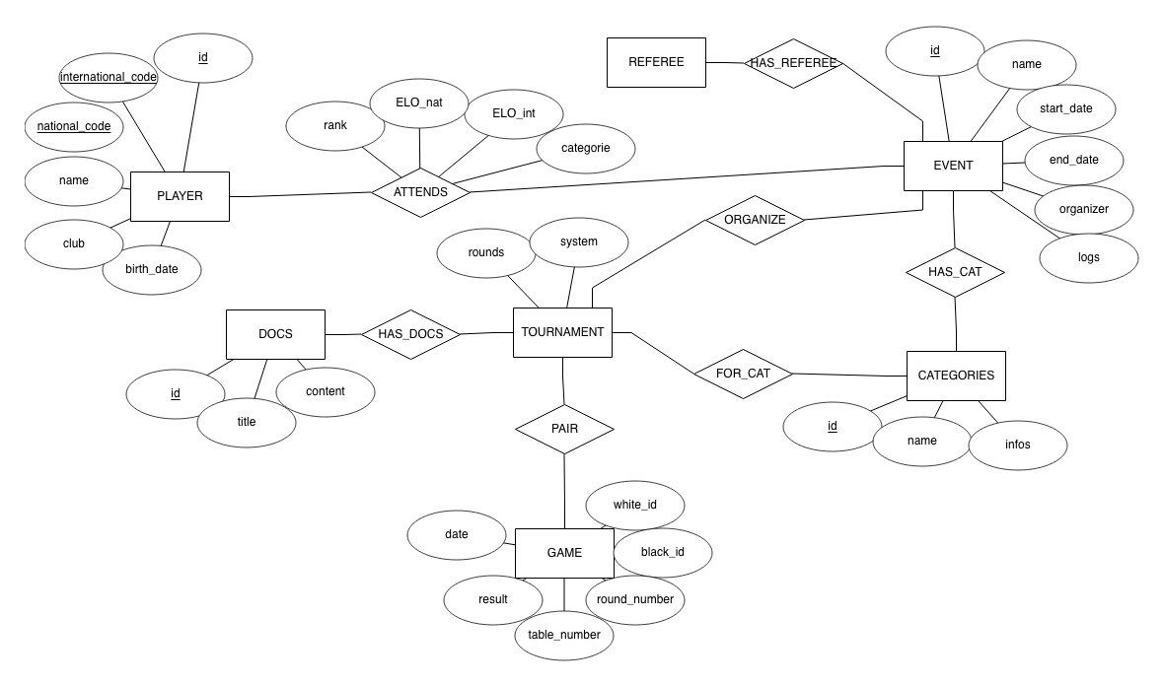

## 

# To-be Long-Term Evolution

Editorial note: This section the long-term vision that would possibly expand the described project. The project described should be small enough to be feasible (quick win idea) but should illustrated what would be the long-term plan. This is in the spirit of the agile methods. This description is not the strategy description but part of it (if a strategy does exist).

In three years, we want ChessHub to be used in the majority of tournaments in countries where VEGA in used (Italy, Spain, New-Zeeland and Australia). We also want to find deals with other pairings programs so we can extend our number of clients. We mostly want an agreement with SwissManager so we can enter the swiss market.

In a long-term view, we want to have an agreement with all FIDE approved pairing program.

We also want to find some deals with different national federation and provide them a tool that can simplify their ranking system.

# Annex I – Abbreviations & References

# Annex II – Customer Meetings, Joint Sessions

Editorial note: description of when did you meet whom and main insights.