# 

**CONTINUOUS ASSESSMENT -1**

**Course Name:** Machine Learning

**Course Code: C**SM354

**Topic:** Start-Up Profit Prediction

**Student Details:**

**Name:** SHAIK JULFEEN AHMADH

**Section:** K21UN

**Roll Number:** RK21UNA18

**Reg. Number:** 12110554

# Startup Profit Prediction

### Importing the libraries

import numpy as np  
import matplotlib.pyplot as plt  
import pandas as pd  
import seaborn as sns  
import statsmodels.api as sm  
  
from sklearn import metrics  
from sklearn.model_selection import train_test_split  
from sklearn.linear_model import LinearRegression  
from sklearn.ensemble import RandomForestRegressor as RF  
from sklearn.compose import ColumnTransformer  
from sklearn.preprocessing import OneHotEncoder  
from sklearn.preprocessing import MinMaxScaler  
from statsmodels.stats.outliers_influence import variance_inflation_factor  
  
%matplotlib inline

import warnings  
warnings.filterwarnings('ignore')

# Reading and undersatnding the data

## Importing the dataset

df = pd.read_csv('50_Startups.csv')

df.head()

R&D Spend Administration Marketing Spend State Profit  
0 165349.20 136897.80 471784.10 New York 192261.83  
1 162597.70 151377.59 443898.53 California 191792.06  
2 153441.51 101145.55 407934.54 Florida 191050.39  
3 144372.41 118671.85 383199.62 New York 182901.99  
4 142107.34 91391.77 366168.42 Florida 166187.94

df.shape

(50, 5)

df.info()

<class 'pandas.core.frame.DataFrame'>  
RangeIndex: 50 entries, 0 to 49  
Data columns (total 5 columns):  
 # Column Non-Null Count Dtype   
--- ------ -------------- -----   
 0 R&D Spend 50 non-null float64  
 1 Administration 50 non-null float64  
 2 Marketing Spend 50 non-null float64  
 3 State 50 non-null object   
 4 Profit 50 non-null float64  
dtypes: float64(4), object(1)  
memory usage: 2.1+ KB

NO null values found!

df.describe()

R&D Spend Administration Marketing Spend Profit  
count 50.000000 50.000000 50.000000 50.000000  
mean 73721.615600 121344.639600 211025.097800 112012.639200  
std 45902.256482 28017.802755 122290.310726 40306.180338  
min 0.000000 51283.140000 0.000000 14681.400000  
25% 39936.370000 103730.875000 129300.132500 90138.902500  
50% 73051.080000 122699.795000 212716.240000 107978.190000  
75% 101602.800000 144842.180000 299469.085000 139765.977500  
max 165349.200000 182645.560000 471784.100000 192261.830000

df['State'].value_counts()

New York 17  
California 17  
Florida 16  
Name: State, dtype: int64

From the above Observation I conclude that it is balanced set

# Data Visualization

## Exploratory Data Analysis

* Exploring various feautures present in the dataset for better understanding

# Checking the null values   
df.isnull().sum()

R&D Spend 0  
Administration 0  
Marketing Spend 0  
State 0  
Profit 0  
dtype: int64

* The dataset is cleaned and has no null values

# Checking for outliers  
df_numeric = df.drop(columns=["State"])  
  
df_numeric.boxplot()  
plt.title('Box plot for each column')  
plt.ylabel('Value')  
plt.xlabel('Columns')  
plt.xticks(rotation=45)  
plt.show()

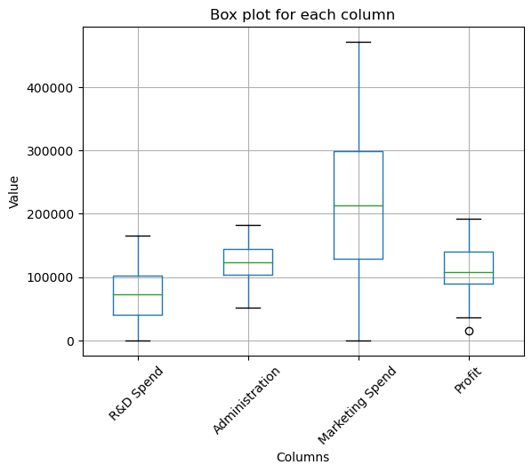

* The dataset has no outliers present

# Pairwise plot among all numerical columns  
sns.pairplot(df)

<seaborn.axisgrid.PairGrid at 0x2762db9d9d0>

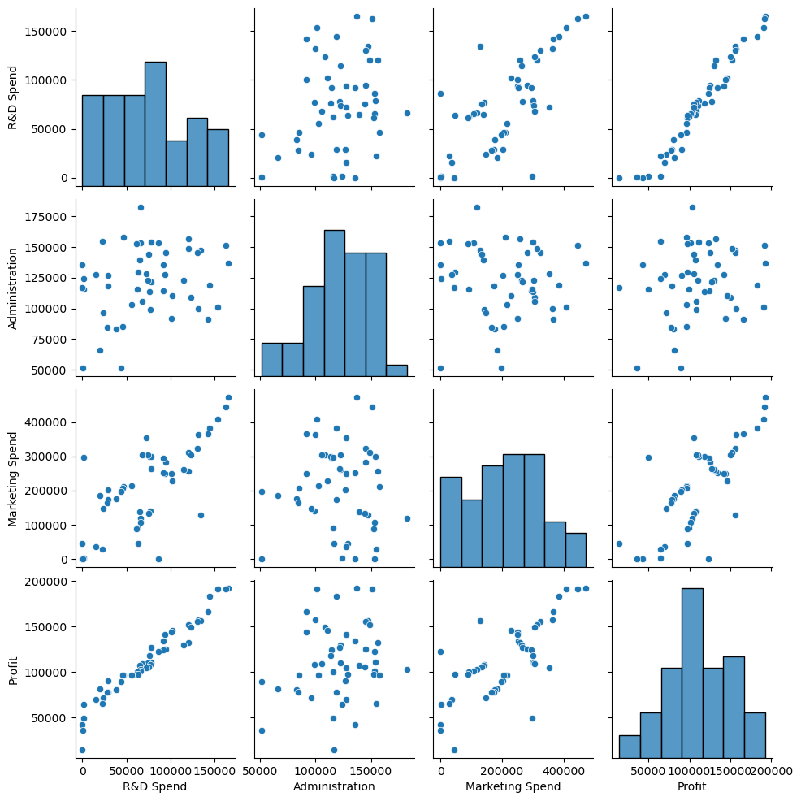

Based on this plot R&D spend is mostly correlated with the Profit. We can check the same using HeatMap

# HeatMAp used to find intercollinearity among numerical rows present in the dataset  
corr = df.corr()  
sns.heatmap(corr, annot=True, cmap='coolwarm')  
plt.title('Correlation Heatmap')  
plt.show()

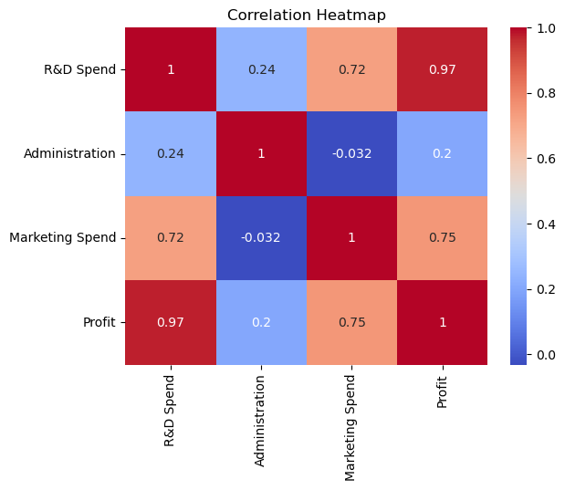

# Kernel Density Estimation : KDE is a non-parametric method for estimating the probability density function of a random variable  
df.plot.kde()

<AxesSubplot:ylabel='Density'>

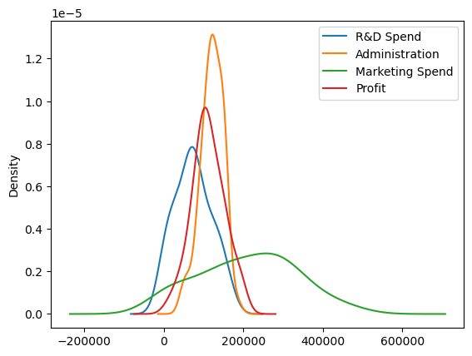

* From the above plot its clear that all numerical features are normally distributed
* Detailed analysis of outliers

sns.boxplot(x=df['Administration'])

<AxesSubplot:xlabel='Administration'>

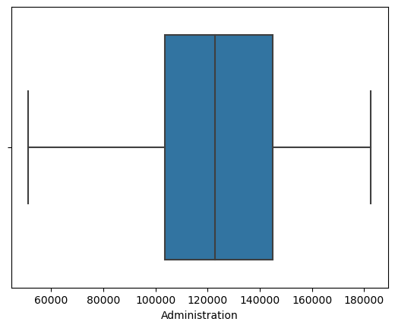

sns.boxplot(x=df['R&D Spend'])

<AxesSubplot:xlabel='R&D Spend'>

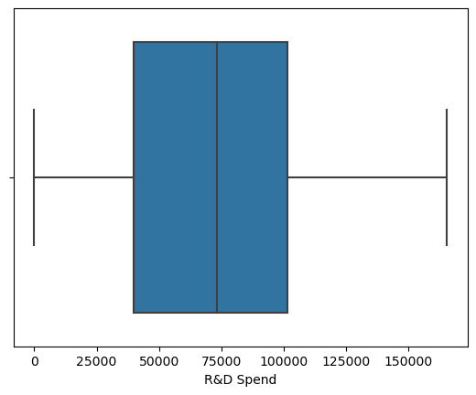

sns.boxplot(x=df['R&D Spend'],y=df['State'])

<AxesSubplot:xlabel='R&D Spend', ylabel='State'>

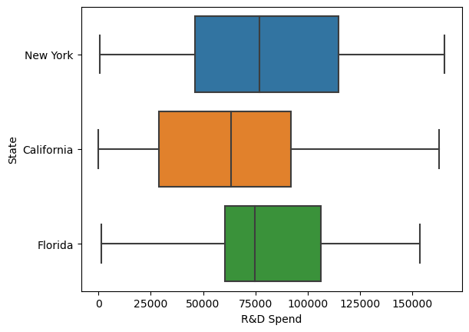

There are no outliers in the data

#lmplot used to create scatter plots with linear regression fits.  
  
sns.lmplot(x='Profit',y='R&D Spend',data=df)

<seaborn.axisgrid.FacetGrid at 0x27630e1faf0>

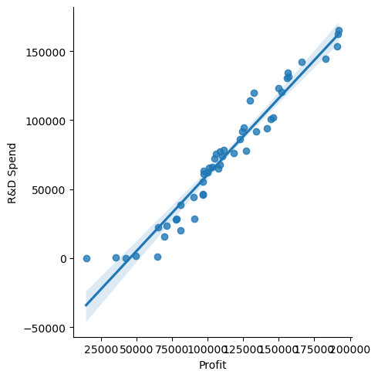

# Understanding detailed relationship b/w 'R&D Spend' column and 'Profit' column  
sns.jointplot(data=df, x="R&D Spend", y="Profit",kind="reg")

<seaborn.axisgrid.JointGrid at 0x27630f0e7c0>

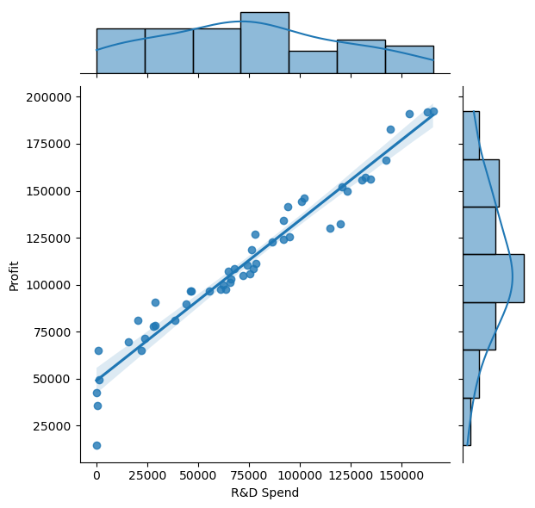

* The terms are normllay distribution
* The best fit line clearly lies covering most of the points

# Understanding relationship b/w 'Marketing Spend' Column and 'Profit' Column  
  
sns.jointplot(data=df, x="Marketing Spend", y="Profit",kind='reg')

<seaborn.axisgrid.JointGrid at 0x2763101e0a0>

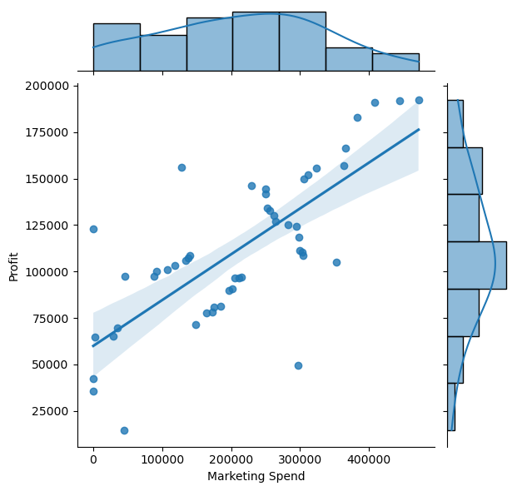

* The terms are normllay distribution
* The best fit line is trying to cover some data points

# Understanding relationship b/w 'Administration' Column and 'Profit' Column  
sns.jointplot(data=df, x="Administration", y="Profit",kind='reg')

<seaborn.axisgrid.JointGrid at 0x276312b01f0>

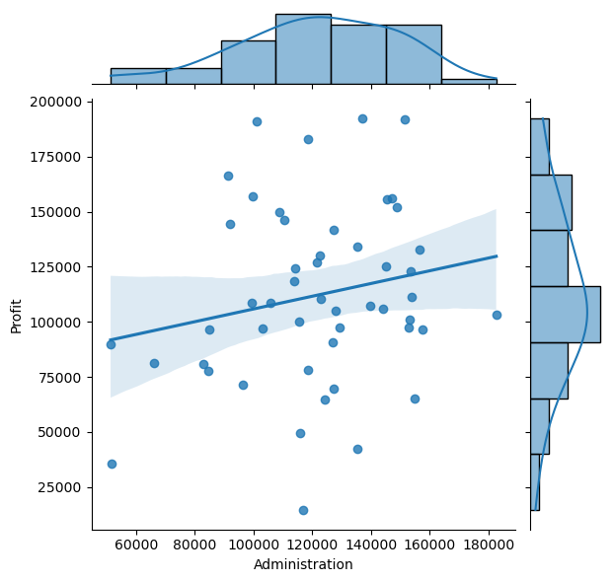

* Althrough the terms are normally distributed , it doesnt explain Profir clearly

sns.jointplot(data=df, x="Marketing Spend", y="R&D Spend", kind="reg")

<seaborn.axisgrid.JointGrid at 0x27632928430>

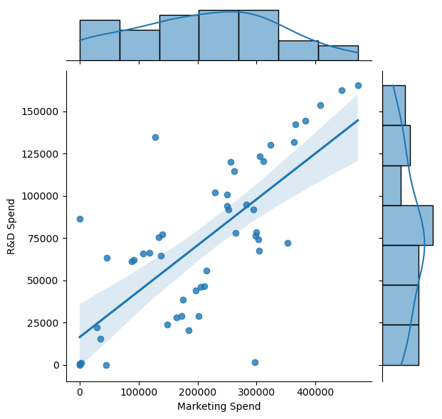

# Understandeing relationship b/w catergorical varibale 'State' and target variable 'Profit'  
sns.catplot(x="State", y="Profit", kind="bar", data=df)

<seaborn.axisgrid.FacetGrid at 0x27632d566d0>

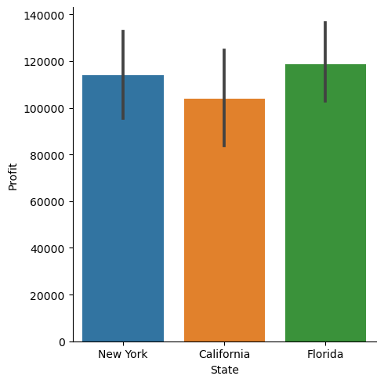

# Data Preparation

### Splitting the dataset into the Training set and Test set

df_train, df_test = train_test_split(df, test_size = 0.2, random_state = 0)

df_train.head()

R&D Spend Administration Marketing Spend State Profit  
33 55493.95 103057.49 214634.81 Florida 96778.92  
35 46014.02 85047.44 205517.64 New York 96479.51  
26 75328.87 144135.98 134050.07 Florida 105733.54  
34 46426.07 157693.92 210797.67 California 96712.80  
18 91749.16 114175.79 294919.57 Florida 124266.90

### Encoding

* The categorical column -'State' is encoded to numerical using OnehatEncoder and the reamining numerical are scaled using MinMaxScaler

numerical_columns = ['R&D Spend', 'Marketing Spend','Administration','Profit']  
categorical_columns = ['State']

ct = ColumnTransformer(transformers=[  
 ('num', MinMaxScaler(), numerical_columns), # Apply MinMaxScaler to numerical columns  
 ('cat', OneHotEncoder(), categorical_columns) # Apply OneHotEncoder to categorical columns  
], remainder='passthrough') # Keep remaining columns unchanged  
  
df_train_transformed =ct.fit_transform(df_train)  
df_test_transformed = ct.transform(df_test)

print(type(df_train_transformed))  
print(type(df_test_transformed))

<class 'numpy.ndarray'>  
<class 'numpy.ndarray'>

# Convert the transformed arrays back to DataFrames  
df_train = pd.DataFrame(df_train_transformed, columns=numerical_columns + ['encoded_' + col for col in ct.named_transformers_['cat'].get_feature_names_out()])  
df_test = pd.DataFrame(df_test_transformed, columns=numerical_columns + ['encoded_' + col for col in ct.named_transformers_['cat'].get_feature_names_out()])

print(type(df_train))  
print(type(df_test))

<class 'pandas.core.frame.DataFrame'>  
<class 'pandas.core.frame.DataFrame'>

df_train.describe()

R&D Spend Marketing Spend Administration Profit \  
count 40.000000 40.000000 40.000000 40.000000   
mean 0.433406 0.428461 0.677641 0.533646   
std 0.282906 0.265022 0.246379 0.230775   
min 0.000000 0.000000 0.000000 0.000000   
25% 0.218371 0.259806 0.575948 0.411261   
50% 0.431999 0.441214 0.698439 0.525378   
75% 0.602505 0.630589 0.882500 0.666444   
max 1.000000 1.000000 1.000000 1.000000   
  
 encoded_State_California encoded_State_Florida encoded_State_New York   
count 40.000000 40.000000 40.000000   
mean 0.400000 0.250000 0.350000   
std 0.496139 0.438529 0.483046   
min 0.000000 0.000000 0.000000   
25% 0.000000 0.000000 0.000000   
50% 0.000000 0.000000 0.000000   
75% 1.000000 0.250000 1.000000   
max 1.000000 1.000000 1.000000

# Multiple Linear Regression

**Multiple Linear Regression (MLR)** is a statistical method used to model the relationship between multiple independent variables and a single dependent variable. It extends the simple linear regression model to handle situations where more than one predictor variable influences the target variable.

* MLR is supervised Regression model used for dealing with linear entities (the variables that exhibit a linear realtionship)

### Initializing x_train , y_train

y_train = df_train['Profit']  
X_train = df_train.drop(['Profit'],axis=1)

print(X_train.shape)  
print(y_train.shape)

(40, 6)  
(40,)

X_train.head()

R&D Spend Marketing Spend Administration encoded_State_California \  
0 0.335617 0.454943 0.486552 0.0   
1 0.278284 0.435618 0.317301 0.0   
2 0.455574 0.284134 0.872589 0.0   
3 0.280776 0.446810 1.000000 1.0   
4 0.554881 0.625116 0.591036 0.0   
  
 encoded_State_Florida encoded_State_New York   
0 1.0 0.0   
1 0.0 1.0   
2 1.0 0.0   
3 0.0 0.0   
4 1.0 0.0

y_train.head()

0 0.462312  
1 0.460626  
2 0.512737  
3 0.461939  
4 0.617103  
Name: Profit, dtype: float64

### Training the Multiple Linear Regression model on the Training set

# Initialise teh Linear Regressor  
linear_regressor = LinearRegression()  
  
# Train the train data set   
linear_regressor.fit(X_train, y_train)  
  
# Predict the y_train using X_train  
y_train_pred = linear_regressor.predict(X_train)  
  
# Calculate Residuals  
res = (y_train - y_train_pred)

##### Residual Analysis

# Residual analysis - checking weather the error terms are normally distributed or not  
fig = plt.figure()  
sns.distplot(res, bins = 20,hist_kws={'color': 'green'})  
fig.suptitle('Error Terms', fontsize = 20)   
plt.xlabel('Errors', fontsize = 18)

Text(0.5, 0, 'Errors')

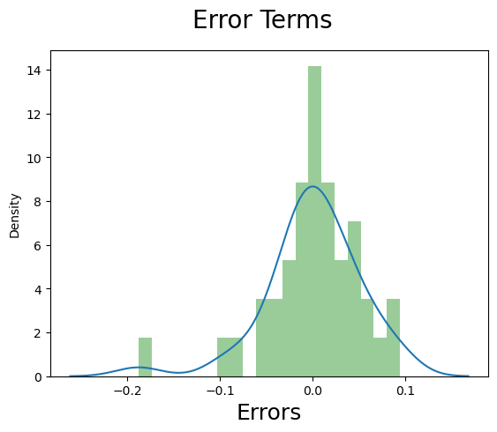

* The error terms are normally distributed

### Predicting the Test set results

# Initialize the X-test and y_test  
  
y_test = df_test['Profit']  
X_test = df_test.drop(['Profit'],axis=1)

# predict y_test using x_test  
y_test_pred = linear_regressor.predict(X_test)

# Plot a scatter plot with predicted y value and test y value  
  
fig = plt.figure()  
sns.regplot(x=y_test,y= y_test_pred,data=df,line_kws={'color': 'red'})  
fig.suptitle('y_test vs y_pred', fontsize = 20)   
plt.xlabel('y_test', fontsize = 18)   
plt.ylabel('y_pred', fontsize = 16)

Text(0, 0.5, 'y_pred')

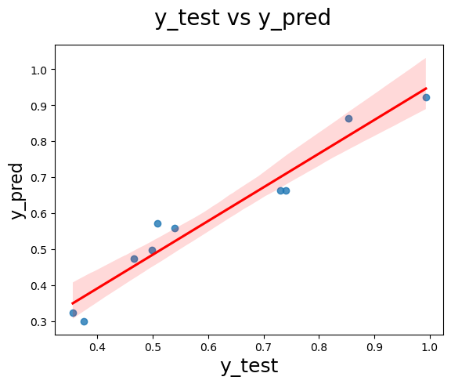

### Evaluating the Model

Let's evaluate our model performance by calculating the residual sum of squares and the explained variance score (R^2).

# Calculate the evaluation metrics  
  
# The Coefficient of variables  
print('Coefficient: ',linear_regressor.coef_)  
  
# The intercept made by regression line   
print('Intercept: ' , linear_regressor.intercept_)  
  
# Absolute Mean Error = |yobs-ypred|  
print('Absolute MEan Error: ', metrics.mean_absolute_error(y_test, y_test_pred))  
  
# Mean Square Error = |yobs - ypred|^2  
print("Mean Square Error(MSE): ",metrics.mean_squared_error(y_test, y_test_pred, squared=False))  
  
# RMSE = rt(MSE)  
print("Root MeanSquare Error(RMSE): ",np.sqrt(metrics.mean_squared_error(y_test,y_test_pred)))  
  
print()  
  
# R2_score = 1- (RSS/TSS)  
print("R2 Score: ",metrics.r2_score(y_test,y_test_pred))

Coefficient: [ 7.20192994e-01 9.72631281e-02 1.97053001e-02 4.87882416e-04  
 -4.91408761e-03 4.42620519e-03]  
Intercept: 0.16596735725805262  
Absolute MEan Error: 0.04231487478457284  
Mean Square Error(MSE): 0.051458317522910246  
Root MeanSquare Error(RMSE): 0.051458317522910246  
  
R2 Score: 0.9347068473282426

### Building the model using StatsModel for summary

import statsmodels.api as sm  
  
  
# Add a constant  
X_train_lm = sm.add_constant(X_train)  
  
# Create a first fitted model  
linear_model = sm.OLS(y_train, X_train_lm).fit()  
  
# Check the parameters obtained  
  
linear_model.params

const 0.124476  
R&D Spend 0.720193  
Marketing Spend 0.097263  
Administration 0.019705  
encoded_State_California 0.041980  
encoded_State_Florida 0.036578  
encoded_State_New York 0.045918  
dtype: float64

print(linear_model.summary())

OLS Regression Results   
==============================================================================  
Dep. Variable: Profit R-squared: 0.950  
Model: OLS Adj. R-squared: 0.943  
Method: Least Squares F-statistic: 129.7  
Date: Tue, 02 Apr 2024 Prob (F-statistic): 3.91e-21  
Time: 22:32:48 Log-Likelihood: 62.390  
No. Observations: 40 AIC: -112.8  
Df Residuals: 34 BIC: -102.6  
Df Model: 5   
Covariance Type: nonrobust   
============================================================================================  
 coef std err t P>|t| [0.025 0.975]  
--------------------------------------------------------------------------------------------  
const 0.1245 0.022 5.588 0.000 0.079 0.170  
R&D Spend 0.7202 0.051 14.025 0.000 0.616 0.825  
Marketing Spend 0.0973 0.052 1.884 0.068 -0.008 0.202  
Administration 0.0197 0.040 0.495 0.624 -0.061 0.101  
encoded_State_California 0.0420 0.013 3.143 0.003 0.015 0.069  
encoded_State_Florida 0.0366 0.017 2.153 0.038 0.002 0.071  
encoded_State_New York 0.0459 0.014 3.249 0.003 0.017 0.075  
==============================================================================  
Omnibus: 15.823 Durbin-Watson: 2.468  
Prob(Omnibus): 0.000 Jarque-Bera (JB): 23.231  
Skew: -1.094 Prob(JB): 9.03e-06  
Kurtosis: 6.025 Cond. No. 1.17e+16  
==============================================================================  
  
Notes:  
[1] Standard Errors assume that the covariance matrix of the errors is correctly specified.  
[2] The smallest eigenvalue is 6.43e-31. This might indicate that there are  
strong multicollinearity problems or that the design matrix is singular.

* The p-value of Administration is high(.0.05) so it should be removed for better results

Looking at the p-values, it looks like some of the variables aren't really significant (in the presence of other variables).

We could simply drop the variable with the highest, non-significant p value. A better way would be to supplement this with the VIF information.

### Checking VIF

Variance Inflation Factor or VIF, gives a basic quantitative idea about how much the feature variables are correlated with each other. It is an extremely important parameter to test our linear model. The formula for calculating VIF is:

### $ VIF_i = \frac{1}{1 - {R_i}^2} $

from statsmodels.stats.outliers_influence import variance_inflation_factor  
  
# Create a dataframe that will contain the names of all the feature variables and their respective VIFs  
vif = pd.DataFrame()  
vif['Features'] = X_train.columns  
vif['VIF'] = [variance_inflation_factor(X_train.values, i) for i in range(X_train.shape[1])]  
vif['VIF'] = round(vif['VIF'], 2)  
vif = vif.sort_values(by = "VIF", ascending = False)  
vif

Features VIF  
3 encoded_State_California 4.91  
5 encoded_State_New York 4.49  
4 encoded_State_Florida 4.07  
0 R&D Spend 2.70  
1 Marketing Spend 2.40  
2 Administration 1.23

* The intercorelation /multicolinearity is less so the columns can be left alone

### Removing the 'Administration' variable and rebuilding the model

# Remove the "Administration" column from X_train and X_test  
X_train_updated = X_train.drop(['Administration'],axis=1)  
X_test_updated = X_test.drop(['Administration'],axis=1)  
  
# Retrain the Linear Regression model  
linear_regressor_updated = LinearRegression()  
linear_regressor_updated.fit(X_train_updated, y_train)  
  
# Predict the y_train using X_test  
y_train_pred_new = linear_regressor_updated.predict(X_train_updated)  
  
# Calculate Residuals  
res = (y_train - y_train_pred_new) # Residuals

# Residual analysis - checking weather the error terms are normally distributed or not  
fig = plt.figure()  
sns.distplot(res, bins = 20,kde_kws={'color': 'green'})  
fig.suptitle('Error Terms', fontsize = 20)   
plt.xlabel('Errors', fontsize = 18)

Text(0.5, 0, 'Errors')

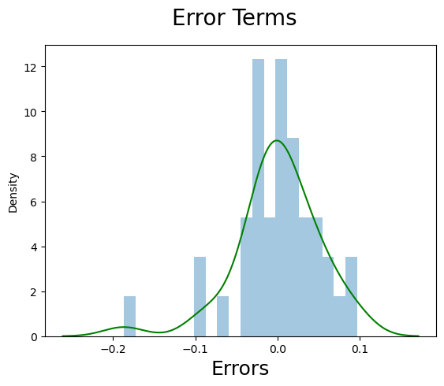

* the error terms/ residuals are normally distributed

#### Evaluate the performance of updated model on test data

# Evaluate the performance of the updated model  
y_test_pred_new = linear_regressor_updated.predict(X_test_updated)

# Plot a scatter plot with predicted y value and test y value  
  
fig = plt.figure()  
sns.regplot(x=y_test,y= y_test_pred_new,data=df,scatter_kws={'color': 'red'}) # used for specifying the color of scatter plot  
fig.suptitle('y_test vs y_pred', fontsize = 20)   
plt.xlabel('y_test', fontsize = 18)   
plt.ylabel('y_pred', fontsize = 16)

Text(0, 0.5, 'y_pred')

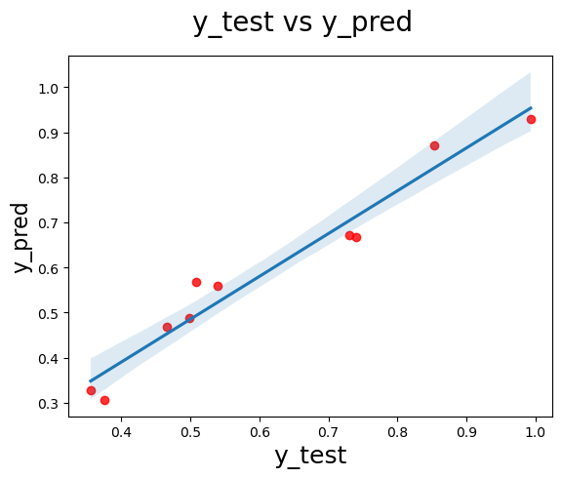

# Calculate the evaluation metrics  
  
# The Coefficient of variables  
print('Coefficient: ',linear_regressor_updated.coef_)  
  
# The intercept made by regression line   
print('Intercept: ' , linear_regressor_updated.intercept_)  
  
# Absolute Mean Error = |yobs-ypred|  
print('Absolute MEan Error: ', metrics.mean_absolute_error(y_test, y_test_pred_new))  
  
# Mean Square Error = |yobs - ypred|^2  
print("Mean Square Error(MSE): ",metrics.mean_squared_error(y_test, y_test_pred_new, squared=False))  
  
# RMSE = rt(MSE)  
print("Root MeanSquare Error(RMSE): ",np.sqrt(metrics.mean_squared_error(y_test,y_test_pred_new)))  
  
print()  
  
# R2_score = 1- (RSS/TSS)  
print("R2 Score: ",metrics.r2_score(y_test,y_test_pred_new))

Coefficient: [ 7.31063411e-01 9.02131542e-02 5.10211675e-04 -4.14383809e-03  
 3.63362642e-03]  
Intercept: 0.17770571098352195  
Absolute MEan Error: 0.0400334766484711  
Mean Square Error(MSE): 0.04735835313888054  
Root MeanSquare Error(RMSE): 0.04735835313888054  
  
R2 Score: 0.9446968769427516

* Check for any redundant columns present/not

vif = pd.DataFrame()  
vif['Features'] = X_train_updated.columns  
vif['VIF'] = [variance_inflation_factor(X_train_updated.values, i) for i in range(X_train_updated.shape[1])]  
vif['VIF'] = round(vif['VIF'], 2)  
vif = vif.sort_values(by = "VIF", ascending = False)  
vif

Features VIF  
4 encoded_State_New York 2.23  
1 Marketing Spend 2.22  
0 R&D Spend 2.21  
3 encoded_State_Florida 1.97  
2 encoded_State_California 1.94

* No redundant columns are present

### Validating model using Statsmodel for evaluation metrics

import statsmodels.api as sm  
  
  
# Add a constant  
X_train_lm2 = sm.add_constant(X_train_updated)  
  
# Create a first fitted model  
linear_model_2 = sm.OLS(y_train, X_train_lm2).fit()  
  
# Check the parameters obtained  
  
linear_model_2.params

const 0.133279  
R&D Spend 0.731063  
Marketing Spend 0.090213  
encoded_State_California 0.044937  
encoded_State_Florida 0.040283  
encoded_State_New York 0.048060  
dtype: float64

print(linear_model_2.summary())

OLS Regression Results   
==============================================================================  
Dep. Variable: Profit R-squared: 0.950  
Model: OLS Adj. R-squared: 0.944  
Method: Least Squares F-statistic: 165.6  
Date: Tue, 02 Apr 2024 Prob (F-statistic): 3.19e-22  
Time: 22:32:49 Log-Likelihood: 62.246  
No. Observations: 40 AIC: -114.5  
Df Residuals: 35 BIC: -106.0  
Df Model: 4   
Covariance Type: nonrobust   
============================================================================================  
 coef std err t P>|t| [0.025 0.975]  
--------------------------------------------------------------------------------------------  
const 0.1333 0.013 10.055 0.000 0.106 0.160  
R&D Spend 0.7311 0.046 15.924 0.000 0.638 0.824  
Marketing Spend 0.0902 0.049 1.838 0.074 -0.009 0.190  
encoded_State_California 0.0449 0.012 3.803 0.001 0.021 0.069  
encoded_State_Florida 0.0403 0.015 2.671 0.011 0.010 0.071  
encoded_State_New York 0.0481 0.013 3.611 0.001 0.021 0.075  
==============================================================================  
Omnibus: 14.873 Durbin-Watson: 2.511  
Prob(Omnibus): 0.001 Jarque-Bera (JB): 21.150  
Skew: -1.038 Prob(JB): 2.56e-05  
Kurtosis: 5.895 Cond. No. 2.46e+16  
==============================================================================  
  
Notes:  
[1] Standard Errors assume that the covariance matrix of the errors is correctly specified.  
[2] The smallest eigenvalue is 1.16e-31. This might indicate that there are  
strong multicollinearity problems or that the design matrix is singular.

## Insights from MLR Model

MLR can be implemented either by using Sckit Learn / Stats Model

* Using Sckit learn we got r2_score around 0.94
* Using Stats Model we got r2_score around 0.95
* This cost_function(r2_score) determines the quality of our multiple Linear Regression Model

# Random Forest Regression

**Random Forest Regression** is a popular ensemble learning method used for both classification and regression tasks. It operates by constructing a multitude of decision trees during training and outputting the average prediction of the individual trees for regression tasks.

* Random Forest is a supervised learning algorithm that utilizes the ensemble of decision trees to improve predictive performance and reduce overfitting.

## Data Preparation

### Splitting the dataset into the Training set and Test set

df_train, df_test = train_test_split(df, test_size = 0.2, random_state = 0)

df_train.head()

R&D Spend Administration Marketing Spend State Profit  
33 55493.95 103057.49 214634.81 Florida 96778.92  
35 46014.02 85047.44 205517.64 New York 96479.51  
26 75328.87 144135.98 134050.07 Florida 105733.54  
34 46426.07 157693.92 210797.67 California 96712.80  
18 91749.16 114175.79 294919.57 Florida 124266.90

### Encoding

numerical_columns = ['R&D Spend', 'Marketing Spend','Administration','Profit']  
categorical_columns = ['State']

from sklearn.preprocessing import MinMaxScaler  
  
ct = ColumnTransformer(transformers=[  
 ('num', MinMaxScaler(), numerical_columns), # Apply MinMaxScaler to numerical columns  
 ('cat', OneHotEncoder(), categorical_columns) # Apply OneHotEncoder to categorical columns  
], remainder='passthrough') # Keep remaining columns unchanged  
  
df_train_transformed =ct.fit_transform(df_train)  
df_test_transformed = ct.transform(df_test)

print(type(df_train_transformed))  
print(type(df_test_transformed))

<class 'numpy.ndarray'>  
<class 'numpy.ndarray'>

# Convert the transformed arrays back to DataFrames  
df_train = pd.DataFrame(df_train_transformed, columns=numerical_columns + ['encoded_' + col for col in ct.named_transformers_['cat'].get_feature_names_out()])  
df_test = pd.DataFrame(df_test_transformed, columns=numerical_columns + ['encoded_' + col for col in ct.named_transformers_['cat'].get_feature_names_out()])

print(type(df_train))  
print(type(df_test))

<class 'pandas.core.frame.DataFrame'>  
<class 'pandas.core.frame.DataFrame'>

df_train.describe()

R&D Spend Marketing Spend Administration Profit \  
count 40.000000 40.000000 40.000000 40.000000   
mean 0.433406 0.428461 0.677641 0.533646   
std 0.282906 0.265022 0.246379 0.230775   
min 0.000000 0.000000 0.000000 0.000000   
25% 0.218371 0.259806 0.575948 0.411261   
50% 0.431999 0.441214 0.698439 0.525378   
75% 0.602505 0.630589 0.882500 0.666444   
max 1.000000 1.000000 1.000000 1.000000   
  
 encoded_State_California encoded_State_Florida encoded_State_New York   
count 40.000000 40.000000 40.000000   
mean 0.400000 0.250000 0.350000   
std 0.496139 0.438529 0.483046   
min 0.000000 0.000000 0.000000   
25% 0.000000 0.000000 0.000000   
50% 0.000000 0.000000 0.000000   
75% 1.000000 0.250000 1.000000   
max 1.000000 1.000000 1.000000

### Initialising the target and predictor variable for train data set

y_train = df_train['Profit']  
X_train = df_train.drop(['Profit'],axis=1)

print(X_train.shape)  
print(y_train.shape)

(40, 6)  
(40,)

X_train.head()

R&D Spend Marketing Spend Administration encoded_State_California \  
0 0.335617 0.454943 0.486552 0.0   
1 0.278284 0.435618 0.317301 0.0   
2 0.455574 0.284134 0.872589 0.0   
3 0.280776 0.446810 1.000000 1.0   
4 0.554881 0.625116 0.591036 0.0   
  
 encoded_State_Florida encoded_State_New York   
0 1.0 0.0   
1 0.0 1.0   
2 1.0 0.0   
3 0.0 0.0   
4 1.0 0.0

y_train.head()

0 0.462312  
1 0.460626  
2 0.512737  
3 0.461939  
4 0.617103  
Name: Profit, dtype: float64

* All the above pre processing steps are same for both MLR and Random Forest

### Training the Random forest model on training set

from sklearn.ensemble import RandomForestRegressor as RF  
# Initialize the RandomForestRegressor   
rf_regressor = RF(n_estimators=500)  
  
# Train teh data set  
rf_regressor.fit(X_train, y_train)  
  
# Predict the y_train using X_train  
y_train_pred = linear_regressor.predict(X_train)  
  
# # Calculate Residuals (ycal - ypred)  
res = (y_train - y_train_pred)

* the parameter n_estimators specifies the number of decision trees that will be used in the ensemble. Each decision tree in the Random Forest is referred to as an estimator.
* Therefore, n_estimators controls the size of the forest, or the number of trees in the ensemble.

**Residual Analysis**

# Residual analysis - checking weather the error terms are normally distributed or not  
fig = plt.figure()  
sns.distplot(res, bins = 20,hist_kws={'color': 'green'})  
fig.suptitle('Error Terms', fontsize = 20)   
plt.xlabel('Errors', fontsize = 18)

Text(0.5, 0, 'Errors')



* The error terms are normally distributed

### Predicting the Test set results

# Initialize the X-test and y_test  
  
y_test = df_test['Profit']  
X_test = df_test.drop(['Profit'],axis=1)

# predict y_test using x_test  
y_test_pred = rf_regressor.predict(X_test)

# Plot a scatter plot with predicted y value and test y value  
  
fig = plt.figure()  
sns.regplot(x=y_test, y=y_test_pred,data=df, line_kws={'color': 'red'}) # used for specfying the color of regressionline  
fig.suptitle('y_test vs y_pred', fontsize = 20)   
plt.xlabel('y_test', fontsize = 18)   
plt.ylabel('y_pred', fontsize = 16)

Text(0, 0.5, 'y_pred')

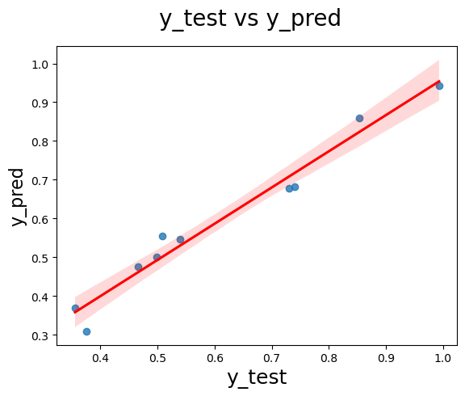

### Evaluating the Model

# Calculate the evaluation metrics  
  
# Absolute Mean Error = |yobs-ypred|  
print('Absolute Mean Error: ', metrics.mean_absolute_error(y_test, y_test_pred))  
  
# Mean Square Error = |yobs - ypred|^2  
print("Mean Square Error(MSE): ",metrics.mean_squared_error(y_test, y_test_pred, squared=False))  
  
# RMSE = rt(MSE)  
print("Root MeanSquare Error(RMSE): ",np.sqrt(metrics.mean_squared_error(y_test,y_test_pred)))  
  
print()  
  
# R2_score = 1- (RSS/TSS)  
print("R2 Score: ",metrics.r2_score(y_test,y_test_pred))

Absolute Mean Error: 0.03133570459312483  
Mean Square Error(MSE): 0.039409202283800834  
Root MeanSquare Error(RMSE): 0.039409202283800834  
  
R2 Score: 0.9617041457050264

* The r2_score of 0.96 is really good which is significat measure the accuracy and correctness of our model
* Compared to MLR , with Random Forest the improved from 0.95 to 0.96
* In the above case using MLR we found that 'Administration' variable has high p -value . so following which we will be removing it and rebuildig the model

# Remove the "Administration" column from X_train and X_test  
X_train_updated = X_train.drop(['Administration'],axis=1)  
X_test_updated = X_test.drop(['Administration'],axis=1)  
  
# Retrain the Linear Regression model  
rf_regressor_updated = RF(n_estimators=500)  
rf_regressor_updated.fit(X_train_updated, y_train)  
  
  
# Predict the y_train using X_test  
y_train_pred_new = linear_regressor_updated.predict(X_train_updated)  
  
# Calculate Residuals  
res = (y_train - y_train_pred_new)

# Residual analysis - checking weather the error terms are normally distributed or not  
fig = plt.figure()  
sns.distplot(res, bins = 20,kde_kws={'color': 'green'})  
fig.suptitle('Error Terms', fontsize = 20)   
plt.xlabel('Errors', fontsize = 18)

Text(0.5, 0, 'Errors')



* The error terms are normally distributed

#### Evaluate the performance of updated model on test data

# Evaluate the performance of the updated model  
y_test_pred_new = rf_regressor_updated.predict(X_test_updated)

# Plot a scatter plot with predicted y value and test y value  
  
fig = plt.figure()  
sns.regplot(x=y_test, y= y_test_pred_new,data=df,scatter_kws={'color': 'red'})  
fig.suptitle('y_test vs y_pred', fontsize = 20)   
plt.xlabel('y_test', fontsize = 18)   
plt.ylabel('y_pred', fontsize = 16)

Text(0, 0.5, 'y_pred')

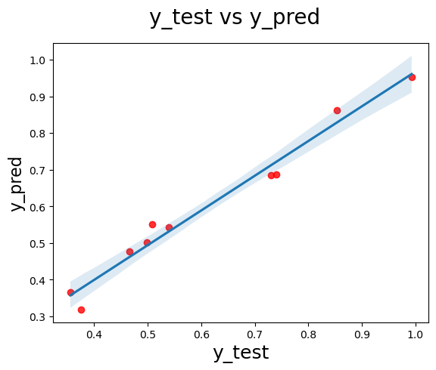

### Evaluating the Model

# Calculate the evaluation metrics  
  
# Absolute Mean Error = |yobs-ypred|  
print('Absolute Mean Error: ', metrics.mean_absolute_error(y_test, y_test_pred_new))  
  
# Mean Square Error = |yobs - ypred|^2  
print("Mean Square Error(MSE): ",metrics.mean_squared_error(y_test, y_test_pred_new, squared=False))  
  
# RMSE = rt(MSE)  
print("Root MeanSquare Error(RMSE): ",np.sqrt(metrics.mean_squared_error(y_test,y_test_pred_new)))  
  
print()  
  
# R2_score = 1- (RSS/TSS)  
print("R2 Score: ",metrics.r2_score(y_test,y_test_pred_new))

Absolute Mean Error: 0.027130412985260234  
Mean Square Error(MSE): 0.03424444902903638  
Root MeanSquare Error(RMSE): 0.03424444902903638  
  
R2 Score: 0.9710840916050402

* The r2_score slightly increased from 0.966 to 0.969 after removing the variable 'Administration'

## **Insights of RF Model**

* The RF is implemented using sckit learn library
* The R2 score had a slight increase slight ater removing the redundant variables
* The accuracy of prediction using RF is more when compared to MLR

# Save the models for Inference

import joblib  
  
#joblib.dump(scaler,"minmax_scaler.joblib")  
#joblib.dump(ct, "col_transformer.joblib")  
#joblib.dump(rf_regressor, "rf_regressor.joblib")  
#joblib.dump(linear_regressor, "linear_regressor.joblib")

* These models will be further used while creating a interface using gradio for predicting the target variable

# User Interface using Gradio

import gradio as gr  
import joblib  
import warnings  
warnings.filterwarnings('ignore')

# load models and transformer  
ct = joblib.load("col_transformer.joblib")  
linear_regressor = joblib.load("linear_regressor.joblib")  
rf_regressor = joblib.load("rf_regressor.joblib")

def predict(R_and_D_Spending, Administration, Marketing_spending, State, model = "Randomforest Regressor"):  
 rdspending = int(R_and_D_Spending)  
 admin = int(Administration)  
 mspending = int(Marketing_spending)  
 s = State  
  
 inputs = ct.transform([[rdspending, admin, mspending, s]])  
 print(inputs)  
  
 if model == "Randomforest Regressor":  
 print("Using Randomforest Regression")  
 model = rf_regressor  
 else:  
 print("Using Linear Regression")  
 model = linear_regressor  
 output = model.predict(inputs)  
  
 return output

demo = gr.Interface(  
 title="Profit Prediction",  
 fn=predict,  
 inputs=[gr.Text(label='R_and_D_Spending'),  
 gr.Text(label='Administration'),  
 gr.Text(label='Marketing_spending'),  
 gr.Dropdown(['New York', 'California', 'Florida']),  
 gr.Dropdown(["Randomforest Regressor", "LInear Regrssor"])],  
 outputs="number")  
  
  
  
if __name__ == "__main__":  
 demo.launch(share=True)

Running on local URL: http://127.0.0.1:7862  
Running on public URL: https://064f9c92acabd2c941.gradio.live  
  
This share link expires in 72 hours. For free permanent hosting and GPU upgrades, run `gradio deploy` from Terminal to deploy to Spaces (https://huggingface.co/spaces)

<IPython.core.display.HTML object>

# Conclusions

## 1. Project Outcomes

* The main aim of the project is to predict 'Profit' obtained when a startup is placed in a particular 'State' with various factors effecting such as 'R&D Spend', 'MArketing Spend', 'Administration'
* The data set primarily has 5 variables - 'R&D Spend', 'MArketing Spend', 'Administration' , 'State' and 'Profit'
* The 'Profit' variable is taken as target variables -> predicted using other predictor variables
* In the process 2 Models are used
  + Multiple linear Regression
  + Random Forest Regression
* The quality of the model is checked using a mtreic(cost function) R2_score
* The MLR is implimented using 2 different
  + Using Sckit Learn We got a R-score around 0.94
  + Using Stats Model We got around 0.95
* With this we can conclude that MLR model gives good accuracy in predicting the target Variable
* The RF is implement using Sckit Learn library
  + Usinh which we got a final accuracy around 0.969
* This score explains how good is our model in predicting the target variable
* Overall when compared to MLR , RF is used for providng better and more accurate resullts for predicting 'Profit'

## 2. Learning Outcomes

* Through this prject , I learnt in detail about machine learning algorithms such as Multiple Linear Regression, Random Forest Regression

**1.Multiple Linear Regression (MLR):**

- Understanding how to implement MLR using both scikit-learn and StatsModels libraries.  
- Comparing the performance of MLR models using the R-squared metric.  
- Appreciating the differences between scikit-learn and StatsModels in terms of implementation & performance evaluation.

**2. Random Forest Regression (RF):**

- Implementing Random Forest Regression using scikit-learn.  
- Evaluating the performance of the RF model using the R-squared metric.  
- Understanding how ensemble methods like Random Forest can improve predictive accuracy compared to simple linear regression models.

**3. Evaluation Metrics:**

- Understanding the importance of evaluation metrics like R-squared, RSS, MSE,RMSE in assessing model performance.  
- Interpreting R-squared scores to gauge the goodness-of-fit of regression models.

**4. ColumnTransformer:**

- Learning how to preprocess data using ColumnTransformer to handle categorical and numerical variables simultaneously.  
- Understanding the purpose and usage of ColumnTransformer in machine learning pipelines.  
- Function of 'OneHotEncoder' used during conversion of categorical variables to numerical Variables

**5. Gradio Library:**

- Introduction to Gradio library for building interactive web interfaces for machine learning models.  
- Understanding how to use Gradio to create user-friendly interfaces for model predictions.  
- Exploring different input and output components provided by Gradio for model interaction.

Google Drive Link:

<https://drive.google.com/drive/folders/1bMstkETpiripKbZIY5lkD8ftVnZXDjFy?usp=sharing>