# Portfolio Risk & Performance Report

This report summarizes the portfolio’s performance, risk metrics, and underlying holdings based on data from ../outputs/portfolio1/analysis.

## 1. Portfolio Summary

Number of Holdings: 17

Date Range: 10/22/2019 → 10/17/2025

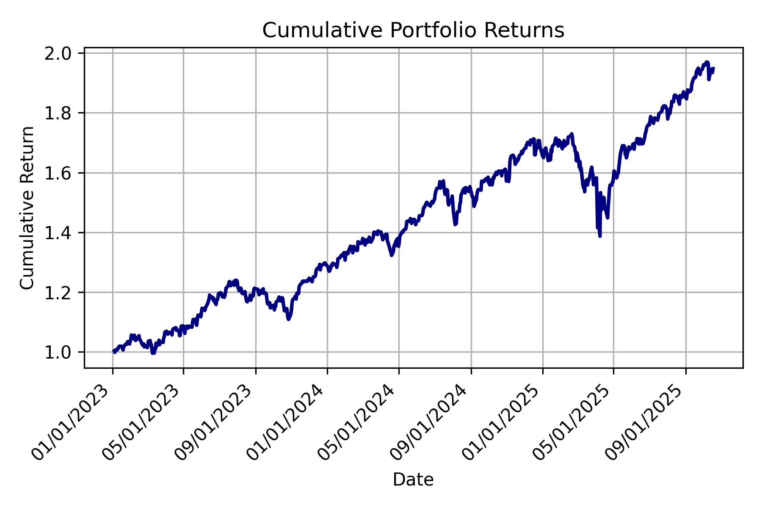

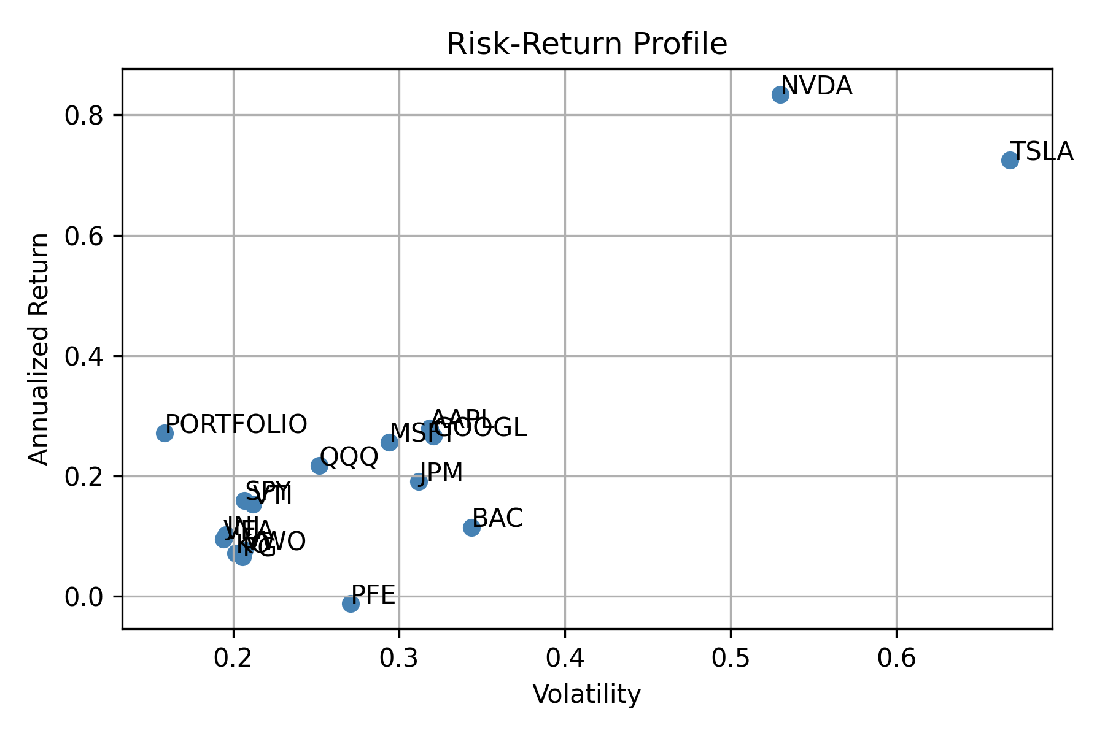

## 2. Performance Metrics

|  |  |  |  |  |  |  |  |
| --- | --- | --- | --- | --- | --- | --- | --- |
| Symbol | Total Return | Annualized Return | Volatility | Sharpe Ratio | Max Drawdown | Upside Capture | Downside Capture |
| AAPL | 335.64% | 27.92% | 31.84% | 87.68% | -33.36% | 126.06% | 117.43% |
| MSFT | 291.34% | 25.65% | 29.43% | 87.16% | -37.15% | 120.00% | 112.79% |
| GOOGL | 309.95% | 26.63% | 32.07% | 83.02% | -44.32% | 124.52% | 116.74% |
| SPY | 142.16% | 15.95% | 20.68% | 77.14% | -33.72% | 100.00% | 100.00% |
| QQQ | 223.92% | 21.73% | 25.18% | 86.32% | -35.12% | 122.12% | 119.78% |
| VTI | 134.90% | 15.36% | 21.18% | 72.53% | -35.00% | 102.00% | 102.76% |
| TSLA | 2499.47% | 72.49% | 66.84% | 108.45% | -73.63% | 218.76% | 177.80% |
| NVDA | 3658.26% | 83.46% | 53.00% | 157.48% | -66.34% | 220.90% | 182.45% |
| JPM | 184.18% | 19.10% | 31.20% | 61.20% | -43.63% | 101.14% | 95.99% |
| BAC | 91.59% | 11.49% | 34.39% | 33.42% | -48.95% | 109.22% | 111.54% |
| VEA | 72.73% | 9.58% | 19.41% | 49.33% | -35.27% | 78.92% | 81.31% |
| VWO | 55.53% | 7.67% | 20.66% | 37.12% | -34.32% | 70.90% | 73.48% |
| JNJ | 78.80% | 10.21% | 19.58% | 52.15% | -27.37% | 33.85% | 27.69% |
| PFE | -6.61% | -1.14% | 27.07% | -4.21% | -58.96% | 40.29% | 44.41% |
| KO | 51.78% | 7.23% | 20.16% | 35.87% | -36.99% | 45.95% | 44.60% |
| PG | 46.62% | 6.61% | 20.55% | 32.17% | -23.77% | 37.24% | 35.15% |
| PORTFOLIO | 94.75% | 27.12% | 15.85% | 171.08% | -19.79% | 102.08% | 98.94% |

## 3. Risk Metrics

* Volatility

|  |  |  |  |  |  |
| --- | --- | --- | --- | --- | --- |
| Symbol | Vol 3M | Vol 1Y | Vol 3Y | Vol 5Y | Vol Max |
| AAPL | 25.77% | 32.38% | 27.61% | 28.42% | 31.84% |
| MSFT | 17.06% | 24.67% | 25.03% | 25.91% | 29.43% |
| GOOGL | 27.58% | 32.31% | 31.36% | 30.98% | 32.07% |
| SPY | 10.73% | 19.57% | 16.36% | 17.23% | 20.68% |
| QQQ | 13.76% | 23.61% | 21.21% | 22.77% | 25.18% |
| VTI | 11.04% | 19.54% | 16.56% | 17.60% | 21.18% |
| TSLA | 47.42% | 70.76% | 62.26% | 61.22% | 66.84% |
| NVDA | 30.33% | 49.38% | 51.89% | 52.18% | 53.00% |
| JPM | 17.41% | 26.71% | 23.40% | 25.26% | 31.20% |
| BAC | 21.65% | 28.06% | 26.47% | 28.33% | 34.39% |
| VEA | 11.70% | 16.19% | 15.26% | 16.20% | 19.41% |
| VWO | 13.68% | 17.16% | 16.19% | 17.52% | 20.66% |
| JNJ | 13.33% | 19.28% | 17.07% | 16.82% | 19.58% |
| PFE | 31.26% | 26.37% | 24.48% | 25.75% | 27.07% |
| KO | 13.16% | 17.07% | 14.89% | 16.20% | 20.16% |
| PG | 15.29% | 18.56% | 16.33% | 17.22% | 20.55% |
| PORTFOLIO | 11.10% | 20.02% | nan% | nan% | 15.85% |

* VaR

|  |  |  |  |  |  |  |  |  |  |  |
| --- | --- | --- | --- | --- | --- | --- | --- | --- | --- | --- |
| Symbol | VaR95 3M | VaR99 3M | VaR95 1Y | VaR99 1Y | VaR95 3Y | VaR99 3Y | VaR95 5Y | VaR99 5Y | VaR95 Max | VaR99 Max |
| AAPL | -1.93% | -3.31% | -3.21% | -4.91% | -2.66% | -4.24% | -2.91% | -4.65% | -3.07% | -4.98% |
| MSFT | -1.62% | -2.33% | -2.16% | -3.71% | -2.34% | -3.62% | -2.63% | -4.13% | -2.71% | -4.53% |
| GOOGL | -1.76% | -2.17% | -2.91% | -4.81% | -2.72% | -4.80% | -2.96% | -4.80% | -3.08% | -5.15% |
| SPY | -0.67% | -2.04% | -1.70% | -3.67% | -1.48% | -2.47% | -1.68% | -2.96% | -1.81% | -3.69% |
| QQQ | -1.13% | -2.54% | -2.42% | -4.06% | -1.98% | -3.39% | -2.38% | -3.89% | -2.53% | -4.25% |
| VTI | -0.69% | -2.05% | -1.76% | -3.59% | -1.55% | -2.55% | -1.71% | -3.09% | -1.86% | -3.69% |
| TSLA | -4.44% | -6.28% | -5.67% | -9.38% | -5.66% | -9.74% | -5.86% | -9.25% | -6.09% | -11.36% |
| NVDA | -3.27% | -4.59% | -4.61% | -8.14% | -4.43% | -7.08% | -4.93% | -7.60% | -4.91% | -7.79% |
| JPM | -1.87% | -2.63% | -2.05% | -4.39% | -1.93% | -4.38% | -2.33% | -4.18% | -2.82% | -5.16% |
| BAC | -1.75% | -3.45% | -2.11% | -5.04% | -2.41% | -4.10% | -2.75% | -4.02% | -3.09% | -5.73% |
| VEA | -0.88% | -1.64% | -1.25% | -2.24% | -1.40% | -2.13% | -1.57% | -2.59% | -1.67% | -3.07% |
| VWO | -0.87% | -2.07% | -1.57% | -3.04% | -1.55% | -2.28% | -1.76% | -2.74% | -1.84% | -3.36% |
| JNJ | -1.09% | -1.59% | -1.67% | -3.19% | -1.55% | -2.76% | -1.60% | -2.67% | -1.69% | -3.33% |
| PFE | -2.80% | -3.64% | -2.52% | -4.07% | -2.29% | -4.04% | -2.34% | -4.03% | -2.39% | -4.61% |
| KO | -1.24% | -1.62% | -1.53% | -2.46% | -1.39% | -2.09% | -1.55% | -2.64% | -1.71% | -3.79% |
| PG | -1.59% | -2.09% | -1.97% | -3.28% | -1.55% | -2.74% | -1.72% | -2.90% | -1.78% | -3.95% |
| PORTFOLIO | -0.63% | -2.01% | -1.64% | -3.60% | nan% | nan% | nan% | nan% | -1.44% | -2.57% |

* CVaR

|  |  |  |  |  |  |
| --- | --- | --- | --- | --- | --- |
| Symbol | CVaR95 3M | CVaR95 1Y | CVaR95 3Y | CVaR95 5Y | CVaR95 Max |
| AAPL | -2.79% | -4.57% | -3.79% | -3.96% | -4.46% |
| MSFT | -2.03% | -3.40% | -3.26% | -3.60% | -4.12% |
| GOOGL | -2.02% | -4.46% | -4.42% | -4.33% | -4.60% |
| SPY | -1.44% | -2.87% | -2.21% | -2.51% | -3.13% |
| QQQ | -1.99% | -3.53% | -2.87% | -3.29% | -3.71% |
| VTI | -1.46% | -2.87% | -2.25% | -2.56% | -3.20% |
| TSLA | -5.70% | -8.39% | -8.24% | -8.17% | -8.96% |
| NVDA | -4.03% | -7.27% | -6.50% | -6.81% | -7.00% |
| JPM | -2.42% | -3.91% | -3.42% | -3.48% | -4.44% |
| BAC | -2.74% | -4.36% | -3.75% | -3.77% | -4.81% |
| VEA | -1.38% | -2.13% | -1.94% | -2.20% | -2.79% |
| VWO | -1.62% | -2.50% | -2.16% | -2.38% | -2.95% |
| JNJ | -1.40% | -2.64% | -2.35% | -2.32% | -2.75% |
| PFE | -3.40% | -3.67% | -3.37% | -3.39% | -3.69% |
| KO | -1.45% | -2.20% | -1.93% | -2.28% | -3.04% |
| PG | -1.94% | -2.87% | -2.40% | -2.60% | -3.11% |
| PORTFOLIO | -1.39% | -2.92% | nan% | nan% | -2.18% |

* Beta

|  |  |  |  |  |  |
| --- | --- | --- | --- | --- | --- |
| Symbol | Beta 3M | Beta 1Y | Beta 3Y | Beta 5Y | Beta Max |
| AAPL | 1.31 | 1.25 | 1.24 | 1.25 | 1.21 |
| MSFT | 0.82 | 0.92 | 1.10 | 1.15 | 1.15 |
| GOOGL | 1.33 | 1.02 | 1.19 | 1.25 | 1.13 |
| SPY | 1.02 | 1.00 | 1.00 | 1.00 | 1.00 |
| QQQ | 1.23 | 1.17 | 1.24 | 1.24 | 1.14 |
| VTI | 1.04 | 1.00 | 1.01 | 1.02 | 1.02 |
| TSLA | 2.42 | 2.33 | 2.16 | 1.98 | 1.70 |
| NVDA | 1.77 | 1.84 | 2.11 | 2.10 | 1.80 |
| JPM | 1.00 | 0.99 | 0.88 | 0.90 | 1.08 |
| BAC | 1.06 | 1.00 | 0.99 | 0.99 | 1.18 |
| VEA | 0.79 | 0.64 | 0.74 | 0.77 | 0.81 |
| VWO | 0.89 | 0.61 | 0.63 | 0.67 | 0.75 |
| JNJ | 0.01 | 0.06 | 0.14 | 0.24 | 0.43 |
| PFE | 0.18 | 0.44 | 0.43 | 0.41 | 0.53 |
| KO | -0.42 | 0.06 | 0.22 | 0.35 | 0.55 |
| PG | -0.16 | 0.16 | 0.24 | 0.33 | 0.50 |
| PORTFOLIO | 1.03 | 1.02 | nan | nan | 1.00 |

* Correlation

|  |  |  |  |  |  |
| --- | --- | --- | --- | --- | --- |
| Symbol | Corr 3M | Corr 1Y | Corr 3Y | Corr 5Y | Corr Max |
| AAPL | 53.57% | 75.20% | 73.25% | 75.59% | 78.55% |
| MSFT | 50.44% | 72.58% | 71.84% | 76.25% | 80.73% |
| GOOGL | 51.04% | 61.48% | 62.16% | 69.28% | 72.97% |
| SPY | 100.00% | 100.00% | 100.00% | 100.00% | 100.00% |
| QQQ | 94.76% | 97.00% | 95.16% | 94.05% | 93.63% |
| VTI | 99.40% | 99.78% | 99.59% | 99.47% | 99.61% |
| TSLA | 53.79% | 64.15% | 56.62% | 55.63% | 52.42% |
| NVDA | 61.77% | 72.81% | 66.34% | 69.26% | 70.14% |
| JPM | 60.66% | 72.28% | 61.22% | 61.29% | 71.27% |
| BAC | 51.76% | 69.25% | 61.00% | 59.91% | 70.86% |
| VEA | 71.48% | 77.45% | 78.91% | 81.72% | 86.66% |
| VWO | 68.64% | 68.89% | 63.52% | 65.83% | 74.67% |
| JNJ | 0.74% | 6.12% | 13.69% | 24.26% | 45.25% |
| PFE | 6.22% | 32.43% | 28.72% | 27.58% | 40.76% |
| KO | -33.70% | 7.27% | 24.22% | 37.13% | 56.43% |
| PG | -10.86% | 16.89% | 24.24% | 33.07% | 50.16% |
| PORTFOLIO | 98.05% | 99.07% | nan% | nan% | 98.18% |

## 4. Analysis Notes

This section includes commentary or automatically generated insights based on portfolio performance and risk exposure. All visuals and tables are generated from saved data in outputs/portfolio1.