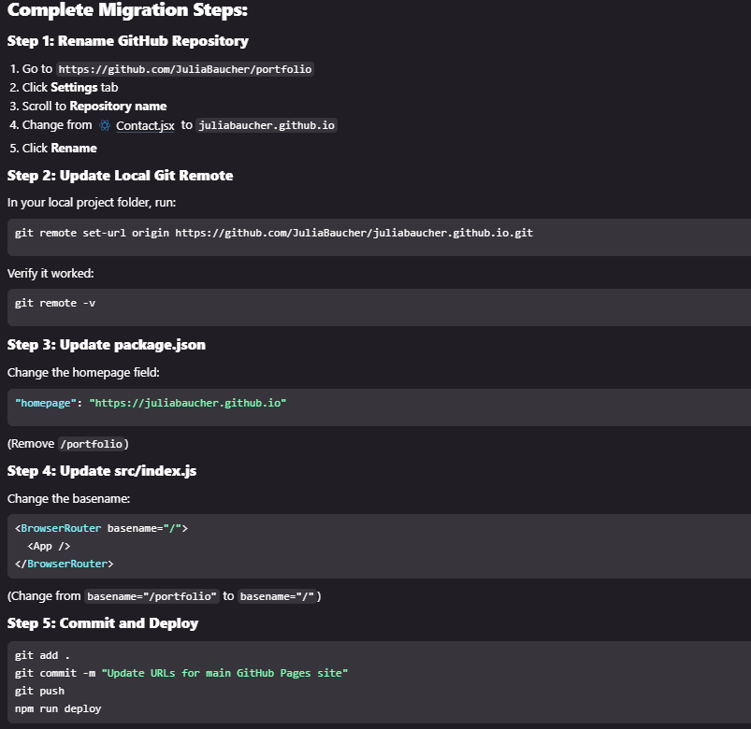
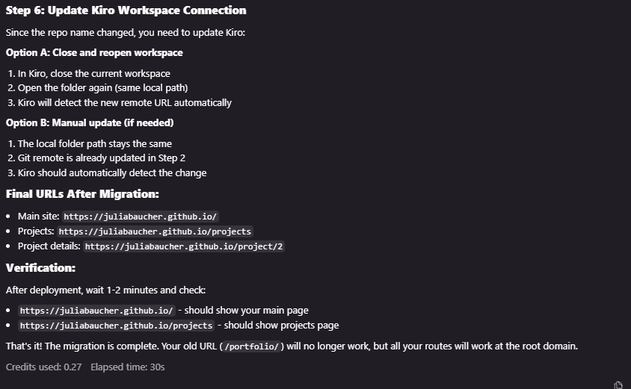

Complete Migration Steps:
Step 1: Rename GitHub Repository
Go to https://github.com/JuliaBaucher/portfolio
Click Settings tab
Scroll to Repository name
Change from
Contact.jsx
to juliabaucher.github.io
Click Rename
Step 2: Update Local Git Remote
In your local project folder, run:

git remote set-url origin https://github.com/JuliaBaucher/juliabaucher.github.io.git
Verify it worked:

git remote -v
Step 3: Update package.json
Change the homepage field:

"homepage": "https://juliabaucher.github.io"
(Remove /portfolio)

Step 4: Update src/index.js
Change the basename:

<BrowserRouter basename="/">
<App />
</BrowserRouter>
(Change from basename="/portfolio" to basename="/")

Step 5: Commit and Deploy
git add .
git commit -m "Update URLs for main GitHub Pages site"
git push
npm run deploy
Step 6: Update Kiro Workspace Connection
Since the repo name changed, you need to update Kiro:

Option A: Close and reopen workspace

In Kiro, close the current workspace
Open the folder again (same local path)
Kiro will detect the new remote URL automatically
Option B: Manual update (if needed)

The local folder path stays the same
Git remote is already updated in Step 2
Kiro should automatically detect the change
Final URLs After Migration:
Main site: https://juliabaucher.github.io/
Projects: https://juliabaucher.github.io/projects
Project details: https://juliabaucher.github.io/project/2
Verification:
After deployment, wait 1-2 minutes and check:

https://juliabaucher.github.io/ - should show your main page
https://juliabaucher.github.io/projects - should show projects page
That's it! The migration is complete. Your old URL (/portfolio/) will no longer work, but all your routes will work at the root domain.

