|  |
| --- |
|  |
| Software Engineering Project |
| Business Informatics III C |

|  |
| --- |
| Prepared by: Julia Bogdani, Krisa Zhanasi, Eno Myderizi  3.06.2023 |

Table of Contents

**Introduction3**

Project goal3

**Application Specifications 3**

Technology Stack3

User Authentication and Authorization3

Functionality 4

Database 4

User Interface 5

**User Requirements5**

Registration 5

Login 5

Event Registration 5

Event Viewing 5

User Profile 6

Map Feature6

**DataBase 7**

**Software Design and Modeling8**

**Introduction:**

Flask Event Calendar Application.

This repository contains a Flask web application that functions as a calendar for events. The application allows users to register their events, view their past events and provides a page with all events. It also includes a user profile page, an event details page that provides additional information about specific events, and a map feature to visualize the event locations.

**Project Goal:**

The goal of this project is to develop a Flask web application that serves as an event calendar. The application aims to provide users with a platform to register their events, view their past events, and explore a comprehensive list of all available events. Additionally, the application will offer a user profile page, an event details page with extended information, and a map feature to visualize the event locations.

By creating this Flask event calendar application, we aim to streamline the process of event management and provide users with a convenient platform to organize, track, and discover various events. The application will empower users to easily register their events, keep a record of their past activities, and gain insights into upcoming events. The inclusion of a user profile page will allow users to manage their account settings and personalize their experience, while the event details page will provide comprehensive information about specific events. The map feature will enhance the user experience by visualizing event locations and facilitating navigation.

Ultimately, the project's goal is to deliver a user-friendly and feature-rich Flask web application that simplifies event management and provides a comprehensive event calendar platform for users.

**Application Specifications:**

1. Technology Stack:

* Backend Framework: Flask (Python)
* Frontend Framework: HTML, CSS, JavaScript
* Database: MySQL
* Web Server: LocalHost

1. User Authentication and Authorization:

* Users should be able to register and log in to the application.
* Passwords should be securely stored using encryption.
* User roles should be implemented to differentiate between administrators and regular users.

1. Functionality:

* Users can register their events, providing details such as event title, date, time, location, description, and event type.
* Users can view their past events, displaying event details and past occurrences. Users have access to a page displaying all events, allowing them to browse and search for specific events based on different criteria (e.g., date, type).
* Users have a user profile page where they can manage their account settings, update personal information, and view a summary of their registered events.
* Users can access an event details page that provides additional information about specific events, including event description, location, and a map visualization.
* The application includes a map feature to display the event locations, allowing users to visualize event venues and plan their attendance.

1. Database:

Event Registration:

* Users can register events on the platform.
* The Event Table stores event information, including a unique ID, user ID (the person who created the event), name, date, location, time, information, player number (playerNR), type of event, and timestamp of the last update.
* Each event is associated with a user who created it.

User Registration:

* Users can create accounts on the platform.
* The User Table stores user information, including a unique ID, name, last name, email, password, birthday, and photo name.
* Users can authenticate using their email and password to access the platform.
* A connection is established between the user and the event they create.

Messaging:

* Users can exchange messages related to events.
* The Messages Table facilitates a many-to-many relationship between users and events.
* Each message is associated with a user who wrote it and an event it belongs to.

Attendance:

* Users can indicate their attendance at events.
* The Attendance Table establishes a many-to-many relationship between users and events.
* For each event, multiple users can attend, and multiple events can have attendees.
* The table records the user ID and event ID for attendance tracking.

1. User Interface

* The application provides a user-friendly interface with intuitive navigation and visually appealing design.
* Users can easily register events, view their past events, and explore the event calendar.

**User Requirements**

1. Registration:

* Users should be able to create an account by providing their username, emailaddress, and password.
* The registration process should validate the uniqueness of the username and email address.
* Users should receive a confirmation email to verify their account.

1. Login:

* Registered users should be able to log in using their credentials (username/email and password).
* The application should authenticate the user's credentials and grant access to the user-specific features and data.

1. Event Registration:

* Users should be able to register their events by providing event details such as event title, date, time, location, description, and event type.
* The application should validate the required fields and provide appropriate error messages for missing or invalid information.
* Users should have the option to add additional event-specific information, such as event images or attachments.

1. Event Viewing:

* Users should be able to view their past events, including event details and historical occurrences.
* The application should provide a page that displays all events, allowing users to browse and search for specific events based on different criteria such as date, type, or keyword.
* Users should be able to navigate to an event details page to access additional information about specific events, including event description, location, and a map visualization.

1. User Profile:

* Users should have a user profile page where they can manage their account settings and update their personal information.
* The profile page should display a summary of the user's registered events, including event titles and dates.
* Users should be able to edit or delete their events from the profile page.

1. Map Feature:

* The application should include a map feature that visualizes event locations.
* The map should display event markers or pins representing different event venues.
* Users should be able to interact with the map, zoom in/out, and click on markers to view event details

**DataBase:**

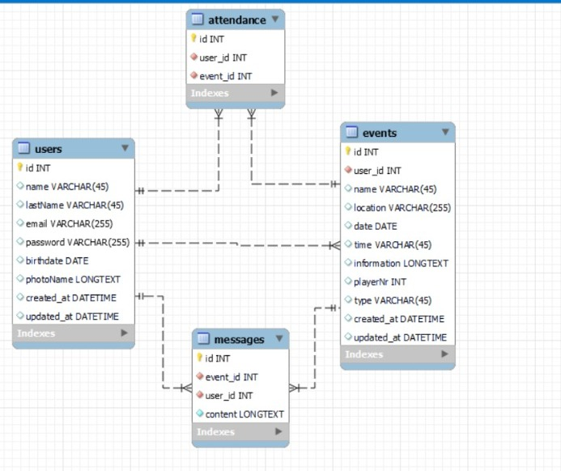

**Software Design and Modeling**

