Описание БД:

Данная база данных моделирует работу сайта booking.com, представляет:

1. Данные о пользователях (имя, фамилия, контактные данные, адрес проживания, платежные данные) (см. рис. 1 – 3);

**CREATE** **TABLE** users (

user_id **int** **auto_increment** **primary** **key**,

title **ENUM** ('Mr','Ms','Mrs'),

first_name **varchar**(100) **NOT** **NULL**,

last_name **varchar**(100) **NOT** **NULL**,

display_name **varchar**(20) **NOT** **NULL**,

email **varchar**(100) **NOT** **NULL**,

phone **varchar**(100) **NOT** **NULL**,

birthday **date** **not** **NULL**,

nationality_id **int** **NOT** **null**,

password_user **varchar**(100) **NOT** **NULL**,

gender **ENUM** ('Male','Female'),

address **varchar**(130) **NOT** **NULL**,

created_at **datetime** **DEFAULT** **current_timestamp**(),

updated_at **datetime** **DEFAULT** **current_timestamp**(),

**CONSTRAINT** nationality_id_fk

**foreign** **key** (nationality_id) **references** nationalities(nationality_id) **on** **delete** **cascade** **on** **update** **cascade**

);

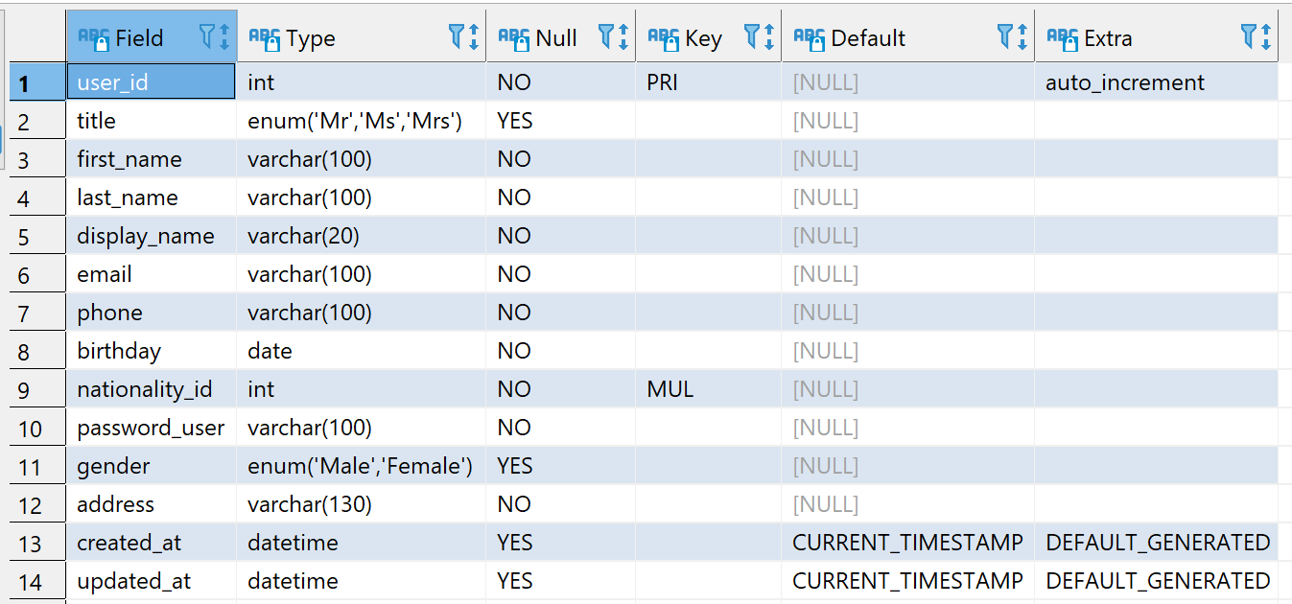

Рис. 1 Таблица Users

**CREATE** **TABLE** nationalities (

nationality_id **int** **auto_increment** **primary** **key**,

nationality **VARCHAR**(20) **NOT** **NULL**

);

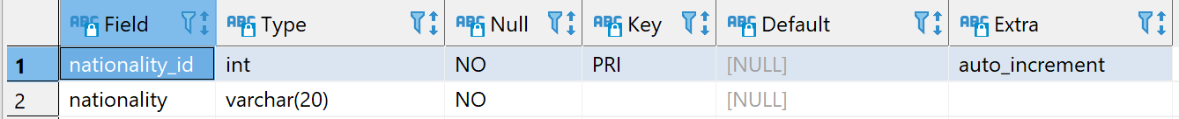

Рис. 2 Таблица Nationalities

**CREATE** **TABLE** payment_details (

user_id **int** **NOT** **null** **primary** **key**,

cardholders_name **varchar**(30) **NOT** **NULL**,

card_number **BIGINT** **unsigned** **NOT** **NULL**,

expiration_date **datetime** **DEFAULT** **NULL**,

**CONSTRAINT** user_id_payment_fk

**foreign** **key** (user_id) **references** users(user_id) **on** **delete** **cascade** **on** **update** **cascade**

);

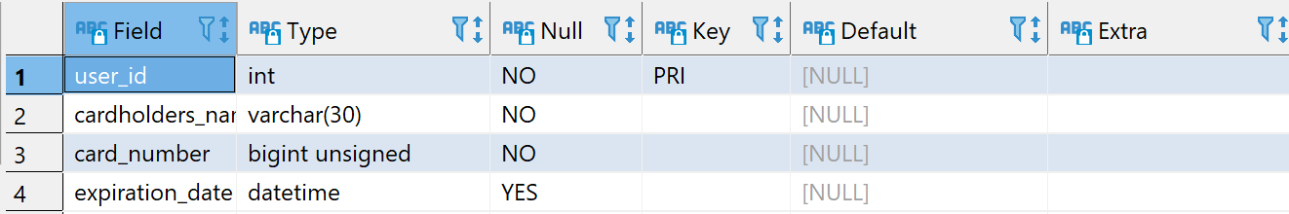

Рис. 3 Таблица Payment_details

1. Данные об отелях (название отеля, местоположение, средний рейтинг согласно отзывам пользователей сайта (если оценок нет, то по умолчанию значение 0), а также отсутствие или присутствие определённых характеристик (парковка, терраса, сейф и т.д.), медиа-данные отеля) (см. рис. 4 – 7);

**CREATE** **TABLE** hotels (

hotel_id **int** **NOT** **NULL** **auto_increment** **primary** **key**,

hotel_name **varchar**(100) **NOT** **NULL**,

street_hotel **varchar**(100) **NOT** **NULL**,

city_hotel **varchar**(100) **NOT** **NULL**,

country_hotel **varchar**(100) **NOT** **NULL**,

year_of_construction **datetime** **NOT** **NULL**,

prepayment **ENUM** ('Yes','No') **NOT** **NULL**,

price **int** **NOT** **NULL**,

type_card **varchar**(100) **NOT** **NULL**,

rating **int**(10) **default** 0,

media_id **int** **NOT** **NULL**,

created_at **datetime** **DEFAULT** **current_timestamp**(),

updated_at **datetime** **DEFAULT** **current_timestamp**(),

**CONSTRAINT** media_id_fk

**foreign** **key** (media_id) **references** media(media_id) **on** **delete** **cascade** **on** **update** **cascade**

);

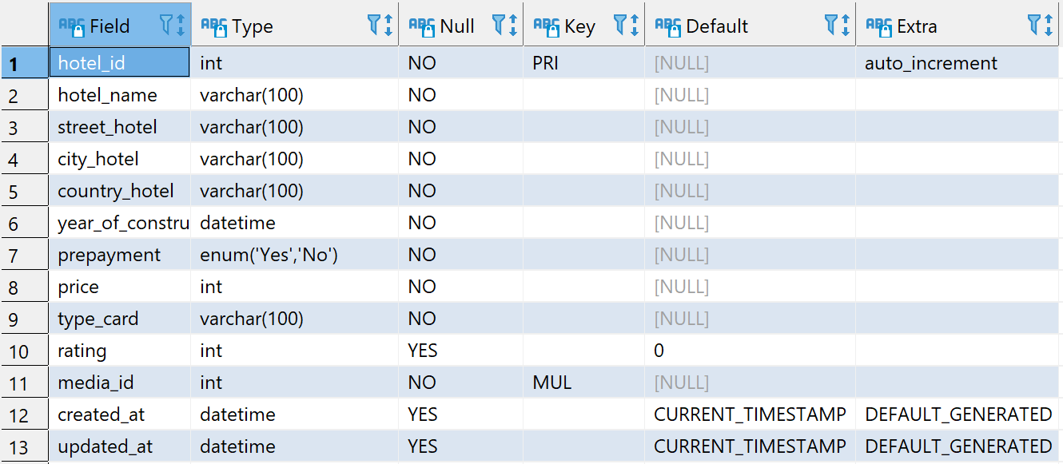

Рис. 4 Таблица Hotels

**CREATE** **TABLE** hotels_included (

hotel_included_id **int** **NOT** **null** **primary** **key**,

wifi **BOOLEAN**,

animal_id **BOOLEAN**,

age_limit **BOOLEAN**,

safe **BOOLEAN**,

patio **BOOLEAN**,

conditioner **BOOLEAN**,

parking_lot **BOOLEAN**,

kid_bedroom **BOOLEAN**,

family_room **BOOLEAN**,

cafe **BOOLEAN**,

nature **BOOLEAN**,

beach **BOOLEAN**,

public_transport **BOOLEAN**,

airport_near **BOOLEAN**,

**CONSTRAINT** hotel_id_fk

**foreign** **key** (hotel_included_id) **references** hotels(hotel_id) **on** **delete** **cascade** **on** **update** **cascade**

);

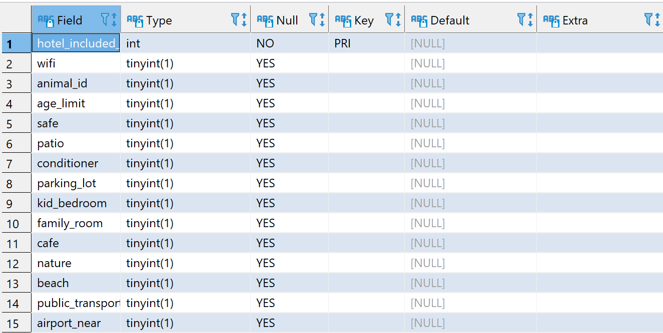

Рис. 5 Таблица Hotel_included

**CREATE** **TABLE** media (

media_id **int**(10) **auto_increment** **primary** **key**,

filename **varchar**(100) **NOT** **NULL**,

**size** **int**(10) **NOT** **NULL**,

metadata JSON,

media_type_id **int** **NOT** **NULL**,

created_at **datetime** **DEFAULT** **current_timestamp**(),

updated_at **datetime** **DEFAULT** **current_timestamp**(),

**CONSTRAINT** media_type_id_fk

**foreign** **key** (media_type_id) **references** media_types(media_type_id) **on** **delete** **cascade** **on** **update** **cascade**

);

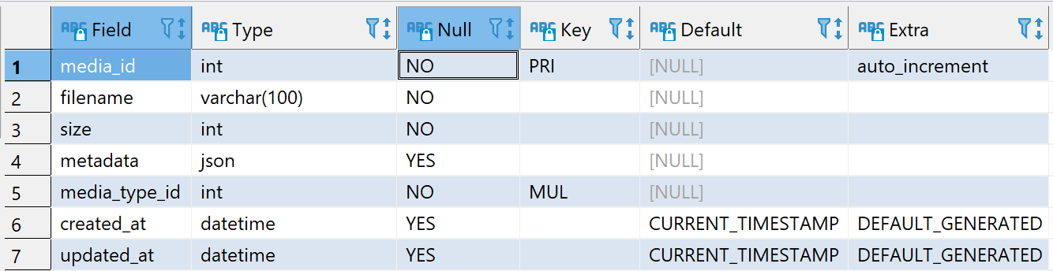

Рис. 6 Таблица Media

**CREATE** **TABLE** media_types (

media_type_id **int** **NOT** **NULL** **auto_increment** **primary** **key**,

type_media **varchar**(100) **NOT** **NULL**,

created_at **datetime** **DEFAULT** **current_timestamp**(),

updated_at **datetime** **DEFAULT** **current_timestamp**()

);

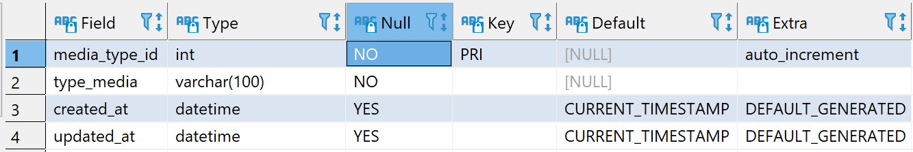

Рис. 7 Таблица Media_types

**CREATE** **TABLE** bookings (

booking_id **int** **NOT** **null** **AUTO_INCREMENT** **primary** **key**,

user_id **int** **NOT** **NULL**,

hotel_id **int** **NOT** **NULL**,

created_at **datetime** **DEFAULT** **NULL**,

arrival_day **datetime** **DEFAULT** **NULL**,

check_out_day **datetime** **DEFAULT** **NULL**,

count_days **int** **unsigned** **DEFAULT** **NULL**,

business_trip **boolean**,

count_adult **int**(5) **NOT** **NULL**,

count_child **int**(5) **NOT** **NULL**,

count_animal **int**(5) **NOT** **NULL**,

review_id **int** **default** **NULL**,

**CONSTRAINT** user_id_booking_fk

**foreign** **key** (user_id) **references** users(user_id) **on** **delete** **cascade** **on** **update** **cascade**,

**CONSTRAINT** hotel_id_booking_fk

**foreign** **key** (hotel_id) **references** hotels(hotel_id) **on** **delete** **cascade** **on** **update** **cascade**

);

1. Данные о бронировании отеля пользователями (id отеля, id отеля, дата бронирования, дата заезда, даты выезда, количество дней, отметка «бизнес поездка», количество взрослых, детей, животных в номере)

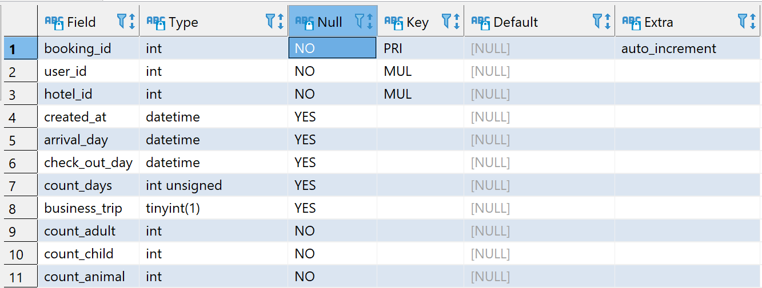

Рис. 8 Таблица Bookings

1. Отзывы пользователей после посещения выбранного ими отеля с проставлением оценки по 10-ти бальной шкале

**CREATE** **TABLE** reviews (

review_id **int** **auto_increment** **primary** **key**,

hotel_id **int** **not** **null**,

rating **int**(10),

body **text** **NOT** **NULL** COMMENT 'Текст сообщения',

created_at **datetime** **DEFAULT** **null**,

**CONSTRAINT** hotel_id_reviews_fk

**foreign** **key** (hotel_id) **references** bookings(hotel_id) **on** **delete** **cascade** **on** **update** **cascade**

);

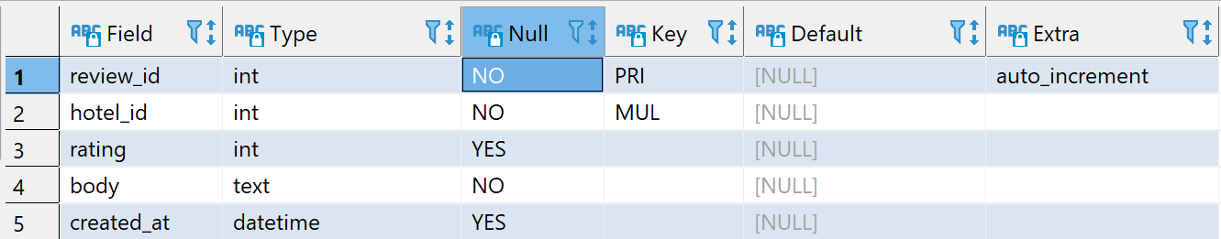

Рис. 9 Таблица Reviews

ERDiagram для данной БД:

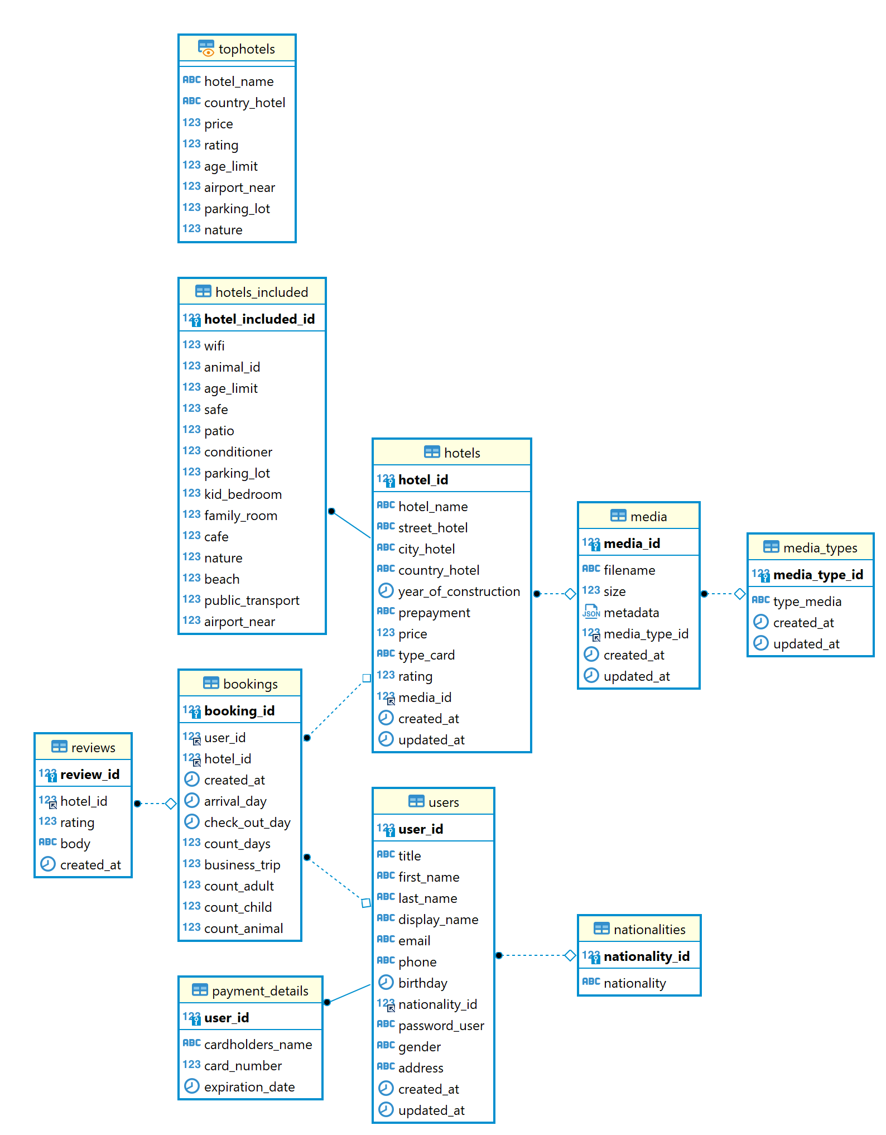

Скрипты наполнения БД данными:

Заполнение таблицы nationalities

**INSERT** **INTO** nationalities (nationality) **VALUES**

('Afghan'), ('Argentine'),('Australian'),('American'),

('Belarusian'), ('Belgian'), ('Brazilian'), ('Bolivian'), ('British'),

('Cambodian'), ('Canadian'), ('Chilean'), ('Chinese'), ('Colombian'), ('Costa Rican'), ('Cuban'), ('Cypriot'), ('Czech'),

('Danish'), ('Dominican'),

('Ecuadorian'), ('Egyptian'), ('Emirati')…

Заполнение таблицы users

**INSERT** **INTO** `users` (`user_id`, `title`, `first_name`, `last_name`, `display_name`, `email`, `phone`, `birthday`, `nationality_id`, `password_user`, `gender`, `address`, `created_at`, `updated_at`) **VALUES** (1, 'Ms', 'Kelsi', 'Schmeler', 'beatae', 'kolby86@example.com', '(472)348-2537x173', '2005-01-07', 70, 'a3c5cbf2702a03a64ddeac7a4ca30cd4', 'Male', '29168 Bahringer Gateway Apt. 814\nRunolfsdottirmouth, NE 80586-2831', '1992-07-25 03:57:32', '1995-03-30 04:27:20');

**INSERT** **INTO** `users` (`user_id`, `title`, `first_name`, `last_name`, `display_name`, `email`, `phone`, `birthday`, `nationality_id`, `password_user`, `gender`, `address`, `created_at`, `updated_at`) **VALUES** (2, 'Mrs', 'Kaylee', 'Yundt', 'assumenda', 'marilou.marquardt@example.com', '228.696.2075x18456', '1970-08-12', 2, '9d16f1636777386754ab92523e963d29', 'Male', '386 Bradtke Springs Suite 628\nLake Estevanview, MD 09157', '2020-09-22 14:30:51', '1992-11-07 06:44:55');

**INSERT** **INTO** `users` (`user_id`, `title`, `first_name`, `last_name`, `display_name`, `email`, `phone`, `birthday`, `nationality_id`, `password_user`, `gender`, `address`, `created_at`, `updated_at`) **VALUES** (3, 'Mr', 'Ada', 'Trantow', 'autem', 'timmy.reilly@example.org', '(905)731-7915x54055', '1991-10-25', 3, '2803226be9d8f1e4683ef9f6e5bc0174', 'Male', '90180 Boris Circles\nNew Abagailport, SC 50462', '1983-06-13 07:07:40', '1983-08-09 19:58:12');

**INSERT** **INTO** `users` (`user_id`, `title`, `first_name`, `last_name`, `display_name`, `email`, `phone`, `birthday`, `nationality_id`, `password_user`, `gender`, `address`, `created_at`, `updated_at`) **VALUES** (4, 'Mrs', 'Anastasia', 'Gottlieb', 'voluptatem', 'dibbert.ernestina@example.net', '588.297.8599x5582', '2003-02-12', 4, '6121ae24593cf7c3af9bd6c043e6e7e5', 'Male', '18035 Faustino Drive Apt. 201\nPort Roslynton, RI 61709', '1976-02-06 21:12:31', '1976-06-15 12:23:46');

**INSERT** **INTO** `users` (`user_id`, `title`, `first_name`, `last_name`, `display_name`, `email`, `phone`, `birthday`, `nationality_id`, `password_user`, `gender`, `address`, `created_at`, `updated_at`) **VALUES** (5, 'Mr', 'Ally', 'Thiel', 'neque', 'myrtice.barrows@example.net', '(961)536-2303x4215', '1981-01-04', 5, '5152e00397b781e8e60ba677c3d9a447', 'Male', '24816 Riley Viaduct\nMarkusbury, WA 32799', '1985-09-17 02:43:53', '1981-11-27 14:14:12');

**INSERT** **INTO** `users` (`user_id`, `title`, `first_name`, `last_name`, `display_name`, `email`, `phone`, `birthday`, `nationality_id`, `password_user`, `gender`, `address`, `created_at`, `updated_at`) **VALUES** (6, 'Mr', 'Lizzie', 'Williamson', 'quasi', 'ekub@example.org', '+17(8)4104053386', '2003-10-28', 6, '5ccdde524690be70ec99fafcc1e036b7', 'Female', '36593 Osinski Inlet Apt. 086\nNorth Tylershire, NM 88207-4054', '1974-12-04 05:20:05', '2001-05-17 03:15:39');

**INSERT** **INTO** `users` (`user_id`, `title`, `first_name`, `last_name`, `display_name`, `email`, `phone`, `birthday`, `nationality_id`, `password_user`, `gender`, `address`, `created_at`, `updated_at`) **VALUES** (7, 'Mrs', 'Eliezer', 'Torp', 'aspernatur', 'lia71@example.com', '+35(5)6693603451', '1974-10-10', 7, 'efbb72d4110c7d6c641f567d99006475', 'Male', '44936 Curtis Isle\nEast Josianne, KS 45793-6937', '2013-06-25 08:21:13', '2010-10-11 09:53:35');

**INSERT** **INTO** `users` (`user_id`, `title`, `first_name`, `last_name`, `display_name`, `email`, `phone`, `birthday`, `nationality_id`, `password_user`, `gender`, `address`, `created_at`, `updated_at`) **VALUES** (8, 'Ms', 'Malinda', 'Kirlin', 'vero', 'acormier@example.org', '(490)996-4610', '1974-01-20', 8, '277c3a74211b59a3744c91488490df99', 'Female', '386 Laila Forge\nWest Gerryborough, NV 95197', '2008-12-19 11:21:53', '1986-11-26 18:45:22');…

Заполнение таблицы payment_details

**INSERT** **INTO** `payment_details` (`user_id`, `cardholders_name`, `card_number`, `expiration_date`) **VALUES** (1, 'vitae', '4024007187397928', '0000-00-00 00:00:00');

**INSERT** **INTO** `payment_details` (`user_id`, `cardholders_name`, `card_number`, `expiration_date`) **VALUES** (2, 'placeat', '375421208900254', '0000-00-00 00:00:00');

**INSERT** **INTO** `payment_details` (`user_id`, `cardholders_name`, `card_number`, `expiration_date`) **VALUES** (3, 'quia', '4539475998420', '0000-00-00 00:00:00');

**INSERT** **INTO** `payment_details` (`user_id`, `cardholders_name`, `card_number`, `expiration_date`) **VALUES** (4, 'eos', '4024007112321', '0000-00-00 00:00:00');

**INSERT** **INTO** `payment_details` (`user_id`, `cardholders_name`, `card_number`, `expiration_date`) **VALUES** (5, 'voluptatibus', '4061666146136', '0000-00-00 00:00:00');

**INSERT** **INTO** `payment_details` (`user_id`, `cardholders_name`, `card_number`, `expiration_date`) **VALUES** (6, 'sunt', '6011015817266880', '0000-00-00 00:00:00');

**INSERT** **INTO** `payment_details` (`user_id`, `cardholders_name`, `card_number`, `expiration_date`) **VALUES** (7, 'quod', '5565446244757730', '0000-00-00 00:00:00');

Заполнение таблицы media_types

**INSERT** **INTO** media_types (type_media) **VALUES** ('video');

**INSERT** **INTO** media_types (type_media) **VALUES** ('audio');

**INSERT** **INTO** media_types (type_media) **VALUES** ('picture');

Заполнение таблицы media

**INSERT** **INTO** `media` (`media_id`, `filename`, `size`, `metadata`, `media_type_id`, `created_at`, `updated_at`) **VALUES** (1, 'ut', 8717, '5', 1, '1989-08-28 17:53:51', '1981-10-12 18:21:46');

**INSERT** **INTO** `media` (`media_id`, `filename`, `size`, `metadata`, `media_type_id`, `created_at`, `updated_at`) **VALUES** (2, 'eveniet', 7423, '7', 2, '1998-05-20 18:36:49', '2020-08-31 19:05:25');

**INSERT** **INTO** `media` (`media_id`, `filename`, `size`, `metadata`, `media_type_id`, `created_at`, `updated_at`) **VALUES** (3, 'sed', 9250, '4', 3, '2011-06-24 23:06:04', '2000-08-14 11:15:41');

**INSERT** **INTO** `media` (`media_id`, `filename`, `size`, `metadata`, `media_type_id`, `created_at`, `updated_at`) **VALUES** (4, 'eaque', 2625, '4', 1, '2018-02-11 23:48:20', '2004-01-10 15:15:38');

Заполнение таблицы hotels

**INSERT** **INTO** `hotels` (`hotel_id`, `hotel_name`, `street_hotel`, `city_hotel`, `country_hotel`, `year_of_construction`, `prepayment`, `price`, `type_card`, `rating`, `media_id`, `created_at`, `updated_at`) **VALUES** (1, 'Dach LLC', '8265 Esta Light', 'Connellyshire', 'Western Sahara', '1985-06-28 18:17:02', 'Yes', 21785, 'MasterCard', 532402698, 1, '1973-06-01 12:42:19', '1973-10-18 10:03:27');

**INSERT** **INTO** `hotels` (`hotel_id`, `hotel_name`, `street_hotel`, `city_hotel`, `country_hotel`, `year_of_construction`, `prepayment`, `price`, `type_card`, `rating`, `media_id`, `created_at`, `updated_at`) **VALUES** (2, 'Osinski-Donnelly', '327 Lowe Plaza', 'Smithstad', 'Haiti', '1987-10-02 17:32:22', 'Yes', 16095, 'American Express', 279, 2, '2008-10-20 12:05:11', '1986-01-11 02:54:23');

**INSERT** **INTO** `hotels` (`hotel_id`, `hotel_name`, `street_hotel`, `city_hotel`, `country_hotel`, `year_of_construction`, `prepayment`, `price`, `type_card`, `rating`, `media_id`, `created_at`, `updated_at`) **VALUES** (3, 'Harber PLC', '805 Meda Harbors', 'West Oma', 'Djibouti', '1971-11-17 11:29:23', 'Yes', 13560, 'MasterCard', 920910, 3, '2000-10-02 08:47:41', '1981-08-07 21:28:51');

**INSERT** **INTO** `hotels` (`hotel_id`, `hotel_name`, `street_hotel`, `city_hotel`, `country_hotel`, `year_of_construction`, `prepayment`, `price`, `type_card`, `rating`, `media_id`, `created_at`, `updated_at`) **VALUES** (4, 'Hoeger-Anderson', '9243 Senger Harbor', 'Jaskolskiview', 'Jordan', '2016-07-13 05:21:44', 'No', 31437, 'Visa', 851778, 4, '2011-12-31 09:32:01', '1997-10-09 13:24:27');

**INSERT** **INTO** `hotels` (`hotel_id`, `hotel_name`, `street_hotel`, `city_hotel`, `country_hotel`, `year_of_construction`, `prepayment`, `price`, `type_card`, `rating`, `media_id`, `created_at`, `updated_at`) **VALUES** (5, 'Boyer and Sons', '774 Carley Trail', 'Kristofferfort', 'Cocos (Keeling) Islands', '1995-01-11 08:02:04', 'Yes', 35529, 'Visa', 0, 5, '2012-05-05 12:14:03', '2019-09-25 12:48:20');

Заполнение таблицы hotels_included

**INSERT** **INTO** `hotels_included` (`hotel_included_id`, `wifi`, `animal_id`, `age_limit`, `safe`, `patio`, `conditioner`, `parking_lot`, `kid_bedroom`, `family_room`, `cafe`, `nature`, `beach`, `public_transport`, `airport_near`) **VALUES** (1, 1, 0, 1, 1, 1, 0, 1, 0, 1, 1, 0, 0, 0, 0);

**INSERT** **INTO** `hotels_included` (`hotel_included_id`, `wifi`, `animal_id`, `age_limit`, `safe`, `patio`, `conditioner`, `parking_lot`, `kid_bedroom`, `family_room`, `cafe`, `nature`, `beach`, `public_transport`, `airport_near`) **VALUES** (2, 0, 1, 1, 0, 1, 0, 1, 1, 0, 0, 0, 1, 1, 1);

**INSERT** **INTO** `hotels_included` (`hotel_included_id`, `wifi`, `animal_id`, `age_limit`, `safe`, `patio`, `conditioner`, `parking_lot`, `kid_bedroom`, `family_room`, `cafe`, `nature`, `beach`, `public_transport`, `airport_near`) **VALUES** (3, 1, 0, 0, 1, 1, 1, 0, 1, 1, 1, 1, 0, 1, 0);

**INSERT** **INTO** `hotels_included` (`hotel_included_id`, `wifi`, `animal_id`, `age_limit`, `safe`, `patio`, `conditioner`, `parking_lot`, `kid_bedroom`, `family_room`, `cafe`, `nature`, `beach`, `public_transport`, `airport_near`) **VALUES** (4, 1, 0, 0, 1, 1, 0, 1, 0, 0, 1, 1, 1, 1, 0);

**INSERT** **INTO** `hotels_included` (`hotel_included_id`, `wifi`, `animal_id`, `age_limit`, `safe`, `patio`, `conditioner`, `parking_lot`, `kid_bedroom`, `family_room`, `cafe`, `nature`, `beach`, `public_transport`, `airport_near`) **VALUES** (5, 1, 1, 0, 0, 0, 1, 1, 0, 0, 0, 1, 1, 1, 0);

Заполнение таблицы bookings

**INSERT** **INTO** `bookings` (`booking_id`, `user_id`, `hotel_id`, `created_at`, `arrival_day`, `check_out_day`, `count_days`, `business_trip`, `count_adult`, `count_child`, `count_animal`, `review_id`) **VALUES** (1, 1, 1, '2003-01-08 22:34:19', '1981-12-04 23:26:55', '2005-02-04 19:30:41', 0, 0, 6, 641465507, 0, 1);

**INSERT** **INTO** `bookings` (`booking_id`, `user_id`, `hotel_id`, `created_at`, `arrival_day`, `check_out_day`, `count_days`, `business_trip`, `count_adult`, `count_child`, `count_animal`, `review_id`) **VALUES** (2, 2, 2, '1998-10-02 07:20:54', '1983-02-26 07:13:47', '1974-08-07 11:11:49', 206, 1, 27577054, 904722611, 2897821, 2);

**INSERT** **INTO** `bookings` (`booking_id`, `user_id`, `hotel_id`, `created_at`, `arrival_day`, `check_out_day`, `count_days`, `business_trip`, `count_adult`, `count_child`, `count_animal`, `review_id`) **VALUES** (3, 3, 3, '2010-05-28 21:47:21', '1992-08-27 08:09:07', '1986-10-08 14:55:17', 734819, 1, 0, 3577713, 485, 3);

**INSERT** **INTO** `bookings` (`booking_id`, `user_id`, `hotel_id`, `created_at`, `arrival_day`, `check_out_day`, `count_days`, `business_trip`, `count_adult`, `count_child`, `count_animal`, `review_id`) **VALUES** (4, 4, 4, '1992-03-04 06:52:47', '1978-11-29 01:30:52', '1974-01-30 06:23:56', 49125, 0, 2515301, 73, 0, 4);

Заполнение таблицы bookings

**INSERT** **INTO** `reviews` (`review_id`, `hotel_id`, `rating`, `body`, `created_at`) **VALUES** (1, (**select** hotel_id **from** bookings **order** **by** **rand**() **limit** 1), 5, 'Assumenda eveniet quis quam repudiandae mollitia. Nemo quia sequi sunt repellat et est expedita. Pariatur vitae quasi non blanditiis veniam qui.', '1982-03-29 08:58:23');

**INSERT** **INTO** `reviews` (`review_id`, `hotel_id`, `rating`, `body`, `created_at`) **VALUES** (2, (**select** hotel_id **from** bookings **order** **by** **rand**() **limit** 1), 4, 'Modi qui dignissimos non molestiae. Reprehenderit autem maiores occaecati optio.\nSapiente voluptatibus quia eaque animi. Sit sed magnam neque quae. Possimus qui aut dolorum sequi.', '2003-07-19 16:49:41');

**INSERT** **INTO** `reviews` (`review_id`, `hotel_id`, `rating`, `body`, `created_at`) **VALUES** (3, (**select** hotel_id **from** bookings **order** **by** **rand**() **limit** 1), 6, 'Voluptatem repellendus praesentium eum voluptatem quam et. Voluptatem quisquam aut magnam vel ipsum velit qui. A ipsum impedit debitis dolorem delectus.', '1986-03-04 15:14:06');

Проведена корректировка данных после автозаполнения полей на сайте http://filldb.info/

**update** payment_details **set** cardholders_name = (**select** **CONCAT**(first_name, ' ', last_name) **from** users **where** payment_details.user_id = user_id);

-- Update card_number

**update** payment_details **set** card_number =**floor**( **rand**()*(9999999999999999-1000000000000000));

**select** * **from** payment_details;

**UPDATE** media **SET** metadata = **CONCAT**('{"owner":"',

(**SELECT** **CONCAT**(first_name, ' ', last_name) **FROM** users **WHERE** media_id = user_id),

'"}');

**DROP** **TABLE** **IF** **EXISTS** `extensions`;

**CREATE** **TEMPORARY** **TABLE** extensions (name **VARCHAR**(10));

**INSERT** **INTO** extensions **VALUES** ('jpeg'), ('avi'), ('mpeg'), ('png');

**UPDATE** media **SET** filename = **CONCAT**(

'http://dropbox.net/booking/',

filename,

'.',

(**SELECT** name **FROM** extensions **ORDER** **BY** **RAND**() **LIMIT** 1)

);

**update** hotels **set** rating = 0;

**UPDATE** media **SET** updated_at = **NOW**() **WHERE** updated_at < created_at;

**UPDATE** bookings **SET** user_id = **FLOOR**(1 + **RAND**() * 30);

**UPDATE** bookings **SET** hotel_id = **FLOOR**(1 + **RAND**() * 100);

**update** bookings **set** created_at = arrival_day - **interval** (1 + **RAND**() * 12) **month**;

**update** bookings **set** check_out_day = arrival_day + **interval** (1 + **RAND**() * 30) **day**;

**UPDATE** bookings **SET** count_days= **DATEDIFF**(check_out_day,arrival_day);

**UPDATE** bookings **SET** count_adult = **FLOOR**(1 + **RAND**() * 3);

**UPDATE** bookings **SET** count_animal = **FLOOR**(1 + **RAND**() * 1);

**UPDATE** bookings **SET** count_child = **FLOOR**(1 + **RAND**() * 2);

**update** hotels **set** rating = (**select** **avg**(rating) **from** reviews **where** hotels.hotel_id = hotel_id);

**update** hotels **set** rating = 0 **where** rating **is** **null**;