sudo apt update && sudo apt -y upgrade

**sudo apt update**

* Contacts all the software repositories listed in your system’s configuration (e.g., Ubuntu’s package servers).
* Downloads the latest package lists — this tells your system what new versions are available but does not install anything yet.

**sudo apt -y upgrade**

* Installs the newest versions of all packages currently installed on your system, based on the list from the apt update.
* The -y flag automatically answers “yes” to any confirmation prompts, so it will proceed without asking you to approve each update.

**In short:** it refreshes your package index and upgrades all installed software to the latest versions available, without asking for manual confirmation.

sudo timedatectl set-timezone Etc/UTC *# or your TZ*

sudo timedatectl set-timezone Asia/Jerusalem

To verify:

timedatectl

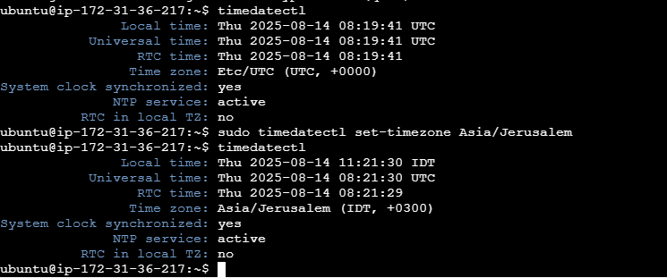

**Effect of server timezone on overseas clients**

* **Networking:** The timezone on your EC2 instance has *no effect* on how clients connect to it. IP routing, DNS, and HTTP requests are independent of your system clock’s timezone.
* **Timestamps in logs & data:** What changes is how the server *displays and records* times — for example, in log files, database timestamps (if using the system timezone), or app-generated reports.
* **Client experience:**
  + If your app just serves data without embedding your server’s local time, overseas users won’t see a difference.
  + If your app uses local server time to tag events, users in other timezones will see those timestamps in Jerusalem time unless you convert them to their local time in the app.
* Currently set timezone to Jerusalem.