MEMORANDUM

To: ACME Corp

From: Chris Hales, Julia Giesbrecht, and Andrew Zinkan

Subject: Agricultural profits

ACME’s proposed transition into the Ghana agricultural market for profit generation has promising outlooks. However, there are specific factors worth focusing on that could weigh heavily on the profitable outcome of this endeavor. Our team has conducted a statistical analysis based on the REPUBLIC OF GHANA – STATISTICAL LIVING STANDARDS SURVEY for 1992 – 1999. This data at large captures agricultural, location-based, and educational survey data from the residence of 10 different regions in Ghana. Found below are the results of our findings from our statistical analysis that most influence agricultural profits.

Agricultural findings:

Based on our statistical findings found in Figure1, it is evident that both region-9 and region-10 impacted profit negatively. Holding everything else constant, these regions decrease agricultural profit by $591,312 and $707,396 respectively. This result is quite significant in comparison to the result seen in region 5, with an increase in profits of $1,232,363 (Figure1). In conclusion, our recommendation would be to avoid any agricultural endeavors in region-9 and regions-10. Instead, favoring region-5 as it is seen to most increase profits in comparison to other regions in Ghana.

For each additional unique type of equipment, profits decrease by $ 24,331(Figure1), while holding everything else constant. This result found in our statistical model reflects the notion that buying more unique equipment for farming (equipment needed for a variety of crops) does not help with profitability. It would be recommended to specialize in a few types of crops, sharing common tooling to increase profits.

Crop acre is straightforward. The more land you devote to crops the more money you are going to make. This strengthens the idea that having more land will increase profits. This idea is also held up by another variable, land amount owned, which behaves similarly in the model. More land, more gross profit can be achieved. However, there is flip side, for each additional acre of land owned decrees the overall profit per acre by about $10,000. (Figure 3A)

Education and household findings:

The number of people in each household has a significant factor in the overall profitability of farms in Ghana. As you can see in (Figure1), for each additional person in a household, there is an increase in profits per acre of $49,441, while holding everything else constant. Therefore, it would be our recommendation to find farms that hold this standard.

Education attainment on the overall profitability of agricultural farms is seen to decrease profits by $59,656, with a later increase in profits by $543, (Figure1-Education^2) while holding everything else constant. This result could be due to fewer members of the household being able to tend to the farm initialy with a later return. In conclusion, it would be our recommendation to look for farms where the household has more education to increase profitability in the long term.

The recent health of the workforce significantly impacts agricultural profits as seen in Figure1. For households who have had recent health condition in the last two weeks, there is a decrease in profit by $176, 601 compared to households who have not. We would recommend farms with individuals who have fewer health concerns to increase profits.

|  |  |  |  |  |  |  |  |  |  |
| --- | --- | --- | --- | --- | --- | --- | --- | --- | --- |
| Variables | Region 5 | Region 9 | Region 10 | Unique Eqt | Crop Acre | Num of People | Education | Education^2 | Recent Health |
| Coefficients | 1,232,363 | -591,312 | -707,396 | -24,331 | 2,572 | 49,441 | -59,656 | 543 | -176,601 |

Figure1. This model reflects the coefficients of our chosen model and their corresponding values in relation to agricultural profit.

**Appendix A**

Statistical Analysis from the REPUBLIC OF GHANA – STATISTICAL LIVING STANDARDS SURVEY for 1992-1999. Found below is the statistical interpretation of our findings that most influence agricultural profits in Ghana.

Agricultural Variables

|  |  |  |
| --- | --- | --- |
| **Variable** | **Description** | **Predictions** |
| Region | Categorical indicator for region with which the household resides | Certain regions will report statistically different profits per region. |
| Unique_eqt_cnt | The recorded number of unique types of agricultural equipment owned by household | The more types of Equipment available to use will increase the profitability per acre (We found there was a opposite reaction) |
| area | The reported total plot size of agricultural land owned by house (reported in acres) | Predict economies or scale. Reasoning - The more land you have the higher profit you can return (We found there was a opposite reaction) |
| crop_acre | = Crop QTY / total acres. This reports the ratio of total crops reported to the amount of land held in acres. | Predict that the higher the ratio of crop QTY to acres or land would increase profitability of that land.  (More condensed farms will have greater profit per acre) |

Education Variables

|  |  |  |
| --- | --- | --- |
| **Variable** | **Description** | **Predictions** |
| Educational_attainment | Highest level of education completed per household. Found in file sec2a.dta. Created by grouping ‘nh’ and ‘clust’ to get the household level. Summarizing by finding max (s2aq2) per household. | Predicted to increase profits by increasing education levels in the household. |

Health Variables

|  |  |  |
| --- | --- | --- |
| **Variable** | **Description** | **Predictions** |
| b_Health_conditions_in_last_two_weeks | Has someone in the household suffered injury or illness in the last two weeks (0-no, 1-yes). Found in file sec3a.dta. Created by grouping ‘nh’ and ‘clust’ to get the household level. Summarizing by finding max (s3aq1) per household. | Predicted to have a larger decrease in profits if someone in the household has had a health condition in the last two weeks, compared to if they have not |
| Nh_num_people | This is the total number of people within a given household. It is derived from grouping by ‘clust’ and ‘nh’ and then getting the max pid. | With more people profits should increase as more people are around to help with the household and work. |

Figure1A. Variable descriptions. These are the variables we are using, their description, and how they were each created. We have provided our predictions of each variable and how we think it will influence agricultural profit.

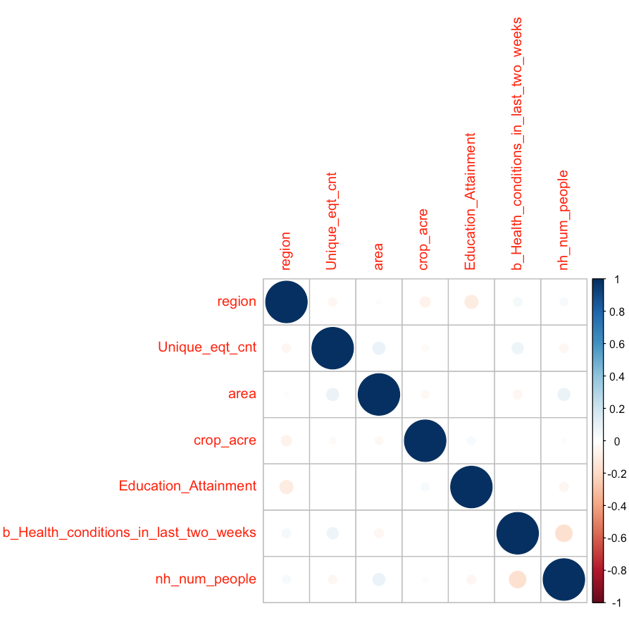

Figure2A. correlation table of the chosen variables. (Notice: variables are not highly correlated)

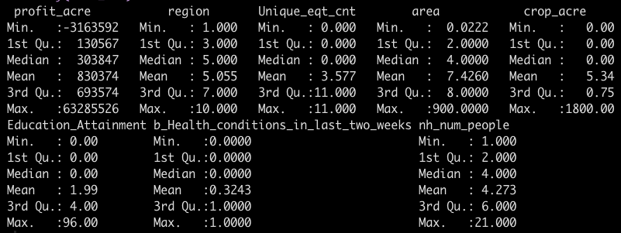

Figure3A. Summary Statistics of variables

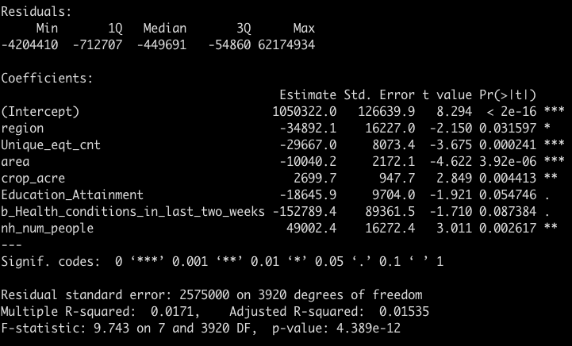

Figure4A. This is the main model, without factors, interactions, or squares. Figure4A reflects a linear model using profit_acre as the dependent variable.

As for Unique_eqt_cnt, with each additional unique type of farm equipment, there is a decrease in profits by $29,667 while holding everything else constant and is statistically significant at the 0.1% level. This is different from our prediction that the more types of equipment available would increase the profit yield of an acre of land.

The total area of land owned by each house shows that for each additional acre of land there is a decrease in profits by $100,040. This is statistically significant at the 0.1% level. This is different from our prediction that the larger the plot of agricultural land the higher the profit yield per acre would be. However, thinking more about the relationship between total profits and total land, a diminishing marginal rate of return makes since as each additional unit of land is not likely to have an increasing yield.

Crops_acre or (the ratio of total crops to total acres) is statistically significant at the 1% level. For each additional unit of ‘crops_acre’ (or a 1-point increase in the ratio of crops to land) increases the yield by $2699 holding all else constant. This matches our assumption that the more condensed your harvest the more it would increase your profit per acre.

According to the model, while holding everything else constant, as the maximum level of education increases by one, there is a decrease in profits by $18,645. This is not statistically significant. This is significantly different than our predicted effect. It was predicted that education would increase profits, however, that is not the results that we are seeing in this model.

For households who have had someone with a health condition in the last two weeks, there is $152,789 less in profit than those who have not had any health conditions in the last two weeks. This is not statistically significant. This result is consistent with our prediction, in that health conditions negatively impact agricultural profits.

For each additional member of the household, there is an increase in profits by $49,002, while holding everything else constant. This is statistically significant at the 1% level. This result is logical, and lines up with our prediction. It was predicted that additional members of the household would increase profits, and this stands true based on our model.

R2 based on our initial model (Figure4A) we receive an R2 value of 0.0171 and an adjusted R2 value of 0.01535. This suggests that based on our regression our data only explains 1.5% of our variation in profit per acre. This suggests that we do not have a strong model, nor would we be able to accurately predict profit per acre with a liner model given the features we elected to use.

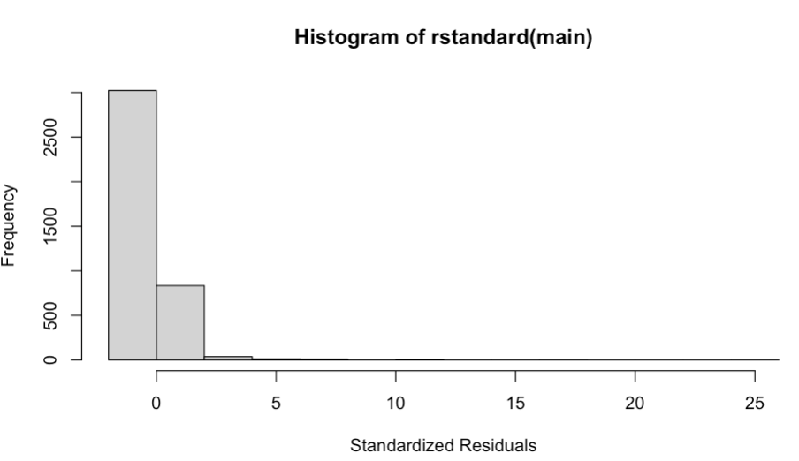

Figure 5A. This graph represents the standardized residuals of the model seen in Figure4A. The standardized residuals from the histogram show that the residuals are not normally distributed. We have a longer tail on the right side than the left side. There is no sign of a symmetric bell-shaped graph.

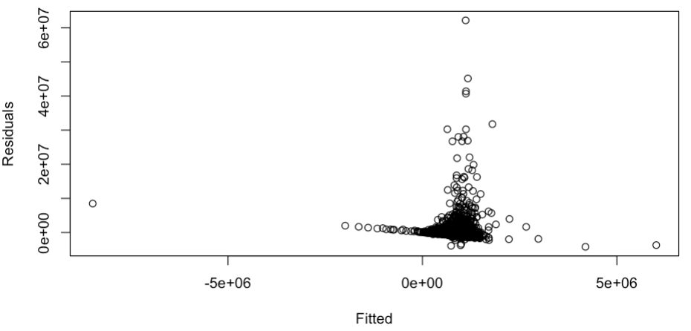

Figure 6A. This graph shows the residual distribution for the model in Figure 6A. It is evident that the residual vs fitted graph has heteroskedasticity and non-constant variance. However, it appears that it has the correct functional form.

“Final” model

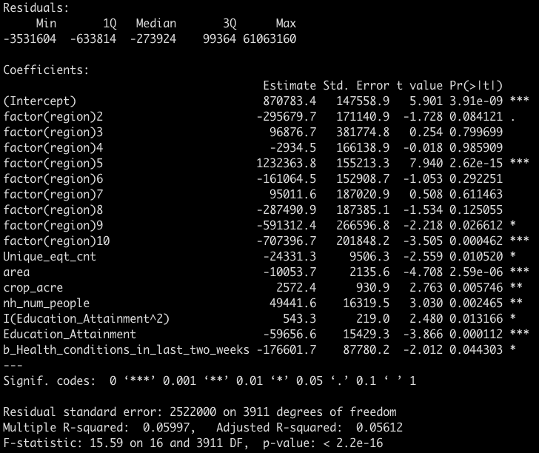

Figure 7A.

Final model with Education_attainment squared and region transformed as a factorial regressed on the dependent variable profit_acre.

Regions in this model are expressed as dummy variables a no longer scalar values like in our original model (figure4A). Regions in this model can be interpreted as if you reside in ‘X’ region or not. In this case we see that holding all else constant Region 5 is predicted to have a $1.2M increase in profit per acre relative to farms not operating in region 5. An opposing observation can be made for region 10, suggesting that farmers in region 10 are likely to produce –$700K less per acre when compared to other regions. Both regions are statistically significant at the 0.1% level.

As for Unique_eqt_cnt, with each additional unique type of farm equipment, there is a decrease in profits by $24,331 while holding everything else constant and is statistically significant at the 5% level. This is different from our prediction that the more types of equipment would increase profit yield per acre.

The total area of land owned by each house shows that for each additional acre of land there is a decrease in profits by $10,053. This is statistically significant at the 0.1% level. This is different from our prediction that the more land you owned the more the more profitable each acre would be.

Crops_acre is statistically significant at the 1% level. For each additional unit of ‘crops_acre’ (or a 1-point increase in the ratio of crops to land) increases the yield by $2572 holding all else constant. This matches our assumption that the more condensed your harvest the more it would increase your profit per acre.

According to the model, as the maximum level of education increases per household, the profit is first decreasing then increasing (the linear coefficient is negative and the square coefficient is positive) First, profit decreases by approximately $59,656 then increases by $543. The coefficient for the square of education attainment is statistically significant at the 5% level while holding everything else constant and the coefficient for the linear education attainment is statistically significant at the 0.1% level. It was predicted that education would increase profits and this result is true. There is an intial decrease but a later increase in profits.

For households who have had someone with a health condition in the last two weeks, there is $176,601 less in profit than those who have not had any health conditions in the last two weeks. This is statistically significant at the 5% level. This result is consistent with our prediction, in that health conditions negatively impact agricultural profits.

For each additional member of the household, there is an increase in profits by $49,441, while holding everything else constant. This is statistically significant at the 1% level. This result is logical, and lines up with our prediction. It was predicted that additional members of the household would increase profits, and this stands true based on our model.

R2 based on our adjusted model (Figure7A) we receive an R2 value of 0.05997 and an adjusted R2 value of 0.05612. This suggest that based on our regression our data only explains ~5.5% of our variation in profit per acre. This suggest that we do not have strong model nor would be able to accurately predict profit per acre with a liner model given the features we elected to use.

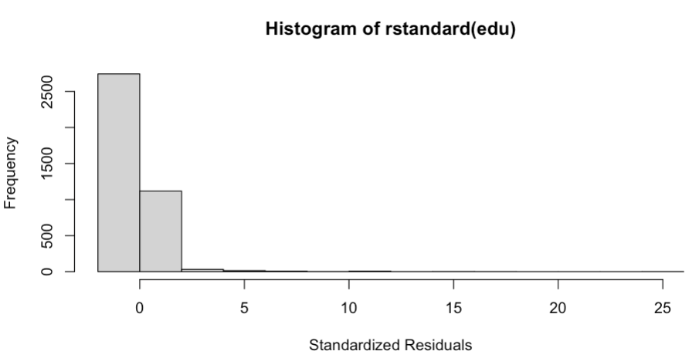

Figure8A. This graph represents the standardized residuals of the model seen in Figure 7A. The standardized residuals from the histogram show that the residuals are not normally distributed. We have a longer tail on the right side than the left side. There is no sign of a symmetric bell-shaped graph.

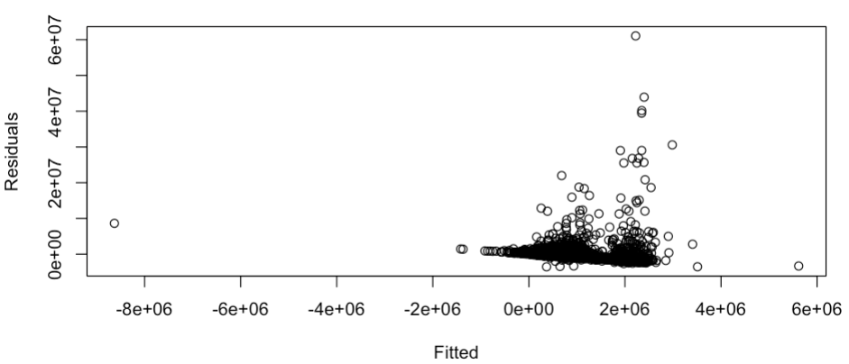

Figure9A. This graph shows the residual distribution for the model in Figure 7A. It is evident that the residual vs fitted graph has heteroskedasticity and non-constant variance. However, it appears that it has the correct functional form.