multiplexer.v:
module multiplexer(X0, X1, Y0, Y1, Out);
input [7:0] X0, X1;
input Y0, Y1;
output [7:0] Out;

wire selector;

assign selector = Y0 ^ Y1;
assign Out = selector ? X0 : X1;
endmodule

multiplexer_tb.v:
`timescale 1ns / 1ns
`include "multiplexer.v"

module multiplexer_tb;
reg [7:0] X0;
reg [7:0] X1;
reg Y0;
reg Y1;
wire [7:0] Out;

multiplexer uut_inst (.X0(X0), .X1(X1), .Y0(Y0), .Y1(Y1), .Out(Out));

initial begin
$dumpfile("multiplexer_tb.vcd");
$dumpvars(0, multiplexer_tb);

X0 = 8'b11110000; X1 = 8'b00001111; Y0 = 0; Y1 = 0; #10;

$display(
"%0t\tX0=%b X1=%b Y0=%b Y1=%b Out=%b",
$time, X0, X1, Y0, Y1, Out);

Y0 = 0; Y1 = 1; #10;

$display(
"%0t\tX0=%b X1=%b Y0=%b Y1=%b Out=%b",
$time, X0, X1, Y0, Y1, Out);

Y0 = 1; Y1 = 0; #10;

$display(
"%0t\tX0=%b X1=%b Y0=%b Y1=%b Out=%b",
$time, X0, X1, Y0, Y1, Out);

Y0 = 1; Y1 = 1; #10;

$display(
"%0t\tX0=%b X1=%b Y0=%b Y1=%b Out=%b",
$time, X0, X1, Y0, Y1, Out);
$display("Test complete");
end
endmodule
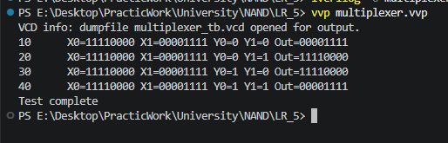

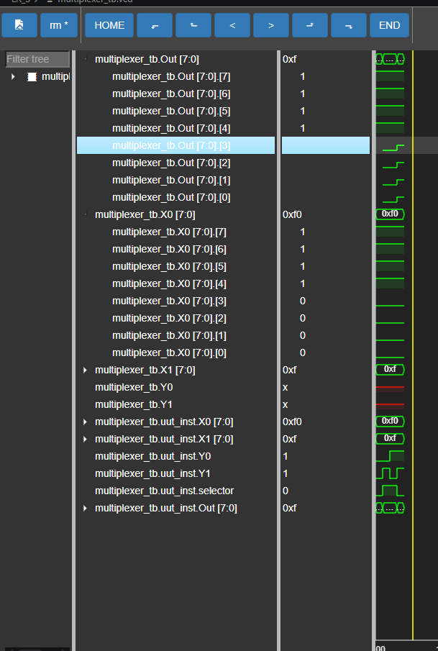
calculator.v:
module calculator(input [3:0] A, input [3:0] B, output [4:0] SUM, output [6:0] SEG);
assign SUM = A + B;
seven_segment display(.num(SUM[3:0]), .seg(SEG));
endmodule

seven_segment.v:
module seven_segment(input [3:0] num, output reg [6:0] seg);
always @(*) begin
case(num)

4'b0000: seg = 7'b0000001; // 0
4'b0001: seg = 7'b0000110; // 1
4'b0010: seg = 7'b1011011; // 2
4'b0011: seg = 7'b1001111; // 3
4'b0100: seg = 7'b1100110; // 4
4'b0101: seg = 7'b1101101; // 5
4'b0110: seg = 7'b1111101; // 6
4'b0111: seg = 7'b0000111; // 7
4'b1000: seg = 7'b1111111; // 8
4'b1001: seg = 7'b1101111; // 9

default: seg = 7'b0000000;
endcase
end
endmodule

calculator_tb.v:
`timescale 1ns / 1ns
`include "multiplexer.v"

module multiplexer_tb;
reg [7:0] X0;
reg [7:0] X1;
reg Y0;
reg Y1;
wire [7:0] Out;

multiplexer uut_inst (
.X0(X0),
.X1(X1),
.Y0(Y0),
.Y1(Y1),
.Out(Out)
);

initial begin
$dumpfile("multiplexer_tb.vcd");
$dumpvars(0, multiplexer_tb);

X0 = 8'b11110000; X1 = 8'b00001111; Y0 = 0; Y1 = 0; #10;

$display(
"%0t\tX0=%b X1=%b Y0=%b Y1=%b Out=%b",
$time, X0, X1, Y0, Y1, Out
);

Y0 = 0; Y1 = 1; #10;

$display(
"%0t\tX0=%b X1=%b Y0=%b Y1=%b Out=%b",
$time, X0, X1, Y0, Y1, Out
);

Y0 = 1; Y1 = 0; #10;

$display(
"%0t\tX0=%b X1=%b Y0=%b Y1=%b Out=%b",
$time, X0, X1, Y0, Y1, Out
);

Y0 = 1; Y1 = 1; #10;

$display(
"%0t\tX0=%b X1=%b Y0=%b Y1=%b Out=%b",
$time, X0, X1, Y0, Y1, Out
);

$display("Test complete");
end
endmodule



