 



Database Programming with SQL 10-1: Fundamentals of Subqueries Practice Activities

# Objectives

* Define and explain the purpose of subqueries for retrieving data
* Construct and execute a single-row subquery in the WHERE clause
* Distinguish between single-row and multiple-row subqueries

# Vocabulary

Identify the vocabulary word for each definition below.

|  |  |
| --- | --- |
| **outer query** | It accepts a value from the inner query to complete its SELECT statement. |
| **multiple-row subquery** | An inner query that returns one or more rows to the outer query |
| **subquery** | An inner query that is nested within an outer query |
| **Pair-wise multiple-column subquery** | An inner query that compares multiple columns at the same time |
| **single-row subquery** | An inner query that returns only one row to the outer query |
| **Non-pair-wise multiple-column subquery** | An inner query that compares the multiple columns one at a time in different subqueries |
| **inner query** | Another name for a subquery |

# Try It / Solve It

1. What is the purpose of using a subquery?

**To find the intermediate information we need to extract information we want. E.g. extracting right part in WHERE/HAVING/FROM clause.**

1. What is a subquery?

**An inner query that is nested within an outer query**

1. What DJs on Demand d_play_list_items song_id’s have the same event_id as song_id 45?

**SELECT song_id**

**FROM d_play_list_items**

**WHERE event_id IN(SELECT event_id FROM d_play_list_items WHERE song_id =45);**

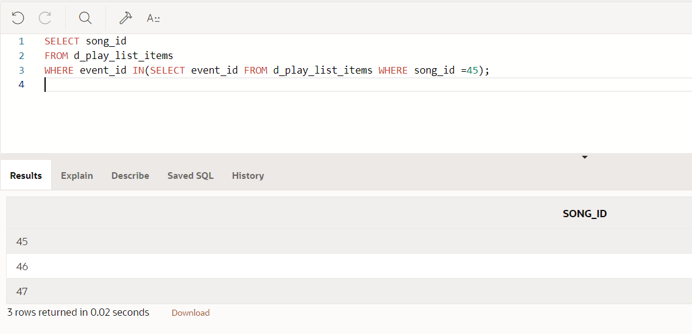

1. Which events in the DJs on Demand database cost more than event_id = 100?

**SELECT id, name**

**FROM d_events**

**WHERE cost > (SELECT cost FROM d_events WHERE id = 100);**

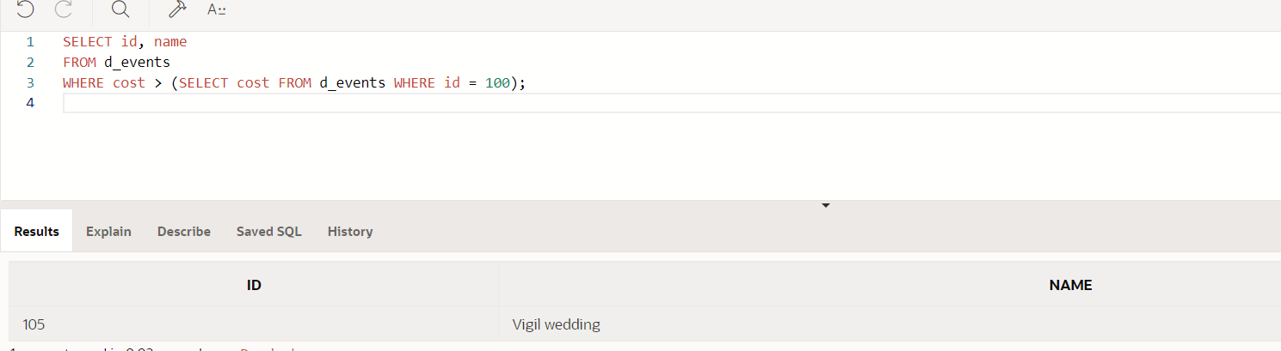

1. Find the track number of the song that has the same CD number as “Party Music for All Occasions.”

**SELECT track**

**FROM d_track_listings**

**WHERE cd_number = (SELECT cd_number FROM d_cds WHERE title = 'Party Music for All Occasions');**

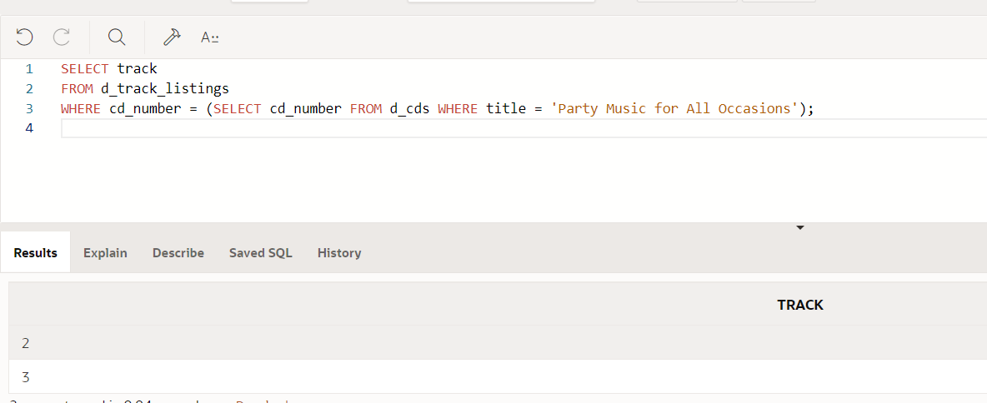

1. List the DJs on Demand events whose theme code is the same as the code for “Tropical.”

**SELECT id, name**

**FROM d_events**

**WHERE theme_code = (SELECT code FROM d_themes WHERE description = 'Tropical');**

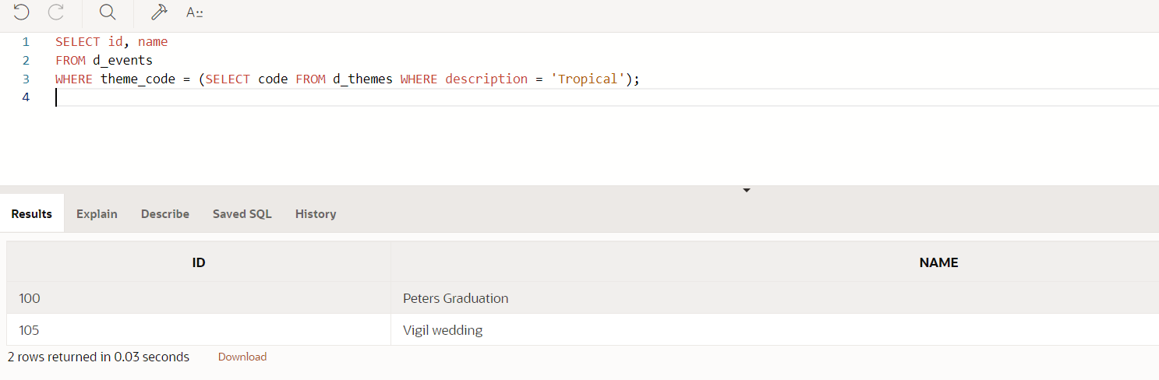

1. What are the names of the Global Fast Foods staff members whose salaries are greater than the staff member whose ID is 12?

**SELECT first_name,last_name**

**FROM f_staffs**

**WHERE salary > (SELECT salary FROM f_staffs WHERE id = 12);**

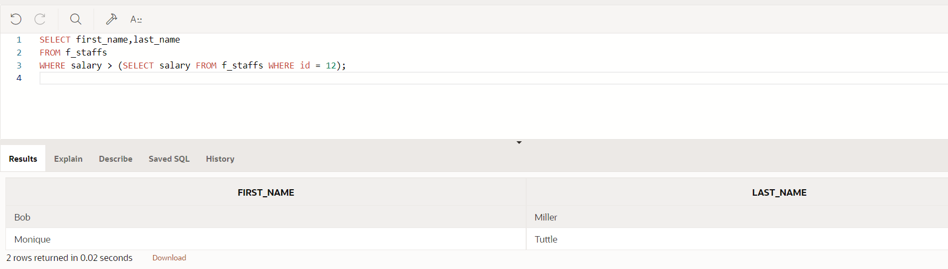

1. What are the names of the Global Fast Foods staff members whose staff types are not the same as Bob Miller’s?

**SELECT first_name,last_name**

**FROM f_staffs**

**WHERE staff_type != (SELECT staff_type FROM f_staffs WHERE first_name = 'Bob' AND last_name ='Miller');**

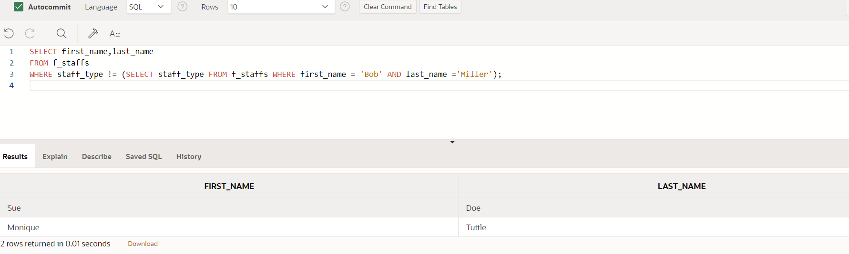

1. Which Oracle employees have the same department ID as the IT department?

**SELECT first_name,last_name**

**FROM employees**

**WHERE department_id = (SELECT department_id FROM departments WHERE department_name = 'IT');**

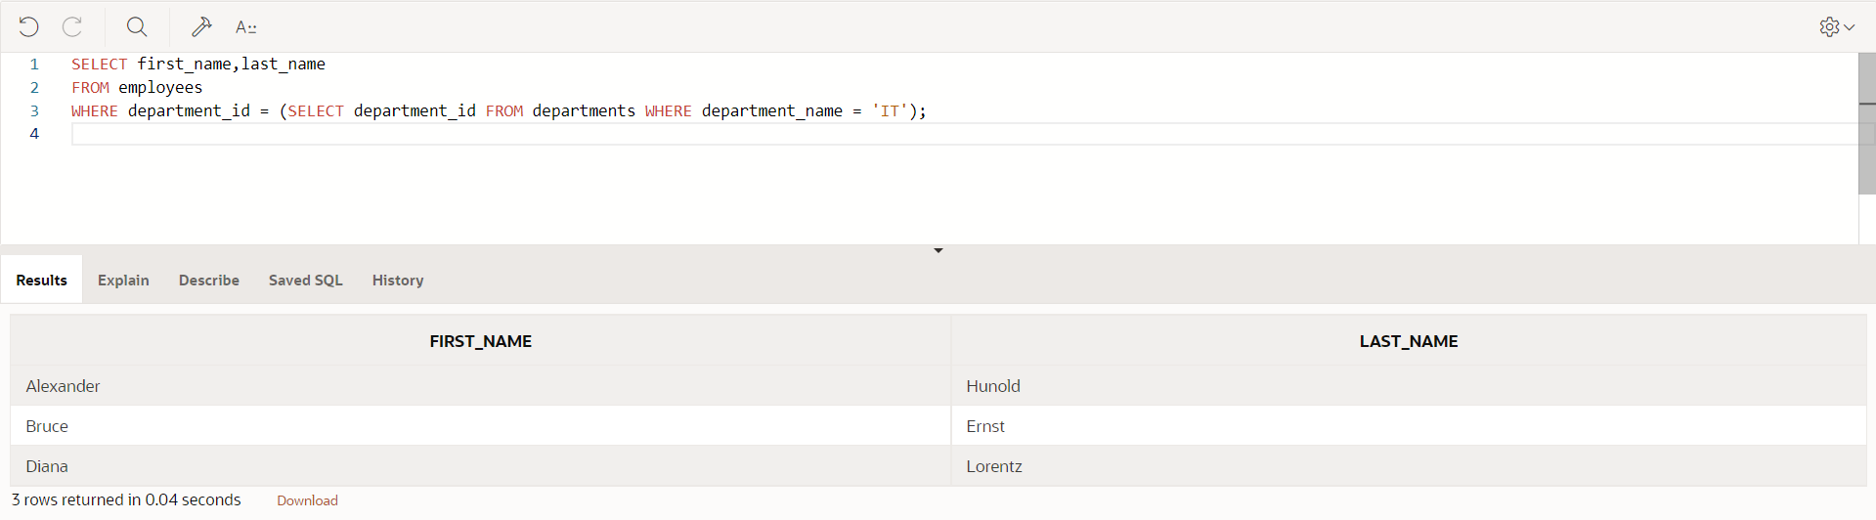

1. What are the department names of the Oracle departments that have the same location ID as Seattle?

**SELECT department_name**

**FROM departments**

**WHERE location_id = ( SELECT location_id FROM locations WHERE city = 'Seattle');**

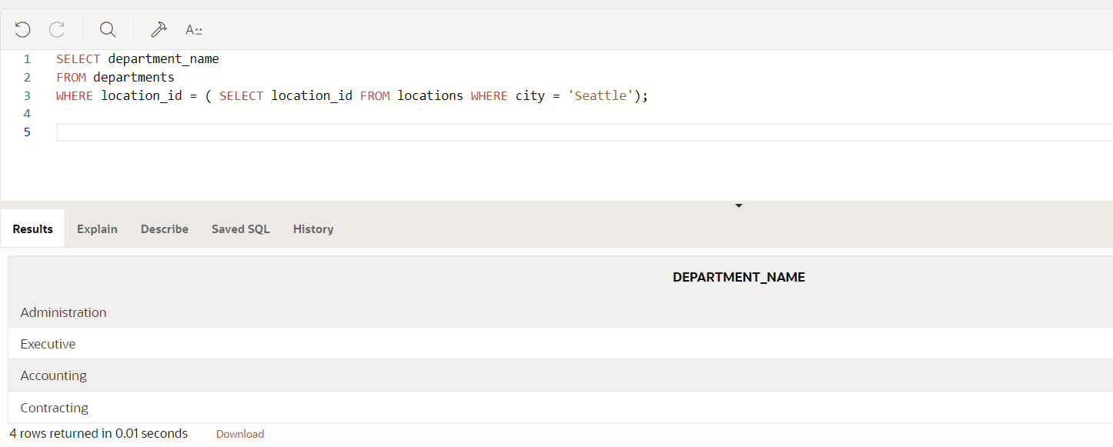

1. Indicate whether the statement regarding subqueries is True or False.
   1. It is good programming practice to place a subquery on the right side of the comparison operator. **TRUE**
   2. A subquery can reference a table that is not included in the outer query’s FROM clause. **TRUE**
   3. Single-row subqueries can return multiple values to the outer query. **FALSE**

Copyright © 2020, Oracle and/or its affiliates. All rights reserved. Oracle and Java are registered trademarks of Oracle and/or its affiliates. Other names may be trademarks of their respective owners.