 



Database Programming with SQL 10-2: Single-Row Subqueries Practice Activities

# Objectives

* Construct and execute a single-row subquery in the WHERE clause or HAVING clause
* Construct and execute a SELECT statement using more than one subquery
* Construct and execute a SELECT statement using a group function in the subquery

# Try It / Solve It

1. Write a query to return all those employees who have a salary greater than that of Lorentz and are in the same department as Abel.

**SELECT  first_name, last_name**

**FROM EMPLOYEES**

**WHERE salary >  (SELECT salary FROM employees WHERE last_name = 'Lorentz') AND department_id = (SELECT department_id FROM employees WHERE last_name = 'Abel');**

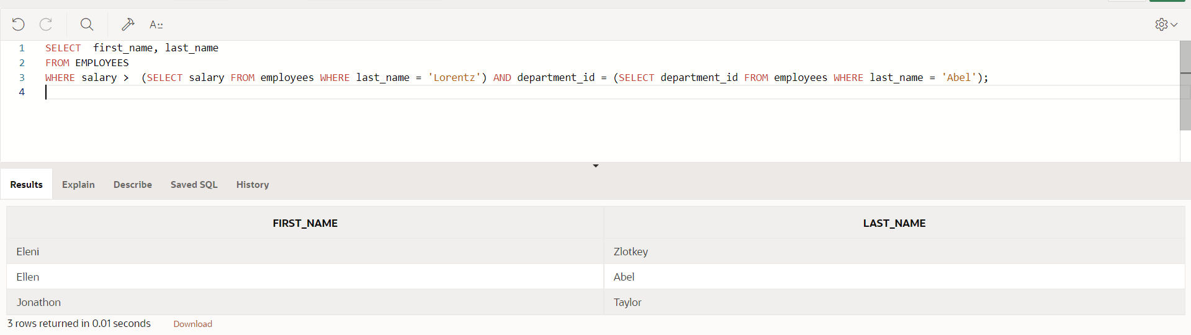

1. Write a query to return all those employees who have the same job id as Rajs and were hired after Davies.

**SELECT  first_name, last_name**

**FROM EMPLOYEES**

**WHERE  job_id = (SELECT job_id  FROM employees WHERE last_name = 'Rajs') AND hire_date >  (SELECT hire_date FROM employees WHERE last_name = 'Davies') ;**

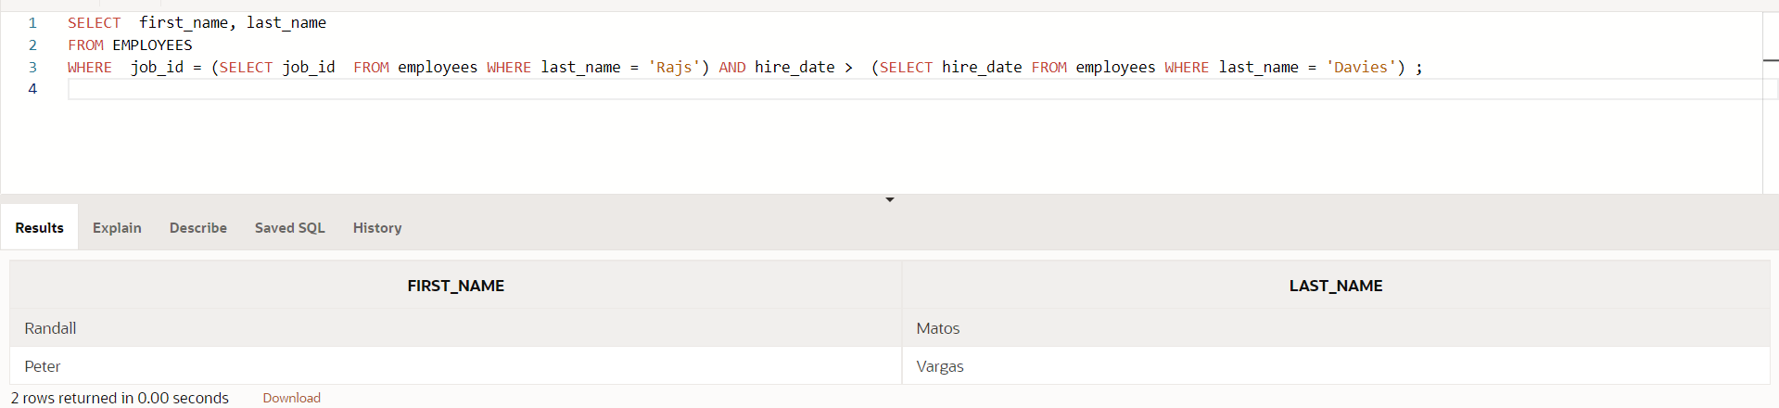

1. What DJs on Demand events have the same theme code as event ID = 100?

**SELECT id, name**

**FROM d_events**

**WHERE theme_code =  (SELECT theme_code FROM d_events WHERE id = 100);**

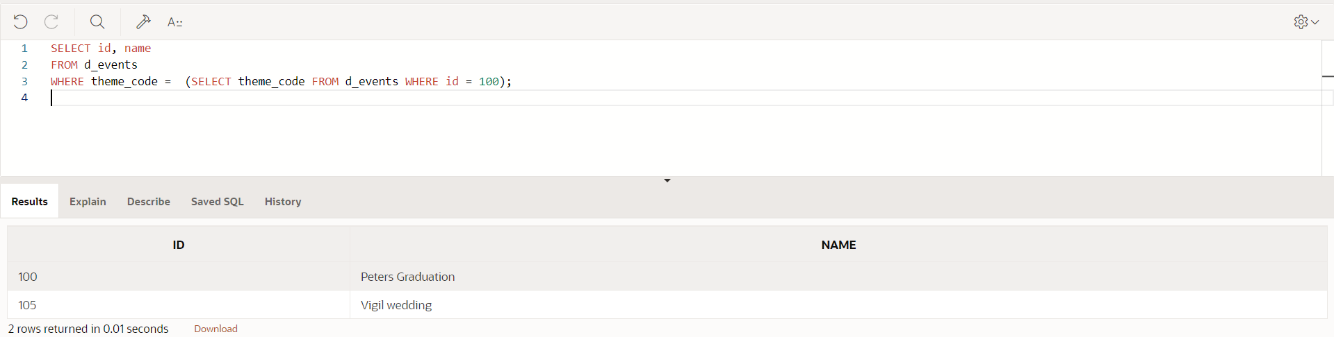

1. What is the staff type for those Global Fast Foods jobs that have a salary less than those of any Cook staff-type jobs?

**SELECT staff_type, MAX(salary)**

**FROM f_staffs**

**GROUP BY staff_type**

**HAVING MAX(salary) < (SELECT MAX(SALARY) FROM f_staffs WHERE staff_type = 'Cook');**

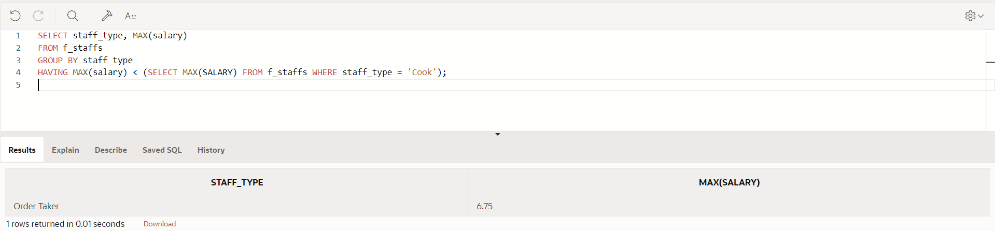

1. Write a query to return a list of department id’s and average salaries where the department’s average salary is greater than Ernst’s salary.

**SELECT department_id, TO_CHAR(ROUND(AVG(salary),2),'$999999.99') "Average Salary"**

**FROM employees**

**GROUP BY department_id**

**HAVING AVG(salary) > ( SELECT salary from employees WHERE last_name = 'Ernst');**

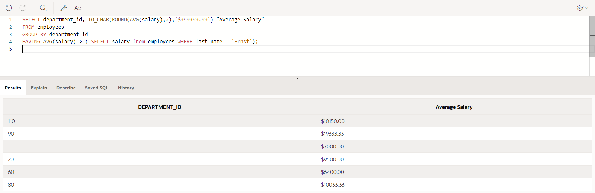

1. Return the department ID and minimum salary of all employees, grouped by department ID, having a minimum salary greater than the minimum salary of those employees whose department ID is not equal to 50.

**SELECT department_id, TO_CHAR(ROUND(MIN(salary),2),'$999999.99') "Minimum Salary"**

**FROM employees**

**GROUP BY department_id**

**HAVING MIN(salary) > ( SELECT MIN(salary) from employees WHERE department_id != 50);**

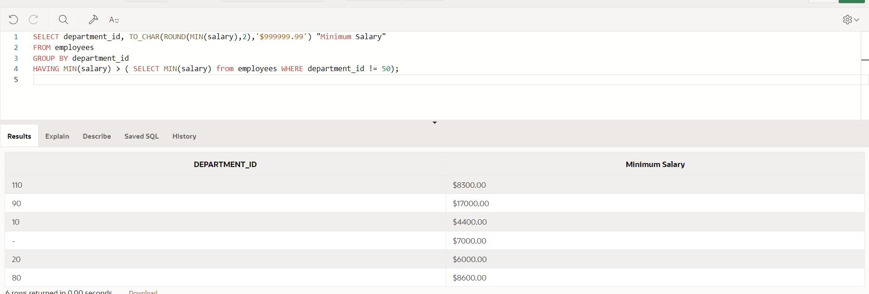

Copyright © 2020, Oracle and/or its affiliates. All rights reserved. Oracle and Java are registered trademarks of Oracle and/or its affiliates. Other names may be trademarks of their respective owners.