 



Database Programming with SQL 12-1: INSERT Statements Practice Activities

# Objectives

* Give examples of why it is important to be able to alter the data in a database
* Construct and execute INSERT statements that insert a single row using a VALUES clause
* Construct and execute INSERT statements that use special values, null values, and date values
* Construct and execute INSERT statements that copy rows from one table to another using a subquery

# Vocabulary

Identify the vocabulary word for each definition below.

|  |  |
| --- | --- |
| **User** | Someone doing “real work” with the computer, using it as a means rather than an end |
| **transaction** | Consists of a collection of DML statements that form a logical unit of work. |
| **explicit** | Fully and clearly expressed; leaving nothing implied |
| **INSERT INTO** | Adds a new row to a table |

# Try It / Solve It

Students should execute DESC tablename before doing INSERT to view the data types for each column. VARCHAR2 data-type entries need single quotation marks in the VALUES statement.

1. Give two examples of why it is important to be able to alter the data in a database.

* **I am on a flight booking site. It shows available flights, say I try to book a ticket and still my transaction is not commenced anywhere, I will be in big trouble.**
* **I am trying to create a login on a site, it takes my details and say never store my information in registration request table, I will keep on waiting for approval which will never happen.**

1. DJs on Demand just purchased four new CDs. Use an explicit INSERT statement to add each CD to the copy_d_cds table. After completing the entries, execute a SELECT * statement to verify your work.

|  |  |  |  |
| --- | --- | --- | --- |
| **CD_Number** | **Title** | **Producer** | **Year** |
| 97 | Celebrate the Day | R & B Inc. | 2003 |
| 98 | Holiday Tunes for All Ages | Tunes are Us | 2004 |
| 99 | Party Music | Old Town Records | 2004 |
| 100 | Best of Rock and Roll | Old Town Records | 2004 |

**Create copy of main table to play around:**

**CREATE TABLE copy_d_cds**

**AS ( SELECT * FROM d_cds);**

**see if copy worked well:**

**DESCRIBE copy_d_cds;**

**DESCRIBE d_cds;**

**(clone table lost its primary key constraint and cd_number became nullable.)**

**see how the copied content looks like.**

**SELECT * FROM copy_d_cds ;**

**I see that cd_number 98 will be repeated with my insert statements, but it won't give error, since primary key constrain is lost in copy.**

**The Explicit insert statements without even missing nullable columns:**

**INSERT INTO copy_d_cds(cd_number,title,producer,year)**

**VALUES(97,'Celebrate the Day','R & B Inc.','2003');**

**INSERT INTO copy_d_cds(cd_number,title,producer,year)**

**VALUES(98,'Holiday Tunes for All Ages','Tunes are Us','2004');**

**INSERT INTO copy_d_cds(cd_number,title,producer,year)**

**VALUES(99,'Party Music','Old Town Records','2004');**

**INSERT INTO copy_d_cds(cd_number,title,producer,year)**

**VALUES(100,'Best of Rock and Roll','Old Town Records','2004');**

**SELECT * FROM copy_d_cds ;**

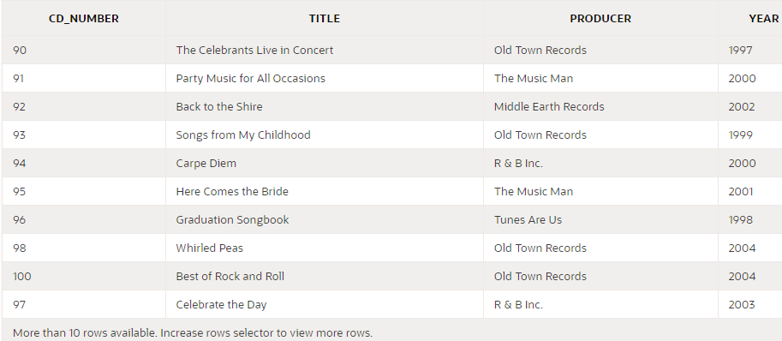

1. DJs on Demand has two new events coming up. One event is a fall football party and the other event is a sixties theme party. The DJs on Demand clients requested the songs shown in the table for their events. Add these songs to the copy_d_songs table using an implicit INSERT statement.

|  |  |  |  |
| --- | --- | --- | --- |
| **ID** | **Title** | **Duration** | **Type_Code** |
| 52 | Surfing Summer | Not known | 12 |
| 53 | Victory Victory | 5 min | 12 |

**Create copy of main table to play around:**

**CREATE TABLE copy_d_songs**

**AS ( SELECT * FROM d_songs);**

**see if copy worked well:**

**DESCRIBE copy_d_songs;**

**DESCRIBE d_songs;**

**(Also, I see that duration & artist is nullable in source table. I could skip these column names in insert into / if I decide to include these columns, I will specify it as NULL in VALUES. I will prefer the later option to be symmetric and avoid missing something by mistake. One more thing the clone table lost its primary key constraint and id became nullable.)**

**The Explicit insert statements without even missing nullable columns:**

**INSERT INTO copy_d_songs**

**VALUES(52,'Surfing Summer',NULL,NULL,12);**

**INSERT INTO copy_d_songs**

**VALUES(53,'Victory Victory','5 min',NULL,12);**

**SELECT * FROM copy_d_songs ;**

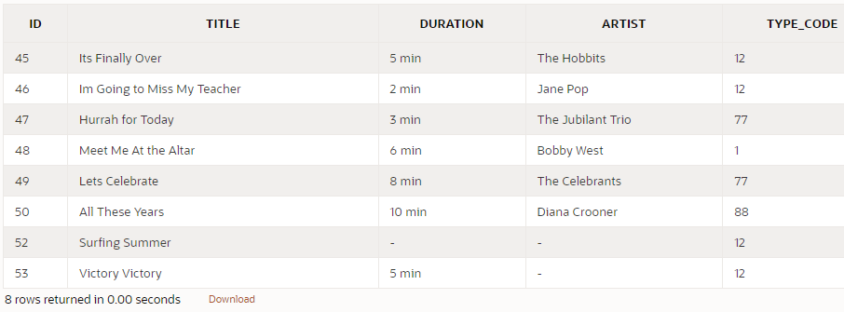

1. Add the two new clients to the copy_d_clients table. Use either an implicit or an explicit INSERT.

|  |  |  |  |  |
| --- | --- | --- | --- | --- |
| **Client_Number** | **First_Name** | **Last_Name** | **Phone** | **Email** |
| 6655 | Ayako | Dahish | 3608859030 | [dahisha@harbor.net](mailto:dahisha@harbor.net) |
| 6689 | Nick | Neuville | 9048953049 | [nnicky@charter.net](mailto:nnicky@charter.net) |

**a) Create copy of main table to play around:**

**CREATE TABLE copy_d_clients**

**AS ( SELECT * FROM d_clients);**

**b) see if copy worked well:**

**DESCRIBE copy_d_clients ;**

**DESCRIBE d_clients;**

**(clone table lost its primary key constraint and client_number became nullable.)**

**SELECT * FROM d_clients ;**

**SELECT * FROM copy_d_clients ;**

**c) The Explicit insert statements without even missing nullable columns:**

**INSERT INTO copy_d_clients(client_number,first_name,last_name,phone,email)**

**VALUES(6655,'Ayako','Dahish',3608859030,'dahisha@harbor.net');**

**INSERT INTO copy_d_clients(client_number,first_name,last_name,phone,email)**

**VALUES(6689,'Nick','Neuville',3608859030,'nnicky@charter.net');**

**d) verify data:**

**SELECT * FROM copy_d_clients ;**

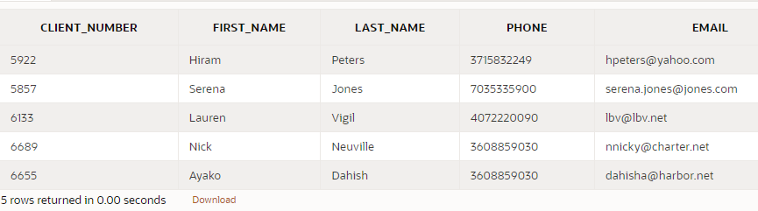

1. Add the new client’s events to the copy_d_events table. The cost of each event has not been determined at this date.

|  |  |  |  |  |  |  |  |  |
| --- | --- | --- | --- | --- | --- | --- | --- | --- |
| **ID** | **Name** | **Event_ Date** | **Description** | **Cost** | **Venue_ ID** | **Package_ Code** | **Theme_ Code** | **Client_ Number** |
| 110 | Ayako Anniversary | 07-Jul-  2004 | Party for 50, sixties dress, decorations |  | 245 | 79 | 240 | 6655 |
| 115 | Neuville Sports Banquet | 09-  Sep- 2004 | Barbecue at residence, college alumni, 100 people |  | 315 | 87 | 340 | 6689 |

**a) Create copy of main table to play around:**

**CREATE TABLE copy_d_events**

**AS ( SELECT * FROM d_events);**

**b) see if copy worked well:**

**DESCRIBE copy_d_events ;**

**DESCRIBE d_events;**

**(All the constraints are lost in this copy.e.g.:**

**•         clone table lost its primary key constraint and id became nullable.**

**•         245 and 315 venue_id are not there in d_venues, but it insert will still work. [This loss of foreign key constraint is not mentioned by DESCRIBE]**

**one more thing:**

**•         cost is not nullable and it needs to be a number. I could either make it nullable, or give some value like 0 to cost. I go with second choice - give value as zero.**

**)**

**SELECT * FROM d_events ;**

**SELECT * FROM copy_d_events ;**

**c) The Explicit insert statements:**

**INSERT INTO copy_d_events(id,name,event_date,description,cost,venue_id,package_code,theme_code,client_number)**

**VALUES(110,'Ayako Anniversary',TO_DATE('07-Jul-2004','dd-Mon-yyyy'),'Party for 50, sixties dress, decorations',0,245,79,240,6655);**

**INSERT INTO copy_d_events(id,name,event_date,description,cost,venue_id,package_code,theme_code,client_number)**

**VALUES(115,'Neuville Sports Banquet',TO_DATE('09-Sep-2004','dd-Mon-yyyy'),'Barbecue at residence, college alumni, 100 people',0,315,87,340,6689);**

**d)verify data:**

**SELECT * FROM copy_d_events ;**

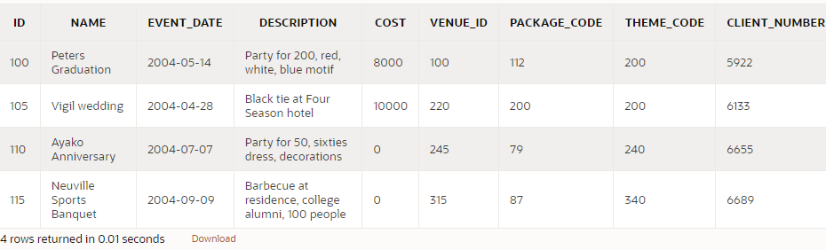

1. Create a table called rep_email using the following statement: CREATE TABLE rep_email (

id NUMBER(3) CONSTRAINT rel_id_pk PRIMARY KEY,

first_name VARCHAR2(10), last_name VARCHAR2(10), email_address VARCHAR2(10))

Populate this table by running a query on the employees table that includes only those employees who are REP’s.

**Those employees could be Marketing Representative, or Sales Representative. There JOB_ID ends with '_REP'**

**DESCRIBE rep_email ;**

**DESCRIBE employees;**

**employee_id has precision 6 and scale 0. But id in problem statement has 2, 0**

**Similarly other fields also have differences.**

**Expected to see errors like ORA-01438: value larger than specified precision allowed for this column**

**Luckily, rest of the mismatches still work because data is ok, but for id, I will have alter it:**

**ALTER TABLE rep_email DROP column id;**

**ALTER TABLE rep_email ADD id NUMBER(6,0) CONSTRAINT rel_id_pk PRIMARY KEY;**

**DESCRIBE rep_email ;**

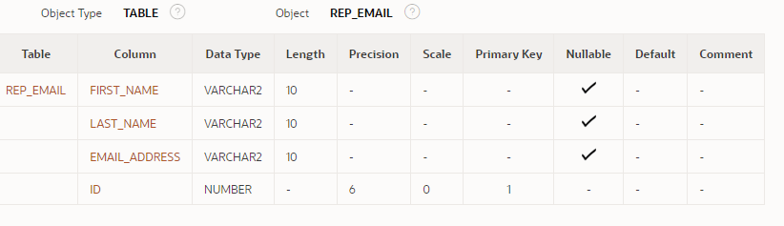

**SELECT employee_id, first_name, last_name, email**

**FROM employees**

**WHERE job_id LIKE '%\_REP' ESCAPE '\';**

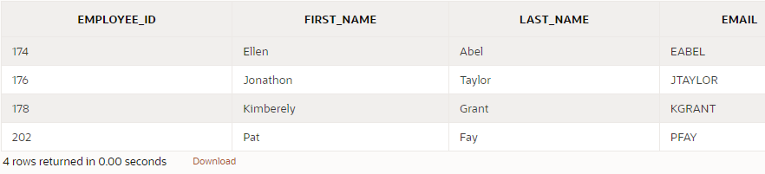

**INSERT INTO rep_email(id, first_name, last_name, email_address)**

**SELECT employee_id, first_name, last_name, email**

**FROM employees**

**WHERE job_id LIKE '%\_REP' ESCAPE '\';**

**SELECT * FROM rep_email;**

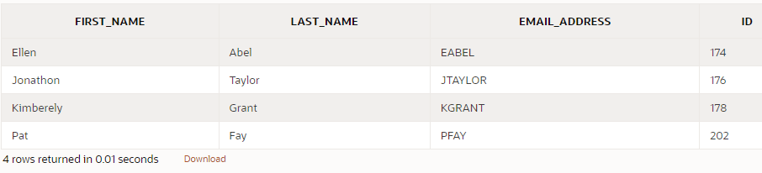

Copyright © 2020, Oracle and/or its affiliates. All rights reserved. Oracle and Java are registered trademarks of Oracle and/or its affiliates. Other names may be trademarks of their respective owners.