 



Database Programming with SQL 13-2: Using Data Types

Practice Activities

# Objectives

* Create a table using TIMESTAMP and TIMESTAMP WITH TIME ZONE column data types
* Create a table using INTERVAL YEAR TO MONTH and INTERVAL DAY TO SECOND column data types
* Give examples of organizations and personal situations where it is important to know to which time zone a date-time value refers
* List and provide an example of each of the number, date, and character data types

# Vocabulary

Identify the vocabulary word for each definition below.

|  |  |
| --- | --- |
| **INTERVAL YEAR**[(x)] **TO MONTH** (x is optional  default is 2) | Allows time to be stored as an interval of years and months |
| **TIMESTAMP** [(fractional_seconds_precision)] **WITH LOCAL TIME ZONE** (data stored in the database is normalized to the database time zone, and the time zone offset is not stored as part of the column data. When users retrieve the data, Oracle returns it in the users' local session time zone) | When a column is selected in a SQL statement the time is automatically converted to the user’s timezone |
| **BLOB** | Binary large object data up to 4 gigabytes |
| **TIMESTAMP** [(fractional_seconds_precision)] **WITH TIME ZONE** (includes a time zone offset or time zone region name in its value) | Stores a time zone value as a displacement from Universal Coordinated Time or UCT |
| **INTERVAL DAY**[(x)] **TO SECOND**[(y)] default for x is 2 and for y is 6 | Allows time to be stored as an interval of days to hours, minutes, and seconds |
| **CLOB** | Character data up to 4 gigabytes |
| **TIMESTAMP** [(fractional_seconds_precision)] (It stores year, month, day, hour, minute, and second values. It also stores fractional seconds, which are not stored by the DATE datatype.) | Allows the time to be stored as a date with fractional seconds |

# Try It / Solve It

1. Using the examples provided in the slides, create eac

h of the three time-zone tables.

ions

e-time

* 1. TIMESTAMP WITH LOCAL TIME ZONE

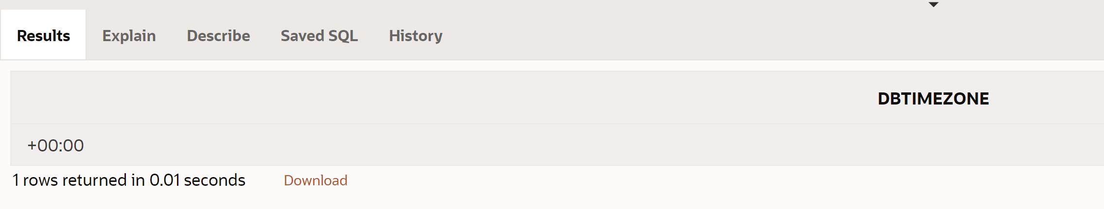

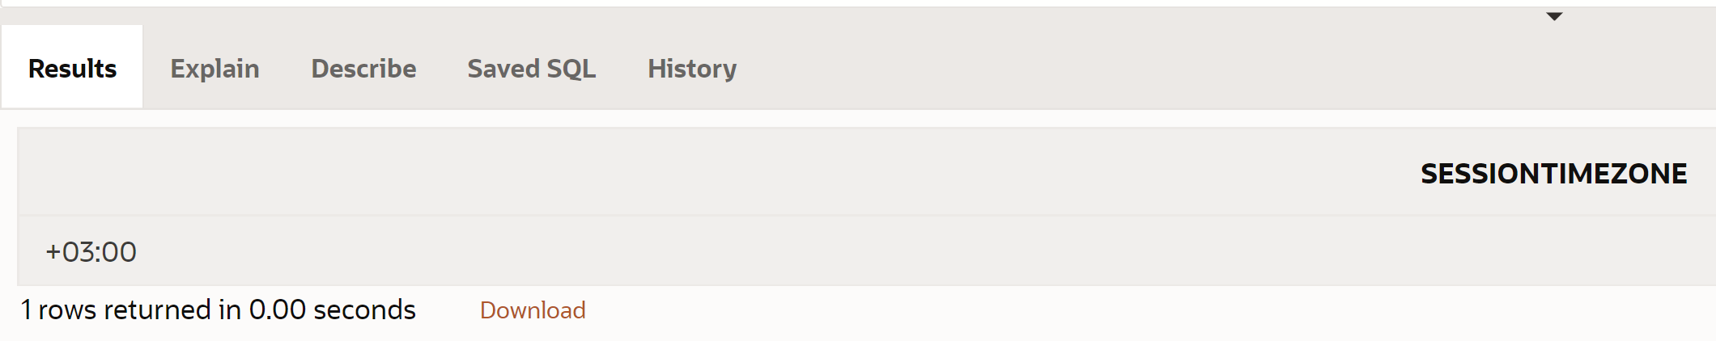

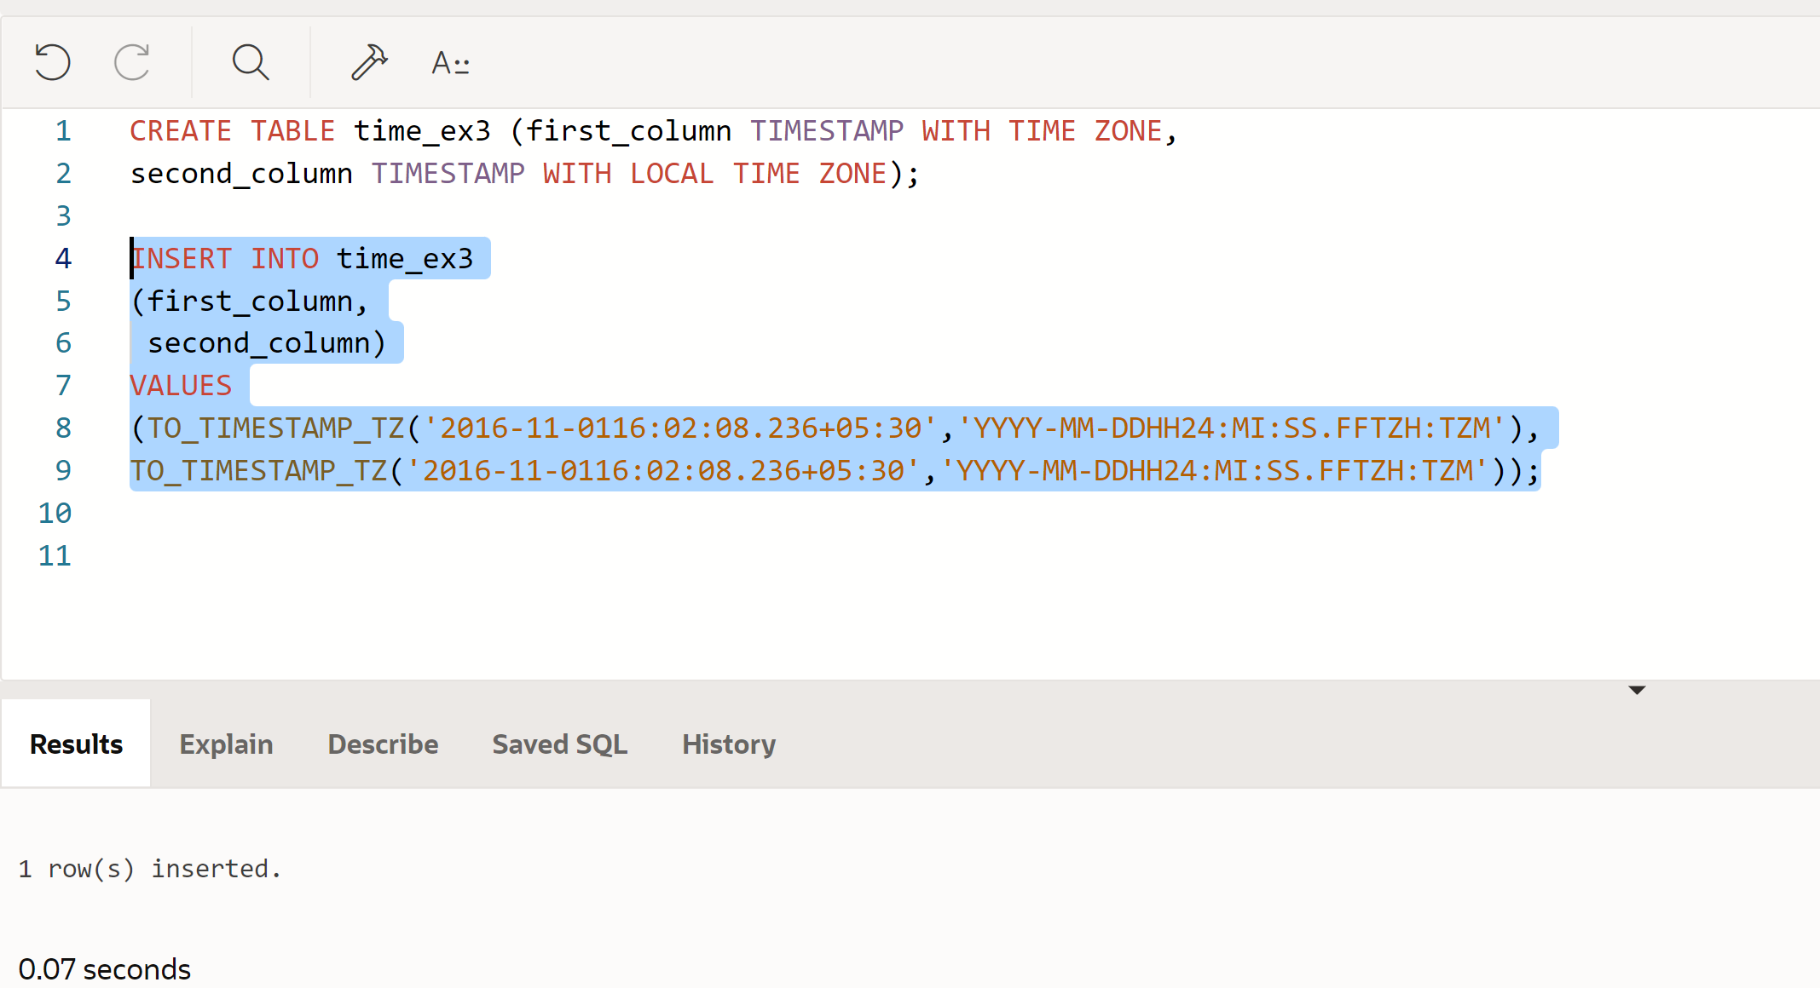

* 1. INTERVAL YEAR TO MONTH

**CREATE TABLE time_ex4**

**(loan_duration1 INTERVAL YEAR(3) TO MONTH,**

**loan_duration2  INTERVAL YEAR(2) TO MONTH);**

**INSERT INTO time_ex4 (loan_duration1, loan_duration2 )**

**VALUES( INTERVAL '120' MONTH(3), INTERVAL '3-6' YEAR TO MONTH);**

* 1. INTERVAL DAY TO SECOND

**CREATE TABLE time_ex5**

**(day_duration1 INTERVAL DAY(3) TO SECOND,**

**day_duration2  INTERVAL DAY(3) TO SECOND);**

**INSERT INTO time_ex5 (day_duration1, day_duration2 )**

**VALUES( INTERVAL '25' DAY(2), INTERVAL '4 10:30:10' DAY TO SECOND);**

1. Execute a SELECT * from each table

to verify your input.

TIMESTAMP WITH LOCAL TIME ZONE

**SELECT * FROM time_ex3;**

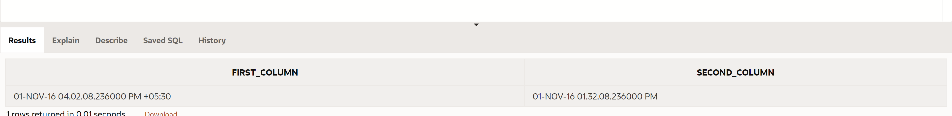

INTERVAL YEAR TO MONTH

**SELECT TO_CHAR( SYSDATE + loan_duration1 , 'DD-Month-YYYY') AS "120 months from Now", TO_CHAR( SYSDATE + loan_duration2 , 'DD-Month-YYYY') AS "3 years 6 months from Now"**

**FROM time_ex4;**

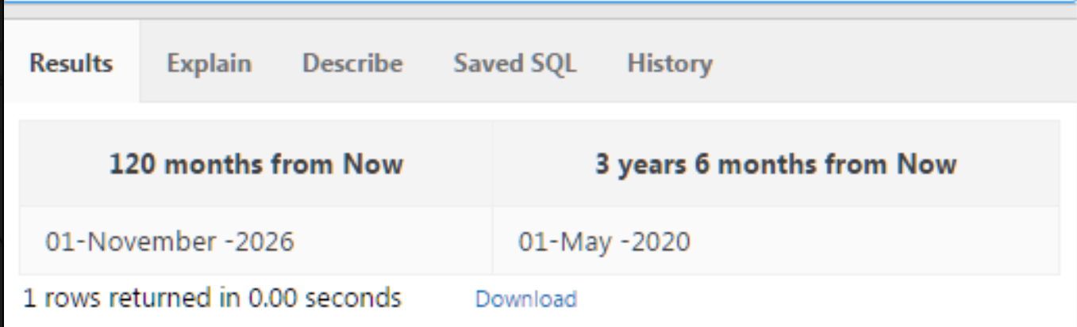

INTERVAL DAY TO SECOND

**SELECT**

**TO_CHAR( SYSDATE , 'DD-Month-YYYY hh:mi:ss') AS now,**

**TO_CHAR( SYSDATE + day_duration1 , 'DD-Month-YYYY hh:mi:ss') AS "25 days from Now",**

**TO_CHAR( SYSDATE + day_duration2 , 'DD-Month-YYYY hh:mi:ss') AS "4day10hr30min10sec from now "**

**FROM time_ex5;**

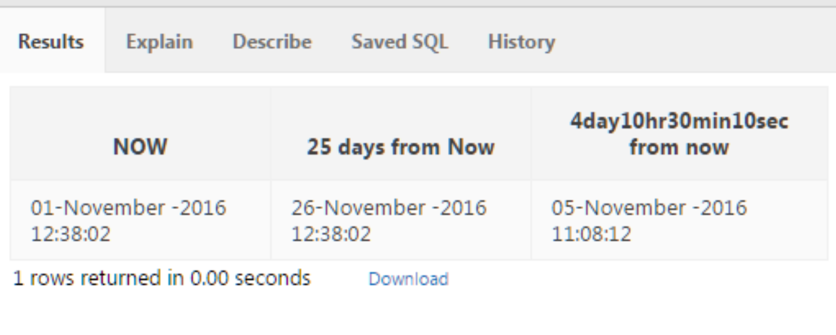

1. Give 3 examples of organizations and personal situat where it is important to know to which time zone a da value refers.

Copyright © 2020, Oracle and/or its affiliates. All rights reserved. Oracle and Java are registered trademarks of Oracle and/or its affiliates. Other names may be trademarks of their respective owners.