 



Database Programming with SQL 13-3: Modifying a Table

Practice Activities

# Objectives

* Explain why it is important to be able to modify a table
* Explain and provide an example for each of the DDL statements—ALTER, DROP, RENAME, and TRUNCATE—and the effect each has on tables and columns
* Construct a query and execute the ALTER TABLE commands ADD, MODIFY, and DROP
* Explain and perform a FLASHBACK QUERY on a table
* Explain and perform FLASHBACK table operations
* Track the changes to data over a period of time
* Explain the rationale for using TRUNCATE versus DELETE for tables
* Add a comment to a table using the COMMENT ON TABLE command
* Name the changes that can and cannot be made to modify a column
* Explain when and why the SET UNUSED statement is advantageous

# Try It / Solve It

Before beginning the practice exercises, execute a DESCRIBE for each of the following tables: o_employees, o_departments and o_jobs. These tables will be used in the exercises. If they do not exist in your account, create them as follows:

1. **Create the three o_tables – jobs, employees, and departments – using the syntax: CREATE TABLE o_jobs AS (SELECT * FROM jobs);**

**CREATE TABLE o_employees AS (SELECT * FROM employees); CREATE TABLE o_departments AS (SELECT * FROM departments);**

1. **Add the Human Resources job to the jobs table:**

**INSERT INTO o_jobs (job_id, job_title, min_salary, max_salary) VALUES('HR_MAN', 'Human Resources Manager', 4500, 5500);**

1. **Add the three new employees to the employees table:**

**INSERT INTO o_employees (employee_id, first_name, last_name, email, hire_date, job_id)**

**VALUES(210, 'Ramon', 'Sanchez', 'RSANCHEZ', SYSDATE, 'HR_MAN');**

1. **Add Human Resources to the departments table:**

**INSERT INTO o_departments(department_id, department_name) VALUES (210,'Human Resources');**

You will need to know which columns do not allow null values.

1. Why is it important to be able to modify a table?

There is nothing permanent in this world except change and I do make mistakes, that is why databases are also dynamic in nature and so are the tables could be modified.

1. CREATE a table called Artists.
   1. Add the following to the table:
      * artist ID
      * first name
      * last name
      * band name
      * email
      * hourly rate
      * song ID from d_songs table

CREATE TABLE artists

(artist_id NUMBER(5,0),

first_name VARCHAR2(25) CONSTRAINT ait_first_name_nn NOT NULL ENABLE,

last_name VARCHAR2(30) CONSTRAINT ait_last_name_nn NOT NULL ENABLE,

band_name VARCHAR2(30),

email VARCHAR2(75) CONSTRAINT ait_email_nn NOT NULL ENABLE,

hr_rate NUMBER(8,2) CONSTRAINT ait_hr_rate_nn NOT NULL ENABLE,

song_id NUMBER(5,0) CONSTRAINT ait_song_id_nn NOT NULL ENABLE,

CONSTRAINT ait_id_pk PRIMARY KEY (artist_id)

);

* 1. INSERT one artist from the d_songs table.

DESCRIBE artists;

It suggests that,

I must have artist_id, which I could take as 1 since I am inserting one row only, please note there is no sequence present here.

First name and last name I must need, I could get it from artist in d_songs by string manipulation.

band name I may skip but I can temporarily take it same as artist full name.

song id I can take from d_songs very well.

email and hourly rate, d_songs will give no clue about, so, I will have to have two constraints:

ALTER TABLE artists

DROP CONSTRAINT ait_email_nn;

ALTER TABLE artists

DROP CONSTRAINT ait_hr_rate_nn;

DESCRIBE artists;

Now insert first select from d_songs to artists:

**INSERT INTO artists (artist_id, first_name, last_name, band_name, email, hr_rate, song_id)**

**SELECT 1 AS artist_id,**

**CASE**

**WHEN artist IS NULL THEN 'first name unknown'**

**WHEN INSTR(artist,' ') = 0 THEN artist**

**ELSE SUBSTR(artist,1,INSTR(artist,' ') -1)**

**END**

**AS first_name,**

**CASE**

**WHEN artist IS NULL THEN 'last name unknown'**

**WHEN INSTR(artist,' ') = 0 THEN artist**

**ELSE SUBSTR(artist,INSTR(artist,' '),LENGTH(artist))**

**END**

**AS last_name,**

**artist as band_name,**

**NULL as email,**

**NULL as hr_rate,**

**id as song_id**

**FROM d_songs**

**WHERE  ROWNUM =1 ;**

SELECT * FROM artists;

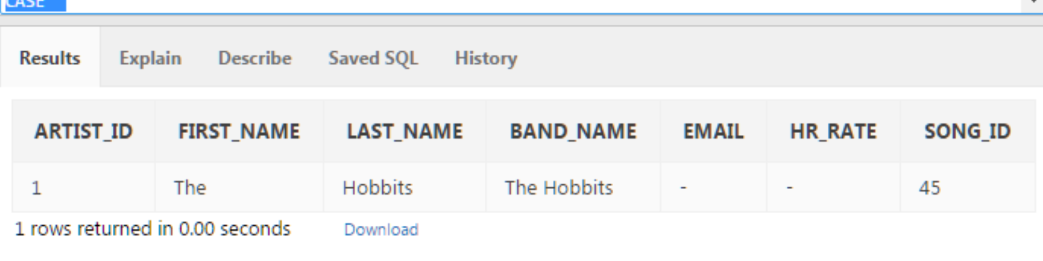

* 1. INSERT one artist of your own choosing; leave song_id blank.

Now leaving song_id blank would require dropping another constraint or I will get error ORA-01400: cannot insert NULL into ("HKUMAR"."ARTISTS"."SONG_ID"):

ALTER TABLE artists

DROP CONSTRAINT ait_song_id_nn;

**INSERT INTO artists (artist_id, first_name, last_name, band_name, email, hr_rate, song_id)**

**VALUES(2,'David','Gray','david''s band','some.email@somedomain.com','999999.99',NULL);**

**SELECT * FROM artists;**

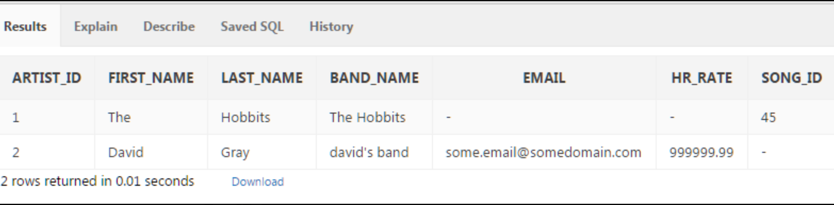

* 1. Give an example how each of the following may be used on the table that you have created:

1. ALTER TABLE

ALTER TABLE artists

ADD (specialty VARCHAR2(100), college VARCHAR2(100));

ALTER TABLE artists

MODIFY (specialty VARCHAR2(99), college VARCHAR2(98));

ALTER TABLE artists

DROP COLUMN specialty;

ALTER TABLE artists

RENAME COLUMN college to university;

ALTER TABLE artists

RENAME TO artists_new_name;

ALTER TABLE artists_new_name

MODIFY (university VARCHAR2(98) DEFAULT 'Great College');

ALTER TABLE artists_new_name

SET UNUSED (university);

SELECT column_name FROM user_tab_columns WHERE LOWER(table_name) = 'artists_new_name';

ALTER TABLE artists_new_name

DROP UNUSED COLUMNS;

1. DROP TABLE

DROP TABLE artists_new2;

1. RENAME TABLE

**RENAME artists_new_name TO artists_new2;**

1. TRUNCATE

TRUNCATE TABLE artists_new2;

SELECT * FROM artists_new2;

1. COMMENT ON TABLE

COMMENT ON TABLE artists_new2 IS 'The exercises are reordered to use same table, next I will drop this table';

1. In your o_employees table, enter a new column called “Termination.” The datatype for the new column should be VARCHAR2. Set the DEFAULT for this column as SYSDATE to appear as character data in the format: February 20th, 2003.

ALTER TABLE o_employees

ADD ("Termination" VARCHAR2(100) DEFAULT TO_CHAR(SYSDATE,'Month ddth, YYYY') );

INSERT INTO o_employees (employee_id, first_name, last_name, email, hire_date, job_id)

VALUES(213, 'Ramon213', 'Sanchez213', 'RSANCHEZ213', SYSDATE, 'HR_MAN');

SELECT "Termination" FROM o_employees WHERE employee_id = 213;

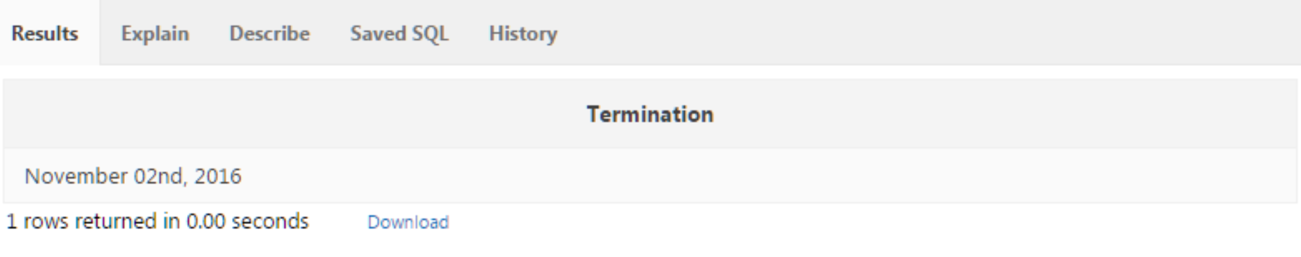

If I wanted it to be 2nd instead of 02nd:

ALTER TABLE o_employees

MODIFY ("Termination" VARCHAR2(100) DEFAULT TO_CHAR(SYSDATE,'fmMonth ddth, YYYY') );

INSERT INTO o_employees (employee_id, first_name, last_name, email, hire_date, job_id)

VALUES(214, 'Ramon214', 'Sanchez214', 'RSANCHEZ214', SYSDATE, 'HR_MAN');

SELECT "Termination" FROM o_employees WHERE employee_id = 214;

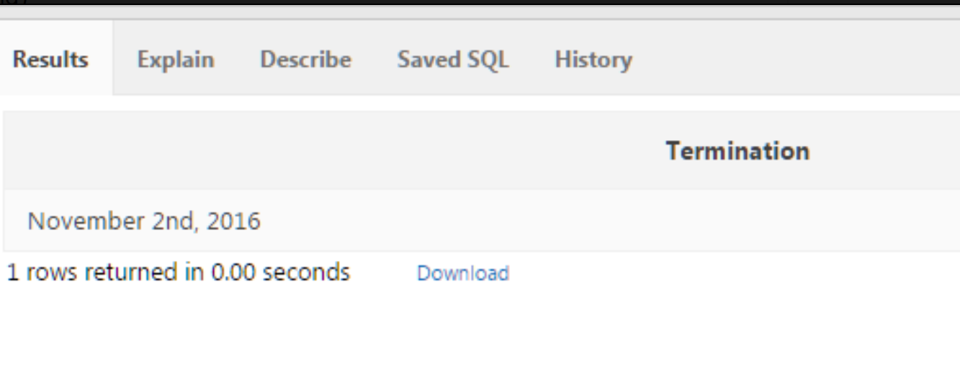

1. Create a new column in the o_employees table called start_date. Use the TIMESTAMP WITH LOCAL TIME ZONE as the datatype.

ALTER TABLE o_employees

ADD (start_date TIMESTAMP WITH LOCAL TIME ZONE);

default fractional_seconds_precision is 6 here

1. Truncate the o_jobs table. Then do a SELECT * statement. Are the columns still there? Is the data still there?

DESCRIBE o_jobs;

SELECT * FROM  o_jobs;

**TRUNCATE TABLE o_jobs;**

DESCRIBE o_jobs;

SELECT * FROM  o_jobs;

1. What is the distinction between TRUNCATE, DELETE, and DROP for tables?

The **DROP TABLE** statement removes the definition of oracle table along with data and indexes. Recovery of a dropped table along with even indexes may be done but it's not guaranteed using FLASHBACK:

**DROP TABLE mytable;**

It is possible to query what  may be restored by command:

SELECT original_name, operation, droptime

FROM user_recyclebin;

**FLASHBACK TABLE** mytable TO BEFORE DROP;

But if PURGE is used along with DROP TABLE, there is no recyclebin in b/w for sure:

**DROP TABLE mytable PURGE;**

**TRUNCATE TABLE** removes all rows and release storage space without possibility of rollback. It will be faster than DELETE. It won't remove columns from table.

**TRUNCATE TABLE sometable;**

**DELETE SQL statement** will remove the rows but won't clean storage space. We may use COMMIT or ROLLBACK here and DELETE triggers may also be used unlike TRUNCATE TABLE.

SELECT * FROM o_employees

WHERE employee_id = 100;

*1 rows returned in 0.01 seconds*

**DELETE FROM o_employees**

**WHERE employee_id = 100;**

*1 row(s) deleted.*

SELECT * FROM o_employees

WHERE employee_id = 100;

*no data found*

SELECT **versions_operation, versions_starttime,  versions_endtime**, employee_id, first_name, last_name, email, phone_number,hire_date,job_id,salary,commission_pct,manager_id, department_id,bonus,"Termination",start_date

FROM o_employees

**VERSIONS BETWEEN SCN MINVALUE AND MAXVALUE**

WHERE employee_id = 100;

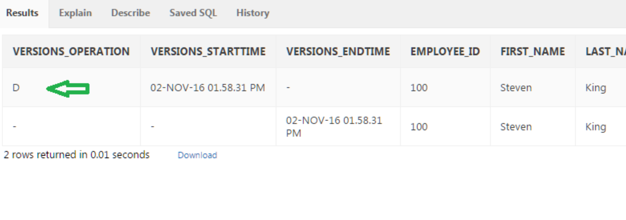

1. List the changes that can and cannot be made to a column.

**-1. Newly created column is always put at last. But select can be written to return in desired manner, so no issues.**

**Adding new column to table will always give null to pre-existing row's new field, even if, default value is assigned to new column.**

**I can increase precision of a number column.**

**In can increase length of character column.**

**varchar2  can become char if column contain nulls or the size given is not less than any existing field for that column.**

**Change in default value is effective to new inserts only not the already present rows.**

**A column containing values can be dropped if this is not referenced as foreign key in further tables. Also, data values in it not recovered after column drop.**

**I can drop only one column at a time. Also, at least one column must remain, I cannot drop last column.**

**I can rename a column if I want.**

1. Add the following comment to the o_jobs table: "New job description added"

View the data dictionary to view your comments.

**COMMENT ON TABLE o_jobs IS 'New job description added';**

**SELECT table_name, comments**

**FROM user_tab_comments WHERE LOWER(table_name) = 'o_jobs';**

1. Rename the o_jobs table to o_job_description.

**ALTER TABLE o_jobs**

**RENAME TO o_job_description;**

**RENAME o_job_description TO o_job_description2**

1. F_staffs table exercises:
   1. Create a copy of the f_staffs table called copy_f_staffs and use this copy table for the remaining labs in this lesson.

**CREATE TABLE copy_f_staffs**

**AS ( SELECT * FROM f_staffs);**

DESCRIBE f_staffs;

DESCRIBE copy_f_staffs;

SELECT * FROM f_staffs;

SELECT * FROM copy_f_staffs;

* 1. Describe the new table to make sure it exists.

**DESC copy_f_staffs;**

* 1. Drop the table.

**DROP TABLE copy_f_staffs;**

* 1. Try to select from the table.

**SELECT * FROM copy_f_staffs;**

* 1. Investigate your recyclebin to see where the table went.

**DESCRIBE user_recyclebin ;**

**Please note droptime is varchar2 here.**

**SELECT * FROM**

**(SELECT * FROM user_recyclebin ORDER BY droptime DESC)**

**WHERE ROWNUM <= 100;**

**SELECT object_name,droptime FROM user_recyclebin  WHERE LOWER(original_name) = 'copy_f_staffs';**

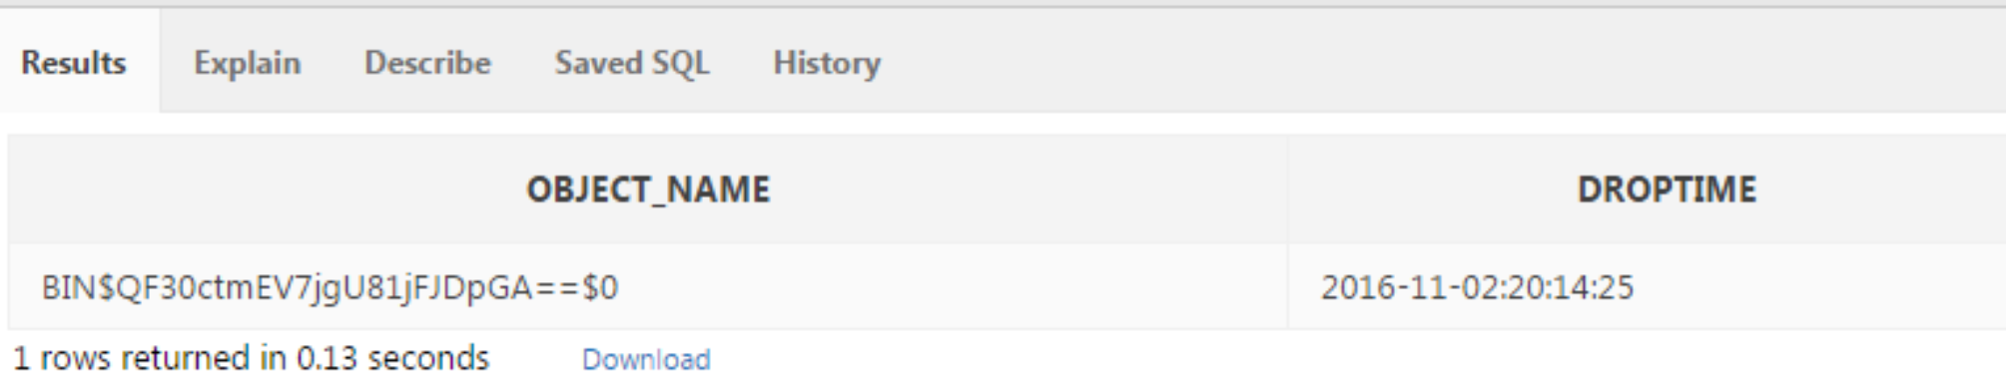

**SELECT object_name FROM user_recyclebin  WHERE LOWER(original_name) = 'copy_f_staffs' AND droptime = '2016-11-02:20:14:25';**

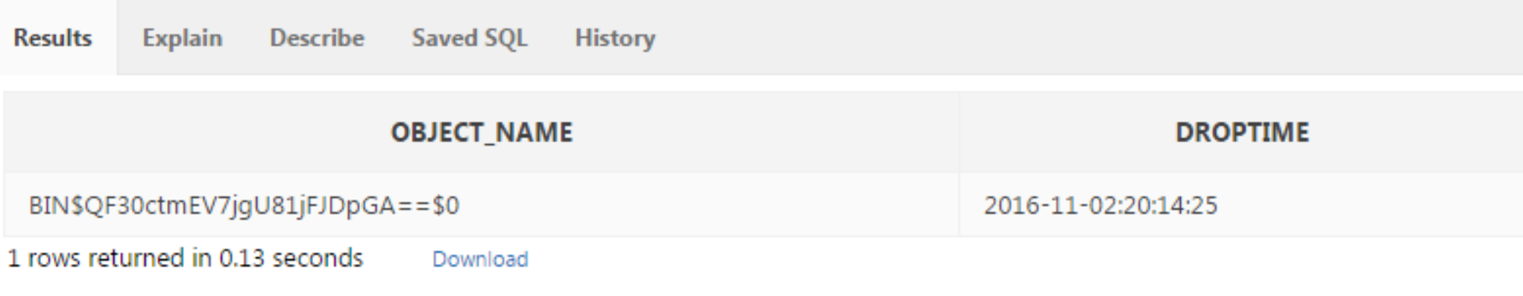

* 1. Try to select from the dropped table by using the value stored in the OBJECT_NAME column. You will need to copy and paste the name as it is exactly, and enclose the new name in “ “ (double quotes). So if the dropped name returned to you is BIN$Q+x1nJdcUnngQESYELVIdQ==$0, you need to write a query that refers to “BIN$Q+x1nJdcUnngQESYELVIdQ==$0”.

**SELECT * FROM "BIN$QF30ctmEV7jgU81jFJDpGA==$0";**

* 1. Undrop the table.

**FLASHBACK TABLE copy_f_staffs TO BEFORE DROP;**

* 1. Describe the table.

**DESCRIBE copy_f_staffs;**

1. Still working with the copy_f_staffs table, perform an update on the table.
   1. Issue a select statement to see all rows and all columns from the copy_f_staffs table;

**SELECT * FROM copy_f_staffs;**

* 1. Change the salary for Sue Doe to 12 and commit the change.

**UPDATE copy_f_staffs**

**SET salary = 12**

**WHERE first_name = 'Sue' AND last_name = 'Doe';**

* 1. Issue a select statement to see all rows and all columns from the copy_f_staffs table;

**SELECT * FROM copy_f_staffs;**

* 1. For Sue Doe, update the salary to 2 and commit the change.

**UPDATE copy_f_staffs**

**SET salary = 2**

**WHERE first_name = 'Sue' AND last_name = 'Doe';**

* 1. Issue a select statement to see all rows and all columns from the copy_f_staffs table;

**SELECT * FROM copy_f_staffs;**

* 1. Now, issue a FLASHBACK QUERY statement against the copy_f_staffs table, so you can see all the changes made.

**SELECT versions_operation, versions_starttime,  versions_endtime, id, first_name, last_name, birthdate, salary,overtime_rate,training,staff_type,manager_id, manager_budget,manager_target**

**FROM copy_f_staffs**

**VERSIONS BETWEEN SCN MINVALUE AND MAXVALUE**

**WHERE id = 12;**

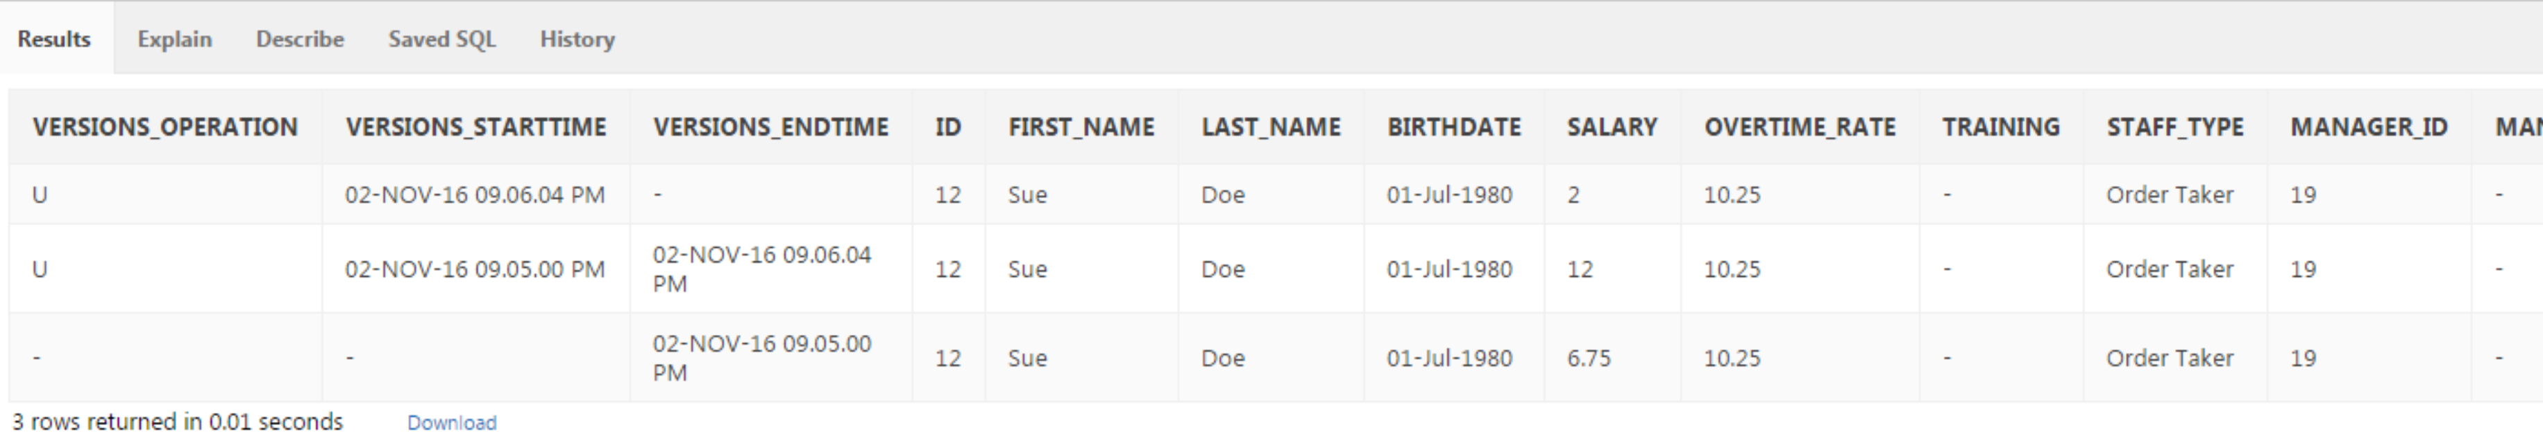

* 1. Investigate the result of f), and find the original salary and update the copy_f_staffs table salary column for Sue Doe back to her original salary.

**UPDATE copy_f_staffs**

**SET salary = (SELECT salary**

**FROM copy_f_staffs**

**VERSIONS BETWEEN SCN MINVALUE AND MAXVALUE**

**WHERE first_name = 'Sue' AND last_name = 'Doe' AND versions_operation IS NULL AND versions_starttime IS NULL)**

**WHERE first_name = 'Sue' AND last_name = 'Doe';**

**Now,**

**SELECT * FROM copy_f_staffs;**

**SELECT versions_operation, versions_starttime,  versions_endtime, id, first_name, last_name, birthdate, salary,overtime_rate,training,staff_type,manager_id, manager_budget,manager_target**

**FROM copy_f_staffs**

**VERSIONS BETWEEN SCN MINVALUE AND MAXVALUE**

**WHERE id = 12;**

