 



# Database Programming with SQL

* 1. : PRIMARY KEY, FOREIGN KEY, and CHECK Constraints

# Practice Activities

## Objectives

* + - Define and give an example of PRIMARY KEY, FOREIGN KEY, and CHECK constraints
    - Explain the purpose of defining PRIMARY KEY, FOREIGN KEY, and CHECK constraints on a table
    - Demonstrate the creation of constraints at the column level and table level in a CREATE TABLE statement
    - Evaluate a business problem requiring the addition of a PRIMARY KEY and FOREIGN KEY constraint and write the code to execute the change

## Vocabulary

Identify the vocabulary word for each definition below.

|  |  |
| --- | --- |
| **ON DELETE CASCADE** | Allows a foreign key row that is referenced to a primary key row to be deleted |
| **Check Constraint** | Explicitly defines a condition that must be met |
| **PRIMARY KEY** | A column or set of columns that uniquely identifies each row in a table |
| **NOT NULL** | Constraint ensures that the column contains no null values |
| **ON DELETE SET NULL** | Allows a child row to remain in a table with null values when a parent record has been deleted |
| **FOREIGN KEY Constraint** | Establishes a relationship between the foreign key column and a primary key or unique key in the same table or a different table |

## Try It / Solve It

1. What is the purpose of a
   1. PRIMARY KEY

**Uniquely identify each row in table.**

* 1. FOREIGN KEY

**Referential integrity constraint links back parent table's primary/unique key to child table's column.**

* 1. CHECK CONSTRAINT

**Explicitly define condition to be met by each row's fields. This condition must be returned as true or unknown.**

1. Using the column information for the animals table below, name constraints where applicable at the table level, otherwise name them at the column level. Define the primary key (animal_id). The license_tag_number must be unique. The admit_date and vaccination_date columns cannot contain null values.

animal_id NUMBER(6) **PRIMARY KEY**

name VARCHAR2(25)

license_tag_number NUMBER(10) **UNIQUE**

admit_date DATE

**NOT NULL**

adoption_id NUMBER(5), vaccination_date DATE

**NOT NULL**

1. Create the animals table. Write the syntax you will use to create the table.

**CREATE TABLE  animals**

**( animal_id  NUMBER(6,0) CONSTRAINT anl_anl_id_pk PRIMARY KEY ,**

**name VARCHAR2(25),**

**license_tag_number NUMBER(10,0) CONSTRAINT anl_l_tag_num_uk UNIQUE,**

**admit_date  DATE CONSTRAINT anl_adt_dat_nn NOT NULL ENABLE,**

**adoption_id   NUMBER(5,0),**

**vaccination_date  DATE CONSTRAINT anl_vcc_dat_nn NOT NULL ENABLE**

**);**

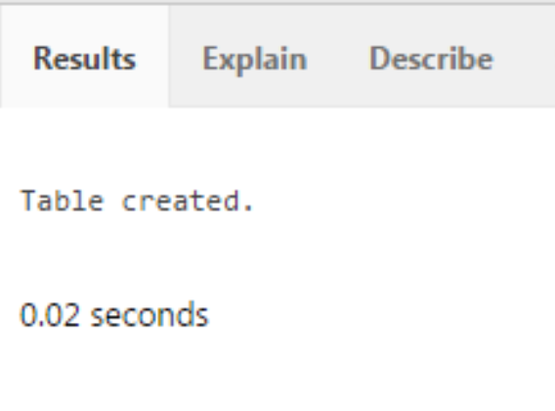

DESCRIBE animals;

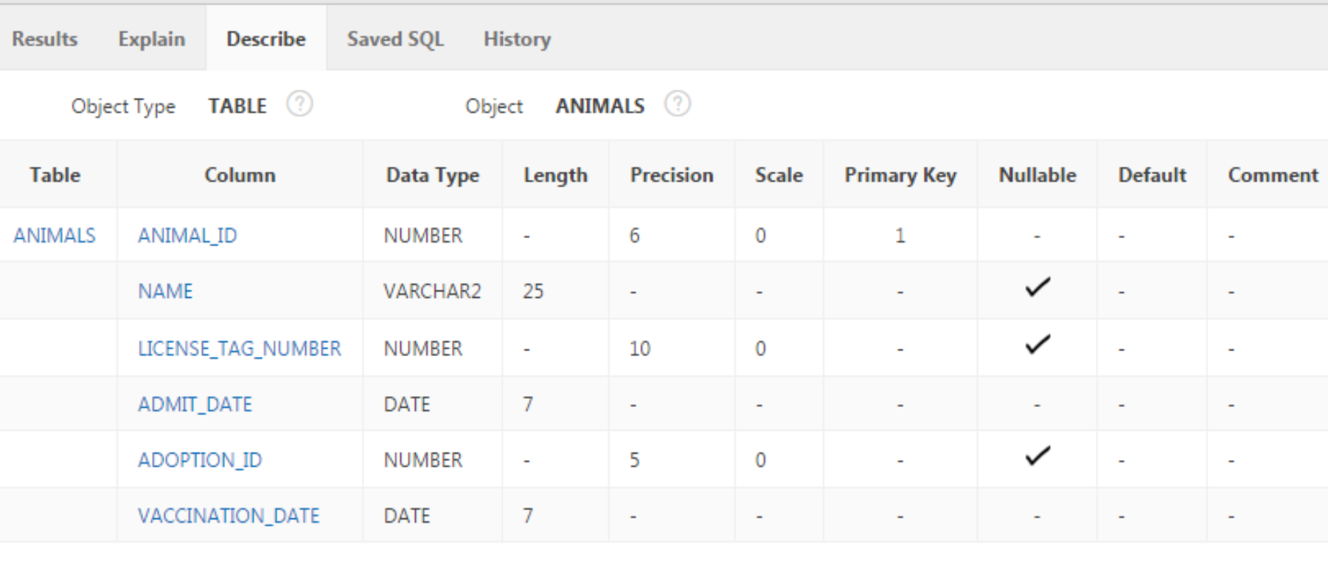

SELECT *

FROM user_constraints

WHERE LOWER(table_name) = 'animals';

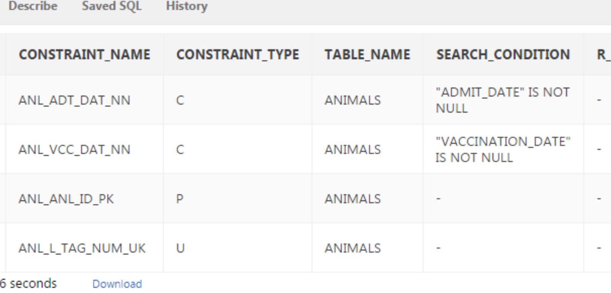

1. Enter one row into the table. Execute a SELECT * statement to verify your input. Refer to the graphic below for input.

**INSERT INTO animals (animal_id, name, license_tag_number, admit_date, adoption_id, vaccination_date)**

**VALUES( 101, 'Spot', 35540, TO_DATE('10-Oct-2004', 'DD-Mon-YYYY'), 205, TO_DATE('12-Oct-2004', 'DD-Mon-YYYY'));**

**SELECT * FROM animals;**

|  |  |  |  |  |  |
| --- | --- | --- | --- | --- | --- |
| ANIMAL_ ID | NAME | LICENSE_TAG_ NUMBER | ADMIT_DATE | ADOPTION_ ID | VACCINATION_ DATE |
| 101 | Spot | 35540 | 10-Oct-2004 | 205 | 12-Oct-2004 |

1. Write the syntax to create a foreign key (adoption_id) in the animals table that has a corresponding primary- key reference in the adoptions table. Show both the column-level and table-level syntax. Note that because you have not actually created an adoptions table, no adoption_id primary key exists, so the foreign key cannot be added to the animals table.
2. What is the effect of setting the foreign key in the ANIMAL table as:
   1. ON DELETE CASCADE

Recreate the row in adoptions with adoptions.id 500 again, refer it in animals.adoption_id.

ALTER TABLE animals

DROP CONSTRAINT anl_adopt_id_fk  ;

**ALTER TABLE  animals**

**ADD CONSTRAINT anl_adopt_id_fk  FOREIGN KEY (adoption_id)**

**REFERENCES  adoptions(id) ON DELETE CASCADE  ENABLE ;**

SELECT delete_rule

FROM user_constraints

WHERE LOWER(table_name) = 'animals' AND constraint_type = 'R';

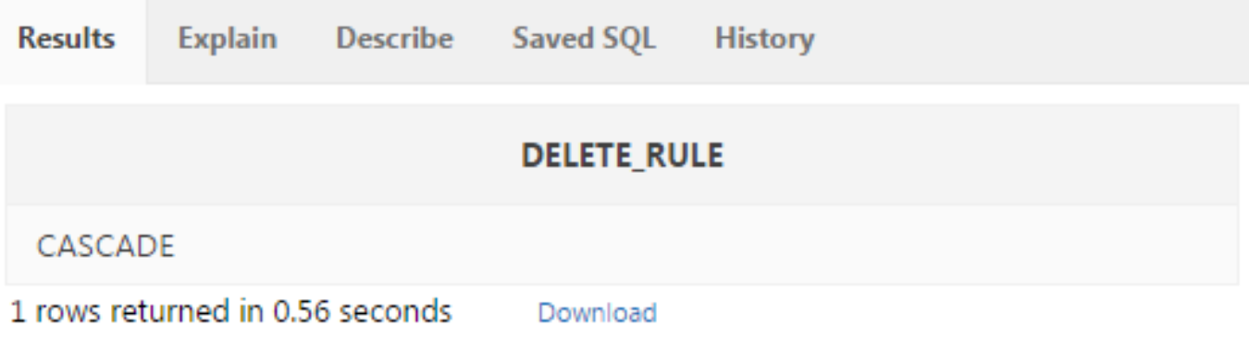

DELETE FROM adoptions WHERE id= 500;

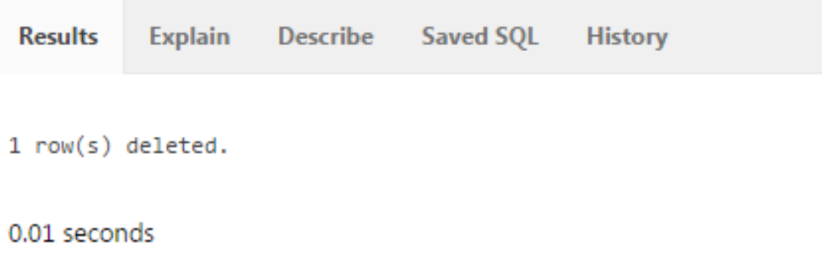

**But in fact child table also lost the row referring to this parent row:**

SELECT * FROM animals;

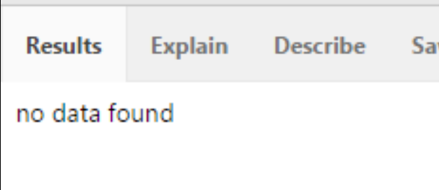

* 1. ON DELETE SET NULL

ALTER TABLE animals

DROP CONSTRAINT anl_adopt_id_fk  ;

**ALTER TABLE  animals**

**ADD CONSTRAINT anl_adopt_id_fk  FOREIGN KEY (adoption_id)**

**REFERENCES  adoptions(id) ON DELETE SET NULL  ENABLE ;**

SELECT delete_rule

FROM user_constraints

WHERE LOWER(table_name) = 'animals' AND constraint_type = 'R';

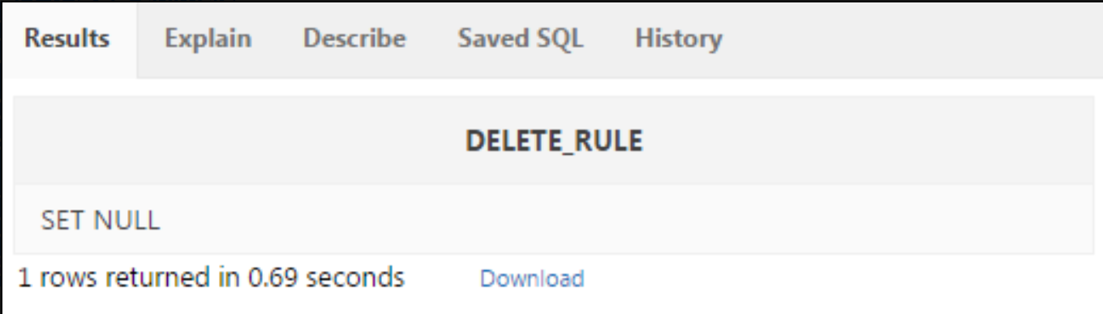

DELETE FROM adoptions WHERE id= 500;

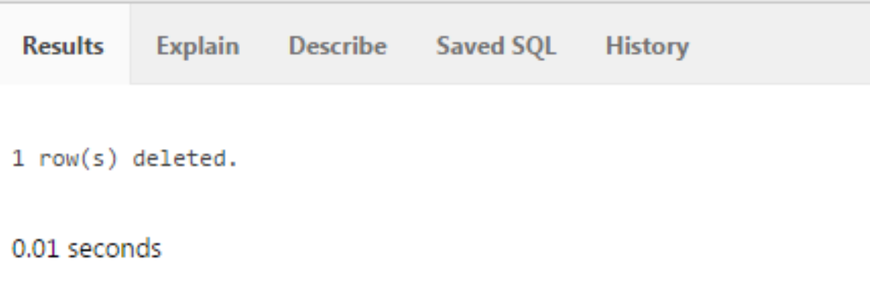

SELECT * FROM animals;

**Value in animals.adoption_id where 500 adoptions.id from parent was referred is now set to NULL;**

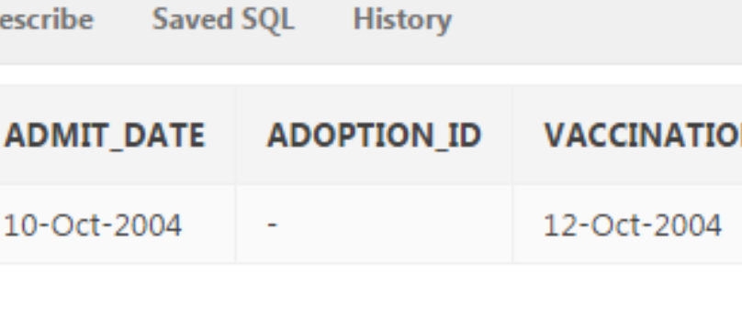

1. What are the restrictions on defining a CHECK constraint?

**I cannot specify check constraint for a view however in this case I could use WITH CHECK OPTION clause**

·         **I am restricted to columns from self table and fields in self row.**

·         **I cannot use subqueries and scalar subquery expressions.**

·         **I cannot call functions that are not deterministic e.g. CURRENT_DATE, CURRENT_TIMESTAMP, DBTIMEZONE, LOCALTIMESTAMP, SESSIONTIMEZONE, SYSDATE, SYSTIMESTAMP, UID, USER, and USERENV**

CREATE TABLE hemant2

(somecolumnname2 DATE CHECK (somecolumnname2  >  SYSDATE)

);

Says ORA-02436: date or system variable wrongly specified in CHECK constraint

But below mentioned works:

CREATE TABLE hemant2

(somecolumnname2 DATE CHECK (somecolumnname2  >  TO_DATE('03-Nov-2016','DD-Mon-YYYY'))

);

SELECT *

FROM user_constraints

WHERE LOWER(table_name) = 'hemant2';

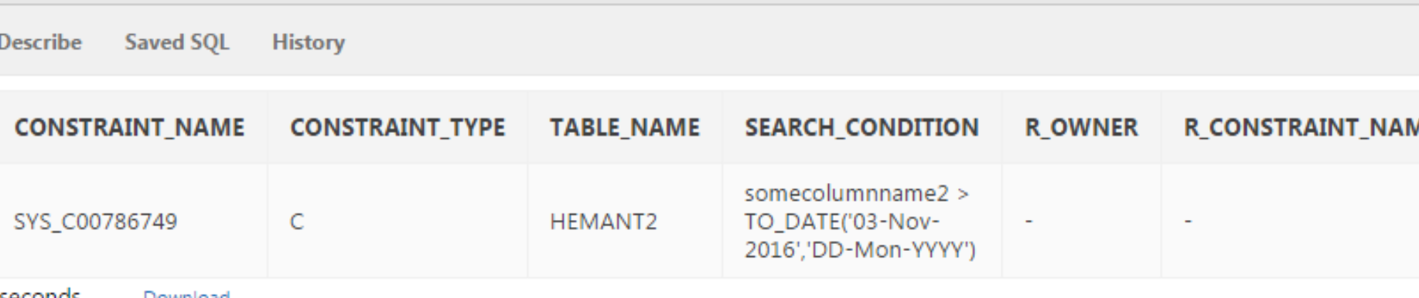

Copyright © 2020, Oracle and/or its affiliates. All rights reserved. Oracle and Java are registered trademarks of Oracle and/or its affiliates. Other names may be trademarks of their respective owners.