 



Database Programming with SQL 14-3: Managing Constraints Practice Activities

# Objectives

* List four different functions that the ALTER statement can perform on constraints
* Write ALTER TABLE statements to add, drop, disable, and enable constraints
* Name a business function that would require a DBA to drop, enable, and/or disable a constraint or use the CASCADE syntax
* Query the data dictionary for USER_CONSTRAINTS and interpret the information returned

# Vocabulary

Identify the vocabulary word for each definition below.

|  |  |
| --- | --- |
| **DISABLE CONSTRAINT** | To deactivate an integrity constraint |
| **CASCADE clause** | Disables dependent integrity constraints |
| **ALTER TABLE** | To add, modify, or drop columns from a table |
| **ENABLE CONSTRAINT** | To activate an integrity constraint currently disabled |
| **DROP CONSTRAINT** | Removes a constraint from a table |
| **DROP COLUMN** | Allows user to delete a column from a table |
| **CASCADE CONSTRAINTS** | Defines the actions the database server takes when a user attempts to delete or update a key to which existing foreign keys point |

# Try It / Solve It

Using Oracle Application Express, click the SQL Workshop tab in the menu bar. Click the Object Browser and verify that you have a table named copy_d_clients and a table named copy_d_events. If you don’t have these tables in your schema, create them before completing the exercises below.

Here is how the original tables are related. The d_clients table has a primary key client_number. This has a primary-key constraint and it is referenced in the foreign-key constraint on the d_events table.

**CREATE TABLE copy_d_clients**

**AS ( SELECT * FROM d_clients);**

DESCRIBE copy_d_clients ;

DESCRIBE d_clients;

SELECT * FROM d_clients ;

SELECT * FROM copy_d_clients ;

SELECT *

FROM user_constraints

WHERE LOWER(table_name) IN ( 'd_clients', 'copy_d_clients');

**CREATE TABLE copy_d_events**

**AS ( SELECT * FROM d_events);**

DESCRIBE copy_d_events ;

DESCRIBE d_events;

SELECT * FROM d_events ;

SELECT * FROM copy_d_events ;

SELECT *

FROM user_constraints

WHERE LOWER(table_name) IN ( 'd_events', 'copy_d_events');

1. What are four functions that an ALTER statement can perform on constraints?

·         **ADD (uses modify clause to add not null on a column though)**

·         **DROP**

·         **ENABLE/DISABLE**

1. Since the tables are copies of the original tables, the integrity rules are not passed onto the new tables; only the column datatype definitions remain. You will need to add a PRIMARY KEY constraint to the copy_d_clients table. Name the primary key copy_d_clients_pk . What is the syntax you used to create the PRIMARY KEY constraint to the copy_d_clients.table?

**ALTER TABLE copy_d_clients**

**ADD  CONSTRAINT copy_d_clt_client_number_pk PRIMARY KEY (client_number);**

SELECT *

FROM user_constraints

WHERE LOWER(table_name) =  'copy_d_clients' and constraint_type = 'P';

1. Create a FOREIGN KEY constraint in the copy_d_events table. Name the foreign key copy_d_events_fk. This key references the copy_d_clients table client_number column. What is the syntax you used to create the FOREIGN KEY constraint in the copy_d_events table?

**ALTER TABLE  copy_d_events**

**ADD CONSTRAINT copy_d_eve_client_number_fk FOREIGN KEY (client_number) REFERENCES  copy_d_clients (client_number) ENABLE;**

SELECT *

FROM user_constraints

WHERE LOWER(table_name) =  'copy_d_events' and constraint_type = 'R';

1. Use a SELECT statement to verify the constraint names for each of the tables. Note that the tablenames must be capitalized.

**SELECT constraint_name, constraint_type, table_name**

**FROM user_constraints**

**WHERE table_name =  UPPER('copy_d_events') ;**

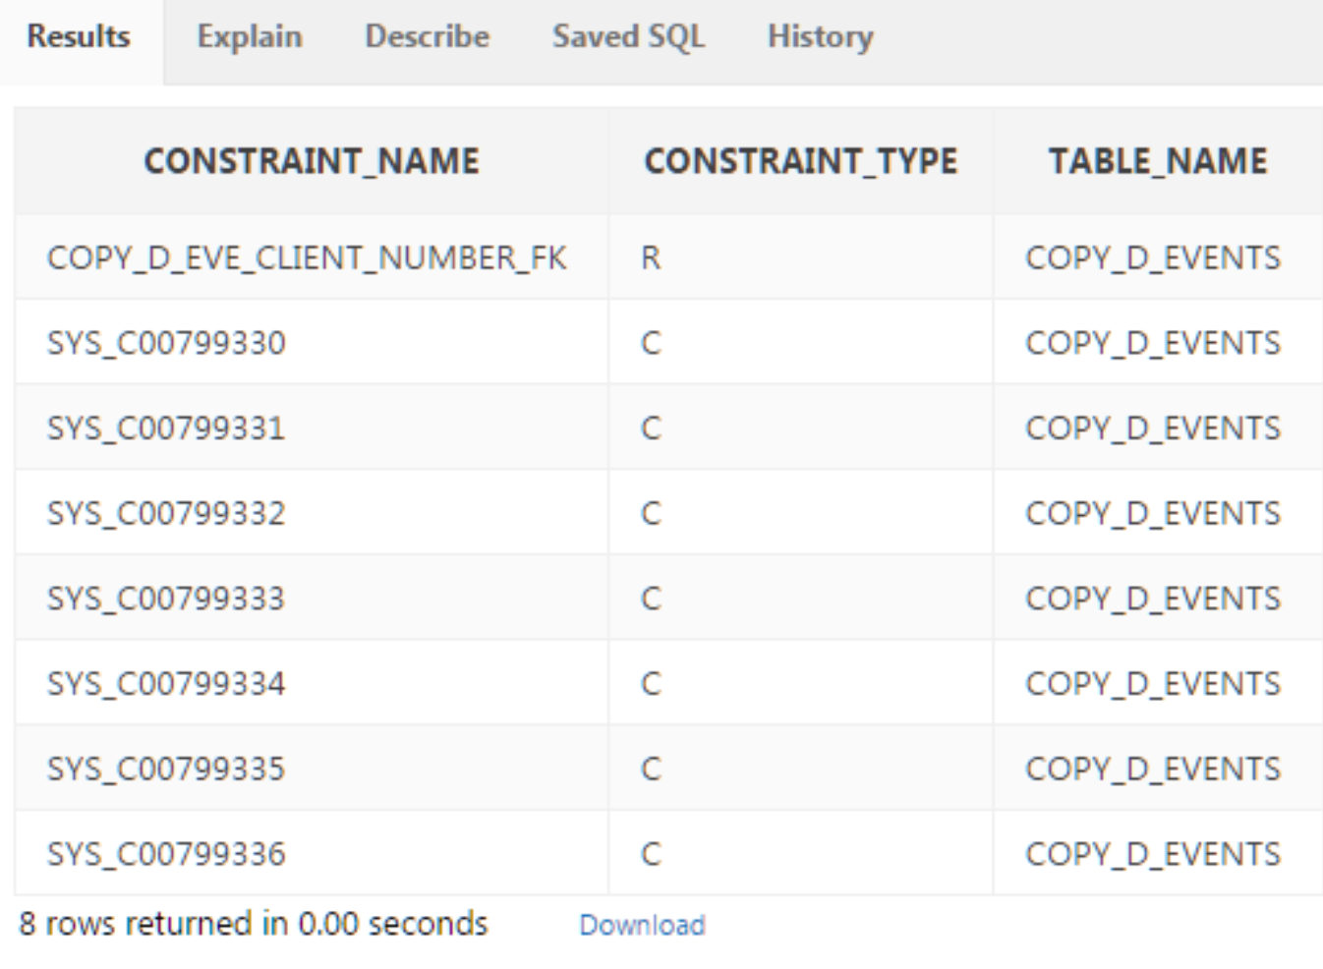

SELECT chld.table_name "Subject", chldcols.column_name "Subject Column Name", chld.constraint_name "constraint_name in Subject",  chld.constraint_type  "constraint_type in Subject",  prnt.table_name "Parent of FK",  prntcols.column_name "Parent's Column Name", prnt.constraint_name "Parent PK"

FROM user_constraints chld LEFT OUTER JOIN user_constraints prnt ON  chld.r_constraint_name = prnt.constraint_name

LEFT OUTER JOIN user_cons_columns chldcols ON chld.constraint_name = chldcols.constraint_name

LEFT OUTER JOIN user_cons_columns prntcols ON prnt.constraint_name = prntcols.constraint_name

WHERE chld.table_name = UPPER('copy_d_events');

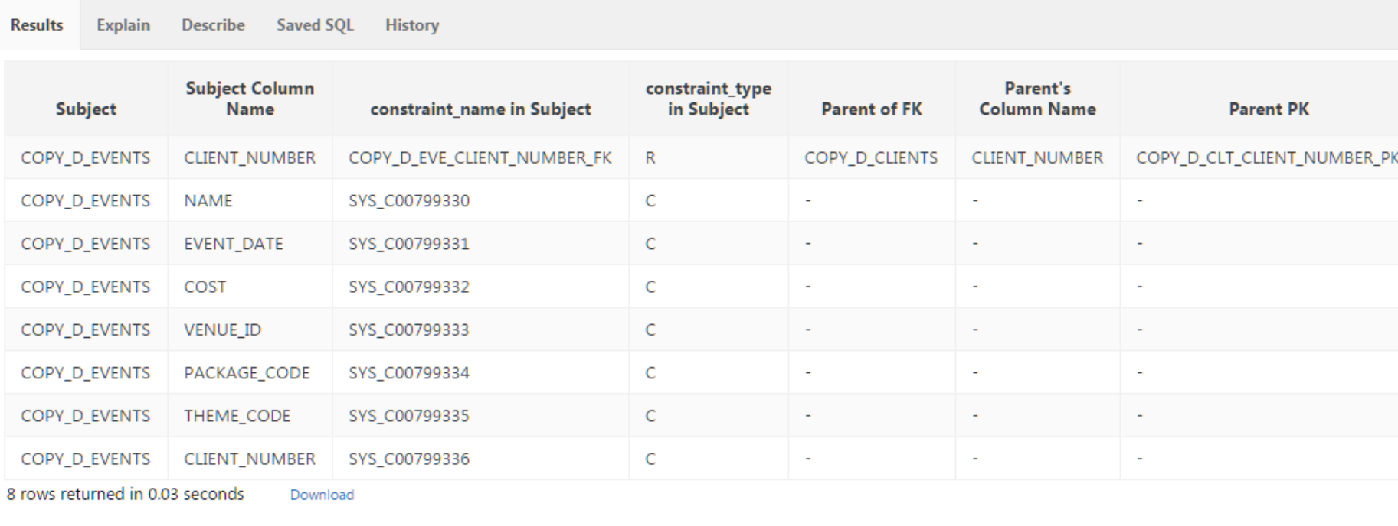

**SELECT constraint_name, constraint_type, table_name**

**FROM user_constraints**

**WHERE table_name =  UPPER('copy_d_clients') ;**

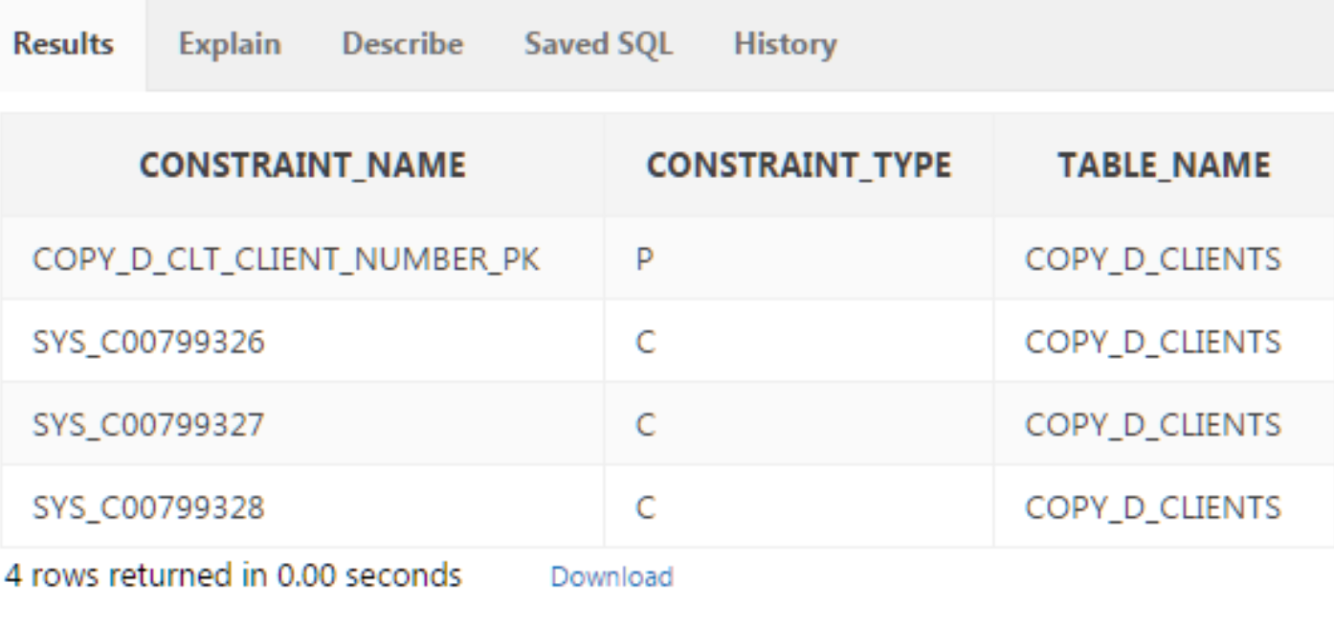

SELECT chld.table_name "Subject", chldcols.column_name "Subject Column Name", chld.constraint_name "constraint_name in Subject",  chld.constraint_type  "constraint_type in Subject",  prnt.table_name "Parent of FK",  prntcols.column_name "Parent's Column Name", prnt.constraint_name "Parent PK"

FROM user_constraints chld LEFT OUTER JOIN user_constraints prnt ON  chld.r_constraint_name = prnt.constraint_name

LEFT OUTER JOIN user_cons_columns chldcols ON chld.constraint_name = chldcols.constraint_name

LEFT OUTER JOIN user_cons_columns prntcols ON prnt.constraint_name = prntcols.constraint_name

WHERE chld.table_name = UPPER('copy_d_clients');

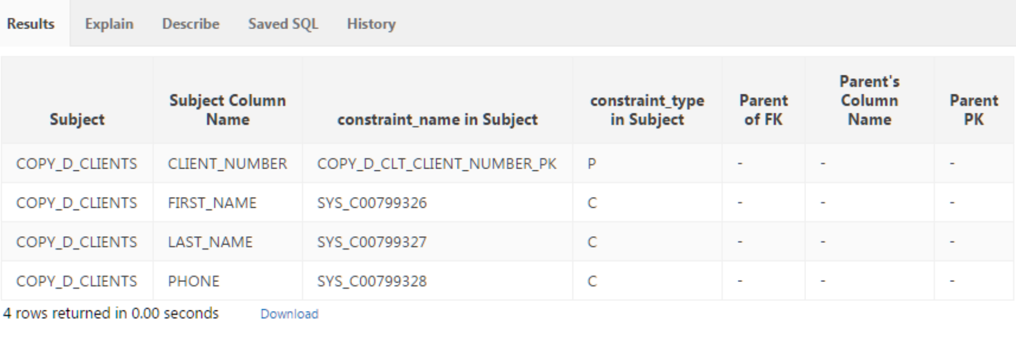

* 1. The constraint name for the primary key in the copy_d_clients table is **COPY_D_CLT_CLIENT_NUMBER_PK**.
  2. The constraint name for the foreign key in the copy_d_events table is **COPY_D_EVE_CLIENT_NUMBER_FK**.

1. Drop the PRIMARY KEY constraint on the copy_d_clients table. Explain your results.

ALTER TABLE copy_d_clients

DROP CONSTRAINT COPY_D_CLT_CLIENT_NUMBER_PK  ;

I get message:

**ORA-02273: this unique/primary key is referenced by some foreign keys**

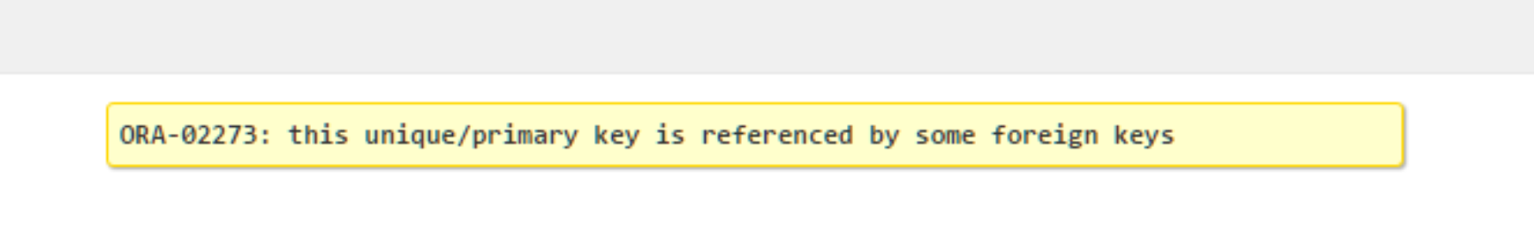

1. Add the following event to the copy_d_events table. Explain your results.

|  |  |  |  |  |  |  |  |  |
| --- | --- | --- | --- | --- | --- | --- | --- | --- |
| ID | NAME | EVENT_DATE | DESCRIPTION | COST | VENUE  _ID | PACKAGE_ CODE | THEME_ CODE | CLIENT_ NUMBER |
| 140 | Cline Bas Mitzvah | 15-Jul-2004 | Church and Private Home formal | 4500 | 105 | 87 | 77 | 7125 |

INSERT INTO copy_d_events(client_number,id,name,event_date,description,cost,venue_id,package_code,theme_code)

VALUES(7125,140,'Cline Bas Mitzvah',TO_DATE('15-Jul-2004','dd-Mon-yyyy'),'Church and Private Home formal',4500,105,87,77);

**ORA-02291: integrity constraint (HKUMAR.COPY_D_EVE_CLIENT_NUMBER_FK) violated - parent key not found**

SELECT * FROM copy_d_clients WHERE client_number = 7125;

no data found

That is why I got above error ORA-02291.

1. Create an ALTER TABLE query to disable the primary key in the copy_d_clients table. Then add the values from #6 to the copy_d_events table. Explain your results.

**ALTER TABLE copy_d_clients**

**DISABLE CONSTRAINT COPY_D_CLT_CLIENT_NUMBER_PK ;**

I get message ORA-02297: cannot disable constraint (HKUMAR.COPY_D_CLT_CLIENT_NUMBER_PK) - **dependencies exist.**

ALTER TABLE copy_d_clients

DISABLE CONSTRAINT COPY_D_CLT_CLIENT_NUMBER_PK **CASCADE**;

**Table altered.**

1. Repeat question 6: Insert the new values in the copy_d_events table. Explain your results.

**INSERT INTO copy_d_events(client_number,id,name,event_date,description,cost,venue_id,package_code,theme_code)**

**VALUES(7125,140,'Cline Bas Mitzvah',TO_DATE('15-Jul-2004','dd-Mon-yyyy'),'Church and Private Home formal',4500,105,87,77);**

**1 row(s) inserted.**

1. Enable the primary-key constraint in the copy_d_clients table. Explain your results.

ALTER TABLE copy_d_clients

ENABLE CONSTRAINT COPY_D_CLT_CLIENT_NUMBER_PK CASCADE;

ORA-00933: SQL command not properly ended

**ALTER TABLE copy_d_clients**

**ENABLE CONSTRAINT COPY_D_CLT_CLIENT_NUMBER_PK ;**

In case of enable I don’t have option like CASCADE.

1. If you wanted to enable the foreign-key column and reestablish the referential integrity between these two tables, what must be done?

ALTER TABLE copy_d_events

ENABLE CONSTRAINT COPY_D_EVE_CLIENT_NUMBER_FK;

ORA-02298: cannot validate (HKUMAR.COPY_D_EVE_CLIENT_NUMBER_FK) - parent keys not found

So first I need to fix the row with client_number to a valid value/null.

But since client_number is not nullable, I will either have to delete invalid row or update that row.

**DELETE FROM copy_d_events WHERE**

**client_number  NOT IN ( SELECT client_number FROM copy_d_clients);**

1 row(s) deleted.

**ALTER TABLE copy_d_events**

**ENABLE CONSTRAINT COPY_D_EVE_CLIENT_NUMBER_FK;**

Table altered.

1. Why might you want to disable and then re-enable a constraint?

**Generally to make bulk operations fast, where my input data is diligently sanitized and I am sure, it is safe to save some time in this clumsy process.**

1. Query the data dictionary for some of the constraints that you have created. How does the data dictionary identify each constraint type?

**Queries are same as in point 2,3, 4 above.**

**I can check value of CONSTRAINT_TYPE in all_constraints/user_constraints view.**

·         **C - Check constraint**

**Sub-case - if I see SEARCH_CONDITION something like "FIRST_NAME" IS NOT NULL , its a NOT NULL constraint.**

·         **P - Primary key**

·         **R - Referential integrity (fk)**

·         **U - Unique key**

Copyright © 2020, Oracle and/or its affiliates. All rights reserved. Oracle and Java are registered trademarks of Oracle and/or its affiliates. Other names may be trademarks of their respective owners.