 



Database Programming with SQL 15-3: Managing Views

Practice Activities

# Objectives

* Create and execute a query that removes a view
* Create and execute a query using an inline view
* Create and execute a top-n-analysis query

# Vocabulary

Identify the vocabulary word for each definition below.

|  |  |
| --- | --- |
| **TOP-N Analysis** | Asks for the N largest or smallest values in a column |
| **DROP** VIEW view_name | Removes a view |
| **INLINE VIEW** | Subquery with an alias that can be used within a SQL statement |

# Try It / Solve It

1. Create a view from the copy_d_songs table called view_copy_d_songs that includes only the title and artist. Execute a SELECT * statement to verify that the view exists.

**CREATE OR REPLACE VIEW view_copy_d_songs  AS**

**SELECT title, artist**

**FROM copy_d_songs;**

**SELECT * FROM view_copy_d_songs;**

1. Issue a DROP view_copy_d_songs. Execute a SELECT * statement to verify that the view has been deleted.

**DROP VIEW view_copy_d_songs;**

**SELECT * FROM view_copy_d_songs;**

**ORA-00942: table or view does not exist**

1. Create a query that selects the last name and salary from the Oracle database. Rank the salaries from highest to lowest for the top three employees.

**SELECT * FROM**

**(SELECT last_name, salary FROM employees ORDER BY salary  DESC)**

**WHERE ROWNUM <= 3;**

1. Construct an inline view from the Oracle database that lists the last name, salary, department ID, and maximum salary for each department. Hint: One query will need to calculate maximum salary by department ID.

There may be some employees without department mentioned since it is nullable. I want to miss such records in my calculations. This is achieved in dptmx in-line view itself. Also a department without an employee is also taken in.

**SELECT empm.last_name, empm.salary, dptmx.department_id**

**FROM**

**(SELECT dpt.department_id, MAX(NVL(emp.salary,0)) max_dpt_sal**

**FROM departments dpt LEFT OUTER JOIN employees emp ON dpt.department_id = emp.department_id**

**GROUP BY dpt.department_id) dptmx LEFT OUTER JOIN employees empm ON dptmx.department_id = empm.department_id**

**WHERE NVL(empm.salary,0) = dptmx.max_dpt_sal;**

1. Create a query that will return the staff members of Global Fast Foods ranked by salary from lowest to highest.

So, it means lowest has rank one:

**SELECT ROWNUM,last_name, salary**

**FROM**

**(SELECT * FROM f_staffs ORDER BY SALARY);**

Extension Exercises

1. Create a new table called my_departments and add all columns and all rows to it using a subquery from the Oracle departments table. Do a SELECT * from my_departments to confirm that you have all the columns and rows.

**CREATE TABLE my_departments**

**AS ( SELECT * FROM departments);**

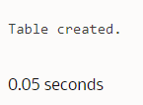

**DESCRIBE my_departments;**

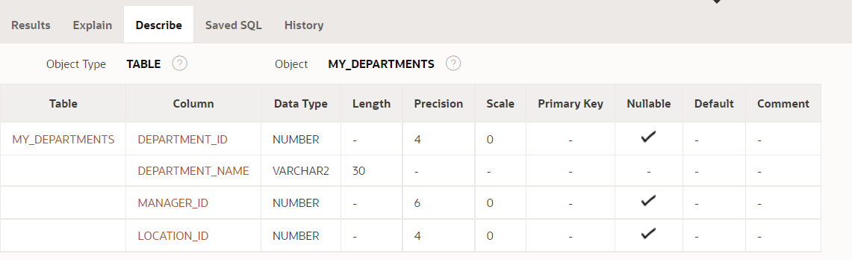

**DESCRIBE departments;**

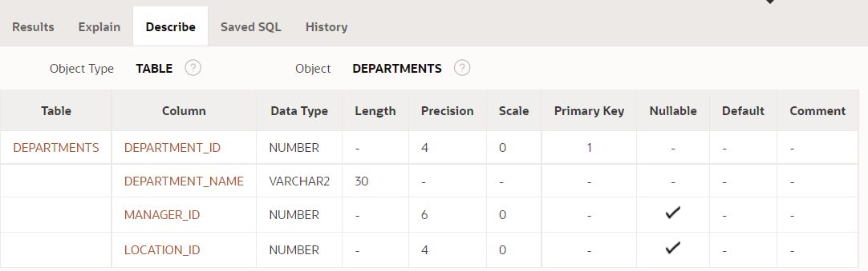

**SELECT * FROM departments;**

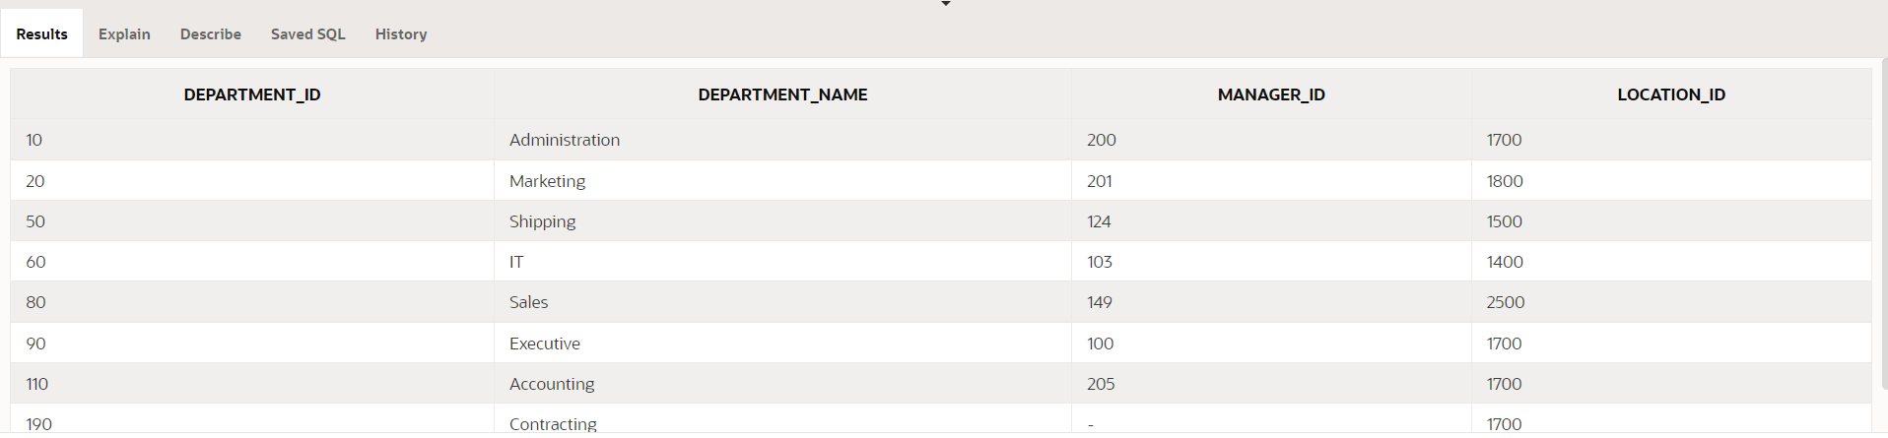

**SELECT * FROM my_departments;**

1. To view any constraints that may affect the my_departments table, DESCRIBE my_departments to check if any constraints were carried over from the departments table. If there are constraints on my_departments, use an ALTER TABLE command to DISABLE all constraints on my_departments.

Foreign key, check and primary key don’t go with copy but not NULL check constraint goes in copy:

**DESCRIBE my_departments;**

I need to look into constraint_name column in results here:

**SELECT * FROM user_constraints WHERE table_name = UPPER('my_departments');**

It suggests that I need:

**ALTER TABLE my_departments**

**DROP CONSTRAINT SYS_C00868380;**

1. Create a view called view_my_departments that includes: department_id and department_name.

**CREATE OR REPLACE VIEW view_my_departments  AS**

**SELECT department_id , department_name**

**FROM my_departments;**

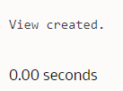

SELECT * FROM view_my_departments ;

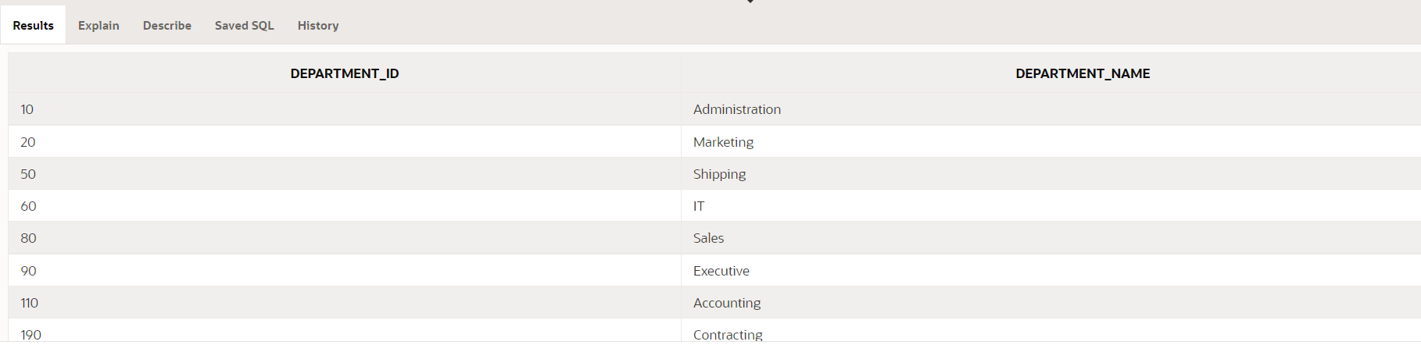

1. Add the following data to the my_departments table using view_my_departments.

|  |  |
| --- | --- |
| department_id | department_name |
| 105 | Advertising |
| 120 | Custodial |
| 130 | Planning |

**INSERT INTO view_my_departments ( department_id, department_name)**

**VALUES(105, 'Advertising');**

**INSERT INTO view_my_departments ( department_id, department_name)**

**VALUES(120, 'Custodial');**

**INSERT INTO view_my_departments ( department_id, department_name)**

**VALUES(130, 'Planning');**

SELECT * FROM my_departments;

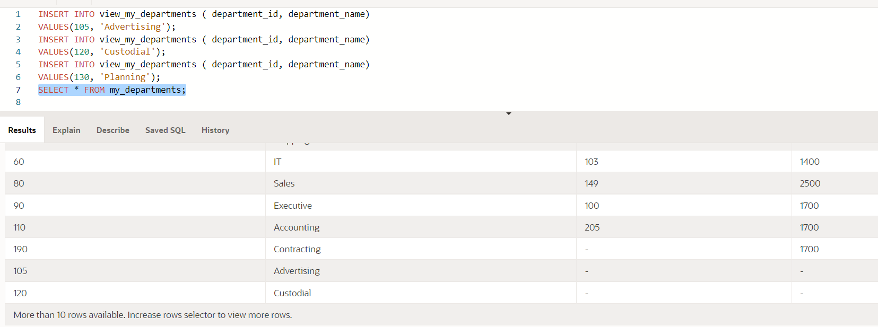

1. Create or enable the department_id column as the primary key.

**This must be done on table itself (not the view) or I will get ORA-00942: table or view does not exist**

**ALTER TABLE my_departments**

**ADD CONSTRAINT my_departments_id_pk  PRIMARY KEY (department_id);**

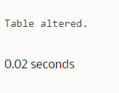

**DESCRIBE my_departments;**

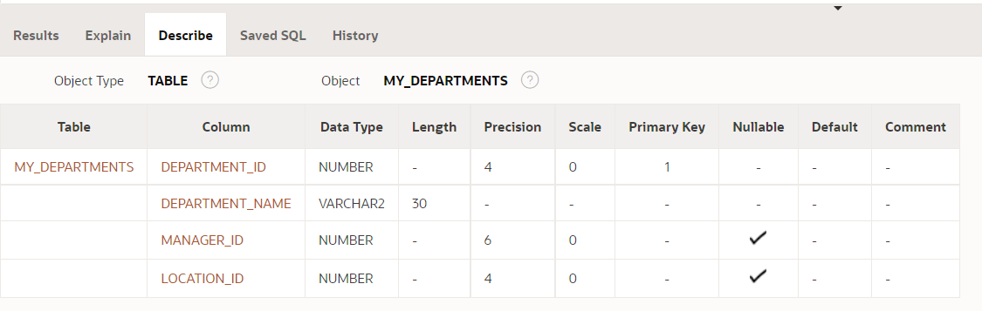

1. Enter a new department named Human Resources into the my_departments table using view_my_departments. Do not add a new department ID.

INSERT INTO view_my_departments ( department_id, department_name)

VALUES(NULL, 'Human Resources');

**ORA-01400: cannot insert NULL into ("HKUMAR"."MY_DEPARTMENTS"."DEPARTMENT_ID")**

INSERT INTO view_my_departments ( department_id, department_name)

VALUES(105, 'Human Resources');

**ORA-00001: unique constraint (HKUMAR.MY_DEPARTMENTS_ID_PK) violated**

1. Add the Human Resources department, department ID 220, to my_departments using view_my_departments.

**INSERT INTO view_my_departments ( department_id, department_name)**

**VALUES(220, 'Human Resources');**

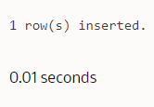

1. Verify that the new additions to my_departments were added using view_my_departments.

**SELECT * FROM my_departments;**

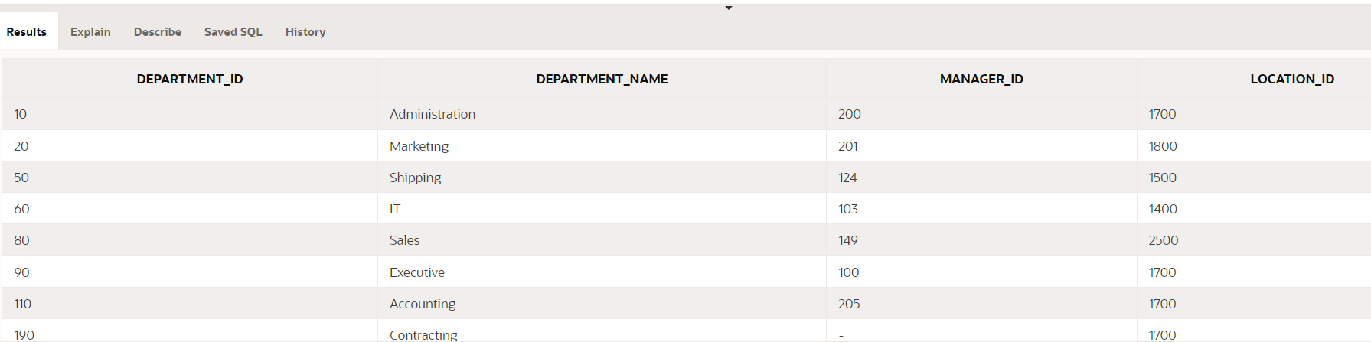

1. Modify view_my_departments to include location ID. Do a SELECT * command to show what columns are present and a DESCRIBE command to view the columns and associated constraints.

**CREATE OR REPLACE VIEW view_my_departments  AS**

**SELECT department_id , department_name, location_id**

**FROM my_departments;**

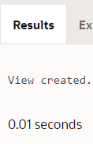

SELECT * FROM view_my_departments ;

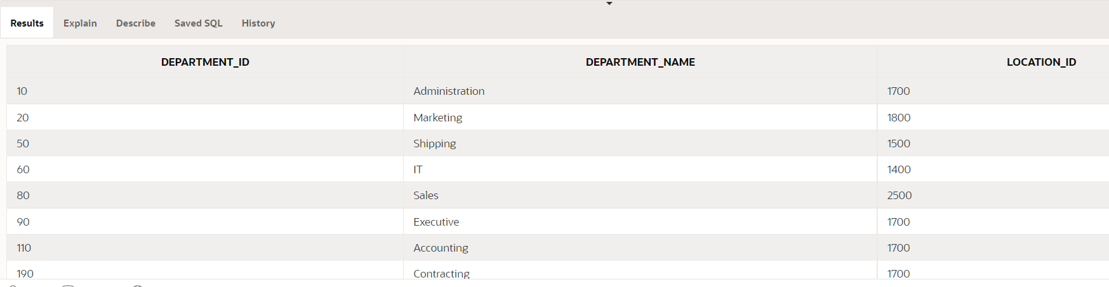

SELECT department_id , department_name, location_id

FROM my_departments;

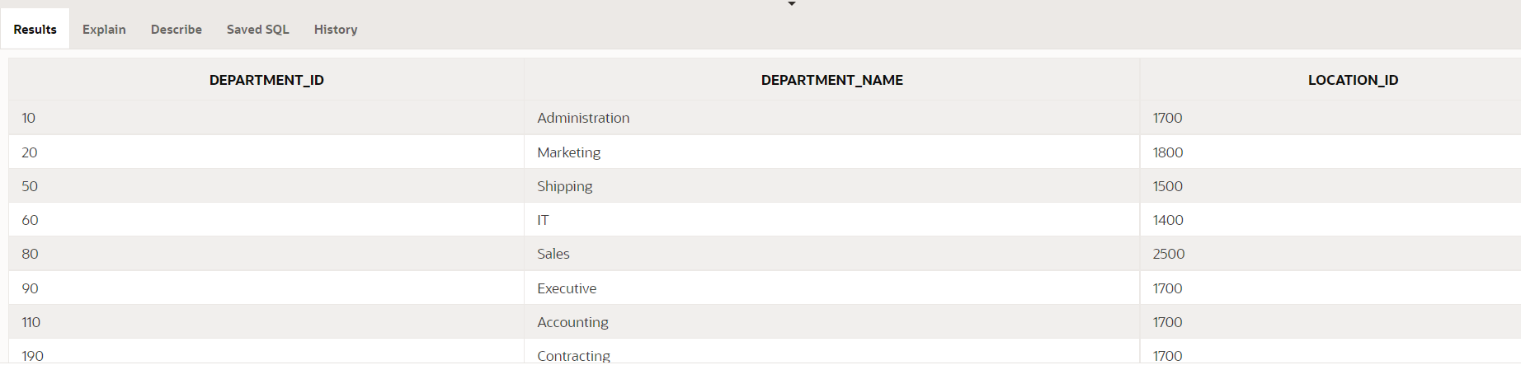

DESCRIBE view_my_departments;

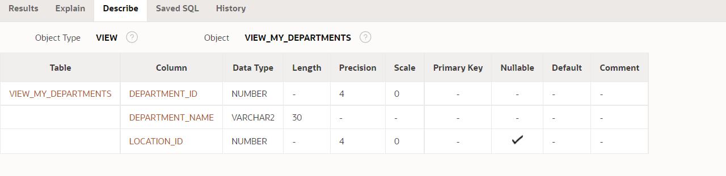

DESCRIBE my_departments;

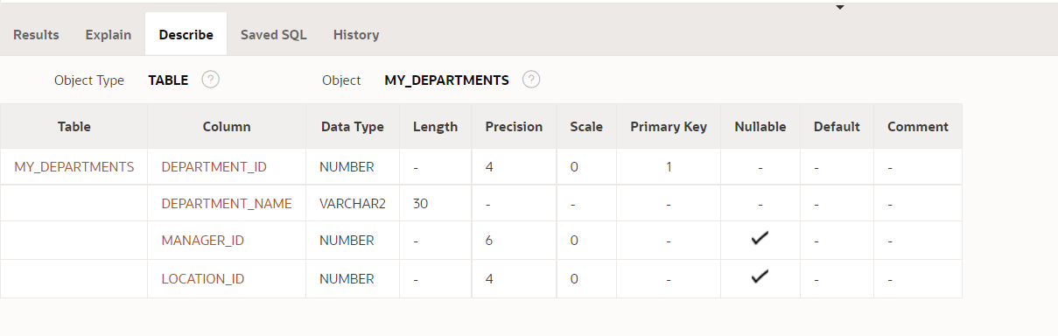

**So DESCRIBE take details from underlying table.**

SELECT * FROM user_constraints WHERE table_name = UPPER('view_my_departments');

SELECT * FROM user_constraints WHERE table_name = UPPER('my_departments');

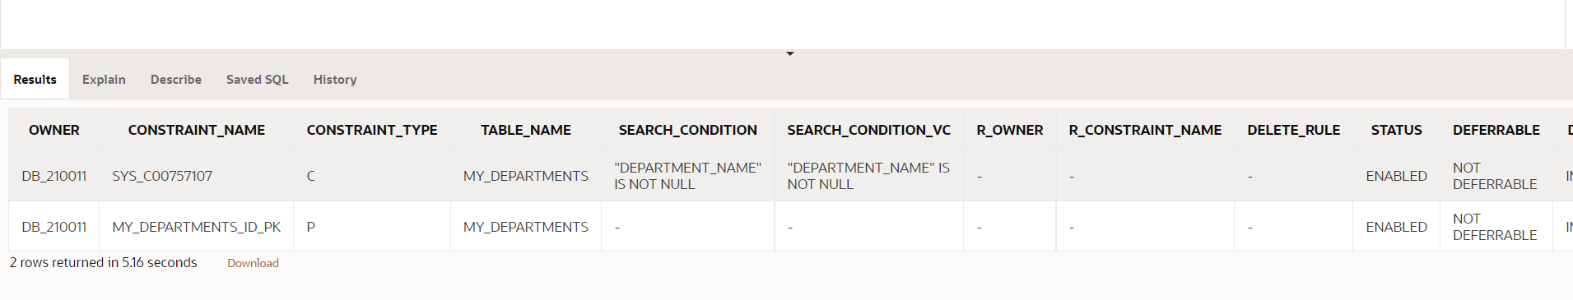

1. Make location_id a NOT NULL column in the my_departments table.

ALTER TABLE my_departments

MODIFY ( location_id NUMBER(4,0) CONSTRAINT my_departments_loc_id_nn NOT NULL); says:

**ORA-02296: cannot enable (HKUMAR.MY_DEPARTMENTS_LOC_ID_NN) - null values found**

ALTER TABLE my_departments

ADD CONSTRAINT my_departments_loc_id_nn CHECK("LOCATION_ID" IS NOT NULL);says:

**ORA-02293: cannot validate (HKUMAR.MY_DEPARTMENTS_LOC_ID_NN) - check constraint violated**

Now fix the error source:

UPDATE  my_departments

SET location_id = 1800

WHERE location_id IS NULL;

4 row(s) updated.

I verified again above mentioned two methods of forcing NOT NULL.**Now above mentioned both ways will work. Even though practically both solve the purpose, I will prefer highlighted in green**, due to results of describe mentioned below.

Some statements used to decide highlighted is better with results:

DESCRIBE my_departments;

SELECT * FROM user_constraints WHERE table_name = UPPER('my_departments') AND constraint_type = 'C';

ALTER TABLE my_departments

DROP CONSTRAINT MY_DEPARTMENTS_LOC_ID_NN;  
SELECT column_name, nullable FROM user_tab_columns  
 WHERE table_name = UPPER('my_departments');

1. Using the Oracle database, create a complex view between locations and departments with only the following columns: department_name, street_address, city, and state. Include only U.S. cities. Verify that the view was created using a SELECT * statement.

location_id is nullable in departments:

**CREATE OR REPLACE VIEW view_dpt_loc  AS**

**SELECT dpt.department_name, loc.street_address, loc.city, loc.state_province**

**FROM**

**departments dpt**

**LEFT OUTER JOIN locations loc ON dpt.location_id = loc.location_id**

**left OUTER JOIN countries con ON loc.country_id = con.country_id**

**WHERE con.country_name = 'United States of America';**

View created.

0.01 seconds

SELECT * FROM view_dpt_loc;

Results of select statement from view:

