 



Database Programming with SQL 17-1: Controlling User Access Practice Activities

# Objectives

* Compare the difference between object privileges and system privileges
* Construct the two commands required to enable a user to have access to a database
* Construct and execute a GRANT… ON …TO statement to assign privileges to objects in a user’s schema to other users and/or PUBLIC
* Query the data dictionary to confirm privileges granted

# Try It / Solve It

1. What are system privileges concerned with?

**System privileges determine what the user can do at the DB level. They are concerned with right to perform a particular action or to perform an action on any object (tables, views, materialized views, synonyms, indexes, sequences, cache groups, replication schemes and PL/SQL functions, procedures and packages) of a particular type. Some system privileges examples:**

·         *CREATE SESSION (Enables a user to create a connection to the database. - bare minimum)*

·         *ADMIN (Enables a user to perform administrative tasks including checkpointing, backups, migration, and user creation and deletion.)*

·         *CACHE_MANAGER (Enables a user to perform operations related to cache groups.)*

·         *CREATE TABLE (Enables a user to create a table owned by that user.)*

·         *CREATE ANY TABLE ( To create a table in another user's schema, I must have the CREATE ANY TABLE privileges)*

·         *XLA (Enables a user to connect to a database as an XLA reader.)*

*And so on.*

1. What are object privileges concerned with?

**Object privilege target specifically object level security (data security). These are concerned with right to perform a particular action on an object or to access another user's object** (table, view, materialized view, index, synonyms [converted to privileges on base table referenced by synonym], sequences, cache group, replication schemes, PL/SQL function, procedure, and package). Object's owner has all privileges for that object and can't be revoked. Owner can grant object privileges for that object to other DB users. Also a user with ADMIN privilege can grant and revoke object privileges from users who do not own the object under consideration. Examples:

·         ALTER, DELETE, INDEX, INSERT, REFRENCEs, SELECT, UPDATE table;

·         DELETE, INDEX, INSERT,  SELECT, UPDATE view;

·         ALTER (excluding START WITH), SELECT sequence;

·         EXECUTE procedure;

·         FLUSH,LOAD,REFRESH, UNLOAD ON Cache group

And so on

1. What is another name for object security?

**Data Security**

1. What commands are necessary to allow Scott access to the database with a password of tiger?

If I get:

ORA-01031: insufficient privileges

Means I don't have sufficient permissions for that action.

**CREATE USER scott IDENTIFIED BY tiger**;

If I wanted to give only create session privilege to scott ( he will also get privileges given as to public):

**GRANT CREATE SESSION TO  scott;**

If I wanted to give something more than create session, say create table, create sequence and so on:

**GRANT CREATE SESSION, CREATE TABLE, CREATE sequence, CREATE VIEW TO scott;**

Another way could be just giving a role: CONNECT which has privileges like CREATE SESSION and also other system privileges, like CREATE TABLE.

**GRANT CONNECT TO scott;**

1. What are the commands to allow Scott to SELECT from and UPDATE the d_clients table?

**GRANT SELECT, UPDATE ON hkumar.d_clients to scott;**

Opposite: REVOKE SELECT, UPDATE ON  d_clients FROM scott;

Verify: SELECT * FROM user_tab_privs_made;



1. What is the command to allow everybody the ability to view the d_songs table?

**GRANT SELECT ON hkumar.d_songs to PUBLIC;**

Opposite: REVOKE SELECT ON hkumar.d_songs FROM PUBLIC;

Verify: SELECT * FROM user_tab_privs_made;

1. Query the data dictionary to view the object privileges granted to you the user.

**SELECT * from user_tab_privs_recd;**

DESCRIBE   user_tab_privs_recd;

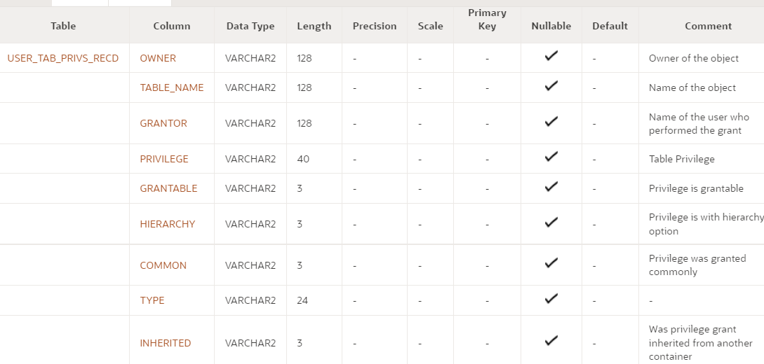

1. What privilege should a user be given to create tables?

**CREATE TABLE** -  Enables a user to create a table owned by that user.

**CREATE ANY TABLE -**Enables a user to create a table owned by any user in the database.

1. If you create a table, how can you pass along privileges to other users just to view your table?

**GRANT SELECT ON hkumar.d_songs to   scott1, scott2, scott3;**

1. What syntax would you use to grant another user access to your copy_employees table?

I assume all type of permissions here now (if it were on read privilege I will use SELECT instead of ALL):

**GRANT ALL ON hkumar.copy_employees to   scott1, scott2, scott3;x`**

Verify: SELECT * FROM user_tab_privs_made;

1. How can you find out what privileges you have been granted for columns in the tables belonging to others?

**SELECT * FROM user_col_privs_recd;**

DESCRIBE user_col_privs_recd;

Copyright © 2020, Oracle and/or its affiliates. All rights reserved. Oracle and Java are registered trademarks of Oracle and/or its affiliates. Other names may be trademarks of their respective owners.