 



Database Programming with SQL 17-3: Regular Expressions Practice Activities

# Objectives

* Describe regular expressions
* Use regular expressions to search, match, and replace strings in SQL statements
* Construct and execute regular expressions and check constraints

# Try It / Solve It

1. Working with the employees table, and using regular expressions, write a query that returns employees whose first names start with a “S” (uppercase) followed by either a “t” (lowercase) or “h” (lowercase).

**SELECT * FROM employees**

**WHERE REGEXP_LIKE(first_name, '^S(t|h)');**



^/$ Matches the start-of-line/end-of-line

() Grouping expression, treated as a single sub-expression

| Alternation operator for specifying alternative matches

1. Investigate the LOCATIONS table.
   1. Describe the table.

**DESCRIBE locations;**

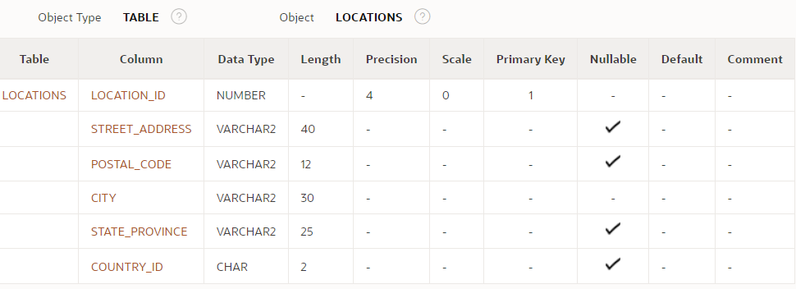

* 1. Perform a select that returns all rows and all columns of that table.

**SELECT * FROM locations;**

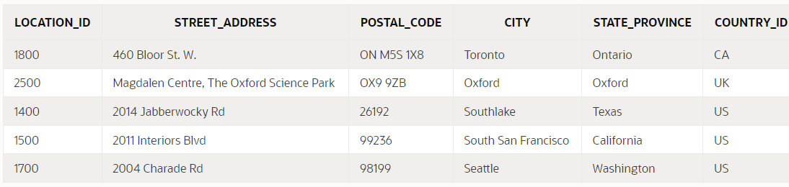

* 1. Write a query using regular expressions that removes the spaces in the street_address column in the LOCATIONS table.

**SELECT street_address, REGEXP_REPLACE(street_address, ' ','')   street_address_changed**

**FROM locations;**

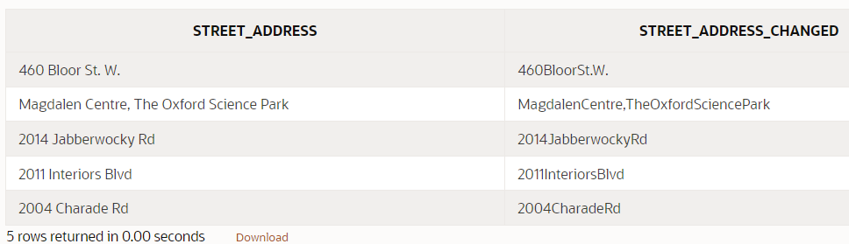

Some most frequently used meta characters:

. (dot) Matches any character in the supported character set,except NULL

?  matches zero or one occurence

* matches zero or more occurences

+ Matches one or more occurences

() Grouping expression, treated as a single sub-expression

\ Escape character

| Alternation operator for specifying alternative matches

^/$ Matches the start-of-line/end-of-line

[] Bracket expression for a matching list matching any one of the expressions represented in the list  
  
  
Regular expressions used as check constraints are another way to ensure data is formatted correctly prior to being written into the database table.  
  
Regular expression functions:REGEXP_INSTR,  REGEXP_SUBSTR, REGEXP_LIKE,  REGEXP_REPLACE,  REGEXP_COUNT

Copyright © 2020, Oracle and/or its affiliates. All rights reserved. Oracle and Java are registered trademarks of Oracle and/or its affiliates. Other names may be trademarks of their respective owners.