 



Database Programming with SQL 19-1: Testing

Practice Activities

# Objectives

* Develop and apply a strategy for testing that a database functions as designed.

# Try It / Solve It

1. Design and carry out tests to check the following:
   1. The business rule that requires that employees have a job_id

"JOB_ID" VARCHAR2(10) CONSTRAINT "EMP_JOB_NN" NOT NULL ENABLE,

**Test No.**

 101

**Date**

11/15/2016

**Test Description**

Confirm NOT NULL constraint on job_id

**Input**

INSERT INTO employees(employee_id,first_name,last_name,email,phone_number,hire_date,job_id,salary,commission_pct,manager_id,department_id)

VALUES(300,'Hemant','Kumar','HKUMAR',NULL,TO_DATE('2016-11-16','yyyy-mm-dd'),NULL,17000,null,100,90 );

**Expected Output**

Should not be able to insert NULL

**Result/Discrepancy**

  
**Action**

None

* 1. The business rule that requires that the end date of an employment is after a start date in the job history table.

CONSTRAINT "JHIST_DATE_INTERVAL" CHECK (end_date > start_date) ENABLE,

**Test No.**

 102

**Date**

11/15/2016

**Test Description**

End date must be greater than start date

**Input**

INSERT INTO job_history(employee_id,start_date,end_date,job_id,department_id)

VALUES(102,TO_DATE('11-15-2016','mm-dd-yyyy'),TO_DATE('06-17-1993','mm-dd-yyyy'),'AD_ASST',90 );

**Expected Output**

Should not be able to insert since start_date is greater than end_date

**Result/Discrepancy**

  
**Action**

None

* 1. The business rule that states that departments can be closed down with employees in that department (resulting in the department_id becoming unknown).

ALTER TABLE  "EMPLOYEES" ADD CONSTRAINT "EMP_DEPT_FK" FOREIGN KEY ("DEPARTMENT_ID")

              REFERENCES  "DEPARTMENTS" ("DEPARTMENT_ID") ENABLE

**Test No.**

 103

**Date**

11/15/2016

**Test Description**

When department is deleted from departments table, department_id in employees table is set to NULL for the corresponding rows.

**Input**

DELETE FROM departments WHERE department_id = 10;

*(Why I chose 10:*

*SELECT CONSTRAINT_NAME , table_name from user_constraints where r_constraint_name = (SELECT r_constraint_name from user_constraints where CONSTRAINT_NAME= 'EMP_DEPT_FK');*

select department_id from employees WHERE department_id not in ( select nvl(department_id , 0) from job_history);

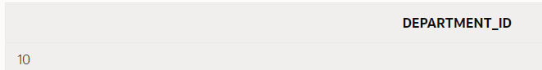

* 1. The minimum salary of an employee is 1000.

CONSTRAINT "EMP_SALARY_MIN" CHECK (salary > 0) ENABLE,

**Test No.**

 104

**Date**

11/15/2016

**Test Description**

The minimum salary of an employee is 1000. Should not be able to edit salary to NULL or less than 1000.

**Input**

UPDATE employees

SET salary = NULL

WHERE employee_id = 144;

UPDATE employees

SET salary = 999

WHERE employee_id = 144;

**Expected Output**

Both of the update statements should fail.

**Result/Discrepancy**



1. If one of the above tests fails, write out the SQL statement(s) that would be needed to correct the test. With the permission of your teacher, implement the change and then rerun the test with the same input and confirm that it works.

Problem 1 c Action:

**ALTER TABLE employees**

**DROP CONSTRAINT emp_dept_fk;**

**ALTER TABLE  employees**

**ADD CONSTRAINT emp_dept_fk   FOREIGN KEY (department_id)**

**REFERENCES  departments (department_id) ON DELETE SET NULL ;**

Now execute test id 103 again:

DELETE FROM departments WHERE department_id = 10;



SELECT department_id FROM employees WHERE employee_id = 200;

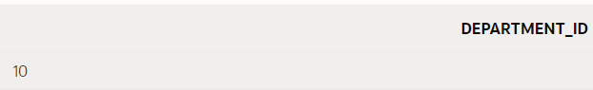

Problem 1 d action:

**ALTER TABLE employees**

**MODIFY salary CONSTRAINT emp_salary_nn NOT NULL;**



**ALTER TABLE employees**

**DROP CONSTRAINT emp_salary_min;**



**UPDATE employees**

**SET salary = 1000 WHERE NVL(salary,0) < 1000;**



**ALTER TABLE employees**

**ADD CONSTRAINT emp_salary_min CHECK (salary >= 1000);**



**Execute test 104 again:**

UPDATE employees

SET salary = NULL

WHERE employee_id = 144;

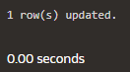

UPDATE employees

SET salary = 999

WHERE employee_id = 144;



Copyright © 2020, Oracle and/or its affiliates. All rights reserved. Oracle and Java are registered trademarks of Oracle and/or its affiliates. Other names may be trademarks of their respective owners.