 



Database Programming with SQL

* 1. : Relational Database Technology Practice Activities

# Objectives

* + - Define and give an example of a relational database
    - Identify table-key terms, including row, column, field, primary key, and foreign key
    - Relate the importance of databases to everyday life

# Vocabulary

Identify the vocabulary word for each definition below.

|  |  |
| --- | --- |
| Строка | An entry in a table, consisting of values for each appropriate column. |
| Первичный ключ | The set of mandatory columns within a table that is used to enforce uniqueness of rows, and that is normally the most frequent means by which rows are accessed. |
| Таблица | An arrangement of data in rows and columns. |
| Внешний ключ | A column or set of columns that refers to a primary key in the same table or another table. |
| Реляционная б.д. | Collections of objects or relations, set of operators to act on those relations, and data integrity for accuracy and consistency |
| Поле | Intersection of a row and column |
| DML | Used to modify the table data by entering, changing, or removing rows |
| DDL | Creates, changes, and removes data structures from the database |
| transaction control language | Used to manage the changes made by DML statements |
| data control language | Used to give or remove access rights to the database and the structures within it |

# Try It / Solve It

1. The Global Fast Foods database consists of how many tables? 9 tables
2. How is the F_SHIFTS table related to the F_STAFFS table?

SELECT DISTINCT table_name from user_constraints

WHERE r_constraint_name in

(

SELECT constraint_name

FROM user_constraints

WHERE table_name in (upper('f_shifts'), upper('F_STAFFS'))

);

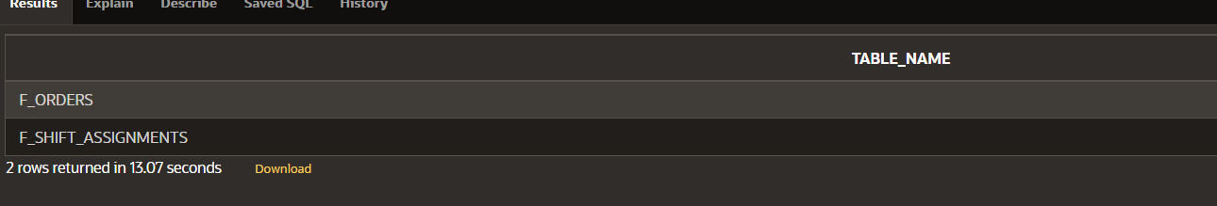

1. What are the names of the columns in the F_CUSTOMERS table?

SELECT column_name

FROM all_tab_cols

WHERE table_name = 'F_CUSTOMERS'COLUMN_NAME:

ID

FIRST_NAME

LAST_NAME

ADDRESS

CITY

STATE

ZIP

PHONE_NUMBER

1. How many rows of data have been entered in the F_PROMOTIONAL_MENUS table?

select count(*) from F_PROMOTIONAL_MENUS;



1. In the F_FOOD_ITEMS table, column is a foreign-key column. What table and column is this key referencing?

select *

from user_constraints

where table_name = 'F_FOOD_ITEMS' and CONSTRAINT_TYPE = 'R';

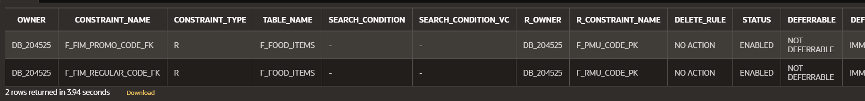

select table_name from user_constraints

where constraint_name in

(

select r_constraint_name

from user_constraints

where table_name = 'F_FOOD_ITEMS' and CONSTRAINT_TYPE = 'R'

);

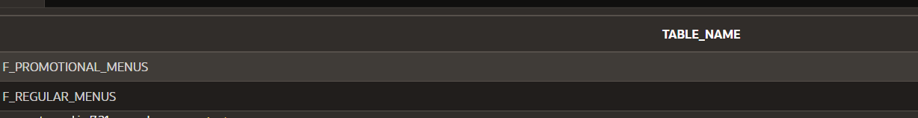

"REGULAR_CODE" to "CODE" in "F_REGULAR_MENUS"

"PROMO_CODE" to "CODE" in "F_PROMOTIONAL_MENUS"

1. List the primary key to foreign key relationships required to go from the F_SHIFTS table to the F_REGULAR_MENUS table.

**ALTER TABLE  "F_REGULAR_MENUS"  ADD CONSTRAINT "F_RMU_SHIFT_CODE_FK" FOREIGN KEY ("SHIFT_CODE")  REFERENCES  "F_SHIFTS" ("CODE")  ENABLE;**

1. Which table(s) contains null values? 10

Copyright © 2020, Oracle and/or its affiliates. All rights reserved. Oracle and Java are registered trademarks of Oracle and/or its affiliates. Other names may be trademarks of their respective owners.