 



Database Programming with SQL 1-3: Anatomy of a SQL Statement Practice Activities

# Objectives

* Match projection, selection, and join with their correct functions capabilities
* Create a basic SELECT statement
* Use the correct syntax to display all rows in a table
* Use the correct syntax to select specific columns in a table, modify the way data is displayed, and perform calculations using arithmetic expressions and operators
* Formulate queries using correct operator precedence to display desired results
* Define a null value
* Demonstrate the effect null values create in arithmetic expressions
* Construct a query using a column alias

# Vocabulary

Identify the vocabulary word for each definition below.

|  |  |
| --- | --- |
| join | Display data from two or more related tables. |
| Арифметический оператор | A symbol used to perform an operation on some values. |
| Столбец | An implementation of an attribute or relationship in a table. |
| Проекция | The capability in SQL to choose the columns in a table that you want returned from a query. |
| null | A value that is unavailable, unassigned, unknown, or inapplicable. |
| Псевдоним столбца | Renames a column heading. |
| Арифметическое выражение | A mathematical equation. |
| selection | The capability in SQL to choose the rows in a table returned from a query. |
| SELECT | Retrieves information from the database |
| select clause | Specifies the columns to be displayed |
| from clause | Specifies the table containing the column listed in the select clause |
| SQL command.  SELECT and FROM | An individual SQL command |

|  |  |
| --- | --- |
| clause | Part of a SQL statement |
| Statement | A combination of the two clauses |

# Try It / Solve It

Now you know the basics of a SELECT statement, It's time to practice what you've learned.

1. Write a SQL statement that demonstrates projection.

SELECT constraint_name

FROM user_constraints

WHERE table_name in (upper('f_shifts'), upper('F_STAFFS'));

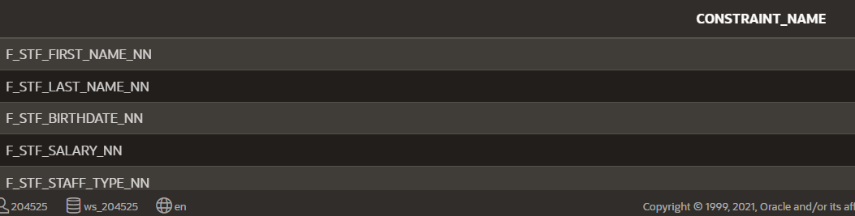

1. Write a query that displays the last_name and email addresses for all the people in the DJs on Demand d_client table. The column headings should appear as “Client” and “Email Address.”

SELECT last_name AS "Client", email AS "Email Address"

FROM d_clients;



1. The manager of Global Fast Foods decided to give all employees at 5%/hour raise + a $.50 bonus/hour. However, when he looked at the results, he couldn't figure out why the new raises were not as he predicted. Ms. Doe should have a new salary of $7.59, Mr. Miller's salary should be $11.00, and Monique Tuttle should be $63.50. He used the following query. What should he have done?

SELECT last_name, salary *.05 +.50 FROM f_staffs;

SELECT last_name, ROUND(salary*1.05 +.50, 2) as "Salary"

FROM f_staffs;



1. Which of the following would be the easiest way to see all rows in the d_songs table?
   1. SELECT id, title, duration, artist, type_code
   2. SELECT columns
   3. SELECT *
   4. SELECT all
2. If tax = 8.5% * car_cost and license = car_cost * .01%, which value will produce the largest car payment?
   1. Payment = (car_cost * 1.25) + 5.00 - (tax) - (license)
   2. Payment = car_cost * 1.25 + 5.00 - (tax - license)
3. In the example below, identify the keywords, the clause(s), and the statement(s): SELECT employee_id, last_name

FROM employees

Keywords:

SELECT employee_id, last_name

FROM employees;

Statement:

SELECT employee_id, last_name

FROM employees

Select Clause:

SELECT employee_id, last_name

FROM Clause:

FROM employees

1. Label each example as SELECTION or PROJECTION.
   1. Please give me Mary Adam's email address. SELECTION
   2. I would like only the manager_id column, and none of the other columns. PROJECTION
2. Which of the following statements are true?
   1. null * 25 = 0;

b. null * 6.00 = 6.00

c. null * .05 = null

d. (null + 1.00) + 5.00 = 5.00

1. How will the column headings be labeled in the following example?

SELECT bear_id bears, color AS Color, age “age” FROM animals;

* 1. bears, color, age
  2. BEARS, COLOR, AGE
  3. BEARS, COLOR, age
  4. Bears, Color, Age

1. Which of the following words must be in a SELECT statement in order to return all rows?
   1. SELECT only
   2. SELECT and FROM
   3. FROM only
   4. SELECT * only