 



Database Programming with SQL

* 1. : Logical Comparisons and Precedence Rules Practice Activities

# Objectives

* + - Evaluate logical comparisons to restrict the rows returned based on two or more conditions
    - Apply the rules of precedence to determine the order in which expressions are evaluated and calculated

# Vocabulary

Identify the vocabulary word for each definition below.

|  |  |
| --- | --- |
| **NOT** | Inverts the value of the condition |
| **AND** | Both conditions must be true for a record to be selected |
| **правила приоритета** | Rules that determine the order in which expressions are evaluated and calculated |
| **OR** | Either condition can be true for a record to be selected |

# Try It / Solve It

1. Execute the two queries below. Why do these nearly identical statements produce two different results? Name the difference and explain why.

SELECT code, description FROM d_themes

WHERE code >200 AND description IN('Tropical', 'Football', 'Carnival');



SELECT code, description FROM d_themes

WHERE code >200 OR description IN('Tropical', 'Football', 'Carnival');

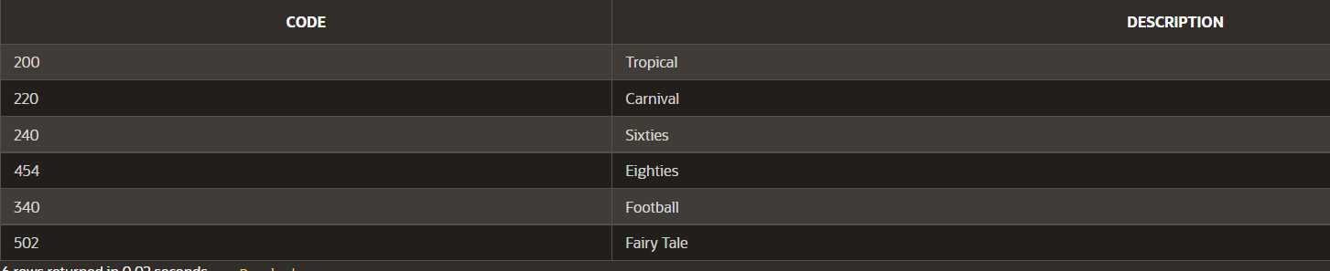

**В первом используется И, поэтому любая из сторон должна возвращать истину, а во втором случае — ИЛИ, может прийти больше записей, потому что для выбора строки любая из сторон должна быть истинна.**

1. Display the last names of all Global Fast Foods employees who have “e” and “i” in their last names.

**SELECT last_name**

**FROM f_staffs**

**WHERE  last_name LIKE '%e%' AND last_name LIKE '%i%';**

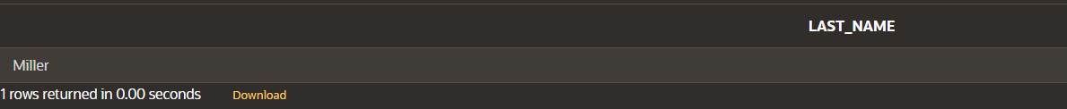

**Miller**

1. I need to know who the Global Fast Foods employees are that make more than $6.50/hour and their position is not order taker.

**SELECT first_name  ||  ' '  || last_name  as "Full Name"**

**FROM f_staffs**

**WHERE  salary > 6.5 AND staff_type = 'Order Taker';**



**Sue Doe**

1. Using the employees table, write a query to display all employees whose last names start with “D” and have “a” and “e” anywhere in their last name.

**SELECT first_name  ||  ' '  || last_name  as "Full Name"**

**FROM employees**

**WHERE  last_name LIKE 'D%' AND last_name LIKE '%a%' AND last_name LIKE '%e%';**

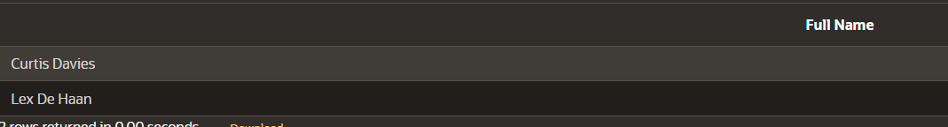

**Curtis Davies**

**Lex De Haan**

1. In which venues did DJs on Demand have events that were not in private homes?

**SELECT DISTINCT d_venues.loc_type**

**FROM  d_events  JOIN d_venues   ON  d_events.venue_id = d_venues.id**

**WHERE d_venues.loc_type != 'Private Home';**

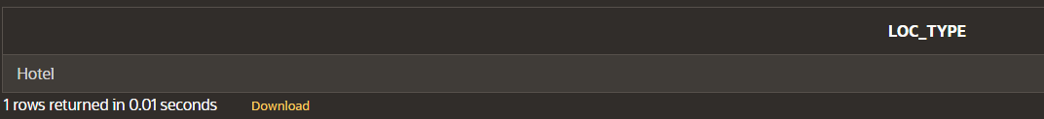

**Hotel**

1. Which list of operators is in the correct order from highest precedence to lowest precedence?
   1. AND, NOT, OR
   2. NOT, OR, AND
   3. **NOT, AND, OR**

**For questions 7 and 8, write SQL statements that will produce the desired output.**

1. Who am I?

I was hired by Oracle after May 1998 but before June of 1999. My salary is less than $8000 per month, and I have an “en” in my last name.

**SELECT first_name || ' ' || last_name as "Full Name"**

**FROM employees**

**WHERE hire_date > '1998-05-31' AND hire_date < '1999-06-01' AND salary < 8000 AND last_name like '%en%';**

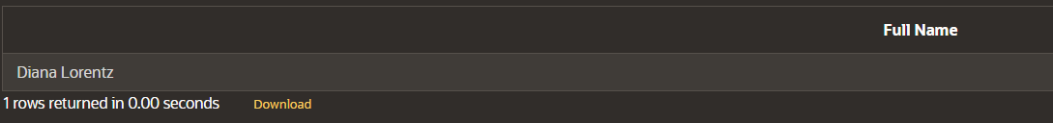

**Diana Lorentz**

1. What's my email address?

Because I have been working for Oracle since the beginning of 1996, I make more than $9000 per month. Because I make so much money, I don't get a commission.

**SELECT LOWER(email) || '@institutedomain.com' as "Email Address"**

**FROM employees**

**WHERE salary > 9000 AND (commission_pct = 0 OR commission_pct IS NULL) AND hire_date >= '1996-01-01' AND hire_date <= '1996-03-31' ;**

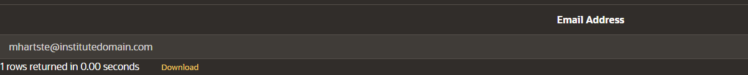

**mhartste@institutedomain.com**

Copyright © 2020, Oracle and/or its affiliates. All rights reserved. Oracle and Java are registered trademarks of Oracle and/or its affiliates. Other names may be trademarks of their respective owners.