 



Database Programming with SQL 3-3: Introduction to Functions Practice Activities

# Objectives

* Identify appropriate applications of single-row functions in query statements
* Classify a function as a single-row or multi-row function
* Differentiate between single-row functions and multirow functions and the result returned by each

# Try It / Solve It

1. For each task, choose whether a single-row or multiple row function would be most appropriate:
   1. Showing all of the email addresses in upper case letters **single**
   2. Determining the average salary for the employees in the sales department **multiple**
   3. Showing hire dates with the month spelled out *(September 1, 2004)* ***single***
   4. Finding out the employees in each department that had the most seniority (the earliest hire date) **multiple**
   5. Displaying the employees’ salaries rounded to the hundreds place **single**
   6. Substituting zeros for null values when displaying employee commissions. **single**
2. The most common multiple-row functions are: AVG, COUNT, MAX, MIN, and SUM. Give your own definition for each of these functions.

AVG- находит среднее значение в группе строк.

COUNT- подсчитывает количество введенных строк

MAX- находит наибольшее значение в группе строк

MIN- находит наименьшее значение в группе строк.

SUM- суммирует значения в группе строк.

1. Test your definitions by substituting each of the multiple-row functions into this query.

SELECT FUNCTION(salary)

FROM employees

Write out each query and its results.

**SELECT AVG(salary)**

**FROM employees;**

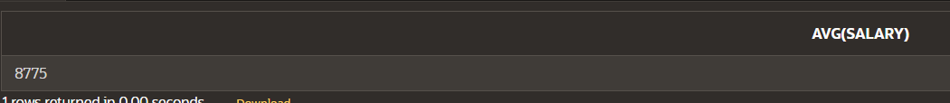

**8775**

**SELECT COUNT(salary)**

**FROM employees;**



**20**

**SELECT MAX(salary)**

**FROM employees;**



**24000**

**SELECT MIN(salary)**

**FROM employees;**



**2500**

**SELECT SUM(salary)**

**FROM employees;**



**175500**

Copyright © 2020, Oracle and/or its affiliates. All rights reserved. Oracle and Java are registered trademarks of Oracle and/or its affiliates. Other names may be trademarks of their respective owners.