 



Database Programming with SQL 4-2: Number Functions

Practice Activities

# Objectives

* Select and apply the single-row number functions ROUND, TRUNC, and MOD in a SQL query
* Distinguish between the results obtained when TRUNC is applied to a numeric value and ROUND is applied to a numeric value
* State the implications for business when applying TRUNC and ROUND to numeric values

# Vocabulary

Identify the vocabulary word for each definition below.

|  |  |
| --- | --- |
| **TRUNC** | Used to terminate the column, expression, or value to a specified number of decimal places |
| **number functions** | These functions accept numeric input and return numeric values. |
| **MOD** | Returns the remainder of a division. |
| **ROUND** | Rounds the column, expression, or value to a set number of decimal places. |

# Try It / Solve It

1. Display Oracle database employee last_name and salary for employee_ids between 100 and 102. Include a third column that divides each salary by 1.55 and rounds the result to two decimal places.

**SELECT last_name, salary, ROUND(salary/1.55,2) "Calculated Salary"**

**FROM employees**

**WHERE employee_id BETWEEN 100 AND 102;**

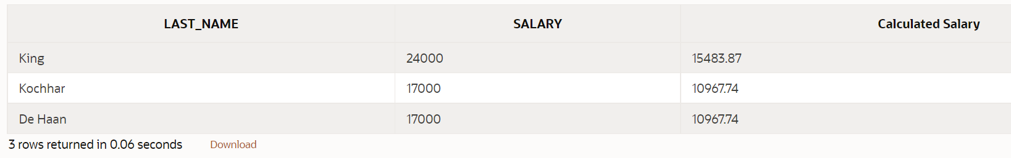

1. Display employee last_name and salary for those employees who work in department 80. Give each of them a raise of 5.333% and truncate the result to two decimal places.

**SELECT last_name, salary, TRUNC(salary*1.0533,2) "Raised Salary"**

**FROM employees**

**WHERE department_id = 80;**

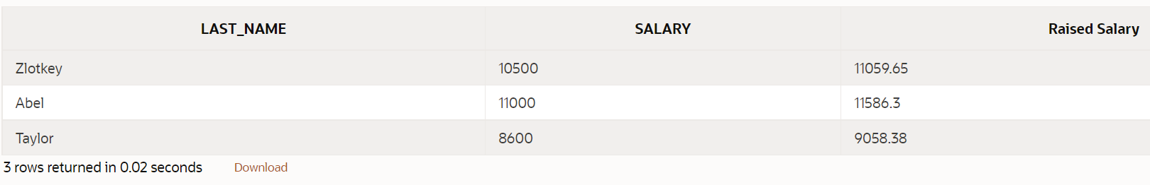

1. Use a MOD number function to determine whether 38873 is an even number or an odd number.

**SELECT CASE WHEN MOD(38873 , 2) = 1 THEN 'odd' ELSE 'even' END as "Odd or Even?"**

**FROM dual;**

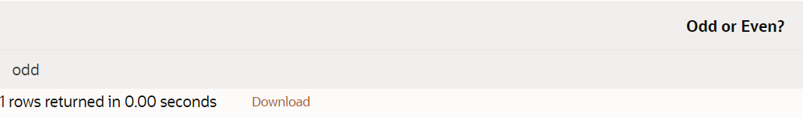

1. Use the DUAL table to process the following numbers:

845.553 - round to one decimal place

**SELECT ROUND( 845.553 , 1)**

**FROM dual;**

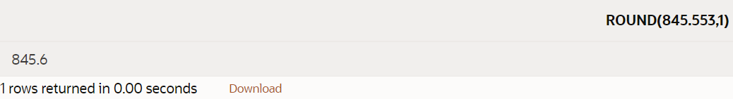

30695.348 - round to two decimal places

**SELECT ROUND( 30695.348  , 2)**

**FROM dual;**

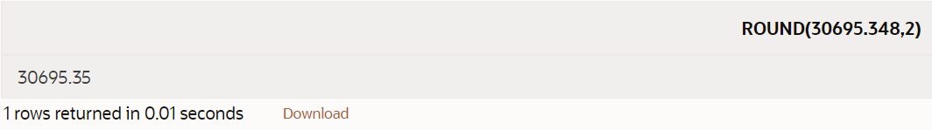

30695.348 - round to -2 decimal places

**SELECT ROUND( 30695.348  , -2)**

**FROM dual;**

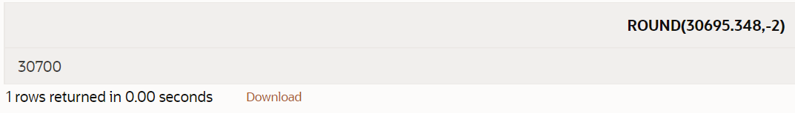

2.3454 - truncate the 454 from the decimal place

**SELECT TRUNC( 2.3454   , 1)**

**FROM dual;**

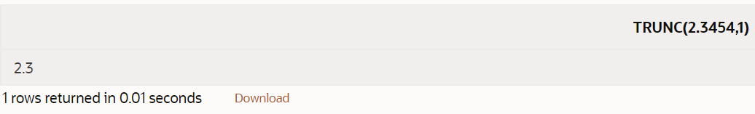

1. Divide each employee’s salary by 3. Display only those employees’ last names and salaries who earn a salary that is a multiple of 3.

**SELECT last_name, salary**

**FROM employees**

**WHERE MOD(salary, 3) = 0;**

**LAST_NAME SALARY**

**King 24000**

**Higgins 12000**

**Zlotkey 10500**

**Hunold 9000**

**Ernst 6000**

**Lorentz 4200**

**Fay 6000**

1. Divide 34 by 8. Show only the remainder of the division. Name the output as EXAMPLE.

**SELECT MOD(34, 8) as example**

**FROM dual;**

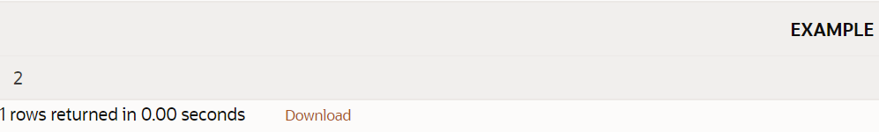

1. How would you like your paycheck – rounded or truncated? What if your paycheck was calculated to be $565.784 for the week, but you noticed that it was issued for $565.78. The loss of .004 cent would probably make very little difference to you. However, what if this was done to one thousand people, one hundred thousand people, or one million people! Would it make a difference then? How much of a difference?

*to one thousand people*

**SELECT (565.784 - ROUND(565.784, 2))*1000 as difference**

**FROM dual;**

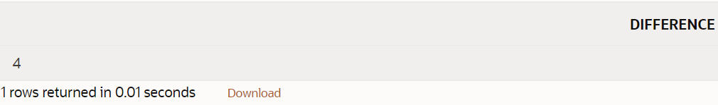 **4$**

*one hundred thousand people*

**SELECT (565.784 - ROUND(565.784, 2))*1000*100 as difference**

**FROM dual**

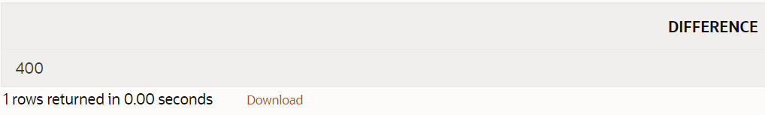 **400%**

*one million people*

**SELECT (565.784 - ROUND(565.784, 2))*1000*1000 as difference**

**FROM dual**

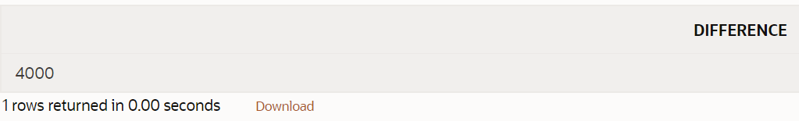 **4000$**

Copyright © 2020, Oracle and/or its affiliates. All rights reserved. Oracle and Java are registered trademarks of Oracle and/or its affiliates. Other names may be trademarks of their respective owners.