 



Database Programming with SQL 5-1: Conversion Functions Practice Activities

# Objectives

* Provide an example of an explicit data-type conversion and an implicit data-type conversion
* Explain why it is important, from a business perspective, for a language to have built-in data- conversion capabilities
* Construct a SQL query that correctly applies TO_CHAR, TO_NUMBER, and TO_DATE single- row functions to produce a desired result
* Apply the appropriate date and/or character format model to produce a desired output
* Explain and apply the use of YY and RR to return the correct year as stored in the database

# Vocabulary

Identify the vocabulary word for each definition below.

|  |  |
| --- | --- |
| **CHAR** | Used for text and character data of fixed length, including numbers, dashes, and special characters. |
| **FM** | Used to remove padded blanks or to suppress leading zeros |
| **conversion function** | Functions that convert a value from one datatype to another. |
| **NUMBER** | Used to store variable-length numeric data. |
| **VARCHAR2** | Used for character data of variable length, including numbers, special characters, and dashes. |
| **DATE** | Used for date and time values. |
| **TO_CHAR** | Converts dates or numbers to character strings with optional formatting |
| **RR** | Century value depends on the specified year and the last two digits of the current year |
| **TO_NUMBER** | Converts a character string containing digits to a number with optional formatting |
| **DD** | Numeric day of the month |
| **TO_DATE** | Converts a character string representing a date to a date value with optional formatting |

# Try It / Solve It

In each of the following exercises, feel free to use labels for the converted column to make the output more readable.

1. List the last names and birthdays of Global Fast Food Employees. Convert the birth dates to character data in the Month DD, YYYY format. Suppress any leading zeros.

**SELECT last_name,TO_CHAR( birthdate, 'Month DD, YYYY') as birthdate**

**FROM f_staffs;**

1. Convert January 3, 04, to the default date format 03-Jan-2004.

**SELECT  TO_DATE('January 3, 04', 'Month DD YY') as converted**

**FROM dual;**

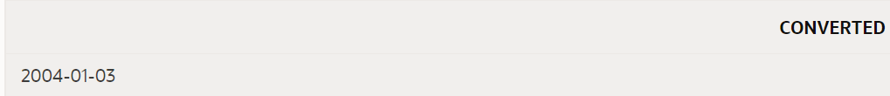

1. Format a query from the Global Fast Foods f_promotional_menus table to print out the start_date of promotional code 110 as: The promotion began on the tenth of February 2004.

**SELECT 'The promotion began on the ' || TO_CHAR(start_date, 'ddthsp "of" Month YYYY') as output**

**FROM f_promotional_menus**

**WHERE code = 110;**

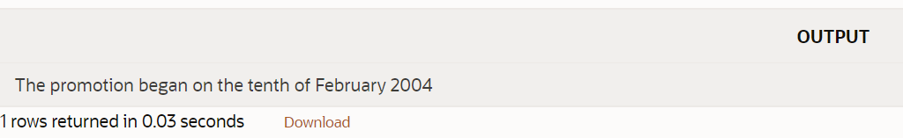

1. Convert today’s date to a format such as: “Today is the Twentieth of March, Two Thousand Four”

**SELECT 'Today is the ' || TO_CHAR(SYSDATE, 'fmDdthsp "of" Month, Year') as today**

**FROM dual;**

1. List the ID, name, and salary for all Global Fast Foods employees. Display salary with a $ sign and two decimal places.

**SELECT EMPLOYEE_ID, first_name ||' '||last_name as name, TO_CHAR( salary, '$999999.99') as salary**

**FROM EMPLOYEES;**

1. Ellen Abel is an employee who has received a $2,000 raise. Display her first name and last name, her current salary, and her new salary. Display both salaries with a $ and two decimal places. Label her new salary column AS New Salary.

**SELECT first_name, last_name, TO_CHAR( salary, '$999999.99') as "** **Сurrent** **Salary", TO_CHAR( salary + 2000 , '$9999999.99') as "New Salary"**

**FROM employees**

**WHERE first_name = 'Ellen'  AND last_name = 'Abel' ;**



1. On what day of the week and date did Global Fast Foods’ promotional code 110 Valentine’s Special begin?

**SELECT TO_CHAR(start_date, 'dd-Mon-YYYY (Day)') as output**

**FROM f_promotional_menus**

**WHERE code = 110;**

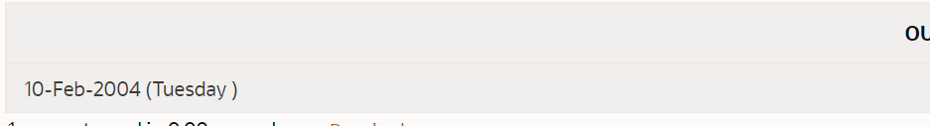

1. Create one query that will convert 25-Dec-2004 into each of the following (you will have to convert 25-Dec-2004 to a date and then to character data):

December 25th, 2004

DECEMBER 25TH, 2004

25th december, 2004

**SELECT TO_CHAR(TO_DATE('25-Dec-2004', 'dd-Mon-yyyy'), 'Month ddth, yyyy') as first**

**FROM dual;**

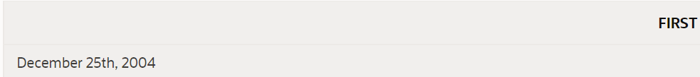

**SELECT TO_CHAR(TO_DATE('25-Dec-2004', 'dd-Mon-yyyy'), 'MONTH DDth, yyyy') as second**

**FROM dual;**



**SELECT TO_CHAR(TO_DATE('25-Dec-2004', 'dd-Mon-yyyy'), 'fmddth month, yyyy') as third**

**FROM dual;**

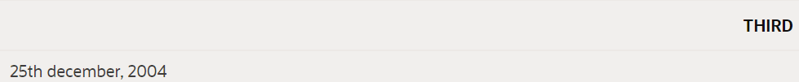

1. Create a query that will format the DJs on Demand d_packages columns, low-range and high- range package costs, in the format $2500.00.

**SELECT code, TO_CHAR(low_range,'$999999.99') as low_range, TO_CHAR(high_range,'$999999.99') as high_range**

**FROM d_packages ;**

**CODE LOW_RANGE HIGH_RANGE**

**79 $500.00 $2500.00**

**87 $2501.00 $5000.00**

**112 $5001.00 $10000.00**

**200 $10001.00 $15000.00**

1. Convert JUNE192004 to a date using the fx format model.

**SELECT TO_DATE('JUNE192004','fxMONTHddyyyy') as output**

**FROM dual;**

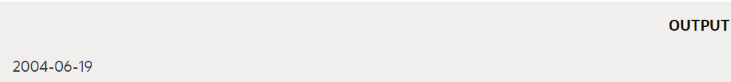

1. What is the distinction between implicit and explicit datatype conversion? Give an example of each.

**1). Implicit conversion:**

**SELECT SYSDATE**

**FROM dual;**

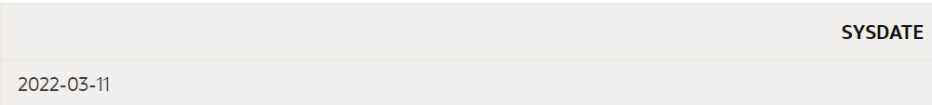

Дата преобразуется в символьный тип данных с использованием формы по умолчанию

**2). Explicit conversion:**

**SELECT TO_CHAR(SYSDATE, 'MONTH DDth, yyyy')**

**FROm dual;**

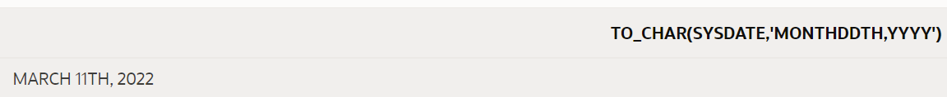

Дата преобразуется в символьный тип данных с использованием формата, отличного от формата по умолчанию

1. Why is it important from a business perspective to have datatype conversions?

**Это необходимо для того, чтобы база данных удовлетворяла основную потребность приложения - была полезной для пользователя. Дата сохраняется как число внутри базы данных, которое ни один пользователь не сможет понять. Знак $, напечатанный перед цифрой, дает представление о том, о какой валюте идет речь в приложении. Ценность данных в базе данных заключается в том, что они передают полезную информацию и могут быть обработаны после преобразований.**

Copyright © 2020, Oracle and/or its affiliates. All rights reserved. Oracle and Java are registered trademarks of Oracle and/or its affiliates. Other names may be trademarks of their respective owners.