 



Database Programming with SQL 5-2: NULL Functions

Practice Activities

# Objectives

* Demonstrate and explain the evaluation of a nested function
* List at least four general functions that work with any data type and relate to handling null values
* Explain the use of the COALESCE and the NVL functions
* Explain the use of general functions to deal with null values in data
* Construct and execute a SQL query that correctly applies NVL, NVL2, NULLIF, and COALESCE single-row functions

# Vocabulary

Identify the vocabulary word for each definition below.

|  |  |
| --- | --- |
| **NVL** | Converts nulls to an actual value |
| **COALESCE** | Returns the first non-null expression in the list |
| **NVL2** | Examines the first expression; if the first expression is not null, it returns the second expression; if the first expression is null, it returns the third expression |
| **NULLIF** | Compares two expressions; if they are equal, the function returns null; if they are not equal, the function returns the first expression |

# Try It / Solve It

Use aliases to make the output more readable.

1. Create a report that shows the Global Fast Foods promotional name, start date, and end date from the f_promotional_menus table. If there is an end date, temporarily replace it with “end in two weeks.” If there is no end date, replace it with today’s date.

**SELECT name, start_date, end_date, NVL2(end_date, 'end in two weeks', TO_CHAR( SYSDATE, 'DD-MM-YYYY')) as nvl2**

**FROM f_promotional_menus;**

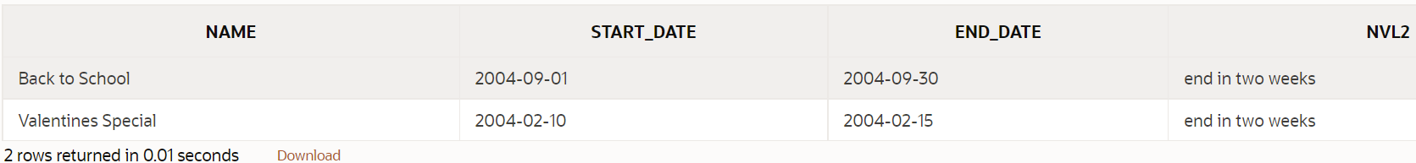

1. Not all Global Fast Foods staff members receive overtime pay. Instead of displaying a null value for these employees, replace null with zero. Include the employee’s last name and overtime rate in the output. Label the overtime rate as “Overtime Status”.

**SELECT last_name, NVL(overtime_rate,0) as "Overtime Status"**

**FROM f_staffs;**

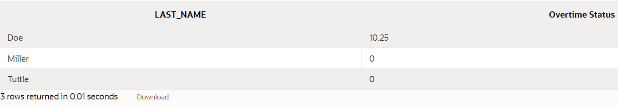

1. The manager of Global Fast Foods has decided to give all staff who currently do not earn overtime an overtime rate of $5.00. Construct a query that displays the last names and the overtime rate for each staff member, substituting $5.00 for each null overtime value

**SELECT last_name, TO_CHAR( NVL(overtime_rate,5), '$99.99') as "Overtime Status"**

**FROM f_staffs;**

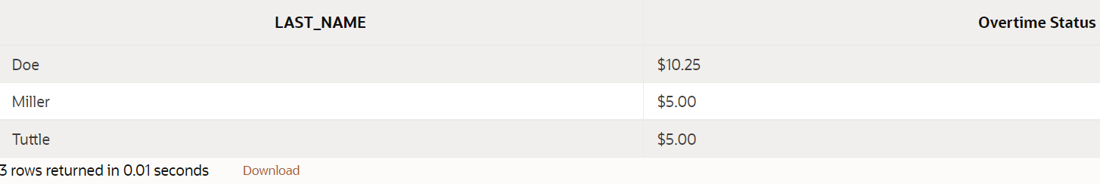

1. Not all Global Fast Foods staff members have a manager. Create a query that displays the employee last name and 9999 in the manager ID column for these employees.

**SELECT last_name, NVL(manager_id,9999) as manager_id**

**FROM f_staffs;**

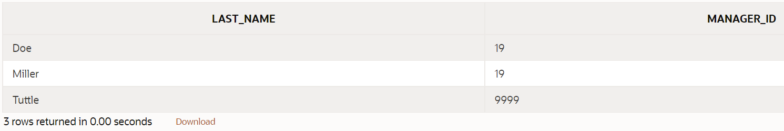

1. Which statement(s) below will return null if the value of v_sal is 50?
   1. SELECT nvl(v_sal, 50) FROM emp;
   2. SELECT nvl2(v_sal, 50) FROM emp;
   3. **SELECT nullif(v_sal, 50) FROM emp;**
   4. SELECT coalesce (v_sal, Null, 50) FROM emp;
2. What does this query on the Global Fast Foods table return?

SELECT COALESCE(last_name, to_char(manager_id)) as NAME FROM f_staffs;

**Поскольку last_name не имеет значения null, он всегда будет возвращать last_name. Если бы last_name было равно нулю и было бы поле last_name с нулевым значением, оно вернулось бы к manager_id, преобразованному в varchar2.**

7.

* 1. Create a report listing the first and last names and month of hire for all employees in the EMPLOYEES table (use TO_CHAR to convert hire_date to display the month).

**SELECT first_name, last_name, TO_CHAR(hire_date, 'Month') as "month of hire"**

**FROM employees;**

* 1. Modify the report to display null if the month of hire is September. Use the NULLIF function.

**SELECT first_name, last_name, NULLIF( TO_CHAR(hire_date, 'Month'), 'September') as "month of hire"**

**FROM employees;**

8. For all null values in the specialty column in the DJs on Demand d_partners table, substitute “No Specialty.” Show the first name and s

**SELECT first_name, NVL(specialty, 'No Specialty') as specialty**

**FROM d_partners;**

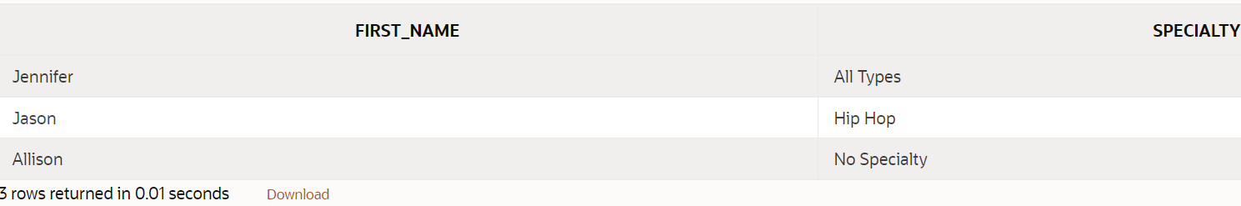

Copyright © 2020, Oracle and/or its affiliates. All rights reserved. Oracle and Java are registered trademarks of Oracle and/or its affiliates. Other names may be trademarks of their respective owners.