 



Database Programming with SQL

* 1. : Oracle Equijoin and Cartesian Product Practice Activities

# Objectives

* + - Name the Oracle proprietary joins and their ANSI/ISO SQL: 1999 counterparts
    - Describe the purpose of join conditions
    - Construct and execute a SELECT statement that results in a Cartesian product
    - Construct and execute SELECT statements to access data from more than one table using an equijoin
    - Construct and execute SELECT statements that add search conditions using the AND operator
    - Apply the rule for using column aliases in a join statement

# Vocabulary

Identify the vocabulary word for each definition below.

|  |  |
| --- | --- |
| **Cartesian Product** | Results from an invalid or omitted join condition; all combinations of rows are displayed |
| **equijoin** | Values in a column in one table are equal to a value in another table; also called an inner join or simple join |
| **proprietary join** | Connection command exclusive to a specific company |
| **alias** | Gives a table another name to simplify queries and improve performance |
| **join conditions** | Display data from two or more related tables |

# Try It / Solve It

1. Create a Cartesian product that displays the columns in the d_play_list_items and the d_track_listings in the DJs on Demand database.

**SELECT d_play_list_items.event_id "event id in playlist", d_play_list_items.song_id "song id in playlist", d_play_list_items.comments "comments in playlist", d_track_listings.song_id "song id in tracklist", d_track_listings.cd_number "cd number in tracklist", d_track_listings.track "track in tracklist"**

**FROM d_play_list_items, d_track_listings;**

1. Correct the Cartesian product produced in question 1 by creating an equijoin using a common column.

**SELECT d_play_list_items.event_id "event id in playlist", d_play_list_items.song_id "song id in playlist", d_play_list_items.comments "comments in playlist", d_track_listings.song_id "song id in tracklist", d_track_listings.cd_number "cd number in tracklist", d_track_listings.track "track in tracklist"**

**FROM d_play_list_items, d_track_listings**

**WHERE d_play_list_items.song_id = d_track_listings.song_id;**

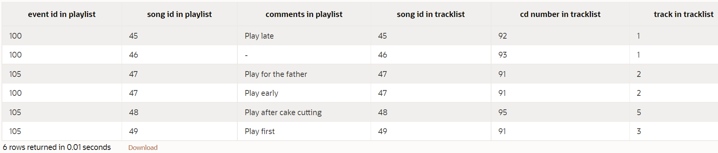

1. Write a query to display the title, type, description, and artist from the DJs on Demand database.

**SELECT d_songs.title, d_songs.type_code type, d_types.description**

**FROM d_songs, d_types**

**WHERE d_songs.type_code = d_types.code;**

1. Rewrite the query in question 3 to select only those titles with an ID of 47 or 48.

**SELECT d_songs.title, d_songs.type_code type, d_types.description**

**FROM d_songs, d_types**

**WHERE d_songs.type_code = d_types.code AND d_songs.id in (47, 48);**

1. Write a query that extracts information from three tables in the DJs on Demand database, the d_clients table, the d_events table, and the d_job_assignments table.

**SELECT d_clients.last_name AS "d_clients - last_name" , d_clients.first_name AS "d_clients - first_name" , d_clients.client_number AS "d_clients - client_number" , d_events.id AS "d_events - id", d_events.name AS "d_events - name", d_events.client_number AS "d_events - client_number", d_job_assignments.partner_id AS "d_job_assignments - partner_id", d_job_assignments.event_id AS "d_job_assignments - event_id"**

**FROM d_clients, d_events, d_job_assignments**

**WHERE d_clients.client_number = d_events.client_number AND d_events.id = d_job_assignments.event_id;**



1. Create and execute an equijoin between DJs on Demand tables d_track_listings and d_cds. Return the song_id and the title only.

**SELECT d_track_listings.song_id "song id in tracklist", d_cds.title "title in cds"**

**FROM d_track_listings, d_cds**

**WHERE d_track_listings.cd_number = d_cds.cd_number;**

1. Mark T for the statements that are true and F for the statements that are false.

a. A join is a type of query that gets data from more than one table based on columns with the same name. **F**

b. To join tables using an equijoin, there must be a common column in both tables and that column is usually a primary key in one of the tables. **T**

c. A Cartesian product occurs because the query does not specify a WHERE clause. **T**

d. Table aliases are required to create a join condition. **F**

e. If a table alias is used for a table name in the FROM clause, it must be substituted for the table name throughout the SELECT statement. **T**

f. Table alias must be only one character in length. **F**

g. A simple join or inner join is the same as an equijoin. **T**

1. What advantage does being able to combine data from multiple tables have for a business?

**Бизнесу все равно, где я храню данные или как я их извлекаю. В реляционной базе данных мы храним данные в разных таблицах, связанных друг с другом. И поскольку мы можем объединять данные из нескольких таблиц, следуя этим связям, мы получаем полезную информацию в качестве выходных данных, что является целью существования БД.**

Copyright © 2020, Oracle and/or its affiliates. All rights reserved. Oracle and Java are registered trademarks of Oracle and/or its affiliates. Other names may be trademarks of their respective owners.