 



Database Programming with SQL 8-2: Count, Distinct, NVL Practice Activities

# Objectives

* Construct and execute a SQL query using the COUNT group function
* Use DISTINCT and the NVL function with group functions

# Vocabulary

Identify the vocabulary word for each definition below.

|  |  |
| --- | --- |
| **COUNT** | Returns the number of non-null values in the expression column |
| **DISTINCT** | The keyword used to return only non-duplicate values or combinations of non-duplicate values in a query. |
| **COUNT(DISTINCT expression)** | Returns the number of unique non-null values in the expression column. |

# Try It / Solve It

1. How many songs are listed in the DJs on Demand D_SONGS table?

**SELECT COUNT(*)**

**FROM d_songs;**

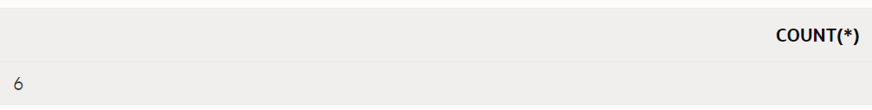

1. In how many different location types has DJs on Demand had venues?

**SELECT COUNT(DISTINCT loc_type)**

**FROM d_venues;**

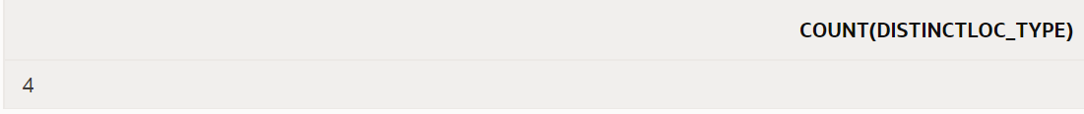

1. The d_track_listings table in the DJs on Demand database has a song_id column and a cd_number column. How many song IDs are in the table and how many different CD numbers are in the table?

**SELECT COUNT(song_id) AS "song with possible duplication", COUNT(distinct cd_number) "cd no. distinct"**

**FROM d_track_listings;**



1. How many of the DJs on Demand customers have email addresses?

**SELECT COUNT(email) "count with email"**

**FROM d_clients;**

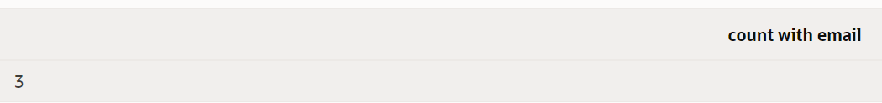

1. Some of the partners in DJs on Demand do not have authorized expense amounts (auth_expense_amt). How many partners do have this privilege?

**SELECT (COUNT(*) - COUNT(auth_expense_amt)) "Free from limit count"**

**FROM d_partners;**

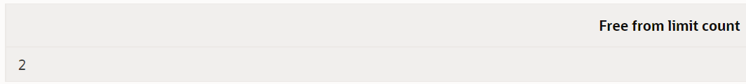

1. What values will be returned when the statement below is issued?

|  |  |  |
| --- | --- | --- |
| **ID** | **type** | **shoe_color** |
| 456 | oxford | brown |
| 463 | sandal | tan |
| 262 | heel | black |
| 433 | slipper | tan |

SELECT COUNT(shoe_color), COUNT(DISTINCT shoe_color) FROM shoes;

**4 and 2**

1. Create a query that will convert any null values in the auth_expense_amt column on the DJs on Demand D_PARTNERS table to 100000 and find the average of the values in this column. Round the result to two decimal places.

**SELECT TO_CHAR(ROUND(AVG(NVL(auth_expense_amt,100000)),2), '$999999.99')**

**FROM d_partners;**



1. Which statement(s) is/are True about the following SQL statement: SELECT AVG(NVL(selling_bonus, 0.10))

FROM bonuses;

a. The datatypes of the values in the NVL clause can be any datatype except date data.

b. If the selling_bonus column has a null value, 0.10 will be substituted.

**c. There will be no null values in the selling_bonus column when the average is calculated.**

d. This statement will cause an error. There cannot be two functions in the SELECT statement.

1. Which of the following statements is/are TRUE about the following query? SELECT DISTINCT colors, sizes

FROM items;

a. Each color will appear only once in the result set.

b. Each size will appear only once in the result set.

**c. Unique combinations of color and size will appear only once in the result set.**

d. Each color and size combination will appear more than once in the result set.

Copyright © 2020, Oracle and/or its affiliates. All rights reserved. Oracle and Java are registered trademarks of Oracle and/or its affiliates. Other names may be trademarks of their respective owners.