 



Database Programming with SQL

* 1. : Using GROUP BY and HAVING Clauses Practice Activities

# Objectives

* + - Construct and execute a SQL query using GROUP BY
    - Construct and execute a SQL query using GROUP BY … HAVING
    - Construct and execute a GROUP BY on more than one column
    - Nest group functions

# Vocabulary

Identify the vocabulary word for each definition below.

|  |  |
| --- | --- |
| **HAVING** | Used to specify which groups are to be displayed; restricts groups that do not meet group criteria |
| **GROUP BY** | Divides the rows in a table into groups |

# Try It / Solve It

1. In the SQL query shown below, which of the following is true about this query?

**T** a. Kimberly Grant would not appear in the results set.

**F** b. The GROUP BY clause has an error because the manager_id is not listed in the SELECT clause.

**F** c. Only salaries greater than 16001 will be in the result set.

**F** d. Names beginning with Ki will appear after names beginning with Ko.

**F** e. Last names such as King and Kochhar will be returned even if they don’t have salaries > 16000.

SELECT last_name, MAX(salary) FROM employees

WHERE last_name LIKE 'K%' GROUP BY manager_id, last_name HAVING MAX(salary) >16000

ORDER BY last_name DESC ;

1. Each of the following SQL queries has an error. Find the error and correct it. Use Oracle Application Express to verify that your corrections produce the desired results.
   1. SELECT manager_id FROM employees

WHERE AVG(salary) <16000

GROUP BY manager_id;

Above query will say ORA-00934: **group function is not allowed here**.

If 'desired' result is getting manger ids, under whom, average salary is less than 16000:

**SELECT manager_id,AVG(salary)**

**FROM employees**

**GROUP BY manager_id**

**HAVING AVG(salary) <16000;**

* 1. SELECT cd_number, COUNT(title) FROM d_cds

WHERE cd_number < 93;

**Above query will say ORA-00937: not a single-group group function**

**If ‘desired’ result is getting row count, excluding anything greater than or equal to 93:**

**SELECT COUNT(*)**

**FROM d_cds**

**WHERE cd_number < 93;**

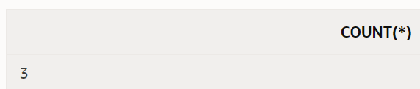

* 1. SELECT ID, MAX(ID), artist AS Artist FROM d_songs

WHERE duration IN('3 min', '6 min', '10 min') HAVING ID < 50

GROUP by ID;

**Above query will say ORA-00979: not a GROUP BY expression**

**id is primary key of the table, so most likely my intention may not be to group by id here.**

**Desired may have been grouping by type_code and getting maximum duration**

**but limiting the input to group by with duration IN('3 min', '6 min', '10 min')  and ID < 50**

**SELECT type_code, MAX(TO_NUMBER(REPLACE(duration,' min',''))) || ' min' as "max duration"**

**FROM d_songs**

**WHERE duration IN('3 min', '6 min', '10 min') AND id < 50**

**GROUP BY type_code;**

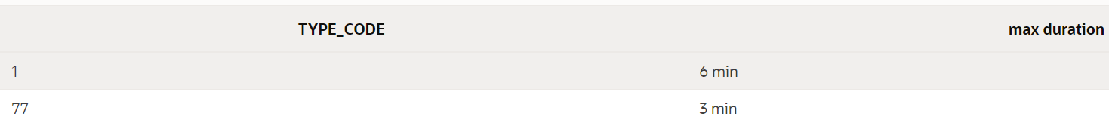

* 1. SELECT loc_type, rental_fee AS Fee FROM d_venues

WHERE id <100 GROUP BY "Fee" ORDER BY 2;

**1) Above query will say ORA-00904: "Fee": invalid identifier**

**2) Even if I replace "Fee" alias in group by [don't use alias in group by clause] it will give me error : ORA-00979: not a GROUP BY expression**

**3) Seems to be question wanted average rental_fee of each loc_type with id less than 100 before grouping.**

**I assumed rental_fee  is a number field:**

**SELECT loc_type, AVG(rental_fee) AS Fee**

**FROM d_venues**

**WHERE id <100**

**GROUP BY loc_type**

**ORDER BY 2;**

**But above query gives error ORA-01722: invalid number, because rental_fee is a VARCHAR2(50)**

**4) Now, I need assumptions to view the calculations with same eyes: /hour, /flat fee, /per person.**

***Let’s assume that we are group of*10 people*and event I am organizing occurs for*5 hours*.***

**SELECT loc_type, AVG(**

**CASE**

**WHEN INSTR(rental_fee, '/hour') != 0 THEN TO_NUMBER(REPLACE(rental_fee,'/hour',''))*5**

**WHEN INSTR(rental_fee, '/flat fee') != 0 THEN TO_NUMBER(REPLACE(rental_fee,'/flat fee',''))**

**WHEN INSTR(rental_fee, '/per person') != 0 THEN TO_NUMBER(REPLACE(rental_fee,'/per person',''))*10**

**ELSE 0**

**END**

**) AS Fee**

**FROM d_venues**

**WHERE id <100**

**GROUP BY loc_type**

**ORDER BY 2;**

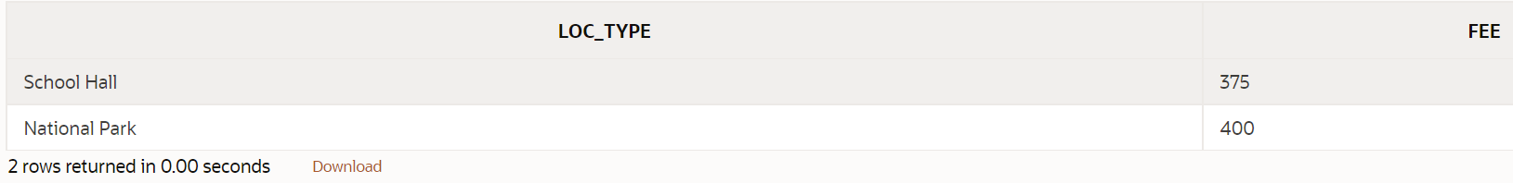

1. **Rewrite** the following query to accomplish the same result: SELECT DISTINCT MAX(song_id)

FROM d_track_listings WHERE track IN ( 1, 2, 3);

**SELECT track, MAX(song_id)**

**FROM d_track_listings**

**WHERE track IN ( 1, 2, 3)**

**GROUP BY track;**

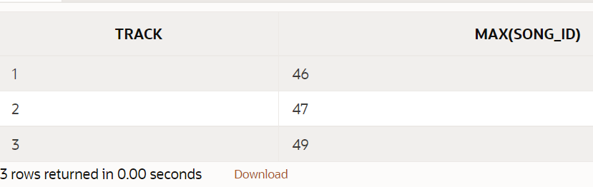

1. Indicate True or False

**T** a. If you include a group function and any other individual columns in a SELECT clause, then each individual column must also appear in the GROUP BY clause.

**F** b. You can use a column alias in the GROUP BY clause.

**F** c. The GROUP BY clause always includes a group function.

1. Write a query that will return both the maximum and minimum average salary grouped by department from the employees table.

**SELECT ROUND(MAX(AVG(salary)),2) as "Maximum Average of Departments", ROUND(MIN(AVG(salary)),2) "Minimum Average of Departments"**

**FROM employees**

**GROUP BY department_id;**

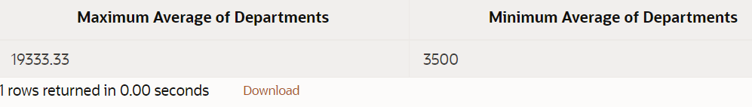

1. Write a query that will return the average of the maximum salaries in each department for the employees table.

**SELECT AVG(MAX(salary))**

**FROM employees**

**GROUP BY department_id;**

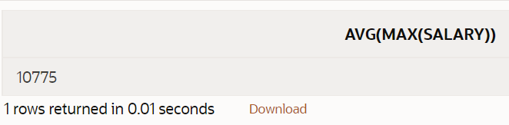

Copyright © 2020, Oracle and/or its affiliates. All rights reserved. Oracle and Java are registered trademarks of Oracle and/or its affiliates. Other names may be trademarks of their respective owners.