Lab 8: Docker and Containers

Activity 1: Build, run and manage a Flask container

Application and Docker setup
The Flask application responded with “Hello World from Docker - Julia Issa!” at http://localhost:5000. The image was built as flask_docker, and the container was started as lab8-hello with port mapping 5000:5000.
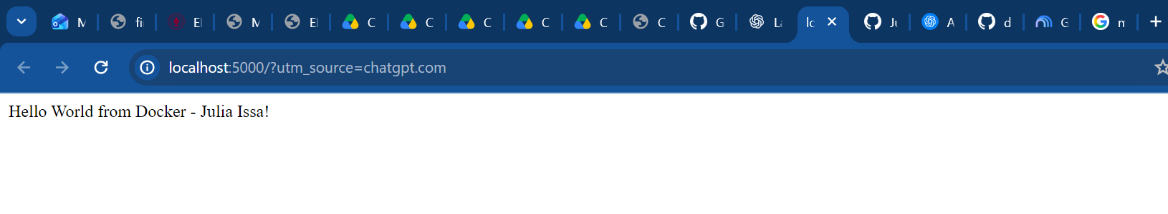

command 1: docker ps -a
Lists all Docker containers, including running and stopped containers. The output includes the container ID, image, creation time, status, ports and name. Here, lab8-hello is shown as running with host port 5000 mapped to container port 5000.
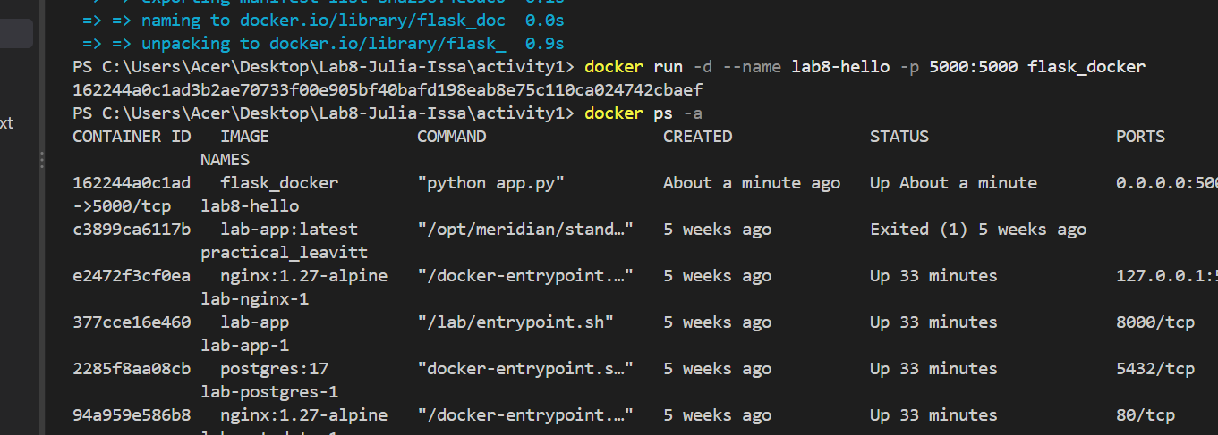

Command 2: docker stop
Requests a graceful stop of the specified running container. The command uses the container name or ID, not the image name. Docker returned “lab8-hello”, indicating the stop command completed.
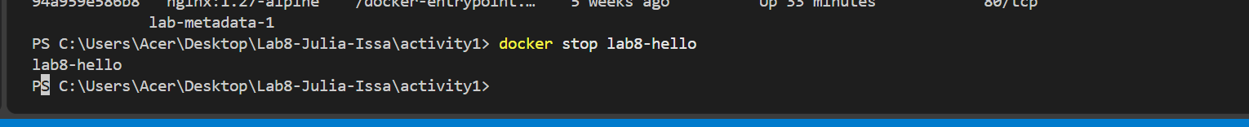
After stopping this container, the page at localhost:5000 was no longer reachable. This is expected because the Flask server was no longer running.

command 3: docker logs
Displays the standard output and error logs recorded for the named container, including application startup messages and HTTP requests. Logs can still be viewed after a container stops.
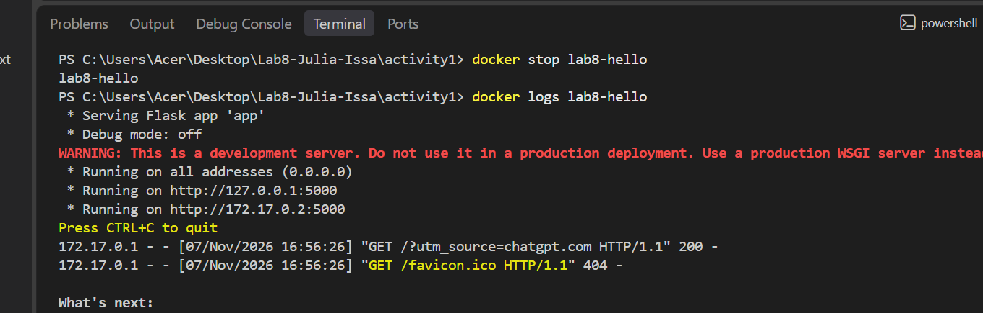
The log records a successful GET request to the homepage (HTTP 200). The favicon request returned HTTP 404 because the sample app does not provide a favicon; this does not affect the lab. The warning about Flask’s development server is expected for this classroom demonstration.
The Flask container was built and tested successfully, and all three required Docker commands were executed and documented. Together, the outputs demonstrate how to list, stop and inspect a container using Docker CLI.

Activity 2: Two Docker image versions
The original Lab 5 Flask/SQLite API was packaged in Docker as version 1. A second version retained those routes and added a GET endpoint that returns user names. Both versions were tested locally and ran in separate containers.
Version | Docker image | Port
1 | jai10/lab8-julia_issa:0.0.1.RELEASE | 5000
2 | jai10/lab8-julia_issa:0.0.2.RELEASE | 3000

Version 1: Original Lab 5 API
The first image packages the existing Flask API and SQLite database. The running container lab8-version1 maps host port 5000 to container port 5000. The existing GET /api/users endpoint returned five database records during testing.
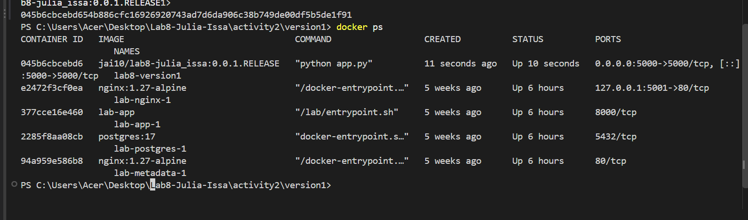

Both versions running simultaneously
The second image runs independently as lab8-version2 on port 3000, while Version 1 remains available on port 5000.
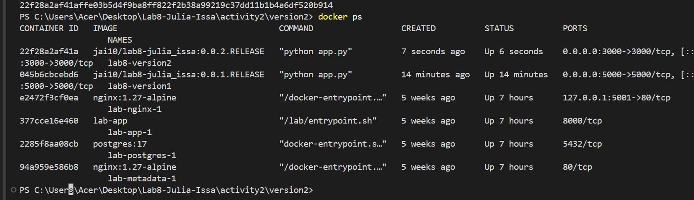

Version 2: GET /get_users endpoint
A new GET /get_users route queries only the name column from the existing SQLite users table and returns a JSON array. The query orders results by user_id, preserves duplicate names, and does not hard-code any users.
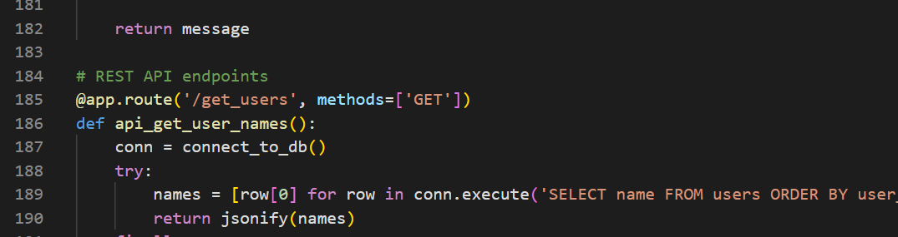

The endpoint was tested in the browser at http://localhost:3000/get_users and returned the five existing names:
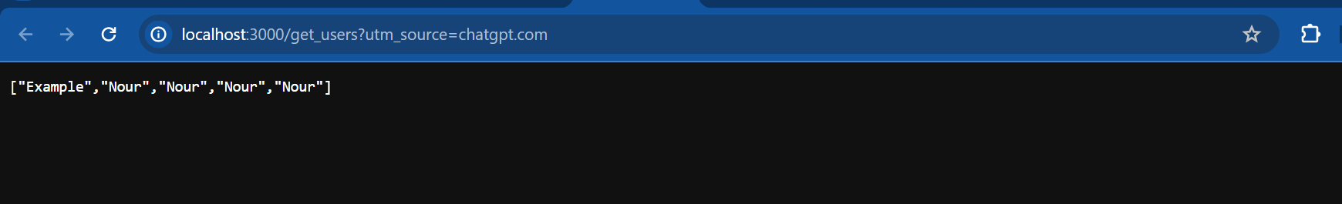

Docker Desktop image verification
The local Images page shows the two required tags under repository jai10/lab8-julia_issa. The additional unprefixed image visible in Docker Desktop was created during testing and is not the requested submission image.


