graficos
Julia Kaori Kuriyama Ramos
2025-11-12

GGPLOT
#Exemplos de gráficos pelo pacote ggplot2 gerados pela disciplina “Ferramentas computacionais 2025”
## Warning: pacote 'rcartocolor' foi compilado no R versão 4.4.3
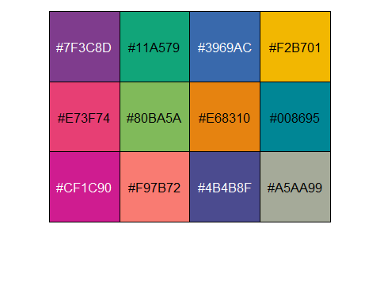
## name pokedex.id height weight
## Length:890 Min. : 1.0 Min. : 1.00 Min. : 1.0
## Class :character 1st Qu.:223.2 1st Qu.: 5.00 1st Qu.: 85.0
## Mode :character Median :445.5 Median : 10.00 Median : 268.0
## Mean :445.5 Mean : 11.82 Mean : 629.9
## 3rd Qu.:667.8 3rd Qu.: 15.00 3rd Qu.: 630.0
## Max. :890.0 Max. :200.00 Max. :9999.0
## type secundary.type hp attack
## Length:890 Length:890 Min. : 1.0 Min. : 5.0
## Class :character Class :character 1st Qu.: 50.0 1st Qu.: 55.0
## Mode :character Mode :character Median : 65.0 Median : 75.0
## Mean : 68.7 Mean : 76.3
## 3rd Qu.: 80.0 3rd Qu.: 95.0
## Max. :255.0 Max. :181.0
## defense sp.atk sp.def speed
## Min. : 5.00 Min. : 10.00 Min. : 20.00 Min. : 5.00
## 1st Qu.: 50.00 1st Qu.: 45.25 1st Qu.: 50.00 1st Qu.: 45.00
## Median : 67.00 Median : 65.00 Median : 65.00 Median : 65.00
## Mean : 71.82 Mean : 69.55 Mean : 69.86 Mean : 65.65
## 3rd Qu.: 90.00 3rd Qu.: 90.00 3rd Qu.: 85.00 3rd Qu.: 85.00
## Max. :230.00 Max. :173.00 Max. :230.00 Max. :160.00
dados<-dados %>%
mutate(
classe_altura = case_when(
height < 5 ~ "Baixo",
height < 50 ~ "Pequeno",
height < 100 ~ "Médio",
TRUE ~ "Alto"
)
) %>%
mutate(
classe_altura = factor(classe_altura, levels = c("Baixo","Pequeno", "Médio", "Alto")))
ggplot(dados, aes(x = classe_altura, y = weight, fill = classe_altura)) +
geom_violin()+
geom_boxplot(width = 0.2, fill = "white") +
labs(x = "Classe altura", y = "Peso")+
scale_y_continuous(trans = "log10")+
scale_fill_manual(values = cores[c(1,2,3,7)])+
theme_bw()+
theme(
axis.text = element_text(size = 14),
axis.title = element_text(size = 16, face = "bold"),
legend.position = "none"
)
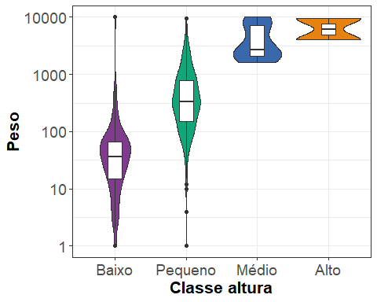
dados%>%
arrange(desc(classe_altura))%>%
ggplot(aes(x = weight, y = height, color = classe_altura)) +
geom_point(alpha = 0.4, size = 2) +
labs(x = "Peso", y = "Altura", color = "Classe altura")+
scale_y_continuous(trans = "log10")+
scale_color_manual(values = cores[c(1,2,3,7)])+
guides(color = guide_legend(override.aes = list(size = 4)))+
theme_bw()+
theme(
axis.text = element_text(size = 14),
axis.title = element_text(size = 16, face = "bold"),
legend.position = "right",
legend.text = element_text(size = 14),
legend.title = element_text(size = 16, face = "bold")
)
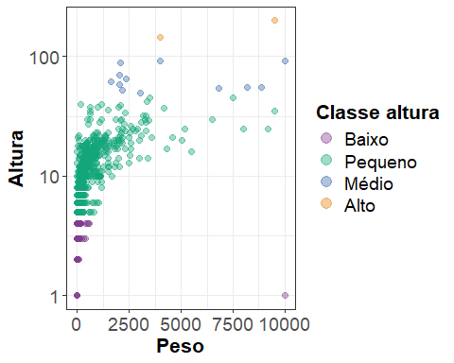

Gráfico facetados e de dois eixos
dados %>%
group_by(classe_altura) %>%
summarise(
media_h = mean(height),
media_w = mean(weight)
) %>%
pivot_longer(cols = c(2,3), values_to = "valor", names_to = "Tipo") %>%
ggplot(aes(x = Tipo, y = valor, fill = classe_altura))+
geom_col()+
facet_wrap(.~classe_altura) +
theme_bw()+
theme(
axis.text = element_text(size = 14),
axis.title = element_text(size = 16, face = "bold"),
legend.position = "none"
)
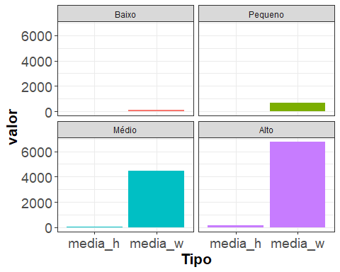
df_media<-dados %>%
group_by(classe_altura) %>%
summarise(
media_h = mean(height),
media_w = mean(weight)
) %>%
pivot_longer(cols = c(2,3), values_to = "valor", names_to = "Tipo") %>%
mutate(
Medida = case_when(
grepl("_h", Tipo) ~"Altura",
TRUE ~"Peso"
)
)
max_alt <- df_media %>%
filter(Medida == "Altura")%>%
arrange(desc(valor))%>%
distinct(Medida, .keep_all = T) %>% pull(valor)
max_pes <- df_media %>%
filter(Medida == "Peso")%>%
arrange(desc(valor))%>%
distinct(Medida, .keep_all = T) %>% pull(valor)
fator <- max_pes/max_alt
df_media%>%
mutate(
valor2 = ifelse(Medida == "Altura", valor*fator, valor)
)%>%
ggplot( aes(x = classe_altura, y = valor2, fill = Tipo))+
geom_col(position = position_dodge2())+
labs(x = "Classe", y = "Valor", fill = "Medida")+
#facet_wrap(.~classe_altura) +
scale_y_continuous(
sec.axis = sec_axis(~./fator, name = "Média da Altura")
)+
theme_bw()+
theme(
axis.text = element_text(size = 14),
axis.title = element_text(size = 16, face = "bold"),
legend.position = "right"
)
