Data Visualisation and its Applications Assignment
Julia Legner
University of Greenwich


- INTRODUCTION TO DATA VISUALISATION

Nowadays, data is everywhere and understanding patterns and behaviours is crucial for managing business strategies (Sadiku et al., 2016). Therefore, it is necessary to visualise data appropriately through data visualisation. According to Kirk (2019), data visualisation is defined as “the visual representation of data to facilitate understanding” through 2 components. Firstly, data exploration, which uses visual tools to identify patterns, trends and irregularities within a dataset. Secondly, a data explanation presenting the analysis findings to the audience/readers (Aparicio and Costa, 2015).

Anscombe (1973) made the case for visualisation over statistics alone. For example, demonstrating four entirely different datasets with identical means, standard deviations and regression lines can reveal completely different patterns/structures when plotted. Extending this logic, Cairo (2016) argues that a well-designed visualisation does more than display data. It should guide the reader towards insight through the deliberate choice of chart type, colour, and structure, i.e., through storytelling.

Each kind of chart type serves a different analytical purpose (Healy, 2019; Camm et al., 2021). Bar charts are used to compare categories by magnitude. Furthermore, you can discover seasonal patterns and changes over time in the best way through line plots. Whereby, box plots are more suitable to show the statistical distribution of data (median, spread, and outliers). Additionally, a heatmap is the best choice to discover correlations across dimensions. Scatter plots and bubble charts will reveal relationships between continuous variables. Finally, radar charts compare multivariate profiles across multiple subjects simultaneously. Therefore, it is very important to use the right kind of graph to demonstrate your findings.

Design principles also affect proper visualisation (Döbler and Großmann, 2019). Tufte (2001) highlights the importance of the ‘data-ink ratio’, which means to minimise non-informative visual elements to enable clear communication of the data. Colour should convey information rather than serve as decoration. A clear title and labelled axes are essential for every chart, and a legend should be included if there are multiple categories (Midway, 2020). This report uses interactivity to extend static charts by allowing users to zoom, pan and hover. This is particularly valuable when datasets are too large to label individually. Therefore, this report applies these principles to analyse ChrisCo's customer visit data from its 45 UK outlets in 2023.

- FINDINGS
The following visualisations in this report have been designed to guide readers through a logical process of exploring the datasets. Figure 1 introduces the outlet network and establishes a threshold-based volume segmentation. Figure 2 examines whether this hierarchy remains consistent throughout the year and whether there are any seasonal patterns. Figure 3 identifies outlets that opened or closed during 2023, providing important context before the in-depth analysis of established outlets begins. Figure 4 examines the day-to-day performance of each outlet and highlights anomalies. Figure 5 investigates whether the busiest outlets share the same busy and quiet days. Figure 6 explores which business characteristics (such as marketing spend, overheads, staff numbers and floor space) influence visit volume across all outlets simultaneously. Figure 7 zooms in on the profiles of the ten high- and medium-volume outlets to identify those that are investing wisely relative to what they receive in return. Finally, Figure 8 presents the investment analysis in a fully interactive format, enabling ChrisCo to explore the relationships between the five business characteristics and annual visit volume at their own pace.
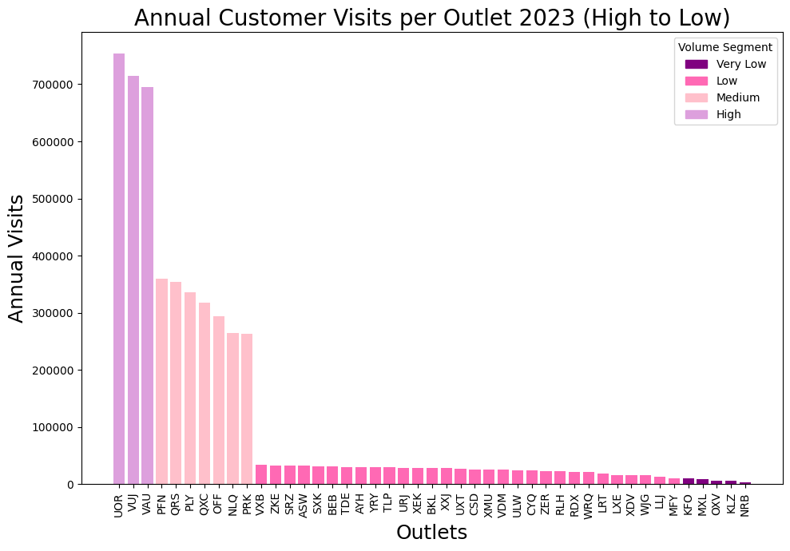
Figure 1: L02 Proportion – Bar Chart All Coloured
Setting the Scene: Who are ChrisCo's Outlets?

Justification:
As established in Lecture 02, a bar chart is the most effective chart type for comparing discrete categories by magnitude. The bar chart was chosen as an opening visualisation because it uses a pre-attentive attribute of length to instantly communicate differences with low cognitive load. Because of the amount of 45 outlets to introduce to the reader, it was from high importance to give the reader an immediate sense of the scale and extent of inequality before any deeper analysis occur. This makes the bar chart a more appropriate choice than a pie chart, as it is unsuitable for comparing many similarly sized categories. Sorting the bars in descending order applies the design principle discussed in Lecture 02, whereby ordering data by value rather than alphabetically makes the performance hierarchy instantly readable. It also exploits the Gestalt principle of proximity by visually grouping outlets with similar performance. The code is based on three lecture examples: the basic bar chart from L02/01 BarChartAll.py, the colour-by-segment approach from L02/07 BarChartAllColoured.py and the sorting logic from L02/08 BarChartAllSorted.py. The code was adapted in four ways. Firstly, instead of sorting by reindexing the full dataframe as demonstrated in the lectures, the code sorts directly on the summed series using total_visits.sort_values(ascending=False). Secondly, segment detection was replaced with a custom get_segment() function, which was applied directly to each outlet's annual total to produce a cleaner implementation. Thirdly, the segment thresholds were changed from the product-based limits in the lecture to outlet-appropriate natural breaks (0, 10,000, 200,000, 500,000), reflecting genuine gaps in the ChrisCo data. Fourthly, the figure size was increased to (10, 7) and the x-axis labels were rotated by 90° to clearly accommodate all 45 outlet codes. A legend was also added using plt.Rectangle to make the colour encoding self-explanatory for a non-technical reader.

Revealing:
Figure 1 shows that ChrisCo's 45 outlets vary significantly in customer footfall. Three outlets: UOR, VUJ and VAU, stand out as clear high-volume performers. They each receive over 500,000 visits per year, with UOR approaching 700,000 in 2023. A second pattern reveals the seven medium-volume outlets (PFN, QRS, PLY, QXC, OFF, NLQ and PRK). They receive between 200,000 and 400,000 visits per year. The remaining outlets fall into the low-volume (approximately 10,000–200,000 visits per year) and very low-volume (below 10,000 visits per year) categories. Therefore, seven outlets (LLJ, MFY, KFO, MXL, OXV, KLZ and NRB) receive negligible footfall by comparison. The clear difference in size between the high- and medium-volume groups, and between the medium- and low-volume groups, shows that threshold-based segmentation is a better reflection of the business reality than equally sized quantiles, because the natural breaks in the data correspond to different operating scales. This segmentation framework is applied with consistency in all subsequent visualisations.

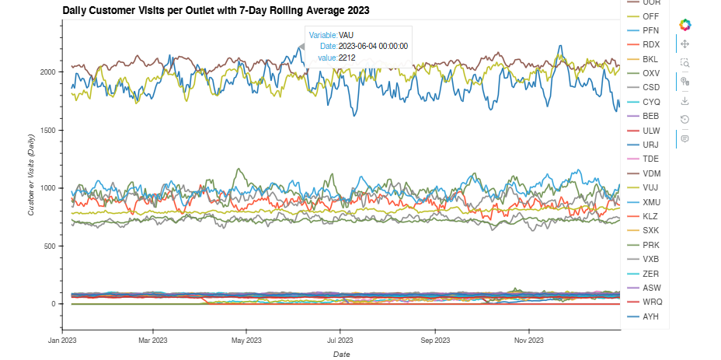
Figure 2: L07 Interactive – Line Plot Rolling Average
Seasonal Impact: How do all outlets perform throughout the year?
Justification:
A line plot was chosen as it is the most appropriate chart type for time-series data. It exploits the Gestalt principle of connection to discover trends, seasonal patterns and performance levels visible simultaneously across all 45 outlets. This visualisation has been made interactive to reflect the discussion of trade-offs in Lecture 07. While interactive code requires more effort to construct, it enables ChrisCo to zoom into specific months, pan across the year, and hover over individual lines to retrieve exact values. This transforms the chart from a fixed image into a directly usable exploratory tool. This is also especially useful for the large dataset of 45 outlets. The code draws on two lecture examples of Lecture 7: Interaction/01LinePlot.all.py and Interaction/03LinePlot.highVolumeSubplots.py. It shows the basic interactive line plot and the selected subset approach. It was adapted in four ways. Firstly, a seven-day rolling average was calculated using data.rolling(window=7).mean() in place of the raw daily data to smooth out the noise and make the seasonal trends more readable, a technique taught in Lecture 03. Secondly, rather than selecting a smaller number of outlets as in the lecture examples, all 45 outlets were included because the three/four performance volumes established in Figure 1 remain clearly distinguishable at full scale. Thirdly, the frame dimensions were changed from (600, 600) to (500, 900) to produce a wider, more readable time series layout. Fourthly, 'hvplot.show(plot)' was replaced with 'hv.extension("bokeh")' followed by 'plot' to ensure compatibility with Google Colab, as specified in the lecture notebook guidance.

Revealing:
Figure 2 reveals three distinct performance bands throughout the year. This provides a visual confirmation of the segmentation established in Figure 1. The three high-volume outlets (UOR, VUJ and VAU) are consistently above all others, with daily visit counts of around 1,800–2,200. The seven medium-volume outlets form a second visible band, with daily visit counts of around 700–1,100. The remaining low- and very low-volume outlets cluster near the bottom of the chart, with most recording fewer than 150 daily visits. Whereby, most outlets do not show significant seasonal variation. Subsequently, most visit levels remain consistent throughout the year. This is, on the contrary, what one might expect from consumer footfall data. VAU is an exception, showing greater fluctuations than both UOR and VUJ. There are noticeable peaks in June and December, as well as a dip in July 2023. This suggests that it may be more sensitive to local seasonal factors or events than other outlets. Several outlets at the lower end of the chart have flat zero lines at the start or end of the year. This indicates that they were not operational for the full period, assuming some outlets closed and reopened during 2023. This finding is examined directly in Figure 3.

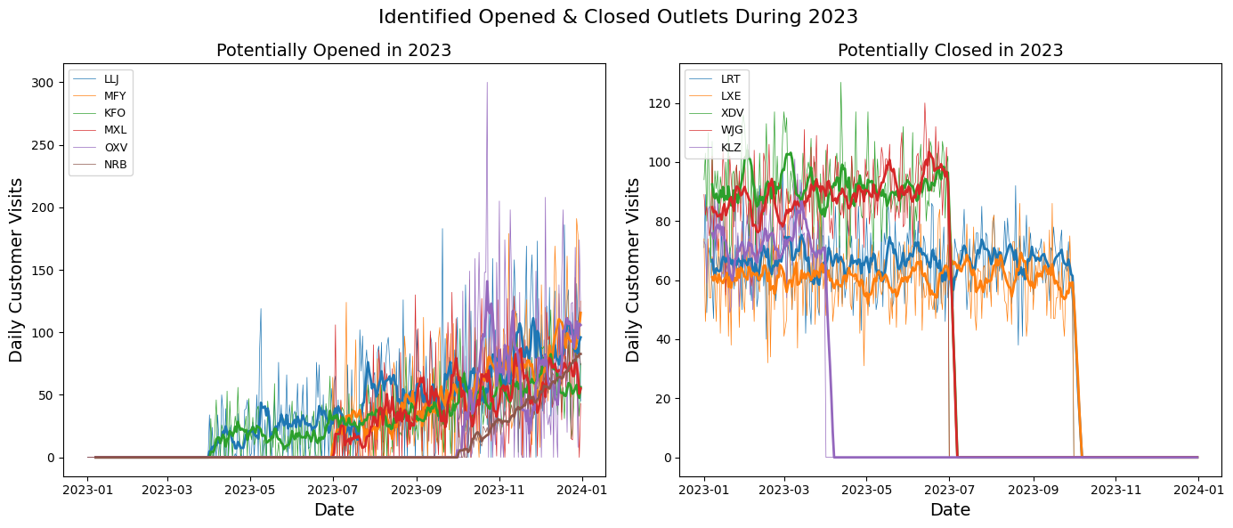
Figure 03: L03 Time – Line Plot averaged (opened & closed)
Identifying Outlets Opened or Closed During 2023

Justification:
Before analysing ChrisCo's established outlets in depth. It is essential to identify those that did not operate for the full year. Including them without acknowledgement would distort further findings. A side-by-side line plot with a seven-day rolling average was chosen in Figure 3 because it clearly shows the exact point at which each outlet transitions from zero to active visits, and vice versa. Meanwhile, the smoothed average line makes the underlying trend immediately apparent against the noisy daily data. Separating the two groups into distinct panels reduces cognitive overload by enabling readers to process each group independently. The code draws on lecture examples of L03 Time, especially of the basic line plot, and the rolling average overlay. It was adapted in three ways. First, a detective analysis of zero values at the start and end of the dataset was performed to identify the two groups: 'new_outlets' and 'closed_outlets'. Those were then passed as selected lists by mirroring the selected variable approach used throughout the lecture code. Secondly, rather than using a single plt.figure(), this visualisation uses a plt.subplot(1, 2, n) structure to display both groups side by side within a single figure. Thus, applying the faceting technique taught in Lecture 04. Thirdly, plt.gca().set_prop_cycle(None) was used, as in the lecture in order to reset the colours of the raw and averaged lines, ensuring that the rolling average of each outlet is colour-matched to its raw data line. The figure size was increased to (14, 6) to clearly accommodate both panels without overlap. Finally, plt.legend() was applied individually to each subplot to ensure that each panel was self-explanatory.

Revealing:
Figure 3 reveals that ChrisCo was actively reshaping its outlet network throughout 2023. The left panel shows six outlets, LLJ, MFY, KFO, MXL, OXV and NRB. Those had no visits at the start of the year. LLJ, MFY, KFO and MXL began receiving customers around April 2023, suggesting a coordinated wave of new openings. OXV started considerably later, in September 2023, indicating that it was a more recent addition to the outlet network. NRB is the most concerning anomaly: despite being present in the dataset, it recorded zero visits for the entire year. It is possible that it never opened, was planned but not yet operational, or that there is a data recording error that ChrisCo should investigate urgently.
Whereby, the right-hand panel shows the five outlets: LRT, LXE, XDV, WJG and KLZ. None of these received any visits at some point during the year. KLZ was the first to close down, in April 2023. XDV and WJG followed in July 2023. LRT and LXE potentially closed around October 2023. This suggests a deliberate mid-year rationalisation of the network. KLZ is particularly noteworthy as it was operational briefly in early 2023, closing in April. It then exhibited a brief spike in activity before disappearing entirely by April, behaviour that is consistent with either a temporary closure followed by a failed reopening or an attempted sale of the outlet. These findings provide critical context for all subsequent visualisations, and the performance analysis that follows excludes all 11 affected outlets.

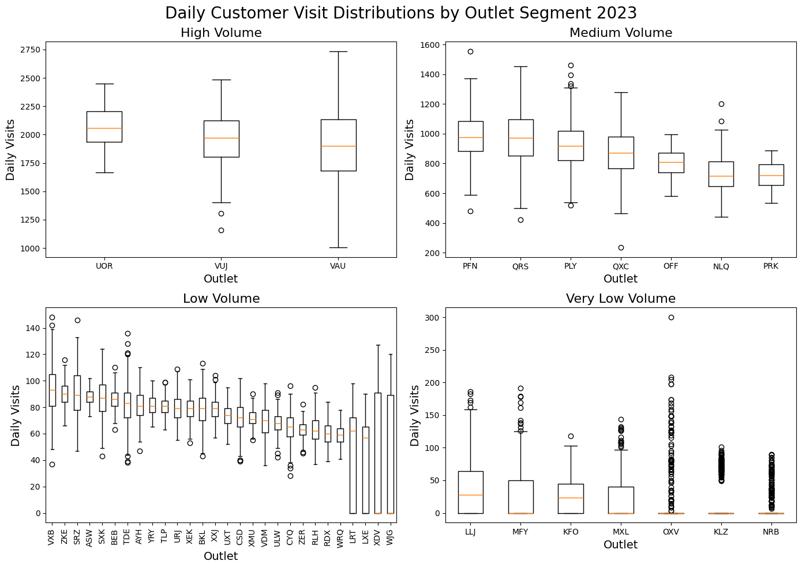
Figure 04: L05 Distribution – Box Plots
Outliers and Consistency: How Reliable Are the Outlets Day to Day?

Justification:
Box plots were chosen because they are the most efficient type of chart for displaying the distribution of daily visits per outlet simultaneously, as well as showing the median, interquartile range, whiskers and outliers in a compact and comparable format. As Lecture 05 explains, box plots answer a different question to line plots. Figure 2 shows how outlets performed over time. However, the box plot reveals how consistent each outlet is from day to day, independent of the time period. This makes it the natural next step in the analytical narrative. The code draws directly on the L05 Distribution/04 BoxPlot High Volume lecture example, which used plt.boxplot(data[selected], tick_labels=selected) for a single group of outlets. This was adapted in three ways. Firstly, the outlets were categorised manually into the four volume segments of high, medium, low and very low volume that have been established in Figure 1, as explicit Python lists. This replaced the single selected list from the lecture. Secondly, a plt.subplot(2, 2, n) faceting structure was introduced to display all four segments in a single figure, rather than in four separate charts. This applies the faceting technique taught in Lecture 04, enabling direct visual comparison across segments. Thirdly, the figure size was increased from (7, 7) to (14, 10) to accommodate the larger number of outlets. The 'plt.xticks(rotation=90)' command was also used on the low-volume panel. This was done to stop the x-axis labels from overlapping. The core code for the functions plt.boxplot(), plt.xlabel(), plt.ylabel() and plt.title() was identical to that used in the lecture.

Revealing:
Figure 4 reveals that high-volume outlets are ChrisCo's most consistently performing assets. The most consistent and popular choices among customer visits are UOR, VUJ and VAU. Their boxes are tight and the medians are close to the centre. This means that daily visits rarely differ dramatically from the typical value. These predictable, dependable performers present few operational surprises.
Medium-volume outlets show considerably more variation. An extreme outlier day is suggested by PLY's, which is visible as an isolated point well above the whisker. Therefore, it is indicated that something unusual happened at least once, such as a local event or promotional campaign, or a data recording error, which should be investigated by ChrisCo. The situation is mixed for low-volume outlets. VXB and ZKE quietly outperform their peers in the same volume segment, with higher medians and narrower boxes. This suggests that they may need to be reassessed. It also suggests that they may need to be moved into the medium segment. Others, such as WJG, demonstrate extreme inconsistency from day to day, by seeing wide boxes with multiple outliers. This makes them difficult to plan around operationally. The very low-volume group tells the most concerning story: OXV, KLZ, and NRB have medians close to zero, meaning they receive almost no customers on a typical day yet show occasional bursts of activity, as reflected by the outliers. This pattern is entirely consistent with the opening and closure behaviour identified in Figure 3.
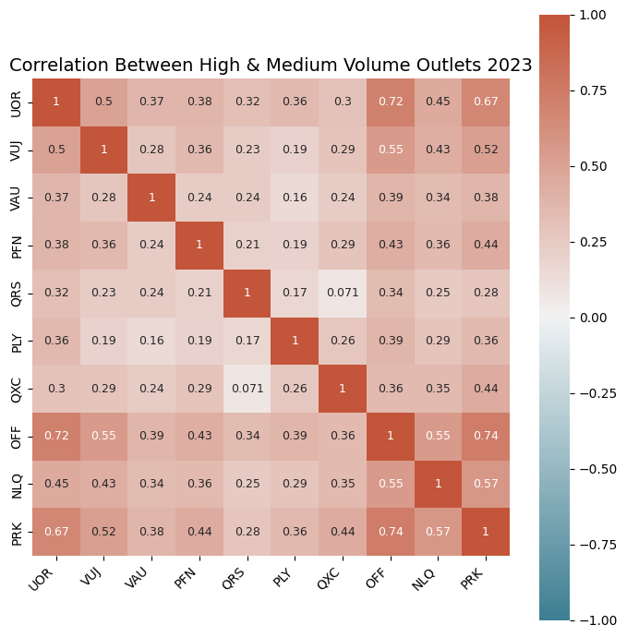
Figure 5: L04 Correlation – Heatmap (High & Medium Volume)
Do the busiest outlets move together or independently?

Justification:
A correlation heatmap was chosen as it is the most efficient way to display the relationships between multiple outlets simultaneously in a single visualisation. As Lecture 04 explains, the Pearson correlation coefficient, calculated using the .corr() function, measures the strength of the linear association between two variables on a scale from −1 to +1. The heatmap uses colour as a pre-attentive attribute to encode this information, enabling the reader to instantly identify the strongest and weakest relationships without performing any calculations. The analysis was restricted to ten high- and medium-volume outlets, as a full 45×45 grid would be illegible and ChrisCo is primarily interested in its most commercially significant outlets. The code is based on the L04 Correlation/05 HeatMap correlation selected.py lecture example, which used sns.heatmap() with sns.diverging_palette(220, 20, n=200), vmin=-1, vmax=1 and centre=0 to ensure the colour scale reflects the full range of possible correlations. This was adapted in three ways. Firstly, instead of using a threshold-based filter on the whole data frame (data.columns[data.sum() > 10000]), as shown in the lecture, a manually created list of the ten high- and medium-volume outlets was used. This method gives you total control over which outlets are included in the matrix and uses the segmentation from Figure 1 directly. Secondly, 'annot=True' and 'annot_kws={"size": 9} were added to display exact correlation values inside each cell, matching the annotation approach from the selected heatmap example in the lecture. Thirdly, a descriptive title was added using plt.title() and plt.tight_layout() was applied to improve the quality of the presentation. The core sns.heatmap(), diverging_palette, vmin, vmax, centre, and ax.set_xticklabels() calls remained identical to those in the lecture code.

Revealing:
The heatmap reveals two particularly notable findings. The strongest positive correlations in the matrix are between UOR and OFF (0.72), and between OFF and PRK (0.74). These are two pairs of outlets that span different volume segments, yet they have very similar daily visit patterns. UOR and PRK also show a strong correlation of 0.67. Taken together, these findings suggest that UOR, OFF, and PRK form a behavioural cluster. It is likely that they serve similar customer demographics and are exposed to the same external demand drivers, such as local events or weather. Alternatively, they may be located close to each other. This is precisely the type of grouping that Lecture 04 suggests may indicate products or, in this case, outlets that are affected by the same underlying cause. On the other hand, QRS and QXC show the lowest correlation in the matrix, with only a value of 0.071. This indicates and shows no linear relationship. This suggests that these two outlets behave independently of each other. VAU is the most independent of the three high-volume outlets, showing relatively low correlations with almost every other outlet, the strongest being 0.39 with OFF, despite being one of ChrisCo's highest performers. This suggests that VAU serves a distinctly different customer base than its peers. A topic explored further in the outlet profiles in Figure 7.

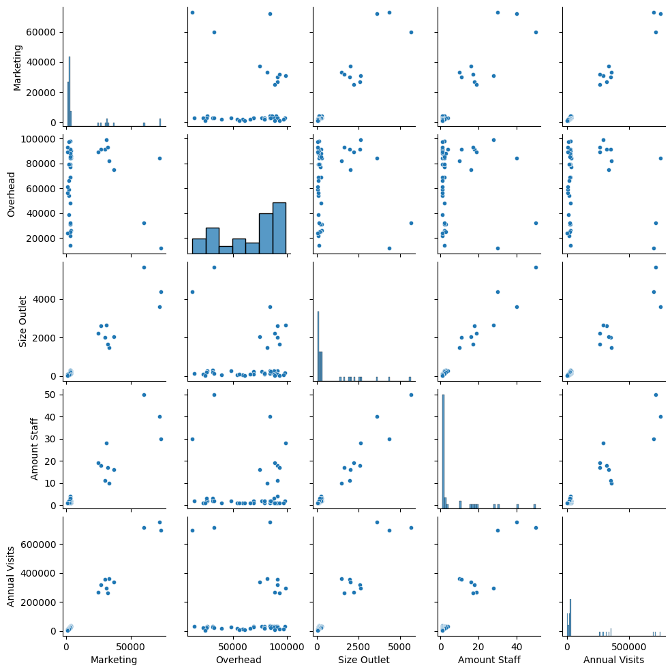
Figure 6: L06 Dimension – Correlogram/Pair Plot
Which business characteristics drive visit volume?

Justification:
A pairplot was chosen as it is the most efficient type of chart, in figure 6, to examining the relationships between the five outlet characteristics: marketing spend, overhead costs, outlet size, staff numbers and annual visits in a single figure. As Lecture 06 explains, a correlogram arranges scatter plots for every possible pair of variables into a grid with histograms on the diagonal. This makes it possible to read all the pairwise relationships at once. This addresses the deeper business question of whether differences in investment across outlets are associated with differences in customer footfall. This question could not be answered in the time-series correlation in Figure 5.
The code draws directly on the L06 Dimension/07 PairPlot lecture example (all.py), which used the command sns.pairplot(summary_data, height=1.5, plot_kwds={"s":20}) to construct a summary_data dataframe from multiple CSV files by aligning each variable using the .values command. The pairplot call itself is identical to the lecture code. It was adapted in two ways. Firstly, the summary data frame was constructed from ChrisCo's five outlet-level CSV files (outlet_marketing, outlet_overhead, outlet_size, outlet_staff and daily customer data) rather than the product-based files used in the lecture (price, profit, marketing and cost). The five variables therefore reflect business characteristics of the outlets rather than financials of the products. Secondly, the column names were updated to 'Marketing', 'Overhead', 'Size Outlet', 'Amount Staff' and 'Annual Visits' to accurately label ChrisCo's data. 'Annual Visits' was calculated using data.sum().values, in the same way that the lecture calculates total sales.

Revealing:
The bottom row of the pairplot is the most informative. It shows annual visits plotted against every other variable. The 'Marketing vs. Annual Visits' panel illustrates a positive yet distinctly non-linear relationship: a small group of outlets (the three high-volume ones) have high levels of both marketing expenditure and visits, while the remaining 42 outlets are concentrated in the corner with low levels of both. This suggests that marketing spend alone does not predict footfall in a straightforward manner, and that high-volume outlets may differ from others in ways that go beyond investment levels.
Of all the panels in the figure, the Staff vs Annual Visits panel reveals the clearest pattern: the three high-volume outlets employ significantly more staff (40–50) than all the other outlets, and this relationship is more consistent than in any other panel. Similar patterns are evident in the Size vs Annual Visits and Overhead vs Annual Visits panels. Overall, the pairplot confirms that ChrisCo's three high-volume outlets: UOR, VUJ and VAU. These are outliers in all dimensions, with higher marketing expenditure, overheads, staffing levels, floor space and annual visits. The remaining 42 outlets cluster tightly together, exhibiting modest characteristics across all variables. This makes us wonder something important that the information alone cannot answer: does investment cause visits, or are the popular shops in busy areas because they are successful, not because of investment?

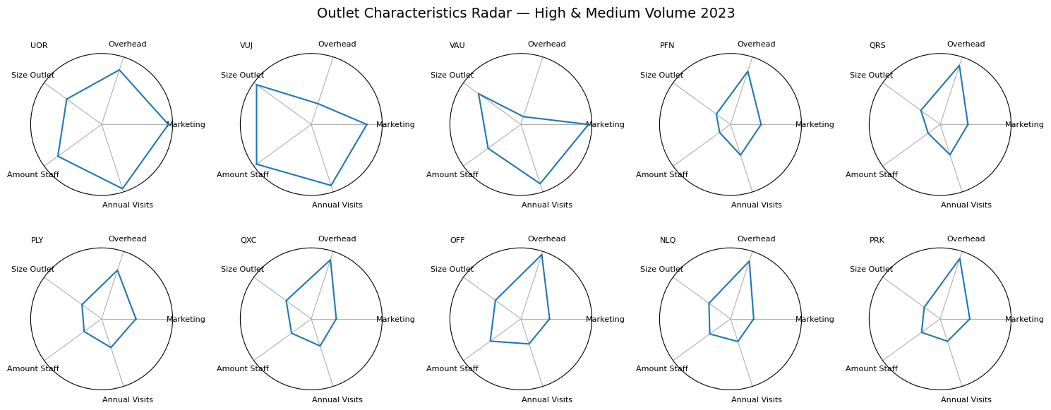
Figure 7: L06 Dimension – Radar Plot (High & Medium Volume)
Which outlets are investing wisely relative to what they get back?

Justification:
A radar chart was chosen in Figure 7 because it is the most effective type of chart for comparing the full, multidimensional profile of individual outlets simultaneously. This makes investment imbalances immediately visible as irregular polygonal shapes. As Lecture 06 explains, a radar plot plots normalised variables around a circle and connects them to form a polygon. If the shape is balanced, it means that the outlet is well-rounded. But if there is a spike in one direction, it shows that there has been disproportionate investment in that dimension. The pair plot in Figure 6 is different from the one in Figure 7 because it compares variables across all outlets at the same time. The radar chart focuses on the profile of each individual outlet. This allows us to answer the specific question of whether each outlet's investment mix is proportionate to its footfall. The code draws on two lecture examples of L06 Radar Plot: the full-grid radar, and the selected subset radar. The core logic here is by using normalisation through summary_data/summary_data.max(), angle calculation using n/float(n_attributes)*2*np.pi. The subplot structure using the polar angles and values is identical to the lecture code. However, it was adapted in four ways. Firstly, the loop iterates over a manually defined list of the ten high- and medium-volume outlets rather than over all 45 outlets, directly applying the segmentation from Figure 1. Secondly, the grid was changed from plt.subplot(5, 5, counter) to plt.subplot(2, 5, counter) in order to display ten outlets neatly in two rows of five. Thirdly, .loc[data.columns] was applied when constructing the summary dataframe to ensure that the outlet rows were aligned correctly across all five CSV files before normalisation. Fourthly, rather than showing y-tick values as in the high-volume example, sub.set_yticks( []) was retained from the all-outlets lecture example, since the smaller radar size at (15, 6) makes tick labels difficult to read clearly.

Revealing:
Figure 7 shows that the three high-volume outlets, UOR, VUJ and VAU, have different characteristic profiles. Even though they belong to the same segment. Among the high-volume outlets: UOR has the most balanced and desirable shape. Its annual visits polygon extends well outwards while its overhead and marketing dimensions remain proportionate, suggesting that its investment mix is working efficiently. This indicates that its investment portfolio is functioning effectively. However, VUJ has a clear overhead spike that is not in line with its annual visits area. It is spending a lot on overheads without a clear increase in visitors. Similarly, VAU shows a large marketing spike relative to visits, raising the question of whether that marketing spend is translating into customer traffic as effectively as it should. Among the medium-volume outlets, PFN is the most efficient performer: it achieves a relatively large annual visit polygon while keeping the overhead and marketing dimensions compact, the exact shape that ChrisCo should aim to replicate. QRS shows the opposite pattern, with Overhead dominating and Annual Visits being comparatively modest. QXC and OFF both have very high overhead costs compared to the number of customers they have. PLY has the smallest overall polygon in the group and experiences low annual visits, with no compensating efficiency in cost dimensions. In relation to the neutral factors, the dimensions of the Staff and Size Outlet are incorporated to demonstrate whether these structural characteristics are commensurate with performance. For example, larger outlets with more staff would naturally be expected to attract more visitors. These dimensions are not included to evaluate efficiency directly. NLQ and PRK demonstrate consistent compact shapes across all dimensions, which is in line with their position at the lower end of the medium segment.

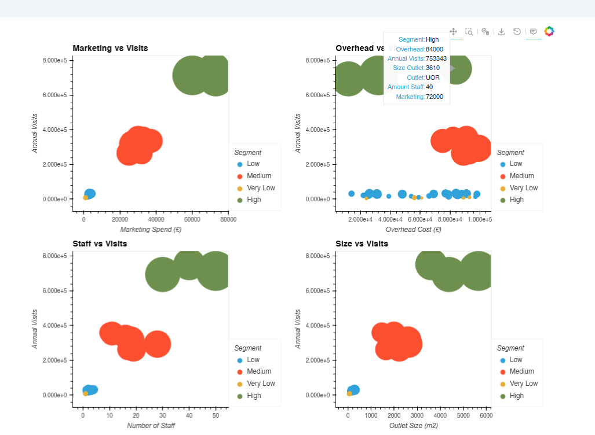
Figure 8: L07 Interactive – Interactive Bubble Chart
Marketing, Overheads, Staff & Size vs. Annual Visits

Justification:
The final visualisation chosen, in Figure 8, is an interactive bubble chart. It brings together all four of the business investment characteristics examined throughout the report into a single, interactive figure. This allows ChrisCo to explore the relationships between investment and footfall at their own pace. As discussed in Lecture 07, the key advantage of interactivity in explanatory analysis is that hover functionality reveals individual outlet profiles without cluttering the chart with labels, which is particularly valuable given the degree of overlap between segments in some panels. Mapping bubble size to outlet floor space adds a third visual dimension to every panel. It makes it possible to see whether large outlets are receiving visits proportionate to their size and eliminates the need for a separate chart. The code draws on lecture examples: the single bubble plot from Lecture 07, Interaction/11BubblePlot.py. This uses the scatter() function with the size variable mapped to reveal outlet details when the user hovers over a bubble. Additionally, it uses the plot composition approach from Lecture 07, Interaction/09ScatterPlots/selected_correlations.py, which used the + operator to combine multiple plots side by side. This was adapted in four ways. First, the single scatter plot was expanded to four panels: Marketing, Overheads, Staff and Size. All of them were plotted against Annual Visits. The + operator and .cols(2) were used to arrange them in a 2×2 grid. This directly applies the composition technique taught in Lecture 07. Secondly, 'by=Segment' was added to colour each bubble according to the volume category established in Figure 1, applying the Gestalt principle of similarity and maintaining visual consistency across all eight figures. Thirdly, an Outlet column was added to summary_data so that, when hovered over, the outlet name is revealed alongside its full profile. The hover_cols were set individually per panel to display the most relevant characteristics for each axis combination. Fourthly, 'hvplot.show(plot)' was replaced with 'hv.extension("bokeh")'.

Revealing:
The findings from Figures 6 and 7 are confirmed and extended by Figure 8. It enables ChrisCo to interactively identify individual outlets, as demonstrated by the screenshot displaying UOR's complete profile. This outlet receives 753,343 visits per year, has overheads of £84,000, floor space of 3,610 m², 40 members of staff and spends £72,000 on marketing. If you look at the four panels, you'll see that the three high-volume outlets (the green bubbles) are always separated from all the other segments. This shows that the difference in performance is a basic part of how the system is set up. However, not all relationships are equally meaningful. The Marketing and Size panels partly reflect co-dependency.
Successful outlets naturally accumulate larger budgets and more extensive premises as a consequence of their performance, rather than as a cause of it. This makes these relationships difficult to interpret causally. The Overhead vs Visits panel is the most analytically valuable. It shows that some medium-volume websites (orange bubbles) have overheads that are almost the same as the high-volume group, even though they have a lot fewer visitors. This indicates that they are paying high operational costs without receiving an equivalent amount of footfall in return. This corroborates the cost-efficiency concerns identified for PLY and VUJ in Figure 7 directly, and the hover functionality enables ChrisCo to identify the outlets with the highest overhead-to-visits burden precisely. Notably, the low- and very low-volume outlets (blue and yellow bubbles) cluster tightly in the bottom left of this panel, showing both minimal overheads and minimal visits. While this may appear efficient, it raises a different concern: these outlets are generating almost no footfall despite being operational. This suggests that low overheads alone are not sufficient for good performance, and that underinvestment may be contributing to their poor customer numbers. The Staff vs. Visits panel is the most structurally independent relationship. You can indicate that management makes staffing decisions based on operations, not financial consequences of success. This results in a clear distinction between high-volume (40–50 staff), medium (10–30 staff) and low-volume (fewer than 10 staff) outlets. This makes staffing capacity a genuine driver of footfall rather than a dependent variable.

- CRITICAL REVIEW
The key takeaway from this module is that the type of chart must align with the analytical question. Otherwise, it can obscure valuable insights. During the exploratory phase, we demonstrated this when displaying all 45 outlets as a stacked area chart produced an unreadable result. The reason for this was that it concealed the behaviour of individual outlets by masking it behind cumulative totals. In contrast, displaying the same data as a line plot with a seven-day rolling average (Lecture 03) immediately revealed three distinct performance bands and the seasonal stability of most outlets. This brought to life the argument from Lecture 1, illustrated by Anscombe's quartet, that statistics alone are insufficient and that the choice of visualisation fundamentally shapes our understanding of data.

These lessons were applied to the coursework, with several of the module's best practices demonstrated throughout the report. Pre-attentive attributes, particularly colour and length, were used consistently across Figures 1, 4 and 8. This used the Gestalt principle of similarity (Lecture 08), which allowed the reader to understand the different categories of volume without needing more explanation Tufte's data-ink ratio idea was used to make choices like putting the legend outside the chart area in Figure 2 and turning the x-axis labels in Figure 4, which made things less messy. Rather than using quantiles of equal size, which the lecture explicitly warns against, the threshold-based segmentation approach from Lecture 2 proved to be analytically sound. The four volume groups behaved as genuinely distinct business scales across every subsequent figure, from the correlation heatmap in Figure 5 to the radar profiles in Figure 7. The two interactive visualisations (Figures 2 and 8) directly reflect the best practice trade-off discussed in Lecture 07. Interactive charts require more effort to construct, but considerably extend analytical value by enabling zooming, panning and hovering, thus transforming a fixed presentation into an exploratory tool that ChrisCo could use directly. However, a genuine limitation is that a PDF report can only capture a single static state of an interactive chart — to realise its full value, the live notebook is required. Another analytical limitation is the inability to establish causality. As Lecture 04 explicitly warns, correlation does not imply causation. Whether investment drives footfall or successful locations simply attract investment cannot be determined from a single year of cross-sectional data.

A further consideration is that with eight visualisations, the breadth of insight that can be presented is limited. With 45 outlets, five business characteristics and a full year of daily data, there are many more analytical angles than can be included without exceeding the specification. This makes storytelling critically important: each visualisation must earn its place by advancing the narrative. The eight figures presented reflect the analytical priorities that I believe are most valuable to ChrisCo: first establishing the volume hierarchy, then examining consistency, correlation and investment efficiency in sequence. However, the selection and ordering of charts in data visualisation storytelling is not neutral. A different business question would justify an entirely different selection and ordering. Had ChrisCo specified a different focus, the visualisations would have been adapted accordingly.

- CONCLUSION
A visual study of ChrisCo's 45 outlets in 2023 led to the following key conclusions:
- ChrisCo's outlets display stark variations in performance across four distinct volume categories: high, medium, low, and very low. UOR, VUJ and VAU stand out as clear high-volume performers, each receiving over 500,000 customer visits in 2023. The majority of outlets fall into the low-volume range, with fewer than 100,000 visits recorded annually.
- The number of visitors to most outlets remains consistent throughout the year, with no major seasonal fluctuations. VAU is the notable exception, being more sensitive to seasonal factors than its high-volume peers. It experiences peaks in June and December, as well as a dip in July.
- ChrisCo actively reshaped its outlet network in 2023, opening six outlets in the middle of the year and closing five others. NRB is a critical anomaly. It appears in the dataset but it recorded zero visits for the entire year. This requires urgent investigation. It may indicate a failed opening or a data recording error.
- High-volume outlets are ChrisCo's most reliable day-to-day performers, with even visitation patterns and minimal anomalies. Whereby, low-volume to very low volume outlets show the greatest variability and most anomalous behaviour, which is consistent with recent openings or closures.
- Not all high-performing outlets behave in the same way. UOR, OFF and PRK form a strong behavioural cluster, whereas VAU operates largely independently, suggesting that it serves a different customer base or geographic market.
- The strongest and most consistent relationship with annual visit volume is shown by staffing levels and outlet size. A positive but non-linear relationship with footfall is shown by marketing spend. Significantly more is invested by the three high-volume outlets than by all the others, while comparatively few visits are received and very little is spent by the remaining outlets.
- Among the medium-volume outlets, PFN is the most efficient in terms of investment, achieving relatively high footfall while keeping overheads and marketing costs low. On the other hand, VUJ and PLY have overhead costs that are much higher than the number of visitors they get, so ChrisCo should be focusing on them and revising its strategy.

- REFERENCES

Anscombe, F.J. (1973) 'Graphs in statistical analysis', The American Statistician, 27(1), pp. 17–21. Available at: https://doi.org/10.1080/00031305.1973.10478966 (Accessed: 24 February 2026).

Aparicio, M. and Costa, C.J. (2015) 'Data visualization', Communication Design Quarterly Review, 3(1), pp. 7–11. Available at: https://doi.org/10.1145/2721882.2721883 (Accessed: 27 February 2026).

Cairo, A. (2016) The Truthful Art: Data, Charts, and Maps for Communication. San Francisco: New Riders. Available at: https://www.amazon.co.uk/Truthful-Art-Data-Charts-Communication/dp/0321934075 (Accessed: 2 March 2026).

Camm, J.D., Cochran, J.J., Fry, M.J. and Ohlmann, J.W. (2021) Data Visualization: Exploring and Explaining with Data. Mason, OH: Cengage Learning. Available at: https://www.cengage.com/c/data-visualization-1e-camm-cochran-fry-ohlmann/9780357631348/ (Accessed: 28 February 2026).

Döbler, M. and Großmann, T. (2019) Data Visualization with Python. Birmingham: Packt Publishing. Available at: https://www.packtpub.com/product/data-visualization-with-python/9781789956467 (Accessed: 25 February 2026).

Healy, K. (2019) Data Visualization: A Practical Introduction. Princeton: Princeton University Press. Available at: https://books.google.co.uk/books?id=v7gfEQAAQBAJ (Accessed: 1 March 2026).

HoloViews/hvplot (2023) hvplot: A high-level plotting API for the PyData ecosystem. Available at: https://hvplot.holoviz.org (Accessed: 3 March 2026).

Hunter, J.D. (2007) 'Matplotlib: A 2D graphics environment', Computing in Science & Engineering, 9(3), pp. 90–95. Available at: https://doi.org/10.1109/MCSE.2007.55 (Accessed: 26 February 2026).

Kirk, A. (2019) Data Visualisation: A Handbook for Data Driven Design. 2nd edn. London: SAGE Publications. Available at: https://uk.sagepub.com/en-gb/eur/data-visualisation/book266150 (Accessed: 24 February 2026).

Midway, S.R. (2020) 'Principles of effective data visualization', Patterns, 1(9), 100141. Available at: https://doi.org/10.1016/j.patter.2020.100141 (Accessed: 28 February 2026).

Sadiku, M.N.O., Shadare, A.E., Musa, S.M. and Akujuobi, C.M. (2016) 'Data visualization', International Journal of Engineering Research and Advanced Technology, 2(12), pp. 11–16. Available at: https://www.researchgate.net/publication/311597028 (Accessed: 2 March 2026).

Tufte, E.R. (2001) The Visual Display of Quantitative Information. 2nd edn. Cheshire, CT: Graphics Press. Available at: https://www.edwardtufte.com/book/the-visual-display-of-quantitative-information/ (Accessed: 27 February 2026).

Waskom, M. (2021) 'Seaborn: Statistical data visualization', Journal of Open Source Software, 6(60), p. 3021. Available at: https://doi.org/10.21105/joss.03021 (Accessed: 1 March 2026).

- APPENDIX

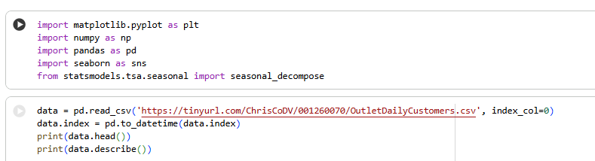
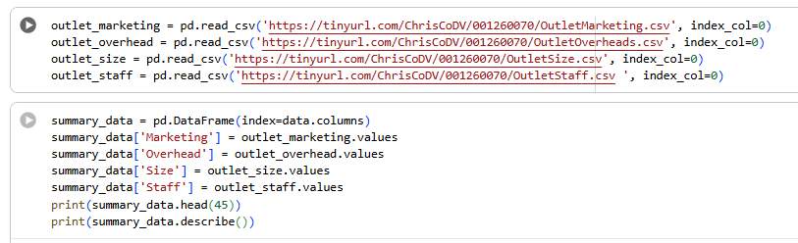

Appendix 1: Code for the main base and combined 2 datasets

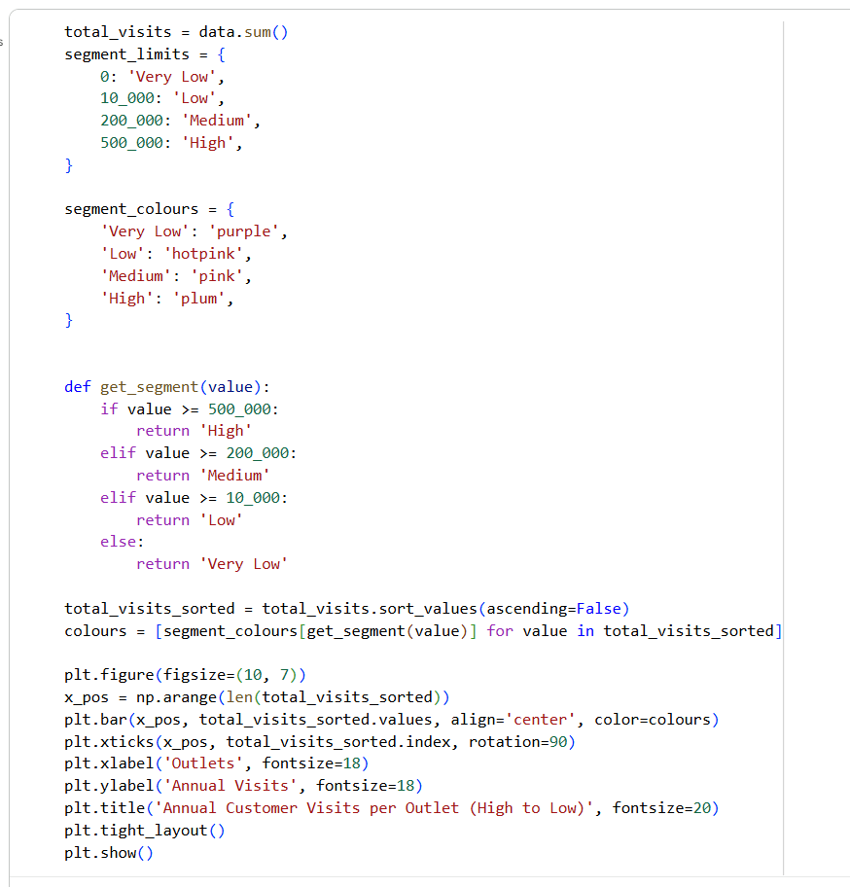
Appendix 2: Used Code for Figure 1

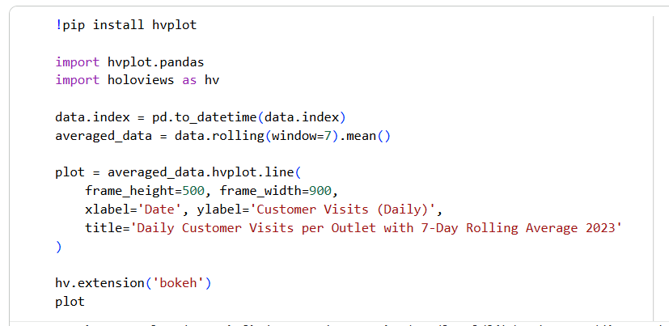
Appendix 3: Used Code for Figure 2

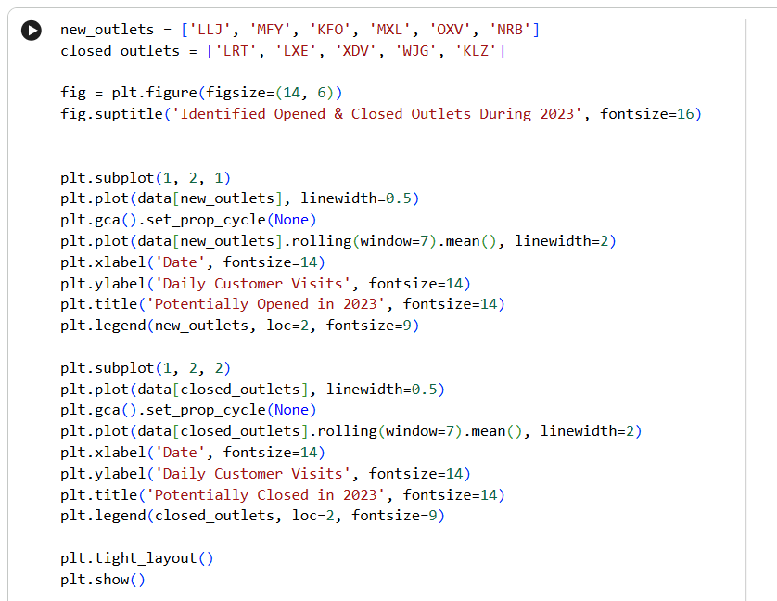
Appendix 4: Used Code for Figure 3

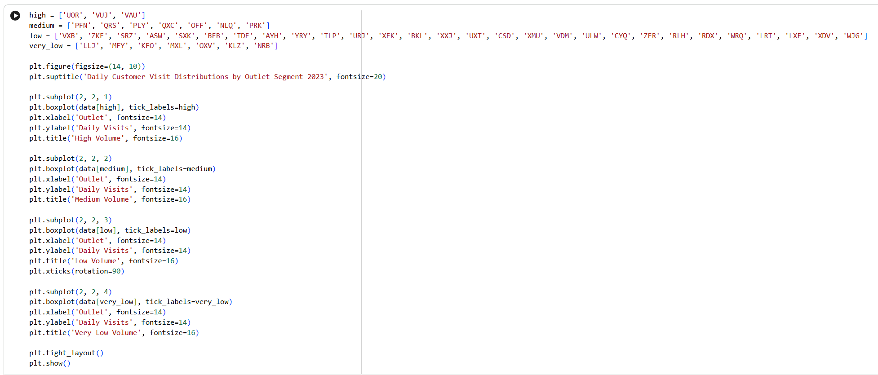
Appendix 5: Used Code for Figure 4

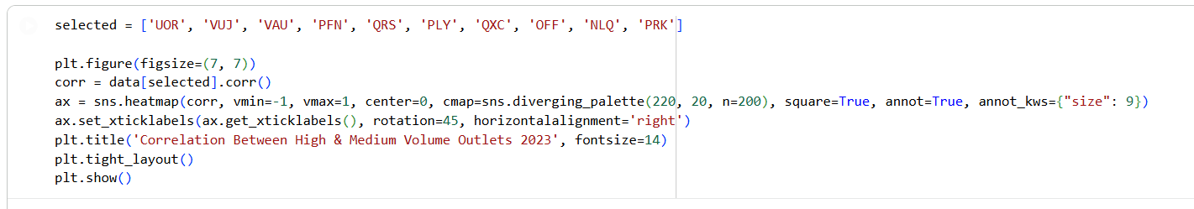
Appendix 6: Used Code for Figure 5

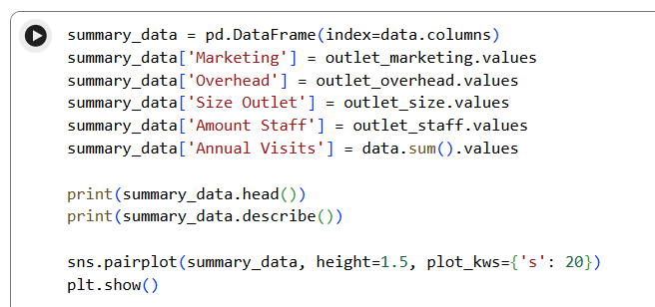
Appendix 7: Used Code for Figure 6

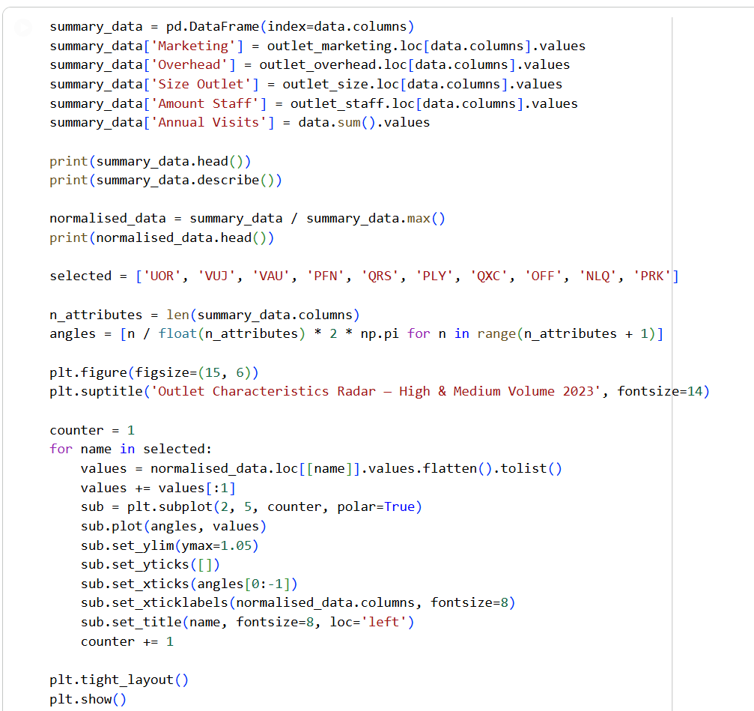
Appendix 8: Used Code for Figure 7

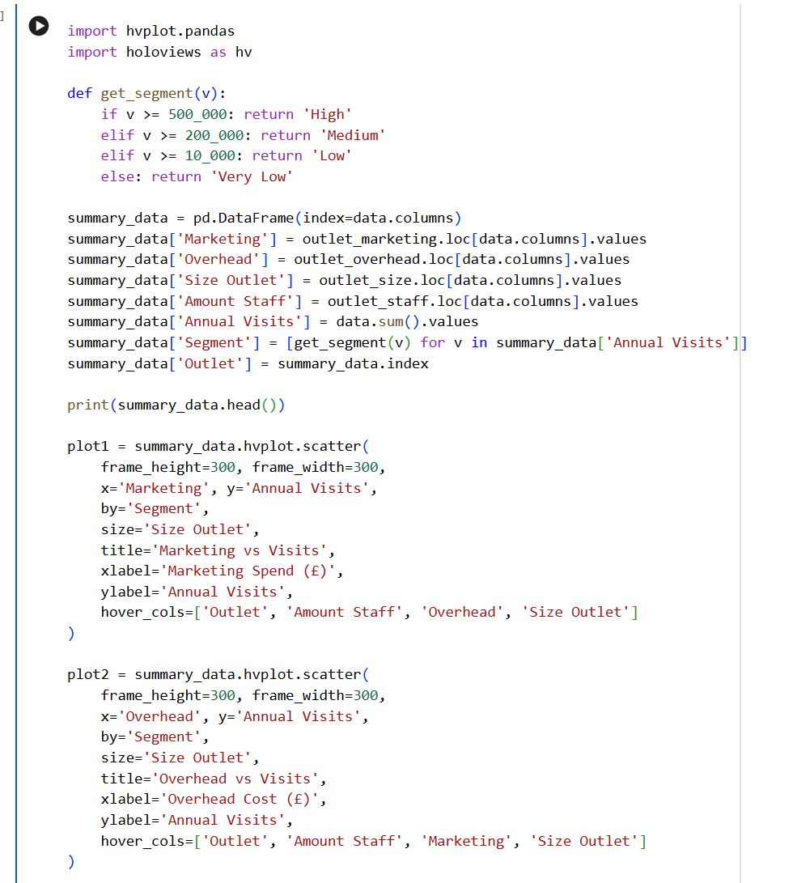
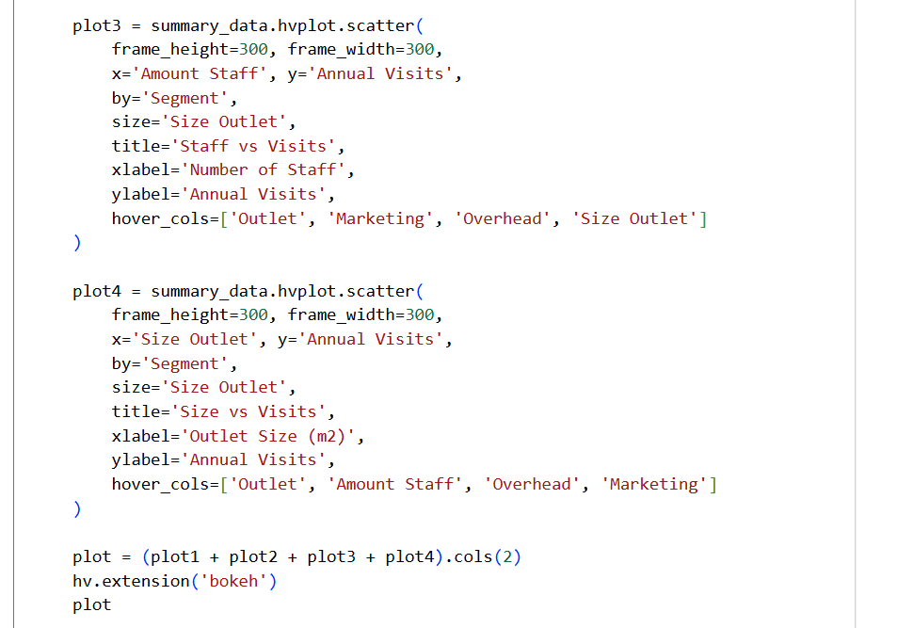

Appendix 9: Used Code for Figure 8

