Documentation

Project Name

Stack Overflow Project

Programming Language

HTML, CSS, JavaScript

Project URL of the GitHub repository:

<https://github.com/JuliaLiu1997/julialiu1997.github.io/tree/master/StackOverflowProject>

Project Online Version:

<https://julialiu1997.github.io/StackOverflowProject/index>

Functionality:

1. Enter a tag in the input area and click “Search”.

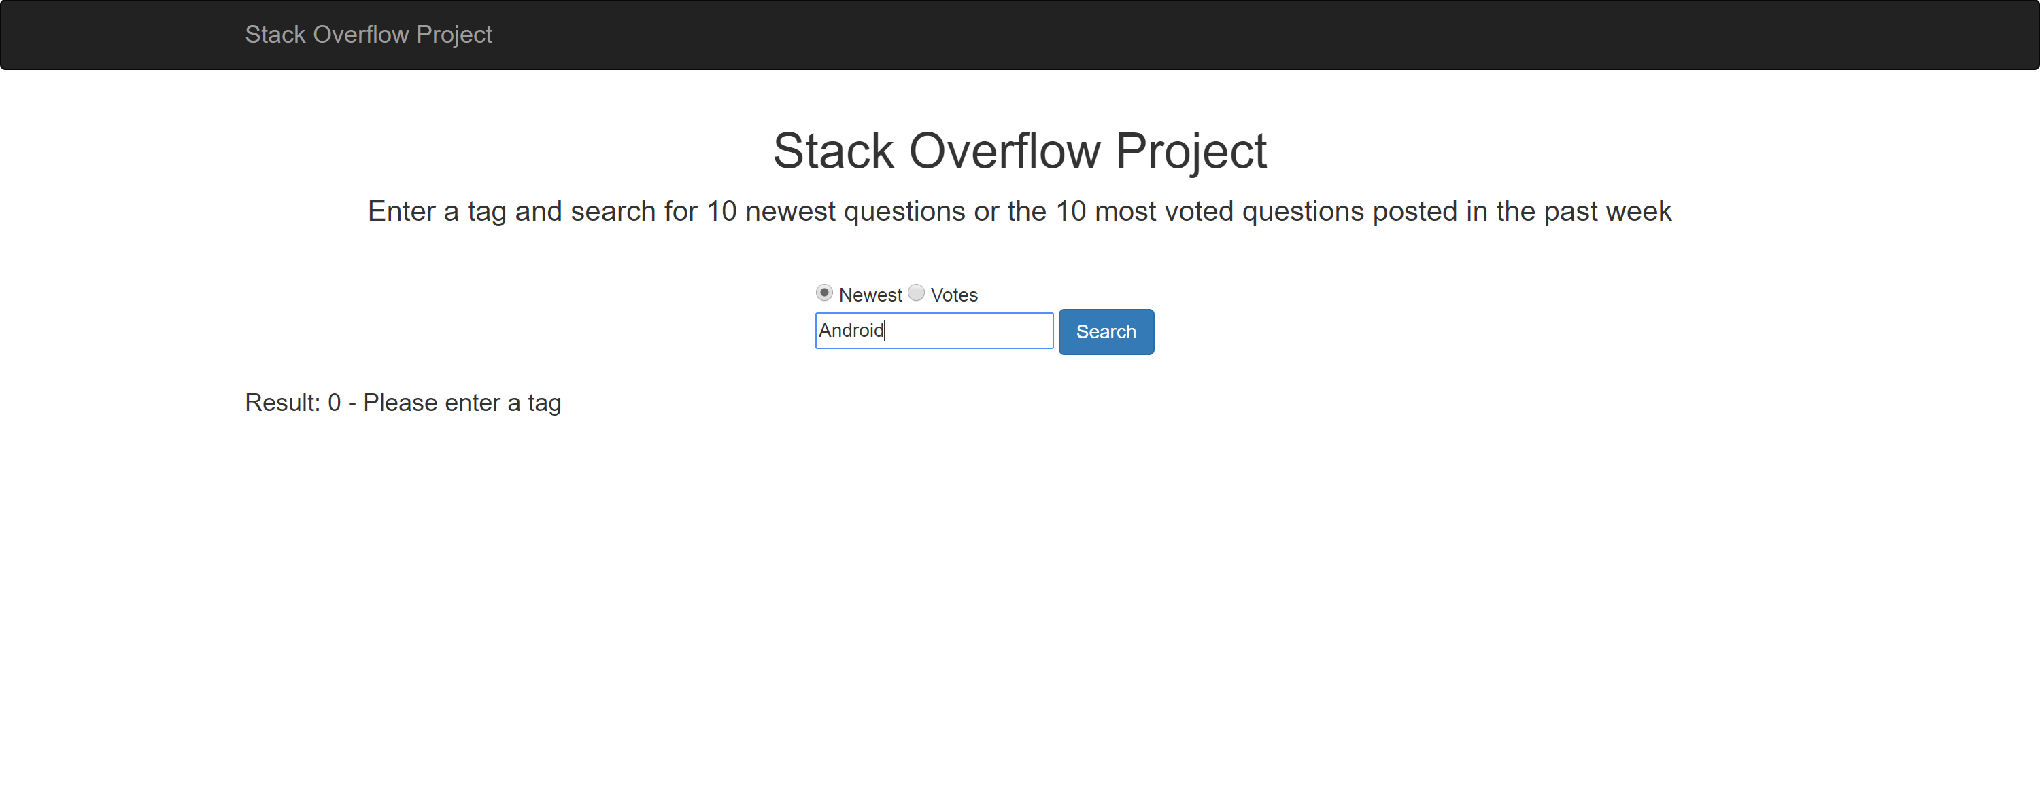

1. The website will show you the top 10 newest question in this area in the past week.

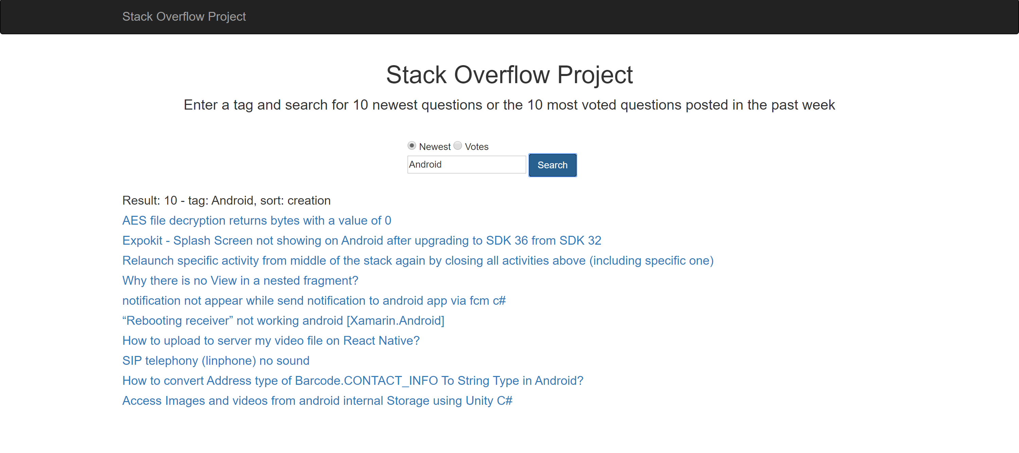

1. You can also click “Votes” and “Search” to see the 10 most votes question in this area in the past week.

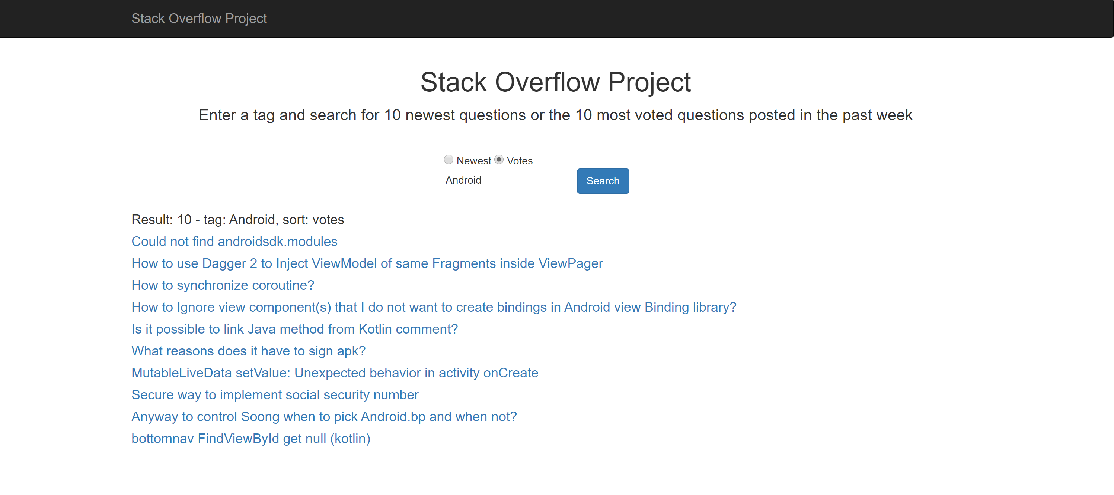

1. When you click on the title of a question, the full question content will be displayed. Click on the weblink and the original website on a blank page will be shown. Click on the title again to hide the question content.

