

|  |
| --- |
| desWeb1 |
| 15/05/17 20:12 |
| **Author:** John Doe  **File name:** desWeb1.vp  **Version** 1.0 |

|  |
| --- |
| Site Map |
|  |

|  |
| --- |
|  |

01. Site Map / desWeb1 

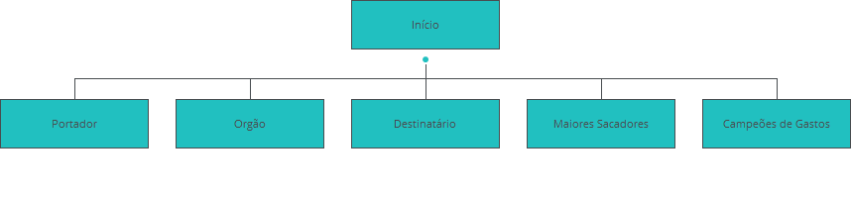

|  |
| --- |
| Screens |
|  |

|  |
| --- |
|  |

02. Screens / desWeb1 

Início

|  |
| --- |
|  |

Interactions

|  |  |
| --- | --- |
| 1 | **on Click:** goes to 'Início' 🡪 |
| 2 | **on Click:** goes to 'Portador' 🡪 goes to 'Portador' 🡪 |
| 3 | **on Click:** goes to 'Orgão' 🡪 goes to 'Orgão' 🡪 |
| 4 | **on Click:** goes to 'Destinatário' 🡪 goes to 'Destinatário' 🡪 |
| 5 | **on Click:** goes to 'Maiores Sacadores' 🡪 goes to 'Maiores Sacadores' 🡪 |
| 6 | **on Click:** goes to 'Campeões de Gastos' 🡪 goes to 'Campeões de Gastos' 🡪 goes to 'Campeões de Gastos' 🡪 goes to 'Campeões de Gastos' 🡪 goes to 'Campeões de Gastos' 🡪 |

02. Screens / desWeb1 

Portador

|  |
| --- |
|  |

Interactions

|  |  |
| --- | --- |
| 7 | **on Click:** goes to 'Início' 🡪 goes to 'Início' 🡪 |
| 8 | **on Click:** goes to 'Portador' 🡪 goes to 'Portador' 🡪 |
| 9 | **on Click:** goes to 'Orgão' 🡪 goes to 'Orgão' 🡪 |
| 10 | **on Click:** goes to 'Destinatário' 🡪 |
| 11 | **on Click:** goes to 'Maiores Sacadores' 🡪 |
| 12 | **on Click:** goes to 'Campeões de Gastos' 🡪 |

02. Screens / desWeb1 

Orgão

|  |
| --- |
|  |

Interactions

|  |  |
| --- | --- |
| 13 | **on Click:** goes to 'Início' 🡪 goes to 'Início' 🡪 goes to 'Início' 🡪 |
| 14 | **on Click:** goes to 'Portador' 🡪 goes to 'Portador' 🡪 |
| 15 | **on Click:** goes to 'Orgão' 🡪 goes to 'Orgão' 🡪 |
| 16 | **on Click:** goes to 'Destinatário' 🡪 goes to 'Destinatário' 🡪 |
| 17 | **on Click:** goes to 'Maiores Sacadores' 🡪 goes to 'Maiores Sacadores' 🡪 |
| 18 | **on Click:** goes to 'Campeões de Gastos' 🡪 goes to 'Campeões de Gastos' 🡪 |

02. Screens / desWeb1 

Destinatário

|  |
| --- |
|  |

Interactions

|  |  |
| --- | --- |
| 19 | **on Click:** goes to 'Início' 🡪 goes to 'Início' 🡪 goes to 'Início' 🡪 |
| 20 | **on Click:** goes to 'Portador' 🡪 goes to 'Portador' 🡪 |
| 21 | **on Click:** goes to 'Orgão' 🡪 goes to 'Orgão' 🡪 |
| 22 | **on Click:** goes to 'Destinatário' 🡪 goes to 'Destinatário' 🡪 |
| 23 | **on Click:** goes to 'Maiores Sacadores' 🡪 goes to 'Maiores Sacadores' 🡪 |
| 24 | **on Click:** goes to 'Campeões de Gastos' 🡪 goes to 'Campeões de Gastos' 🡪 |

02. Screens / desWeb1 

Maiores Sacadores

|  |
| --- |
|  |

Interactions

|  |  |
| --- | --- |
| 25 | **on Click:** goes to 'Início' 🡪 goes to 'Início' 🡪 |
| 26 | **on Click:** goes to 'Portador' 🡪 |
| 27 | **on Click:** goes to 'Orgão' 🡪 |
| 28 | **on Click:** goes to 'Destinatário' 🡪 goes to 'Destinatário' 🡪 |
| 29 | **on Click:** goes to 'Maiores Sacadores' 🡪 |
| 30 | **on Click:** goes to 'Campeões de Gastos' 🡪 goes to 'Campeões de Gastos' 🡪 |

02. Screens / desWeb1 

Campeões de Gastos

|  |
| --- |
|  |

Interactions

|  |  |
| --- | --- |
| 31 | **on Click:** goes to 'Início' 🡪 goes to 'Início' 🡪 |
| 32 | **on Click:** goes to 'Portador' 🡪 |
| 33 | **on Click:** goes to 'Orgão' 🡪 |
| 34 | **on Click:** goes to 'Destinatário' 🡪 |
| 35 | **on Click:** goes to 'Maiores Sacadores' 🡪 goes to 'Maiores Sacadores' 🡪 |
| 36 | **on Click:** goes to 'Campeões de Gastos' 🡪 |

|  |
| --- |
| Templates |
|  |

|  |
| --- |
|  |

03. Templates / desWeb1 

960 grid - 12 columns

|  |
| --- |
|  |

03. Templates / desWeb1 

960 grid - 16 columns

|  |
| --- |
|  |

03. Templates / desWeb1 

Template 1

|  |
| --- |
|  |

|  |
| --- |
| Scenarios |
|  |

|  |
| --- |
|  |

04. Scenarios / desWeb1 

default

|  |
| --- |
|  |